**Quiz 1**

**If you selected the left-side lottery in the screen below, what are the potential outcomes and probabilities of that lottery?**

1. Outcome ________________________ Probability ________________________

2. Outcome ________________________ Probability ________________________

**If you selected the right-side lottery in the screen below, what are the potential outcomes and probabilities of that lottery?**

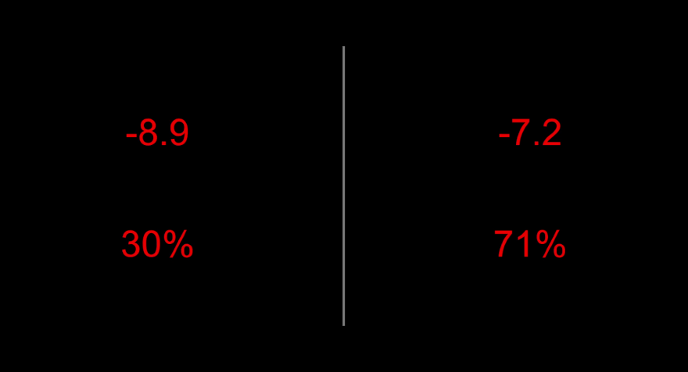

1. Outcome ________________________ Probability ________________________

2. Outcome ________________________ Probability ________________________

**Quiz 2**

**If you selected the right-side lottery in the screen below, what are the potential outcomes and probabilities of that lottery?**

1. Outcome ________________________ Probability ________________________

2. Outcome ________________________ Probability ________________________

**If you selected the left-side lottery in the screen below, what are the potential outcomes and probabilities of that lottery?**

1. Outcome ________________________ Probability ________________________

2. Outcome ________________________ Probability ________________________