Attentional Over-weighting in Gains,

Attentional Under-weighting in Losses

Brenden Eum

California Institute of Technology, USA

Stephen Gonzalez

Stanford University, USA

Antonio Rangel

California Institute of Technology, USA

Introduction

We encounter simple choices between positively valued options in our day-to-day lives (e.g., what to buy for dinner at the grocery store, which product we like on an e-commerce website). In these scenarios, previous studies have documented robust attentional choice biases (Eum et al., forthcoming; Fiedler & Glöckner, 2012; Krajbich et al., 2010; Krajbich & Rangel, 2011; Smith & Krajbich, 2018) which manifest in behavior as last fixation bias (i.e., the tendency to choose the last fixated option), and net fixation bias (i.e., the tendency to choose the option with more relative fixation time). Recent evidence has shown that these attentional effects on choices are causal (Tavares et al., 2017).

However, we also encounter choices between negatively valued options (e.g., which credit card bill to pay off first, whether or not to pay for repairs on a car), which have not been studied using eye-tracking. It is unclear whether attention to a negatively valued option makes it relatively more or less appealing when one is forced to make a choice amongst negatively valued options. Here, we investigate whether attentional choice biases are similar in choices between gains and in choices between losses. Based on the Attentional Drift-Diffusion-Model (Krajbich et al., 2010), we hypothesized a bias towards choosing the more fixated option in gains, and against choosing the more fixated option in losses. This would imply that attention to an option in a choice between losses makes it relatively less appealing. To preview the results, we find evidence of a bias towards choosing the more fixated option, regardless of condition. This instead implies that attention to an option in a choice between losses makes it relatively more appealing.

Methods

Task

We investigated how attention differentially affects the choice process in the gain and loss domains by using the task depicted in Fig. 1. Subjects begin the trial by fixating on an empty screen for 1 s. In the gain condition, subjects are presented with two grey circles on the left and right sides of the screen. Inside each circle are 100 green or white dots. The number of white dots represents the probability of receiving nothing; the number of green dots represents the probability of gaining $10. Subjects are given free response time to select the lottery they prefer, and after selecting, are given 1 s of feedback about the choice they made. In the loss condition, trials are similar, except the green dots are replaced with red dots, which represent the probability of losing $10. In all trials, the number of green or red dots in either option is drawn uniformly from 45 to 55. The remaining dots are colored white. Colors are used to ensure that subjects are always fully aware of what condition they are in.

Subjects completed 400 trials in the exploratory sample, split into 2 blocks of 200 trials each. 1 block was in the gain condition, the other in the loss condition, randomly ordered.

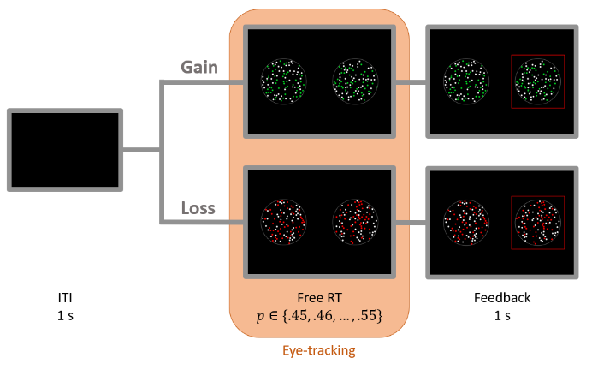

Fig. 1. Task

Participants

70 subjects were recruited for the study (mean age = 26.4, 41 female). Subjects were paid a $30 participation fee. After the experiment was over, subjects drew a number between 1 and 200 out of an urn. The lotteries associated with this number in blocks 1 and 2 were played out, and subjects' total pay was adjusted according to the outcome of those lotteries. The number of subjects and trials per subject were chosen based on similar studies that have shown that this sample size provides reliable estimates of model parameters and effects of interest.

Computational Model

We use a variation of the Drift-Diffusion-Model of binary choice (Mormann et al., 2010; Ratcliff et al., 2016). In particular, we use the Attentional Drift-Diffusion-Model (aDDM), where value comparison is modulated by the location of one's gaze. Subjects integrate noisy value signals into an evidence accumulator that evolves over time, $E_{t}$. Evidence starts at an initial location $b$, incorporating some bias towards one of the two options if $b≠0$.

Once $E_{t}$ crosses one of two pre-specified boundaries ($±1$), a choice is made based on the identity of the boundary (e.g., hitting upper boundary indicates a choice for left option). The evolution of evidence looks like the following diffusion process:

$$E_{t}=E_{t-1}+μ_{t}+ϵ_{t}$$

where $ϵ_{t}$ is Gaussian white noise with variance $σ^{2}$. The drift ($μ_{t}$) in the diffusion process depends on fixation location. If the subject is looking left at time $t$, then $μ_{t}= d\left(V_{L}-θV_{R}\right)$, where $d$ is the drift rate parameter controlling the speed of integration, $V_{i}$ is the value of option $i$, and $θ$ is an attentional bias parameter that changes the relative weighting of fixated and nonfixated options. If the subject is looking right at time $t$, then drift is instead $μ_{t}= d\left(θV_{L}-V_{R}\right)$. Importantly, the aDDM takes fixations as exogenous to the state of the decision process and is therefore agnostic to modeling fixations.

Results

Basic Psychometrics

There were no meaningful differences in average choices, response times, or number of fixations between the two conditions.

Choice Biases

Consistent with previous findings, we find evidence of attentional over-weighting of the fixated option in choices between gains. This can be observed in Fig. 2 as last fixation bias (left) and net fixation bias (right) in the gain trials, shown in green. However, contrary to the predictions of the aDDM, we find evidence of attentional under-weighting of the value of the fixated option in losses, which also results in last and net fixation biases in loss trials, shown in red.

 

Fig. 2. Choice Biases

aDDM

We fit the aDDM separately to each subject $j$, by condition $\{G,L\}$, and compare estimates across the two conditions (see Fig. 3). ${\hat{σ}}_{j}$  and ${\hat{b}}_{j}$ remain consistent across the two conditions, while ${\hat{d}}_{j}^{G}>{\hat{d}}_{j}^{L}$ for some subjects. Crucially, we find that ${\hat{θ}}_{j}^{G}<1$ and ${\hat{θ}}_{j}^{L}>1$ for most subjects, meaning that the value of the fixated option is over-weighted in gains and under-weighted in losses.

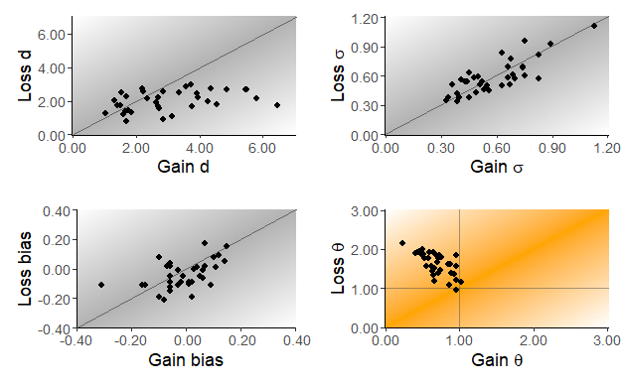

Fig. 3. Comparison of Individuals’ Parameter Estimates

Discussion

Contrary to the predictions of the aDDM, we found attentional under-weighting of the fixated option in losses and attentional over-weighting in gains. That being said, choices and response times can be captured by an aDDM using a non-constant attentional bias parameter.

These results suggest that consumers may be susceptible to marketing influences that draw attention to a target option in choices between losses, just as they are in gains. This attentional mechanism can be used in the field of choice architecture to nudge consumers towards better decisions (Johnson et al., 2012).

There are several potential explanations of these results. The first is that there is a fundamental difference in the role of attention in choices between gains and in choices between losses. Second is that subjects may be solving the task by counting the number of green dots in the gain trials, switching to counting the white dots in loss trials, and making value comparisons based on these counts. If so, an aDDM with constant attentional discounting can explain these results. Another possible explanation is that subjects are evaluating the value of the options with respect to a reference point (Kahneman & Tversky, 1979), such as the minimum value between the two options. We are exploring these hypotheses in subsequent work.

References

Eum, B., Dolbier, S., & Rangel, A. (forthcoming). Peripheral Visual Information Halves Attentional Choice Biases. *Psychological Science*.

Fiedler, S., & Glöckner, A. (2012). The Dynamics of Decision Making in Risky Choice: An Eye-Tracking Analysis. *Frontiers in Psychology*, *3*. https://doi.org/10.3389/fpsyg.2012.00335

Johnson, E. J., Shu, S. B., Dellaert, B. G. C., Fox, C., Goldstein, D. G., Häubl, G., Larrick, R. P., Payne, J. W., Peters, E., Schkade, D., Wansink, B., & Weber, E. U. (2012). Beyond nudges: Tools of a choice architecture. *Marketing Letters*, *23*(2), 487–504. https://doi.org/10.1007/s11002-012-9186-1

Kahneman, D., & Tversky, A. (1979). Prospect Theory: An Analysis of Decision under Risk. *Econometrica*, *47*(2), 263. https://doi.org/10.2307/1914185

Krajbich, I., Armel, C., & Rangel, A. (2010). Visual fixations and the computation and comparison of value in simple choice. *Nature Neuroscience*, *13*(10), 1292–1298. https://doi.org/10.1038/nn.2635

Krajbich, I., & Rangel, A. (2011). Multialternative drift-diffusion model predicts the relationship between visual fixations and choice in value-based decisions. *Proceedings of the National Academy of Sciences*, *108*(33), 13852–13857. https://doi.org/10.1073/pnas.1101328108

Mormann, M. M., Malmaud, J., Huth, A., Koch, C., & Rangel, A. (2010). The Drift Diffusion Model Can Account for the Accuracy and Reaction Time of Value-Based Choices Under High and Low Time Pressure. *Judgement and Decision Making*, *5*(6), 437–449. https://doi.org/10.2139/ssrn.1901533

Ratcliff, R., Smith, P. L., Brown, S. D., & McKoon, G. (2016). Diffusion Decision Model: Current Issues and History. *Trends in Cognitive Sciences*, *20*(4), 260–281. https://doi.org/10.1016/j.tics.2016.01.007

Smith, S. M., & Krajbich, I. (2018). Attention and choice across domains. *Journal of Experimental Psychology: General*, *147*(12), 1810–1826. https://doi.org/10.1037/xge0000482

Tavares, G., Perona, P., & Rangel, A. (2017). The Attentional Drift Diffusion Model of Simple Perceptual Decision-Making. *Frontiers in Neuroscience*, *11*, 468. https://doi.org/10.3389/fnins.2017.00468