Name Seth Owens Team Hot CC TL 2 Date 11/8/2024 Time 10:30

Fill in the underlined areas (and the boxes above), now but don’t write on the remainder of this form.

|  |  |  |  |
| --- | --- | --- | --- |
|  | predicted time(hrs) | time spent(hrs) | Status |
| Animation | 5 | 5 | complete |
| Game Base | 10 | 18 | complete |
| Animation | 5 | 10 | complete |
| Level Design | 8 | 15 | complete |
| A* Path finding | 8 | 7 | complete |
| Pong | 5 | 2 | complete |
| Tetras | 5 | 6 | complete |
| Mine Sweeper | 5 | 5 | complete |
| Donky Kong | 5 | 7 | complete |
| Dynamic Binding | 2 | 3 | complete |
| Factory Pattern | 3 | 1 | complete |
| Integration | 5 | 2 | this week |
| Tests | 10 | 6 | this week |
| Totals | 76 | 87 |  |

|  |  |
| --- | --- |
| Contribution: Briefly describe what your feature(s) is/are:  My feature was to make mini games for the dates. When a player begins a date, they must complete a minigame, and I designed all of them. There are 3 total, and they are a math mini game, minesweeper, and pong.  Walk me through your Gantt chart. How long did this take? How long did you estimate it would take? What did you learn about your skill as an estimator?  My Gantt chart contains requirements collection, minigame level designs, 5 mini games programming, user documentation, testing, and installation. I estimated it would take 76 hours to complete them all, and in total it ended up being 87 hours.  I would say that since I was only off by only a few hours, that I did a good job at estimating how long it would take in terms of the entire project. However, certain tasks ended up being off by quite a bit, like the mini game level designs I estimated taking 8 hours, but it took 15, but also implementing my factory pattern was estimated to take 3 hours but took only 1. So, in the end the time was close, but individual times weren’t always as accurate.  Run your game and point out places where your code is called and run. (I will cycle through asking you this question and the next one until you either run out of interesting things to talk about or it is clear that you have made an above average contribution.)  Vidoe was submitted on canvas.  My code runs whenever the minigames are ran. So, a player will talk to a character, and then they will enter a minigame. Once the scene changes to a mini game, that is all my code running now. My code will run until the end of the mini game, as I control the entire minigames. I have three mini games that can be played, a Math game, Pong, and Minesweeper. I also have code to handle the different elements of the games that play, like the score managers for each game, the paddles in pong, the tiles in minesweeper. It is all my code that is being run.  Show the C++/C# code that was run. Walk me through the methods called from the time it enters your section of code.  Zip file containing code was submitted on canvas. | /1  0 |
| Technical:  Walk me through your test plan. Give an example where a test case later found a bug in your code by things a teammate added later. (Or explain why you chose a test case specifically because you wanted to ensure that a teammate would know if they broke your code.)  My test plan was to test the three different mini games that I have made, and making sure that they run correctly. Since they are minigames, there isn’t much interaction with my teammates code as they are mostly self-contained games. Therefore, I am testing the bounds of the games and the scoring system a lot. My stress tests for the games involved spawning thousands of instances of the games. One example of a test that I made to make sure no other teammates would break my code was to check the BC mode. BC mode is a public method in Patrick’s | /4  /3 |

MainPlayer class, so I made tests to ensure that when the game is in BC mode, it will function the way I intend.

Pick a Prefab you have created that is documented well in a separate readme file.

(I will point to several places in your code documentation and ask) What question where you trying to answer here? Who do you anticipate would be asking that question? What other questions might this person need the answers to?

Prefab Name: PongGame

/3

I have the following questions in my README documentation, and the following answers as to why:

Answer: Basic setup of how to get the prefab into a unity game

Reason why: I was trying to help the users get the project working as quickly as possible to get the project running as fast as possible.

Answer: How to adjust score limits

Reason why: The score to win is an important aspect of the minigame, so being able to know how to change the score to win is important to customize the game to each users needs.

/4

Answer: Can I add additional levels, and how to do it

Reason why: The prefab contains the entire design of the minigames, including the Minigame Level superclass and Pong subclass. So, I explain how to use the structure of the design to add more minigames using the design.

Answer: How to adjust speed of the paddles

Reason why: The pong paddles are, like the score to win, an important aspect of the game that users need to know how to change to customize it to their needs.

Answer: How to adjust base and maximum speed of the ball

Reason why: The ball is another aspect that needs to known how to customize so each user can /4 implement the pong game as they see fit.

Answer: Can I update the sprites

Reason why: The user needs to know how to update the sprites to customize the game to their own style.

Answer: How to set up for mobile games

Reason why: Mobile is an important category for games, so the user might be making a mobile application and want to use this prefab with it. They need the documentation to know how to do this.

In my documentation, I was trying to answer the questions that all level of users will ask. So, beginning programmers might just want to know how to get the game incorporated into their project, so I have a basic usage section explaining this. More advanced users will not only want to have the quick start, but also want to know how to customize the game and change it. So, the most common and likely changes they would make, like the game logic and movement of paddles and the ball, are all questions they need to know the answer to.

I tried to answer every question someone could realistically ask, but in terms of questions that users might have beyond what I have made would be how to add different game modes to the game, and how to change the AI opponent.

Show me a class in your code where there could be either static or dynamic binding. Write some mock code on this paper showing how you would set the static type and dynamic type of a variable.

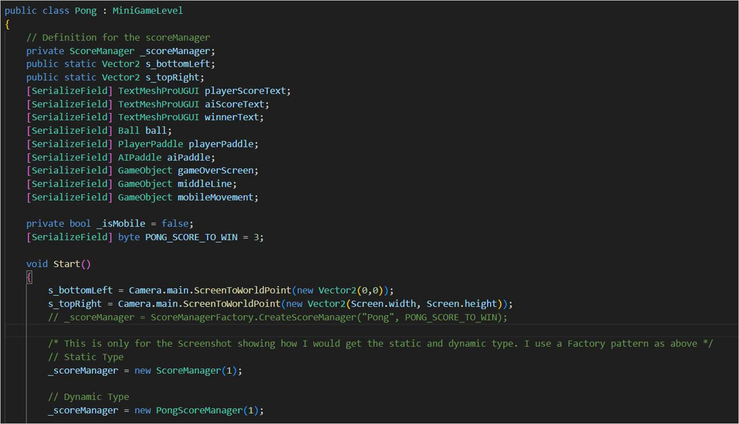

If the screenshot is unclear, to get the static type it is:

_scoreManager = new ScoreManager(1);

The dynamic type is:

_scoreManager = new PongScoreManager(1);

Super Class: ScoreManager

Sub Class: PongScoreManager

Virtual Function: CheckWinCondition()

Choose a dynamically bound method. What method gets called now?

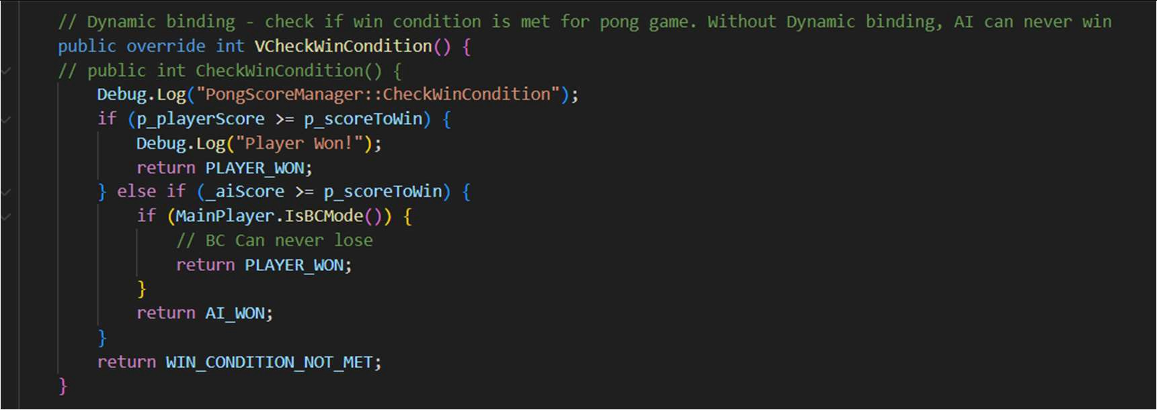

I chose the VCheckWinCondition method. The method that is called with the game is the override VCheckWinCondtion shown above defined in my PongScoreManager class.

With the dynamic type, the game will end when the AI scores 1 point, as shown with this screen show showing the game ending and player losing:

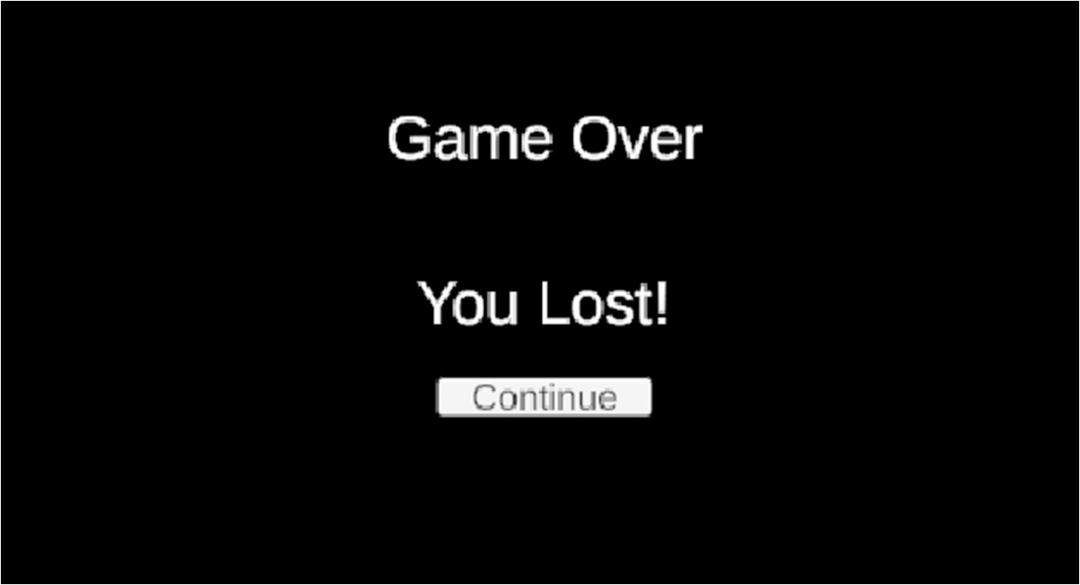

Change the dynamic type. What method gets called now?

The static method is defined in the ScoreManager class, shown in this screen shot:

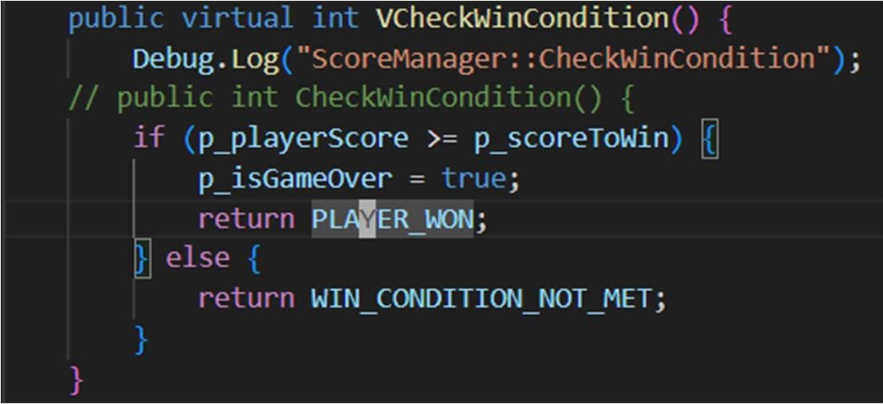

Here is how it changes the game:

With the static type, the AI can never win, as shown with this screen shot below. The score disappears and the AI has scored more than it needs to win, yet the game still continues as it never gets the AI won condition.

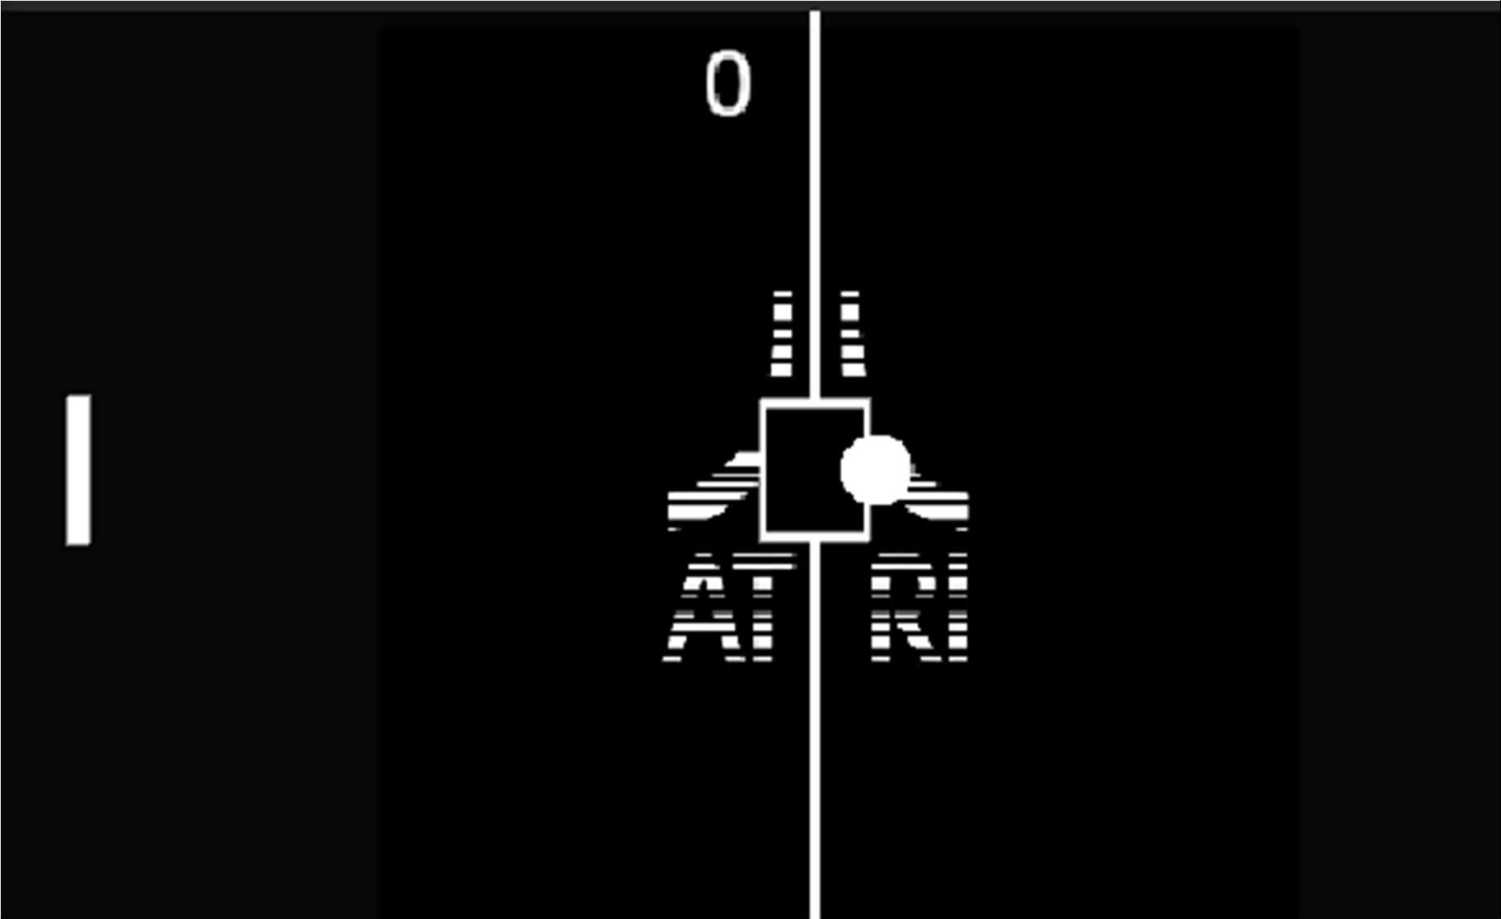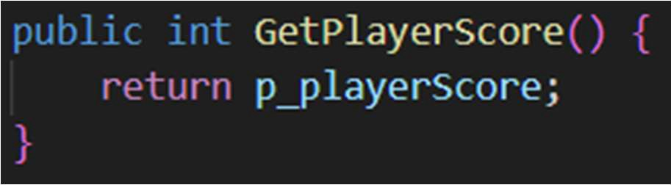

Pick a statically bound method. Which one would be called in each of the two previous cases?

My statically bound method is this:

In both the static and dynamically bound cases, GetPlayerScore would be the same method being called in both. It is a static method and has no dynamic binding, so it would not change based on the type, and either the static and dynamic types will call the same GetPlayerScore method.

Show me an example of reuse in your code where you violate copyright law.

My example of reuse is the Atari logo in the background of the Pong game. Here it is in the game:

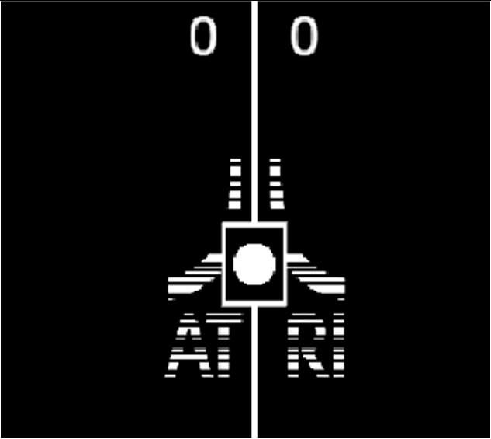

The background is all in the Hierarchy as a GameObject called MiddleLine. So, in the code it looks like this:



How does it violate copyright? I added the Atari logo to the background of my Pong game. This violates copyright as the logo is copyright and Atari says that I am not able to use their logo. What did you have to do to integrate it with the code you wrote? What are the legal implications if you market your code with the re-used portion? Use fair use argue that you can use this anyway.

I was able to add the copyright into the hierarchy and use the GameObject feature to show the background on and off in my code. There was not much work needed to integrate it in the code since Unity handles it all. The legal implications of marketing my code with the Atari logo in it is that I am violating Atari’s copyright, and I am not allowed to do this. I could definitely be sued for doing so, as I do not have their express permission to do so and I am profiting off of this game. However, I transformed the Atari logo extensively, I removed the A in the middle of the name Atari, and I also added a bunch of black lines in the logo to make it have a vaporwave aesthetic that is more cyberpunk for my game. Since I added my own artistic touch into the game, I can argue that I transformed the work and thus it is fair use to use their logo, since I created something new with it.

4. One big or two small, well-chosen patterns. Small Patterns = {Singleton, Private Class Data} Which patterns did you choose?

1. Factory Pattern

2.

Why did you choose each pattern? (Justify your use of it).

I chose the Factory pattern as all of my subclass ScoreManagers were very similar. They really just change the way that the score is added and the win conditions. So, a Factory pattern made sense as the games don’t need to know everything that goes into making a score manager, I just know I want, for example, a PongScoreManager that makes it so that when any player gets to 3 points the game finishes. The factory pattern allows me to encapsulate the implementation and

the usage, which helps with adding new features and giving me a nice API to use the score managers.

Draw the class diagram for your pattern(s).

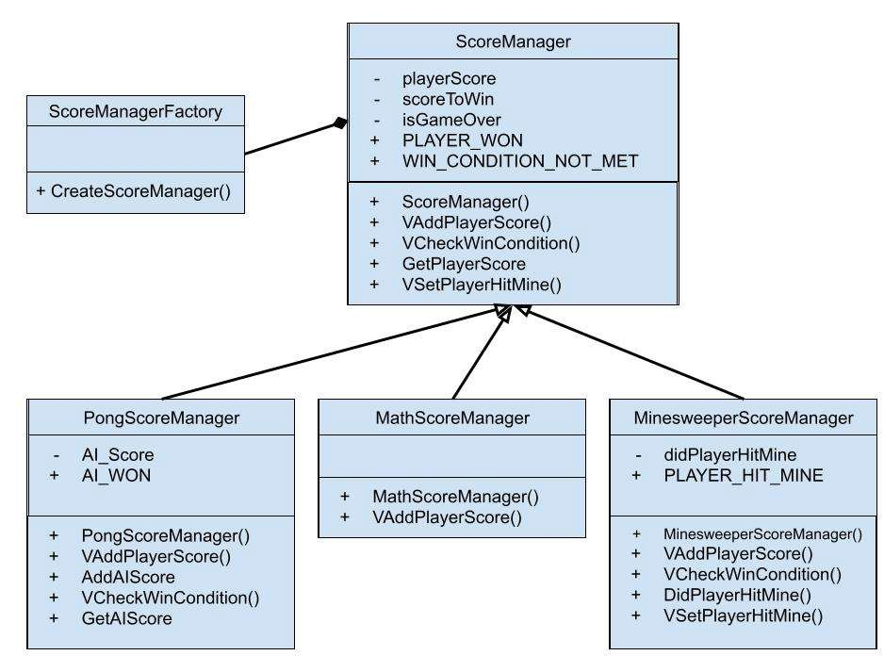

Would something else have worked as well or better than this pattern? When would be a bad time to use this pattern?

Another pattern that would have worked well would be the Decorator pattern. Since I needed a base class with just slightly different functions on each, I could have made them as decorations to add to the base class and used that instead.

A time where it would be a bad tie to use the factory pattern is when there are little or no variations in the object types. If you only have one subclass for example, and it doesn’t add much to the base class. Then, a factory would be a bit pointless. Another bad time would be if creating the subclasses is very simple. If you just have to call the constructor for example with no arguments to pass in, then a factory pattern is actually causing more confusion and complexity as you have to create another class that does the same thing as one line of code.