Name: Malik Robinson Mark _____________________/50

## Brief introduction __/3

My feature for Hex Tanks is map and tile object creation.

When the game starts a random number or rows and colons are chosen and a map of tile objects are instantiated. The tile objects will contain the tiles position and the distance from the tile the player is on. They will also chose random tiles to be obstacles or the Flag. The objects will also change colors to convey information to the player, such as where the player can and cant move and what tiles can be targeted.

## Use case diagram with scenario __14

### 

### Scenarios

**Name:** Create Map

**Summary:** Take 2 random numbers and aa few random location to create the map

**Actors:** Start Game

**Preconditions:** None

**Basic sequence:**

**Step 1:** Get two random numbers for width and height.

**Step 2:** Get several random location based on the width and height.

**Step 3:** Instantiate tile objects based on the pervious values

**Exceptions:**

**Step 1:** Player can chose width and height values.

**Post conditions:** Map is displayed.

**Priority:** 1*

**ID:** C01

*The priorities are 1 = must have, 2 = essential, 3 = nice to have.

## Data Flow diagram(s) from Level 0 to process description for your feature _______14

### Data Flow Diagrams

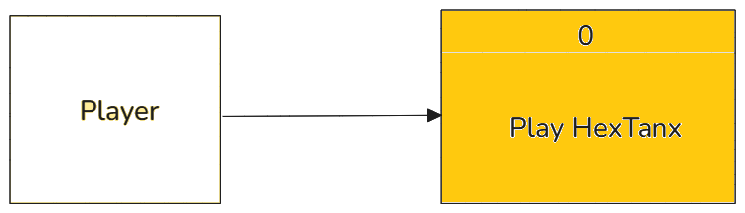

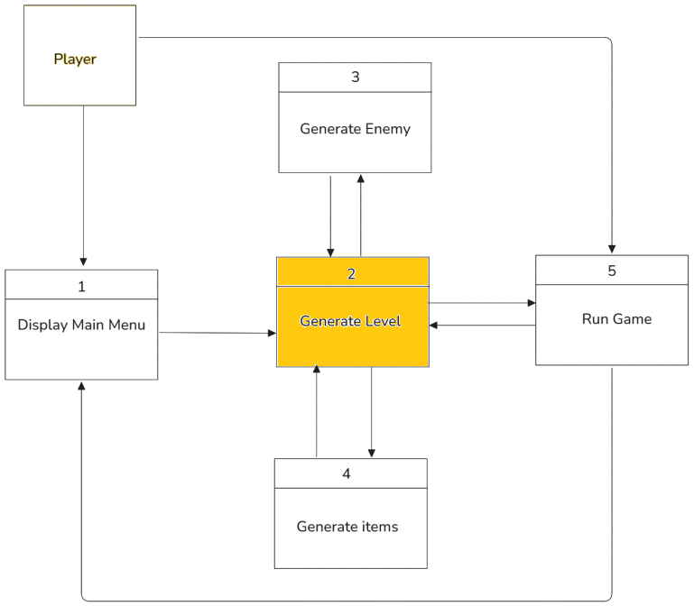

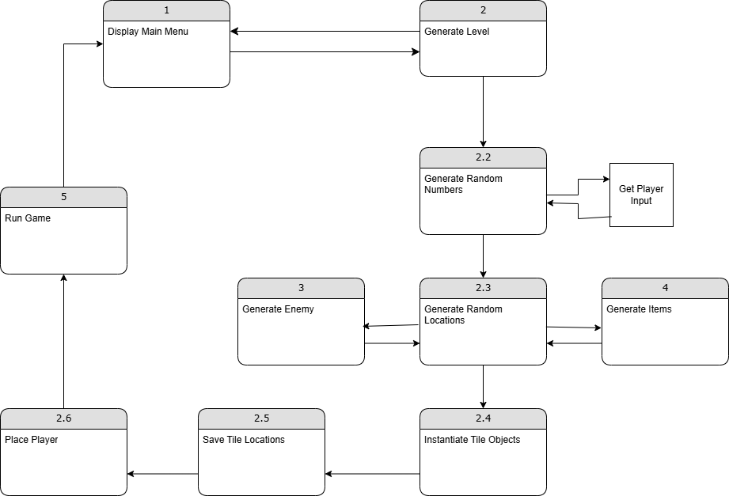

### Process Descriptions

Create Map*:

IF Game start pressed

IF input numbers are blank

Generate two random numbers

ELSE use player input

Generate random locations

Generate enemy

Generate items

Instantiate Tiles

Save all locations

Place player

ENDIF

## Acceptance Tests ________9

Create maps and save location data as x/y coordinates to an output file.

-Locations of player, enemy and Items should never overlap.

-Locations should always be within the width and height.

-Locations of player and enemy should be between half to full width/height apart.

-Locations of player and enemy should be the same distance from the Flag.

-Should reject width and height values that makes the above impossible.

## Timeline _________/10

### Work items

|  |  |  |
| --- | --- | --- |
| Task | Duration (Hours) | Predecessor Task(s) |
| 1. Design Hex Tile Sprites | 3 | - |
| 2. Create Hex tile objects | 4 | 1 |
| 3. Programming Object Scripts | 6 | 2 |
| 4. Program Placement algorithm | 6 | 1,2 |
| 5. Documentation | 4 | 3,4 |
| 6. Testing | 3 | 2,3,4 |
| 7. Instillation | 1 | 6 |

### Pert diagram

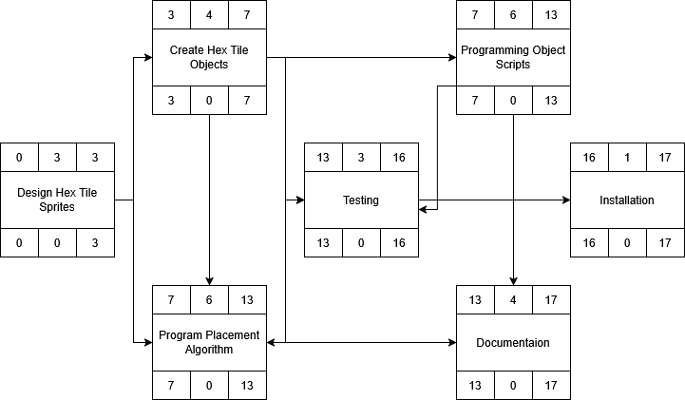

### Gantt timeline

