Ex. No. 2 | Working with HTML5 Form and Media Elements
Date of Exercise | 21.7.26
GitHub Host Link

Aim
To design and develop a Car Rental Service webpage using HTML5 form and media elements to collect customer and booking details and display multimedia content.

Description
This exercise is implemented using HTML5, Form Elements, Media Elements and internal CSS to design a simple Car Rental Service website. The following technical concepts are used:
<!DOCTYPE html> Declares the document as an HTML5 document.
<html> Defines the root element of the HTML webpage.
<head> Contains the title and styling information of the webpage.
<title> Displays the title of the webpage in the browser tab.
<style> Used to apply internal CSS to the webpage.
<body> Contains all the visible content of the webpage.
<div> Divides the webpage into different sections.
<h1>, <h2> Used to display the main heading and section headings.
<p> Used to display paragraph content.
<a> Creates hyperlinks for navigation between sections.
<img> Displays the car image on the webpage.
<table> Displays the available cars and rental details in rows and columns.
<form> Creates the car rental booking form.
<fieldset> Groups related form elements together.
<legend> Provides a heading for a fieldset.
<label> Provides a description for an input field.
<input> Accepts information from the user.
type="text" Accepts the customer's name.
type="email" Accepts the customer's email address.
type="tel" Accepts the customer's phone number.
type="date" Allows the customer to select the pickup date.
type="number" Accepts the number of rental days.
1
Ex. 2 | Working with HTML5 Form and Media Elements

type="radio" Allows the customer to select one transmission type. type="checkbox" Allows the customer to select multiple extra services.
<textarea> Accepts the customer's address in multiple lines.
<select> Creates a drop-down list for selecting a car.
<option> Defines the choices available in the drop-down list.
<progress> Displays the booking completion progress.
type="submit" Creates a button to submit the booking form.
type="reset" Creates a button to clear the entered form details.
<audio> Adds audio content to the webpage.
<video> Adds video content to the webpage.
<source> Specifies the audio or video file to be played.
<embed> Displays the Car Rental Information PDF inside the webpage.
<iframe> Embeds the location map inside the webpage.
HTML Comments Used to identify different sections of the program without
displaying them on the webpage.
Internal CSS Used to apply colors, spacing, alignment, borders and other basic styles to the webpage.

Procedure:
- Open Visual Studio Code and create a new HTML5 file named index.html.
- Create the basic webpage structure using <html>, <head>, <title>, <body> and <div> elements.
- Design the DriveLux Car Rental Service webpage with a header, navigation links, car details and contact section.
- Add a table to display the available cars, vehicle type, number of seats and rental price.
- Create the car booking form using <form>, <fieldset>, <legend> and <label> elements.
- Add different form controls such as text, email, telephone, date and number fields along with radio buttons and checkboxes.
- Use <select>, <option> and <textarea> for car selection and customer address, and add Submit and Reset buttons.
- Add the <progress> element to represent the booking completion status.
- Insert the required multimedia content using image, audio and video elements.
- Use <embed> to display the Car Rental Information PDF and <iframe> to display the location map.
- Apply internal CSS to provide suitable colors, alignment, spacing, borders and an attractive layout.
- Save the file and execute it in a web browser to verify the webpage and all the form and media elements.

2
Ex. 2 | Working with HTML5 Form and Media Elements

Program
<!DOCTYPE html>
<html>
<head>
<title>DriveLux Car Rentals</title>
<style>
body {
background-color: #eeeeee; font-family: Arial;
margin: 0;
color: #222;
}
.header {
background-color: white; padding: 25px;
text-align: center;
}
.header h1 { margin: 0;
color: #111;
}
.header p {
margin-bottom: 0; color: gray;
}
.nav {
background-color: #000000da; text-align: center;
padding: 15px;
}
.nav a {
color: white;
text-decoration: none; margin: 25px;
font-weight: bold;
}
.container { width: 86%; margin: auto;
}
.section {
background-color: white; margin-top: 20px; padding: 25px;
}
3
Ex. 2 | Working with HTML5 Form and Media Elements

h2 {
color: #000000da;
}
.hero {
background-color: #111; color: white;
margin-top: 20px; padding: 25px;
}
.hero h2 { color: white;
font-size: 30px;
}
.hero p {
color: lightgray;
}
.car-image { width: 100%; height: auto;
margin-top: 15px;
}
.row {
display: flex;
justify-content: space-between; margin-top: 20px;
}
.half {
width: 47%;
background-color: white; padding: 20px;
}
table {
width: 100%;
border-collapse: collapse;
}
table, th,
td {
border: 1px solid lightgray;
}
th {
background-color: #111; color: white;
}
th,
d {
4
Ex. 2 | Working with HTML5 Form and Media Elements

padding: 12px; text-align: center;
}
fieldset {
margin-bottom: 20px; padding: 20px;
border: 1px solid lightgray;
}
legend {
font-weight: bold; color: #111;
}
label {
font-weight: bold;
}
input, select, textarea {
padding: 9px; margin-top: 6px;
margin-bottom: 15px;
}
input[type="text"], input[type="email"], input[type="tel"], input[type="date"], input[type="number"], select,
textarea { width: 95%;
}
.button {
background-color: #111; color: white;
border: none; padding: 12px 25px; margin: 5px;
}
progress { width: 100%; height: 25px;
}
video {
width: 100%;
}

5
Ex. 2 | Working with HTML5 Form and Media Elements

audio {
width: 100%;
}
embed {
width: 100%; height: 500px;
}
iframe {
width: 100%; height: 350px;
}
.footer {
background-color: #111; color: white;
text-align: center; padding: 20px; margin-top: 20px;
}
</style>
</head>
<body>
<div class="header">
<h1>DriveLux</h1>
<p>Premium Car Rental Service</p>
</div>
<div class="nav">
<a href="#cars">Cars</a>
<a href="#booking">Book a Car</a>
<a href="#media">Media</a>
<a href="#contact">Contact</a>
</div>
<div class="container">
<div class="hero" id="cars">
<h2>Quick and Affordable Car Rentals</h2>
<p>
Comfortable cars for business trips, family vacations and everyday journeys.
</p>
<img
src="car.jpg" alt="Rental Car" class="car-image">
</div>
<div class="section">
<h2>Our Rental Car Collection</h2>
<p>
6
Ex. 2 | Working with HTML5 Form and Media Elements

Choose the right vehicle for your next journey.
We provide comfortable and well-maintained rental cars.
</p>
<table>
<tr>
<th>Car</th>
<th>Type</th>
<th>Seats</th>
<th>Price / Day</th>
</tr>
<tr>
<td>Honda City</td>
<td>Sedan</td>
<td>5</td>
<td>₹1800</td>
</tr>
<tr>
<td>Hyundai Creta</td>
<td>SUV</td>
<td>5</td>
<td>₹2500</td>
</tr>
<tr>
<td>Mahindra XUV700</td>
<td>SUV</td>
<td>7</td>
<td>₹3000</td>
</tr>
</table>
</div>
<div class="section" id="booking">
<h2>Rent Your Car</h2>
<p>
Complete the form below to enter your rental details.
</p>
<form>
<fieldset>
<legend>Customer Information</legend>
<label>Full Name:</label>
<br>
<input
type="text" name="name"
placeholder="Enter your full name" minlength="3"
maxlength="30"
7
Ex. 2 | Working with HTML5 Form and Media Elements

pattern="[A-Za-z ]+"
title="Only letters and spaces are allowed" required>
<br>
<label>Email:</label>
<br>
<input
type="email" name="email"
placeholder="Enter your email" maxlength="50"
required>
<br>
<label>Phone Number:</label>
<br>
<input
type="tel" name="phone"
placeholder="Enter 10-digit mobile number" pattern="[0-9]{10}"
minlength="10" maxlength="10"
title="Enter a valid 10-digit mobile number" required>
<br>
<label>Address:</label>
<br>
<textarea rows="4" cols="50"
placeholder="Enter your address" minlength="10" maxlength="150" required></textarea>
</fieldset>
<fieldset>
<legend>Rental Information</legend>
<label>Select Car:</label>
<br>
<select
name="car" required>
<option value="">
-- Select a Car --
</option>

8
Ex. 2 | Working with HTML5 Form and Media Elements

<option>Honda City</option>
<option>Hyundai Creta</option>
<option>Mahindra XUV700</option>
</select>
<br>
<label>Pickup Date:</label>
<br>
<input
type="date" name="pickup" required>
<br>
<label>Number of Days:</label>
<br>
<input
type="number" name="days" min="1" max="30" required>
<br>
<label>Transmission:</label>
<br><br>
<input
type="radio" name="transmission" value="manual" required>
Manual
<input
type="radio" name="transmission" value="automatic">
Automatic
<br><br>
<label>Extra Services:</label>
<br><br>
<input
type="checkbox" name="driver">
Driver Service
<br>
<input
type="checkbox" name="airport">

9
Ex. 2 | Working with HTML5 Form and Media Elements

Airport Pickup
<br>
<input
type="checkbox" name="gps">
GPS Navigation
<br>
<input
type="checkbox" name="childseat">
Child Seat
</fieldset>
<fieldset>
<legend>Booking Progress</legend>
<label>
Booking Details Completed:
</label>
<br><br>
<progress value="70" max="100">
</progress>
<p>70% Complete</p>
</fieldset>
<input
type="submit" value="Book Now" class="button">
<input
type="reset" value="Clear Form" class="button">
</form>
</div>
<div class="row" id="media">
<div class="half">
<h2>Experience Our Cars</h2>
<p>
Watch a short video of our rental cars.
</p>
<video controls>
<source
src="car-video.mp4" type="video/mp4">
Your browser does not support the video tag.

10
Ex. 2 | Working with HTML5 Form and Media Elements

</video>
</div>
<div class="half">
<h2>About DriveLux</h2>
<p>
Listen to a short introduction about our car rental service.
</p>
<audio controls>
<source
src="car-audio.mp3" type="audio/mpeg">
Your browser does not support the audio element.
</audio>
</div>
</div>
<div class="row">
<div class="half">
<h2>Rental Information</h2>
<p>
View our complete car rental information document.
</p>
<embed
src="car-info.pdf" type="application/pdf">
</div>
<div class="half">
<h2>Our Location</h2>
<p>
Find DriveLux Car Rentals in Coimbatore.
</p>
<iframe
src="https://www.google.com/maps?q=Coimbatore&output=embed">
</iframe>
</div>
</div>
<div class="section" id="contact">
<h2>Contact DriveLux</h2>
<p>
<b>Email:</b> carrental@gmail.com
</p>
<p>
<b>Phone:</b>
+91 9876543210
</p>

11
Ex. 2 | Working with HTML5 Form and Media Elements

<p>
<b>Location:</b> Coimbatore, Tamil Nadu
</p>
</div>
</div>
<div class="footer">
<p>
DriveLux Car Rentals | Web Technology Lab
</p>
</div>
</body>
</html>

Output
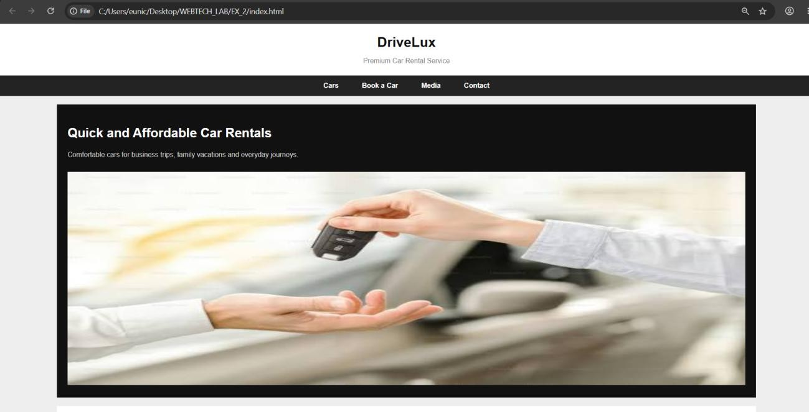

12
Ex. 2 | Working with HTML5 Form and Media Elements

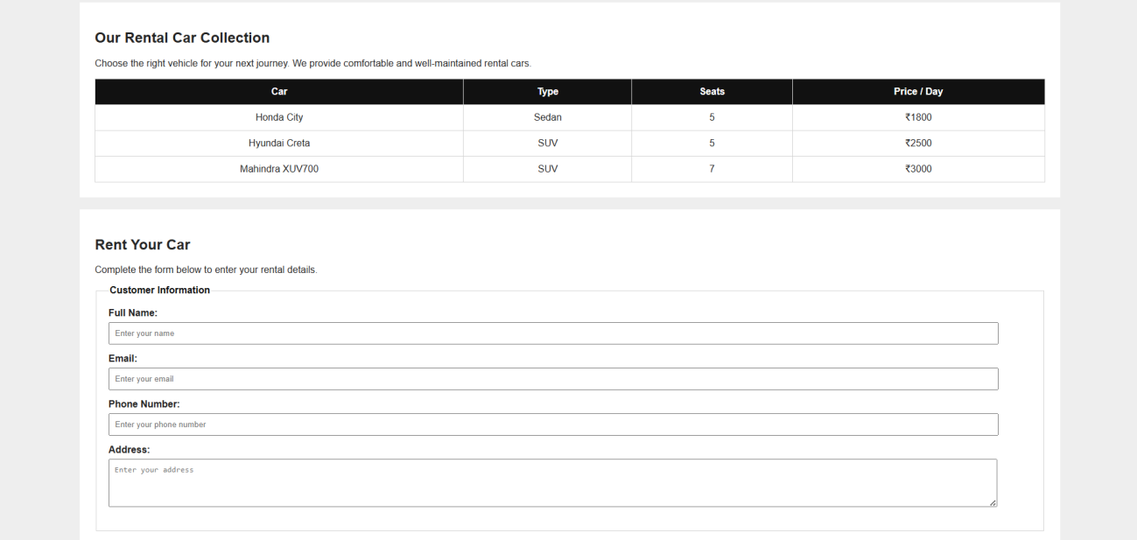

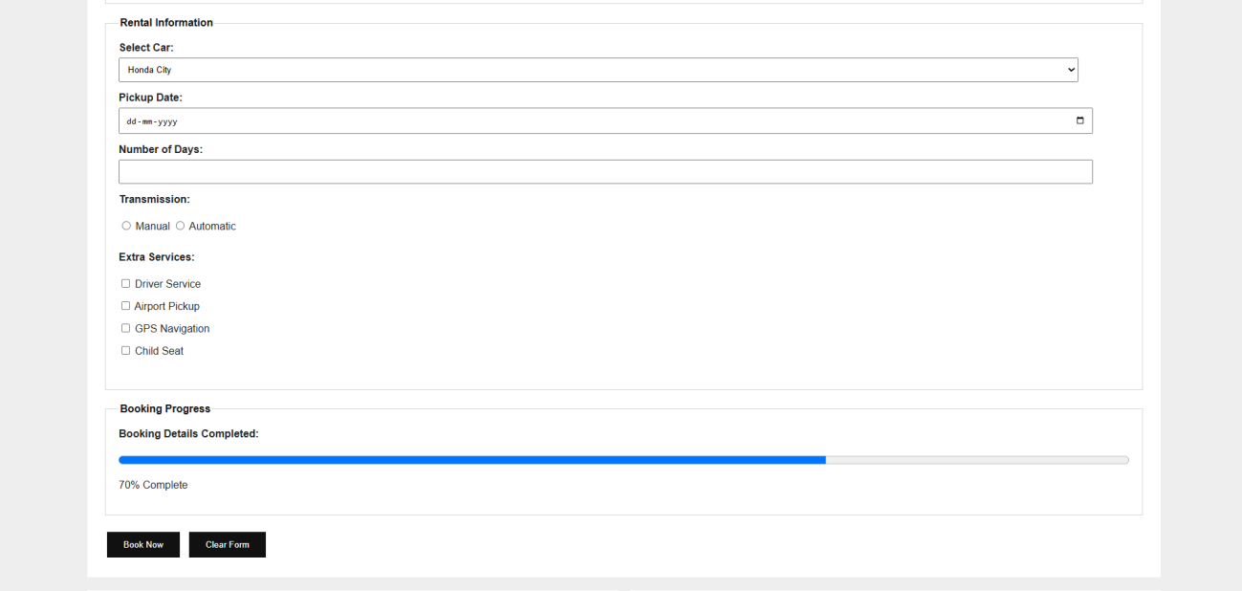

13
Ex. 2 | Working with HTML5 Form and Media Elements

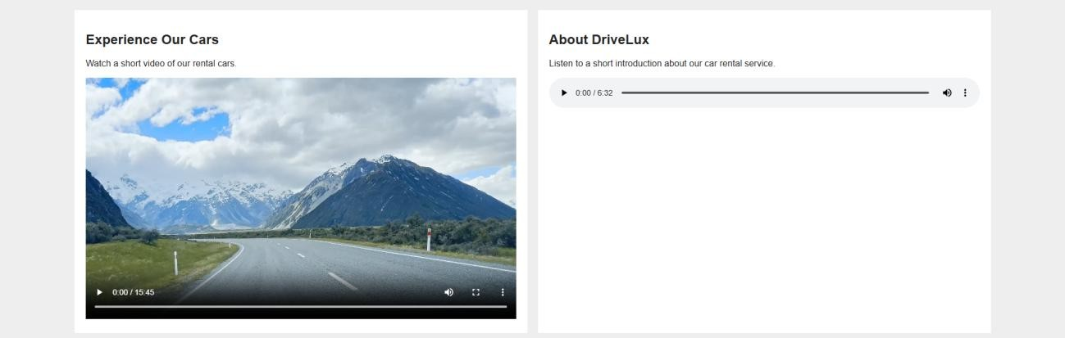
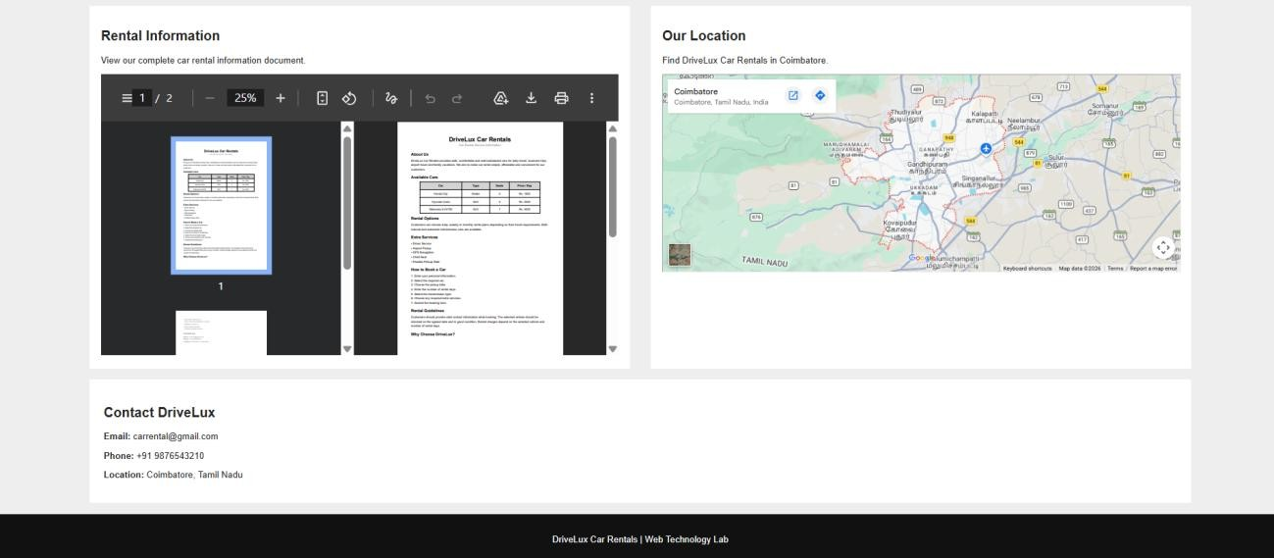

Result
The Car Rental Service website was successfully designed and executed using HTML5 form and media elements. The output was verified successfully.

14
Ex. 2 | Working with HTML5 Form and Media Elements

