Ex. No. 3 | Responsive Webpage using HTML5 and CSS3
Date of Exercise | 10.08.26
GitHub Host Link

Aim
To design and develop a responsive Car Rental Service webpage using HTML5 and External CSS (CSS3) by applying various CSS properties such as margins, padding, fonts, colors, backgrounds, links, display, lists, height, width, and multi-column layout to create an attractive and user-friendly webpage.

Description
This experiment focuses on designing a responsive webpage for a Car Rental Service using HTML5 and External CSS (CSS3). Various CSS properties are used to improve the appearance, layout, and responsiveness of the webpage. The following concepts are implemented along with their purpose:
HTML5 Provides the basic structure of the webpage.
External CSS Stores the webpage styles in a separate CSS file for better organization. Margin Creates space outside an element.
Padding Creates space between the content and the border. Background Color Changes the background color of the webpage and sections. Font Family Changes the font style of the text.
Font Size Changes the size of the text.
Font Style Makes the text italic or normal. Font Weight Makes the text bold or light.
Text Align Aligns text to the left, right, center or justify. Letter Spacing Increases the spacing between letters.
Text Decoration Adds or removes text decorations such as underline. Text Shadow Adds a shadow effect to the text.
Width and Height Sets the size of images and webpage sections. Display Property Controls how elements are displayed on the webpage. List Style Type Changes the style of list bullets.
Hyperlink States Changes the appearance of links using :link, :visited, :hover and :active. Images Display rental cars visually.
Tables Display rental car details in a structured format.
1
Ex. 3 | Responsive Webpage using HTML5 and CSS3

Multi-column Layout Arranges multiple car sections side by side for a better layout.

Procedure:
- Create a new project folder and save the files as index.html and style.css.
- Link the external CSS file to the HTML file using the <link> tag.
- Create the webpage structure using HTML5 elements such as headings, paragraphs, images, lists, tables, hyperlinks, and divisions.
- Add navigation links and different content sections for the Car Rental Service website.
- Apply CSS properties such as margins, padding, fonts, colors, backgrounds, text formatting, height, width, and display using the external CSS file.
- Create a simple multi-column layout to display different rental cars.
- Style hyperlinks using the CSS pseudo-classes :link, :visited, :hover, and :active.
- Save the files and open index.html in a web browser to verify the output.

Program
<!DOCTYPE html>
<html>
<head>
<title>DriveLux Car Rentals</title>
<link rel="stylesheet" href="style.css">
</head>
<body>
<div class="header">
<h1>DriveLux Car Rentals</h1>
<p>Your Trusted Travel Partner</p>
</div>
<div class="nav">
<a href="#home">Home</a>
<a href="#about">About</a>
<a href="#services">Services</a>
<a href="#cars">Cars</a>
<a href="#contact">Contact</a>
</div>
<div class="hero" id="home">
<div class="hero-text">
<p class="small-title">PREMIUM CAR RENTAL</p>
<h2>Drive Your Dream Car Today</h2>
<p>
Affordable prices, premium cars and comfortable journeys.
</p>
<a href="#cars" class="button"> Explore Cars
</a>
</div>
<div class="hero-image">
2
Ex. 3 | Responsive Webpage using HTML5 and CSS3

<img src="hero.jpg" alt="Car Rental">
</div>
</div>
<div class="about" id="about">
<h2>About DriveLux</h2>
<p>
DriveLux provides reliable car rental services for business trips, vacations and daily travel. Our goal is to provide safe, clean and comfortable vehicles at affordable prices.
</p>
</div>
<div class="section" id="services">
<h2>Our Services</h2>
<p class="section-text">
Everything you need for a comfortable journey.
</p>
<div class="service-box">
<h3>Daily Car Rental</h3>
<p>
Rent a car for your daily travel and short trips.
</p>
</div>
<div class="service-box">
<h3>Weekly Rental</h3>
<p>
Affordable rental options for longer journeys.
</p>
</div>
<div class="service-box">
<h3>Airport Pickup</h3>
<p>
Easy and comfortable airport pickup service.
</p>
</div>
<div class="service-box">
<h3>Luxury Car Rental</h3>
<p>
Premium cars for special occasions and events.
</p>
</div>
</div>
<div class="section" id="cars">
<h2>Our Rental Car Collection</h2>
<p class="section-text">
Choose a car that matches your journey.
</p>
3
Ex. 3 | Responsive Webpage using HTML5 and CSS3

<div class="car-box">
<img src="sedan.jpg" alt="Honda City">
<h3>Honda City</h3>
<p>Sedan • 5 Seats</p>
<p class="price">₹1800 / Day</p>
<a href="#contact" class="small-button"> Rent Now
</a>
</div>
<div class="car-box">
<img src="suv.jpg" alt="Hyundai Creta">
<h3>Hyundai Creta</h3>
<p>SUV • 5 Seats</p>
<p class="price">₹2500 / Day</p>
<a href="#contact" class="small-button"> Rent Now
</a>
</div>
<div class="car-box">
<img src="luxury.jpg" alt="BMW 3 Series">
<h3>BMW 3 Series</h3>
<p>Luxury • 5 Seats</p>
<p class="price">₹5000 / Day</p>
<a href="#contact" class="small-button"> Rent Now
</a>
</div>
</div>
<div class="section">
<h2>How It Works</h2>
<p class="section-text">
Renting your car is simple and easy.
</p>
<div class="step-box">
<h3>01</h3>
<h4>Choose Your Car</h4>
<p>
Select a vehicle from our collection.
</p>
</div>
<div class="step-box">
<h3>02</h3>
<h4>Make a Booking</h4>
<p>
Contact us and select your rental dates.
</p>
4
Ex. 3 | Responsive Webpage using HTML5 and CSS3

</div>
<div class="step-box">
<h3>03</h3>
<h4>Enjoy Your Journey</h4>
<p>
Pick up your car and start travelling.
</p>
</div>
</div>
<div class="section">
<h2>Rental Price List</h2>
<table>
<tr>
<th>Car</th>
<th>Type</th>
<th>Seats</th>
<th>Price / Day</th>
</tr>
<tr>
<td>Honda City</td>
<td>Sedan</td>
<td>5</td>
<td>₹1800</td>
</tr>
<tr>
<td>Hyundai Creta</td>
<td>SUV</td>
<td>5</td>
<td>₹2500</td>
</tr>
<tr>
<td>BMW 3 Series</td>
<td>Luxury</td>
<td>5</td>
<td>₹5000</td>
</tr>
</table>
</div>
<div class="contact" id="contact">
<h2>Ready for Your Next Journey?</h2>
<p>
Book your favourite car with DriveLux today.
</p>
<p>
<b>Email:</b> drivelux@gmail.com
</p>
5
Ex. 3 | Responsive Webpage using HTML5 and CSS3

<p>
<b>Phone:</b> +91 9876543210
</p>
<p>
<b>Location:</b> Coimbatore, Tamil Nadu
</p>
</div>
<div class="footer">
<p>
DriveLux Car Rentals | Web Technology Lab
</p>
</div>
</body>
</html>

CSS
body { margin: 0;
font-family: Arial; background-color: #f5f5f5; color: #222;
}
.header {
background-color: white; padding: 22px 8%;
border-bottom: 1px solid #ddd;
}
.header h1 { margin: 0;
color: #111; font-size: 28px;
}
.header p { margin: 5px 0 0;
color: #777;
}
.nav {
background-color: #111; text-align: right; padding: 14px 8%;
}
.nav a { color: white;
text-decoration: none;
6
Ex. 3 | Responsive Webpage using HTML5 and CSS3

margin-left: 25px; font-size: 14px;
}
.nav a:hover { color: #d4a017;
}
.hero { width: 84%;
margin: 25px auto; background-color: white; padding: 30px; overflow: hidden;
}
.hero-text { width: 43%;
display: inline-block; vertical-align: middle; padding: 20px;
}
.small-title { color: #b8860b; font-size: 13px;
font-weight: bold; letter-spacing: 2px;
}
.hero-text h2 { font-size: 42px; line-height: 1.2;
color: #111;
margin: 15px 0;
}
.hero-text p { color: #666;
line-height: 24px;
}
.hero-image { width: 50%;
display: inline-block; vertical-align: middle;
}
.hero-image img { width: 100%; height: 330px; object-fit: cover;
}
.button {
7
Ex. 3 | Responsive Webpage using HTML5 and CSS3

display: inline-block; background-color: #111; color: white;
text-decoration: none; padding: 12px 25px; margin-top: 15px;
}
.button:hover {
background-color: #d4a017; color: black;
}
.about {
background-color: white; text-align: center; padding: 45px 15%; margin-top: 20px;
}
.about h2 { color: #111;
}
.about p { color: #666;
line-height: 25px;
}
.section { width: 84%;
margin: 25px auto; background-color: white; padding: 35px;
text-align: center;
}
.section h2 { color: #111; font-size: 27px; margin-top: 0;
}
.section-text { color: #777;
margin-bottom: 30px;
}
.service-box { display: inline-block; width: 20%;
min-height: 130px; margin: 1%; padding: 20px;
8
Ex. 3 | Responsive Webpage using HTML5 and CSS3

background-color: #f7f7f7; vertical-align: top;
}
.service-box h3 { color: #111;
}
.service-box p { color: #666;
line-height: 22px;
}
.car-box {
display: inline-block; width: 28%;
margin: 1%; padding: 15px;
background-color: #f8f8f8; vertical-align: top;
}
.car-box img { width: 100%; height: 190px; object-fit: cover;
}
.car-box h3 { color: #111;
margin-bottom: 8px;
}
.car-box p { color: #777;
}
.price {
color: #b8860b !important; font-weight: bold;
font-size: 17px;
}
.small-button { display: inline-block;
background-color: #111; color: white;
text-decoration: none; padding: 9px 18px; margin-top: 5px;
}
.small-button:hover { background-color: #d4a017; color: black;
9
Ex. 3 | Responsive Webpage using HTML5 and CSS3

}
.step-box {
display: inline-block; width: 27%;
margin: 1%; padding: 20px; vertical-align: top;
}
.step-box h3 { color: #b8860b; font-size: 28px;
}
.step-box h4 { color: #111;
}
.step-box p { color: #777;
}
table {
width: 100%;
border-collapse: collapse;
}
table, th,
td {
border: 1px solid #ddd;
}
th {
background-color: #111; color: white;
padding: 13px;
}
td {
padding: 13px; color: #555;
}
.contact {
background-color: #111; color: white;
text-align: center; padding: 45px; margin-top: 25px;
}
.contact h2 { color: white; font-size: 28px;
10
Ex. 3 | Responsive Webpage using HTML5 and CSS3

}
.contact p { color: #ccc;
}
.footer {
background-color: #000; color: white;
text-align: center; padding: 20px;
}
.footer p { margin: 0;
}

Output
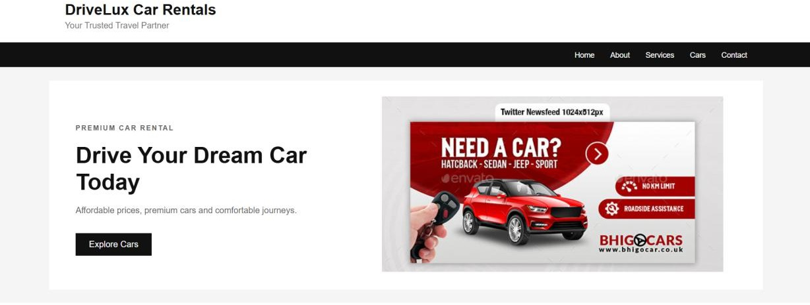

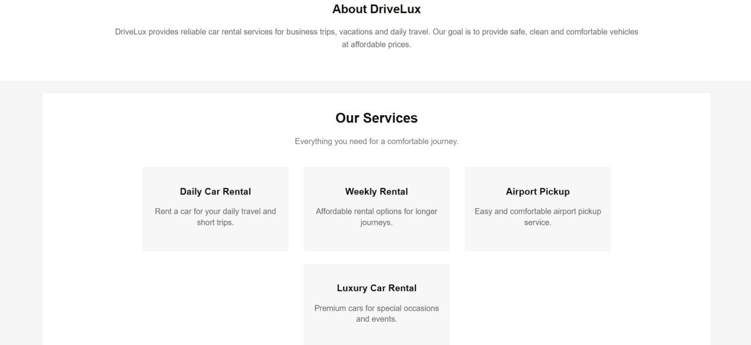
11
Ex. 3 | Responsive Webpage using HTML5 and CSS3

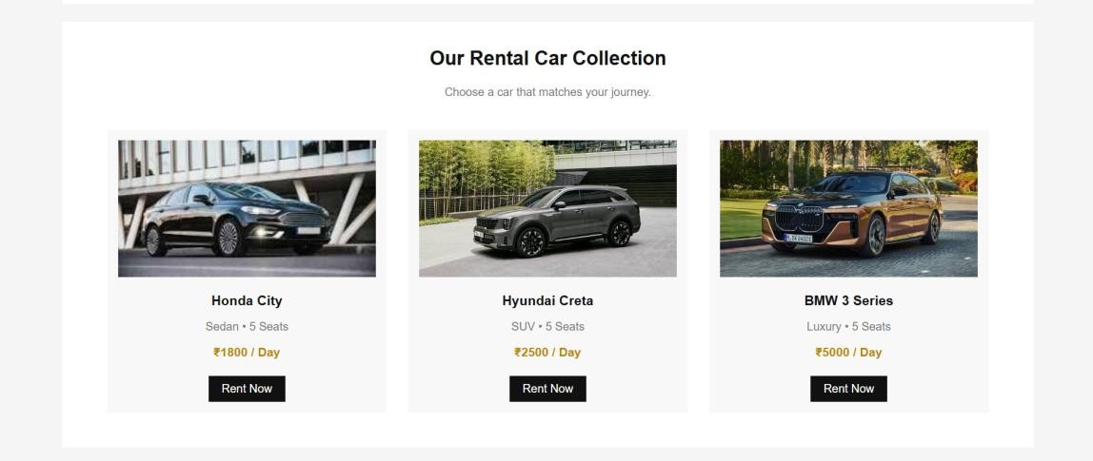
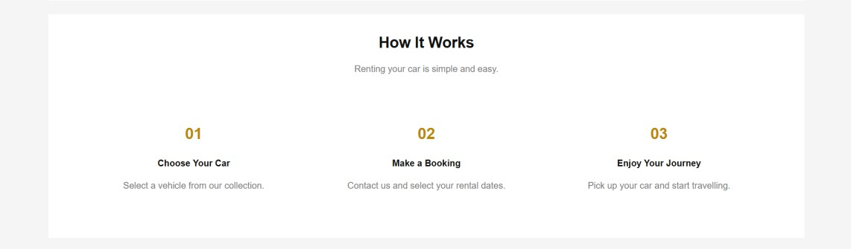
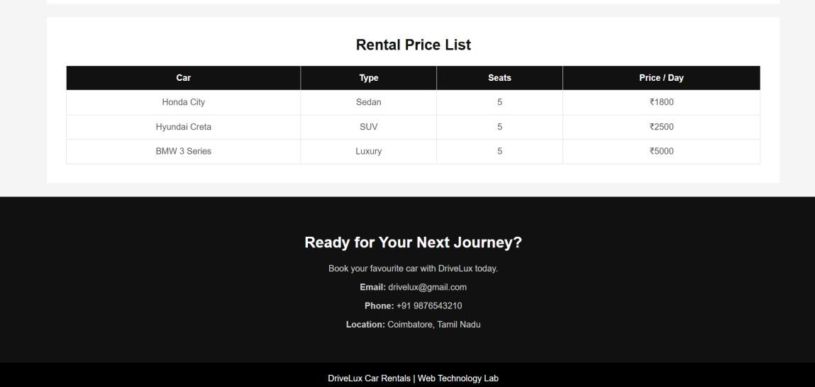

Result
Thus the Car Rental Service webpage was successfully designed using HTML5 and External CSS and verified successfully.
12
Ex. 3 | Responsive Webpage using HTML5 and CSS3

