Ex. No. 5 | JavaScript – DOM Elements and Events
Date of Exercise | 08.09.26
GitHub Host Link | https://github.com/EUNICEMERCY123/Car-Rental-Service.git

Aim
To create web pages which demonstrate the applications of document Object model and events in JavaScript.

Description
This experiment focuses on designing a responsive Car Rental Service webpage using HTML5 and External CSS (CSS3). Various HTML elements and CSS properties are used to create the webpage structure, navigation bar, car rental sections, buttons, styling, and responsive layout. The following concepts are implemented along with their purpose:

Concept Purpose
HTML5 Provides the basic structure of the webpage.
External CSS Stores the webpage styles in a separate CSS file for better organization.
Meta Viewport Makes the webpage adjust properly to different screen sizes.
Header Displays the logo and title of the Car Rental Service. Navigation Bar Provides links to different sections of the webpage. Hyperlinks Connect different sections of the webpage.

Background Color
Changes the background color of different sections.

Font Family Sets the style of text used on the webpage.
Font Size Changes the size of text.
Text Align Aligns text to the required position.
Margin Creates space outside an element.
Padding Creates space between the content and the border.
Width and Height Sets the size of webpage elements.
Display Property Controls how elements are displayed.
Flexbox Arranges the hero section and car models in a flexible layout.
Border Radius Creates rounded corners for cards, images and buttons.
Box Shadow Adds shadow effects around car cards.
Hover Effect Changes the appearance of buttons and links when the mouse moves over them.
1
Ex. 5 | JavaScript – DOM Elements and Events

Concept Purpose
Images Displays the available rental cars and adds visual appearance to the webpage.
Car Cards Displays car model, type, seats and rental price.
Buttons Allows users to select or book a car.
Media Query Makes the webpage responsive on smaller screens.
Footer Displays copyright and Car Rental Service information.

Procedure:
- Create a new project folder and save the files as index.html and style.css.
- Add the required car images to the project folder.
- Link the external CSS file to the HTML file using the <link> tag.
- Add the viewport meta tag to make the webpage responsive on different screen sizes.
- Create the webpage structure using HTML5 elements such as header, navigation, sections, images, hyperlinks, buttons, and footer.
- Create a navigation bar containing Home, Cars, Services, and Contact links.
- Create the Car Rental Service welcome section with a heading, paragraph, car image, and Explore Cars button.
- Create the Car Models section to display different rental cars using separate car cards.
- Add car images, car type, number of seats, rental price, and Rent Now buttons to each car card.
- Arrange the car cards side by side using Flexbox.
- Apply CSS properties such as margin, padding, colors, fonts, background colors, width, height, border radius, and box shadow to improve the appearance.
- Apply hover effects to navigation links and car buttons.
- Use a media query to change the layout of the car cards and other sections for smaller screen sizes.
- Add a footer containing Car Rental Service and Web Technology Lab information.
- Save the files and open index.html in a web browser to verify the final output.

Program
<!DOCTYPE html>
<html>
<head>
<title>DriveLux Car Rental</title>
<link rel="stylesheet" href="style.css">
</head>
<body>
<header>
<div class="logo">Drive<span>Lux</span></div>
<nav>
2
Ex. 5 | JavaScript – DOM Elements and Events

<a href="#">Home</a>
<a href="#cars">Cars</a>
<a href="#">Services</a>
<a href="#">Contact</a>
</nav>
</header>
<section class="hero">
<div class="hero-text">
<p class="small">PREMIUM CAR RENTAL</p>
<h1>
Your journey.<br>
Your <span>choice.</span>
</h1>
<p>
Find the perfect car for your next trip. Simple booking, comfortable rides and affordable prices.
</p>
<a href="#cars" class="hero-button"> Explore Cars
</a>
</div>
<div class="hero-image">
<img src="luxury.jpg" alt="Luxury Car">
</div>
</section>
<section class="cars-section" id="cars">
<p class="small">OUR COLLECTION</p>
<h2>Choose Your Ride</h2>
<p class="subtitle">
Select from our range of comfortable and stylish cars.
</p>
<div class="car-container">
<div class="car">
<img src="sedan.jpg" alt="Honda City">
<div class="car-info">
<p class="type">SEDAN</p>
<h3>Honda City</h3>
<p>5 Seats &nbsp; • &nbsp; Automatic</p>
<div class="bottom">
<div>
<b>₹1800</b>
<small>/ day</small>
</div>
<button class="rent"> Rent Now
3
Ex. 5 | JavaScript – DOM Elements and Events

</button>
</div>
</div>
</div>
<div class="car">
<img src="suv.jpg" alt="Hyundai Creta">
<div class="car-info">
<p class="type">SUV</p>
<h3>Hyundai Creta</h3>
<p>5 Seats &nbsp; • &nbsp; Automatic</p>
<div class="bottom">
<div>
<b>₹2500</b>
<small>/ day</small>
</div>
<button class="rent"> Rent Now
</button>
</div>
</div>
</div>
<div class="car">
<img src="luxury.jpg" alt="BMW 3 Series">
<div class="car-info">
<p class="type">LUXURY</p>
<h3>BMW 3 Series</h3>
<p>5 Seats &nbsp; • &nbsp; Automatic</p>
<div class="bottom">
<div>
<b>₹5000</b>
<small>/ day</small>
</div>
<button class="rent"> Rent Now
</button>
</div>
</div>
</div>
</div>
<button class="book" onclick="bookCar()"> Book Selected Car →
</button>
<p id="message"></p>
</section>
<section class="why">
4
Ex. 5 | JavaScript – DOM Elements and Events

<div>
<h2>Why Choose DriveLux?</h2>
<p>
Everything you need for a smooth and comfortable journey.
</p>
</div>
<div class="features">
<div>
<h3>01</h3>
<p>Clean & Comfortable Cars</p>
</div>
<div>
<h3>02</h3>
<p>Affordable Daily Rates</p>
</div>
<div>
<h3>03</h3>
<p>Easy Booking Process</p>
</div>
</div>
</section>
<footer>
<h2>DriveLux</h2>
<p>Premium Car Rental Service</p>
<p>Coimbatore, Tamil Nadu</p>
</footer>
<script>
function bookCar() { document.getElementById("message").innerHTML =
"✓ Your car booking request has been received!";
}
</script>
</body>
</html>

CSS
* {
margin: 0;
padding: 0;
box-sizing: border-box;
font-family: Arial, sans-serif;
}
body {
background: #f5f5f3;
5
Ex. 5 | JavaScript – DOM Elements and Events

color: #111;
}
header {
position: absolute; top: 0;
left: 0;
width: 100%;
padding: 25px 8%; display: flex;
justify-content: space-between; align-items: center;
z-index: 2;
}
.logo {
color: white; font-size: 26px;
font-weight: bold;
}
.logo span { color: #d9a441;
}
nav a {
color: white;
text-decoration: none; margin-left: 30px; font-size: 14px;
}
nav a:hover { color: #d9a441;
}
.hero {
min-height: 500px; padding: 110px 8% 70px; background: #111; display: flex;
align-items: center; gap: 60px;
color: white;
}
.hero-text { width: 45%;
}
.small {
color: #d9a441; font-size: 12px; font-weight: bold;
6
Ex. 5 | JavaScript – DOM Elements and Events

letter-spacing: 3px; margin-bottom: 15px;
}
.hero h1 {
font-size: 55px; line-height: 1.05;
margin-bottom: 20px;
}
.hero h1 span { color: #d9a441;
}
.hero-text > p:not(.small) { color: #bbb;
line-height: 25px; margin-bottom: 25px;
}
.hero-button {
display: inline-block; background: #d9a441; color: #111;
padding: 13px 25px; border-radius: 25px; text-decoration: none; font-weight: bold;
}
.hero-button:hover { background: white;
}
.hero-image { width: 55%;
}
.hero-image img { width: 100%; height: 320px; object-fit: cover; border-radius: 22px;
}
.cars-section { width: 84%;
margin: 65px auto;
}
.cars-section h2 { font-size: 38px;
margin-bottom: 8px;
}
7
Ex. 5 | JavaScript – DOM Elements and Events

.subtitle { color: #777;
margin-bottom: 30px;
}
.car-container { display: flex; gap: 25px;
}
.car {
background: white; width: 33.33%; border-radius: 16px; overflow: hidden;
box-shadow: 0 8px 25px #ddd; transition: 0.3s;
}
.car:hover {
transform: translateY(-6px);
}
.car-image { width: 100%; height: 210px;
object-fit: contain; display: block; background: #f3f3f3;
}
.car-info { padding: 20px;
}
.type {
color: #c18b2c; font-size: 10px; font-weight: bold; letter-spacing: 2px;
}
.car h3 {
font-size: 22px; margin: 7px 0;
}
.car-info > p:not(.type) { color: #888;
font-size: 14px;
}
.bottom { display: flex;
justify-content: space-between;
8
Ex. 5 | JavaScript – DOM Elements and Events

align-items: center; margin-top: 20px;
}
.bottom b {
font-size: 17px;
}
.bottom small { color: #888;
}
.rent {
background: #111827; color: white;
border: none; padding: 10px 17px; border-radius: 20px; cursor: pointer;
}
.rent:hover { background: #d9a441; color: #111;
}
.book {
margin-top: 30px; padding: 13px 25px; border: none;
border-radius: 25px; background: #111827; color: white;
font-weight: bold; cursor: pointer;
}
.book:hover { background: #d9a441; color: #111;
}
#message {
margin-top: 15px; color: green;
}
.why {
background: white; padding: 55px 8%; display: flex;
justify-content: space-between; align-items: center;
}
9
Ex. 5 | JavaScript – DOM Elements and Events

.why h2 {
font-size: 32px; margin-bottom: 8px;
}
.why p { color: #777;
}
.features { display: flex; gap: 55px;
}
.features h3 { color: #d9a441; font-size: 25px;
margin-bottom: 8px;
}
footer {
background: #111; color: white;
text-align: center; padding: 35px;
}
footer h2 {
color: #d9a441; margin-bottom: 8px;
}
footer p { color: #888; margin: 5px;
}
@media (max-width: 800px) {

header {
position: relative; background: #111; flex-direction: column; gap: 15px;
padding: 20px;
}
nav a {
margin: 8px;
}
.hero {
flex-direction: column; padding: 60px 8%; text-align: center;
10
Ex. 5 | JavaScript – DOM Elements and Events

gap: 35px;
}
.hero-text { width: 100%;
}
.hero-image { width: 100%;
}
.hero-image img { height: 280px; object-fit: contain;
}
.hero h1 {
font-size: 42px;
}
.car-container {
flex-direction: column;
}
.car {
width: 100%;
}
.why {
flex-direction: column; gap: 35px;
text-align: center;
}
.features {
flex-direction: column; gap: 20px;
}
}

JavaScript
// Finding element by ID
var title = document.getElementById("home");
// Finding elements by tag name
var headings = document.getElementsByTagName("h3");
// Finding elements by class name
var cars = document.getElementsByClassName("car");
// Finding elements by CSS selector
var buttons = document.querySelectorAll(".rent");
// Click event document.getElementById("book").addEventListener("click", function() {
document.getElementById("result").innerHTML = "Your car booking request has been received!";
11
Ex. 5 | JavaScript – DOM Elements and Events

});

Output
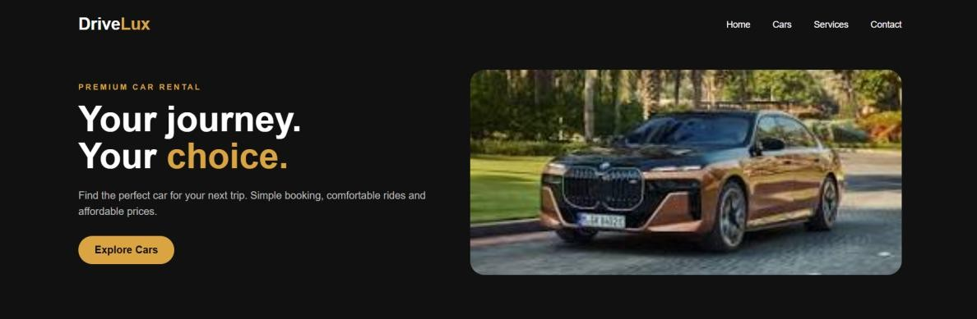
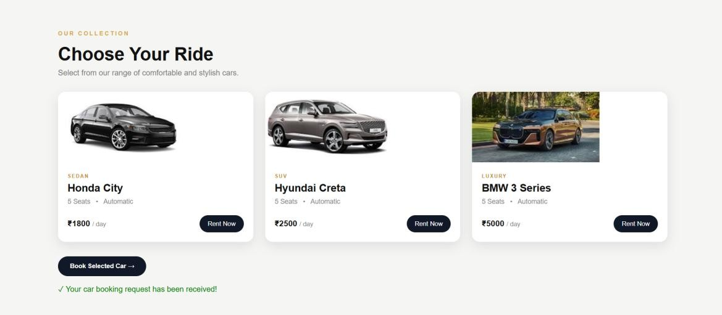
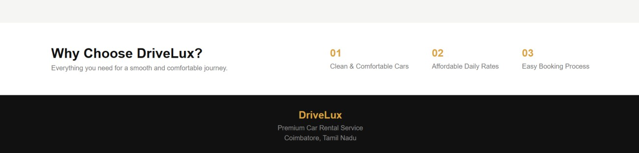

Result
Thus, the Car Rental Service webpage was successfully designed using HTML5 and External CSS (CSS3) with responsive layout, navigation, car model sections, buttons, and styling, and the output was verified successfully.
12
Ex. 5 | JavaScript – DOM Elements and Events

