Ex. No. 4 | Develop a Sign – In and Sign – Up Page with Navigation Bar using CSS
Date of Exercise | 25.08.26
GitHub Host Link

Aim
To design and develop a responsive web page that includes a navigation bar, a Sign-In form, and a Sign-Up form using HTML and CSS, providing an attractive and user-friendly interface with proper layout, styling, and navigation.

Description
This experiment focuses on designing a responsive Car Rental Service webpage using HTML5 and External CSS (CSS3). Various HTML elements and CSS properties are used to create the webpage structure, navigation, dropdown menu, forms, car model sections, styling, and responsive layout. The following concepts are implemented along with their purpose:

Concept | Purpose
HTML5 | Provides the basic structure of the webpage.
External CSS | Stores the webpage styles in a separate CSS file for better organization.
Meta Viewport | Makes the webpage adjust properly to different screen sizes.
Header | Displays the logo and title of the Car Rental Service.
Navigation Bar | Provides links to different sections of the webpage.
Dropdown Menu | Displays additional options under the Home menu using CSS.
Hyperlinks | Connect different sections of the webpage.
Background Image | Adds a car image to the welcome section.
Background Color | Changes the background color of different sections.
Font Family | Sets the style of text used on the webpage.
Font Size | Changes the size of text.
Text Align | Aligns text to the center or other positions.
Margin | Creates space outside an element.
Padding | Creates space between the content and the border.
Width and Height | Sets the size of webpage elements.
Display Property | Controls how elements are displayed.
Flexbox | Arranges car models and forms side by side.
Border Radius | Creates rounded corners for sections, forms and buttons.
1
Ex. 4 | Develop a Sign – In and Sign – Up Page with Navigation Bar using CSS

Concept | Purpose
Box Shadow | Adds shadow effects around webpage elements.
Hover Effect | Changes the appearance of links and buttons when the mouse moves over them.
Forms | Provides Sign-In and Sign-Up forms for the webpage.
Input Fields | Accepts user information such as name, email, phone and password.
Buttons | Allows users to submit the Sign-In and Sign-Up forms.
Media Query | Makes the webpage responsive on smaller screens.
Footer | Displays copyright and developer information at the bottom of the webpage.

Procedure:
- Create a new project folder and save the files as index.html and style.css.
- Add the required logo image and background car image to the project folder.
- Link the external CSS file to the HTML file using the <link> tag.
- Add the viewport meta tag to make the webpage responsive on different screen sizes.
- Create the webpage structure using HTML5 elements such as header, navigation, sections, forms, images, hyperlinks, and footer.
- Create a horizontal navigation bar containing Home, About, Model, and Others links.
- Create a CSS dropdown menu under Home using nested lists and the :hover pseudo-class.
- Create the Car Rental Service welcome section with a background image, heading, paragraph, and Book Now button.
- Create the About and Car Models sections to display information about the rental service and available cars.
- Create Sign-In and Sign-Up forms and arrange them side by side using Flexbox.
- Apply CSS properties such as margin, padding, colors, fonts, background image, width, display, border radius, and box shadow to improve the appearance.
- Apply hover effects to navigation links and buttons.
- Use a media query to change the layout for smaller screen sizes and make the webpage responsive.
- Add a footer containing copyright and developer information.
- Save the files and open index.html in a web browser to verify the final output.

Program
<!DOCTYPE html>
<html>
<head>
<title>DriveLux Car Rental</title>
<meta name="viewport" content="width=device-width, initial-scale=1.0">
2
Ex. 4 | Develop a Sign – In and Sign – Up Page with Navigation Bar using CSS

<link rel="stylesheet" href="style.css">
</head>
<body>
<header>
<img src="logo.jpg" alt="DriveLux Logo">
<h1>DriveLux Car Rental</h1>
</header>
<nav>
<ul>
<li class="home">
<a href="#">Home</a>
<ul class="dropdown">
<li><a href="#cars">Cars</a></li>
<li><a href="#booking">Book a Car</a></li>
<li><a href="#offers">Offers</a></li>
</ul>
</li>
<li><a href="#about">About</a></li>
<li><a href="#model">Model</a></li>
<li><a href="#others">Others</a></li>
</ul>
</nav>
<main>
<section class="welcome">
<h2>Welcome to DriveLux</h2>
<p>
Rent your favourite car at an affordable price.
We provide comfortable and reliable cars for your journey.
</p>
<a href="#booking" class="button">Book Now</a>
</section>
<section id="about" class="section">
<h2>About DriveLux</h2>
<p>
DriveLux is a simple and reliable car rental service.
We provide cars for business trips, family trips and daily travel.
</p>
</section>
<section id="model" class="section">
<h2>Our Car Models</h2>
<div class="cars" id="cars">
<div class="car">
<h3>Honda City</h3>
<p>Sedan - 5 Seats</p>
<p>₹1800 / Day</p>
</div>
3
Ex. 4 | Develop a Sign – In and Sign – Up Page with Navigation Bar using CSS

<div class="car">
<h3>Hyundai Creta</h3>
<p>SUV - 5 Seats</p>
<p>₹2500 / Day</p>
</div>
<div class="car">
<h3>Mahindra XUV700</h3>
<p>SUV - 7 Seats</p>
<p>₹3000 / Day</p>
</div>
</div>
</section>
<section id="booking" class="form-section">
<div class="form-box">
<h2>Sign In</h2>
<form>
<label>Email:</label>
<input type="email" placeholder="Enter your email">
<label>Password:</label>
<input type="password" placeholder="Enter your password">
<input type="submit" value="Sign In">
</form>
</div>
<div class="form-box">
<h2>Sign Up</h2>
<form>
<label>Name:</label>
<input type="text" placeholder="Enter your name">
<label>Email:</label>
<input type="email" placeholder="Enter your email">
<label>Phone:</label>
<input type="tel" placeholder="Enter your phone number">
<label>Password:</label>
<input type="password" placeholder="Create password">
<input type="submit" value="Sign Up">
</form>
</div>
</section>
<section id="others" class="section">
<h2>Why Choose DriveLux?</h2>
<p id="offers">Affordable prices and well-maintained cars.</p>
<p>Easy booking process.</p>
<p>Comfortable and safe travel.</p>
</section>
</main>
<footer>
4
Ex. 4 | Develop a Sign – In and Sign – Up Page with Navigation Bar using CSS

<p>© 2026 DriveLux Car Rental. All Rights Reserved.</p>
<p>
Developed by DriveLux Web Technology Lab, Coimbatore, Tamil Nadu.
</p>
</footer>
</body>
</html>

CSS
body {
margin: 0;
font-family: Arial; background-color: #f2f2f2; color: #222;
}
header {
background-color: white; padding: 20px;
text-align: center;
}
header img { width: 60px;
vertical-align: middle;
}
header h1 { display: inline;
margin-left: 10px;
}
nav {
background-color: #111; text-align: center;
}
nav ul {
list-style: none; margin: 0;
padding: 0;
}
nav li {
display: inline-block; position: relative;
}
nav a {
display: block;
5
Ex. 4 | Develop a Sign – In and Sign – Up Page with Navigation Bar using CSS

color: white;
text-decoration: none; padding: 15px 25px;
}
nav a:hover {
background-color: #d4a017; color: black;
}
.dropdown { display: none; position: absolute;
background-color: #111; width: 160px;
text-align: left;
}
.home:hover .dropdown { display: block;
}
.dropdown li { display: block;
}
.dropdown a { padding: 12px;
}
.welcome { width: 80%;
margin: 30px auto; padding: 70px 30px; text-align: center; color: white;
background-image: url("car-bg.jpg"); background-size: cover;
background-position: center; border-radius: 10px;
box-shadow: 0 4px 10px gray;
}
.welcome h2 { font-size: 35px;
}
.welcome p {
font-size: 18px;
}
.button {
display: inline-block; background-color: #d4a017; color: black;
6
Ex. 4 | Develop a Sign – In and Sign – Up Page with Navigation Bar using CSS

text-decoration: none; padding: 12px 25px; border-radius: 5px;
}
.button:hover {
background-color: white;
}
.section { width: 80%;
margin: 25px auto; padding: 30px; background-color: white; text-align: center;

border-radius: 10px;
box-shadow: 0 3px 8px #ccc;
}
.cars {
display: flex;
justify-content: space-around; gap: 20px;
}
.car {
width: 30%; padding: 20px;
background-color: #f5f5f5;

border-radius: 8px;
box-shadow: 0 2px 6px #ccc;
}
.form-section { width: 84%; margin: 25px auto;

display: flex;
justify-content: space-between; gap: 25px;
}
.form-box { width: 50%;
background-color: white; padding: 30px;
border-radius: 10px;
box-shadow: 0 3px 8px #ccc;
}
.form-box h2 {
7
Ex. 4 | Develop a Sign – In and Sign – Up Page with Navigation Bar using CSS

text-align: center;
}
label {
display: block; margin-top: 12px;
}
input {
width: 95%; padding: 10px; margin-top: 6px;
border: 1px solid #ccc; border-radius: 5px;
}
input[type="submit"] { width: 100%; margin-top: 20px;
background-color: #111; color: white;
cursor: pointer;
}
input[type="submit"]:hover { background-color: #d4a017; color: black;
}
footer {
background-color: #111; color: white;
text-align: center; padding: 25px; margin-top: 30px;
}
@media screen and (max-width: 700px) { nav li {
display: block;
}
.cars {
display: block;
}
.car {
width: 80%; margin: 15px auto;
}
.form-section { display: block;
}
.form-box {
8
Ex. 4 | Develop a Sign – In and Sign – Up Page with Navigation Bar using CSS

width: 80%; margin: 20px auto;
}
}

Output
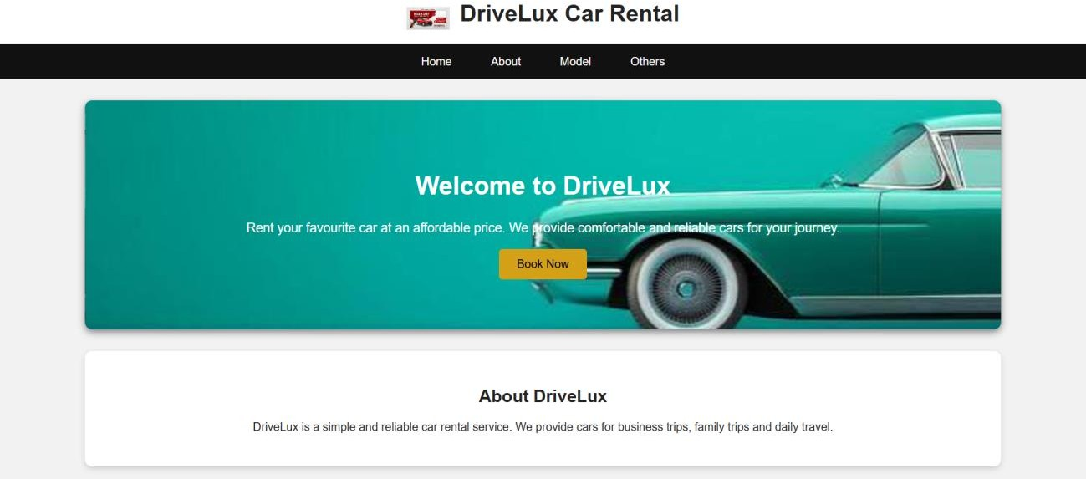
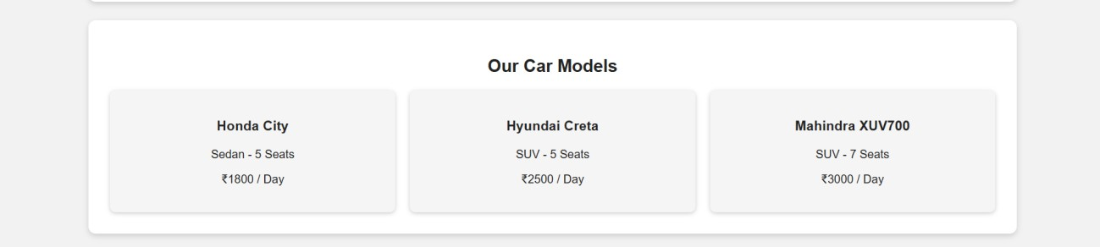
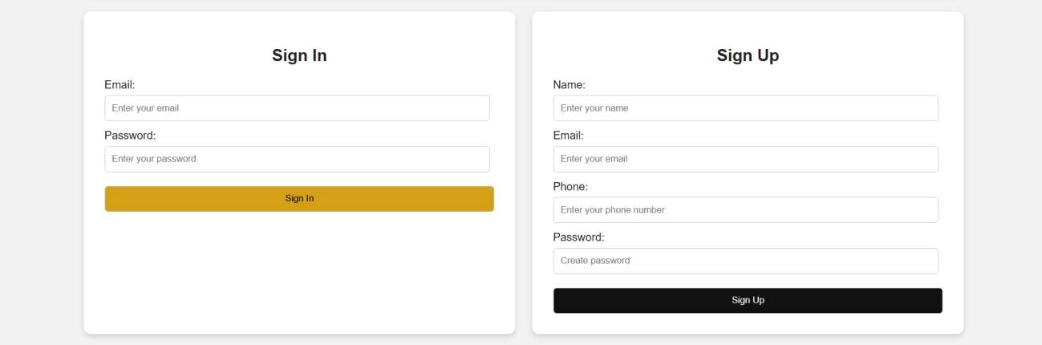

9
Ex. 4 | Develop a Sign – In and Sign – Up Page with Navigation Bar using CSS

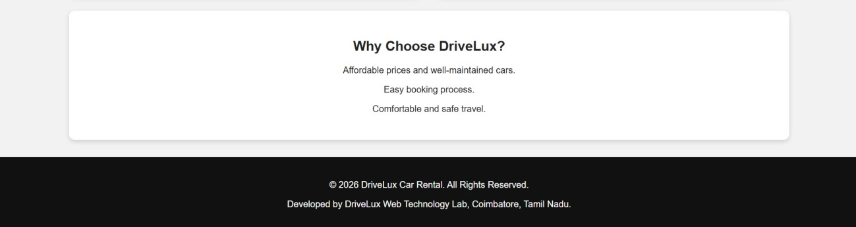

Result
Thus, the Car Rental Service webpage was successfully designed using HTML5 and External CSS (CSS3) with responsive layout, navigation, dropdown menu, forms, and styling, and the output was verified successfully.

10
Ex. 4 | Develop a Sign – In and Sign – Up Page with Navigation Bar using CSS

