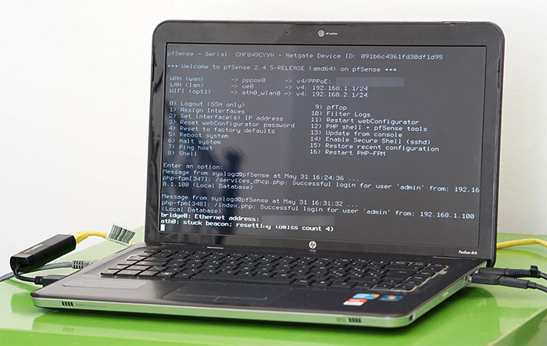

**PFSense Initial Configuration**

Brendon Ahn | Cyber Security | 2022-2023



**Purpose:**

The purpose of this lab was to do the initial configuration and port forwarding for PFSense on a laptop.

**Background:**

PFSense is an open-source firewall that can be downloaded of the web. PFSense can be used as both a router and a firewall. What we do in our lab is the initial configuration of PFSense as well as setting up port forwarding. The initial configuration involves downloading PFSense to a drive and booting it onto a laptop. On the laptop you then start a configuration to set WAN and LAN addresses. In this process DHCP can also be set up. Doing port forwarding is more work and you have to go onto the GUI to configure this, at least that is what we did. You have to go the NAT than port forwarding section in order to do this. To access the actual GUI, you have to change your Firefox version

PFSense is free and it is based on FreeBSD. It is made so it can all be managed and configured on the web. This is also why port forwarding is cool so you can configure it on multiple devices without being directly connected to the firewall. The PFSense project is hosted and developed by Rubicon Communications LLC, also known as Netgate. Although PFSense is based on FreeBSD you don’t need FreeBSD knowledge to configure it.

The original PFSense project started as a part of m0n0wall, a project by Chris Buechler and Scott Ullrich. The PF part comes from Packet Filtering which is what PFSense is used for. Functions of PFSense include traffic shaping, VPN, captive portal, stateful firewall, NAT, etc. It a lot of the features of both Routers and Firewalls and a lot of people prefer PFSense over their own firewall and router.

PFSense can be used on VM or Virtual Machines or a physical computer which is what we did for our lab. Recently there was some issue when PFSense tried to incorporate Wire guard in early 2021 but this was resolved after they temporarily disabled it and fixed the issue.

**Lab Summary:**

We downloaded and setup PFSense on a old laptop and set up port forwarding using the Web GUI.

**Lab Procedure:**

1. Click on “pfSense-CE-2.6.0-RELEASE-amd64.iso.gz in downloads.

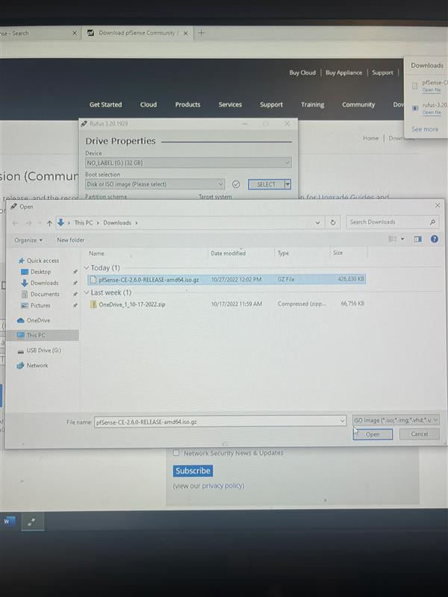

1. Install pfSense by selecting “Install pfSense”

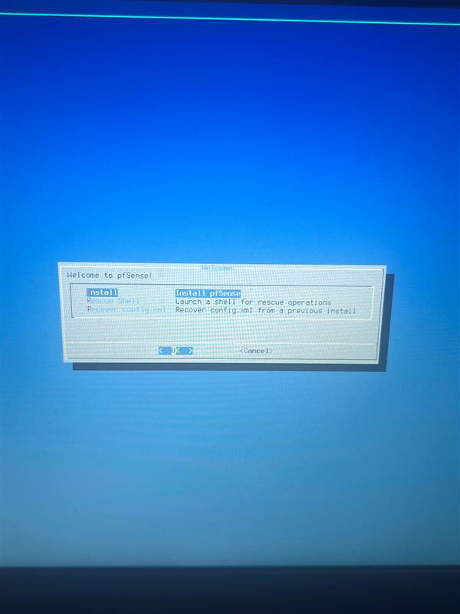

1. Select “continue with default laptop”

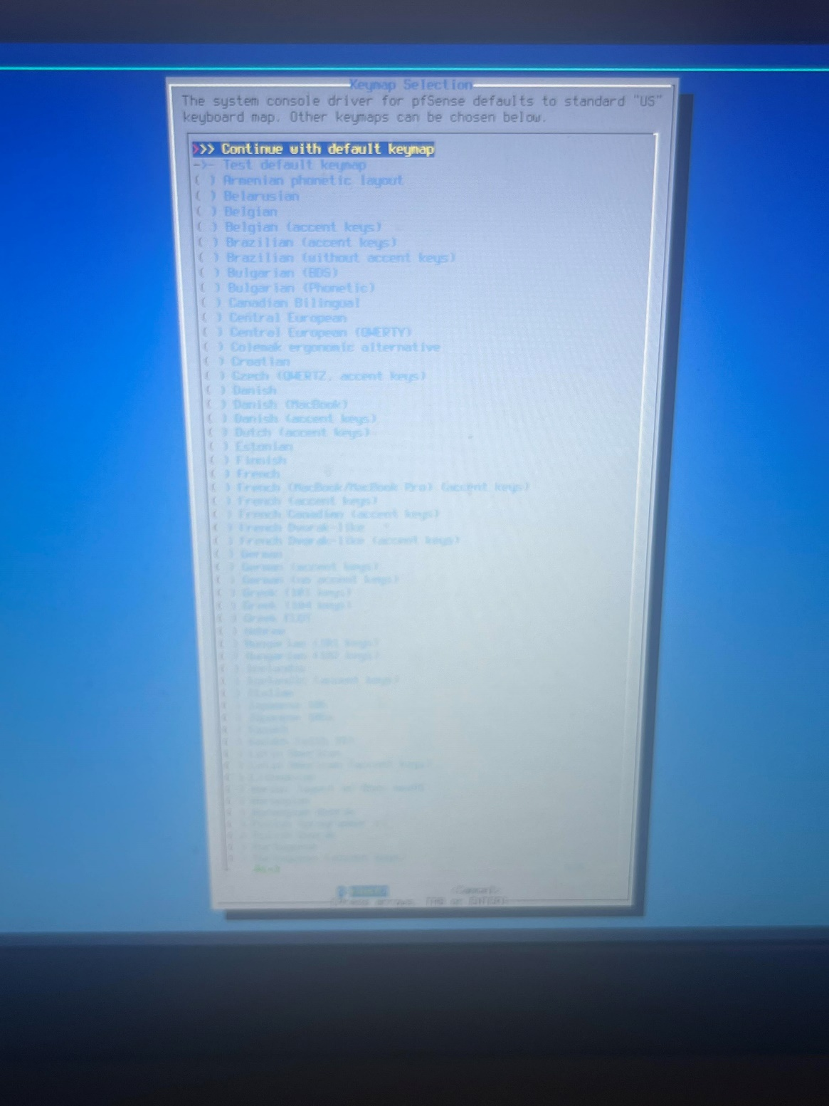

1. Make sure that the correct wires are plugged in:

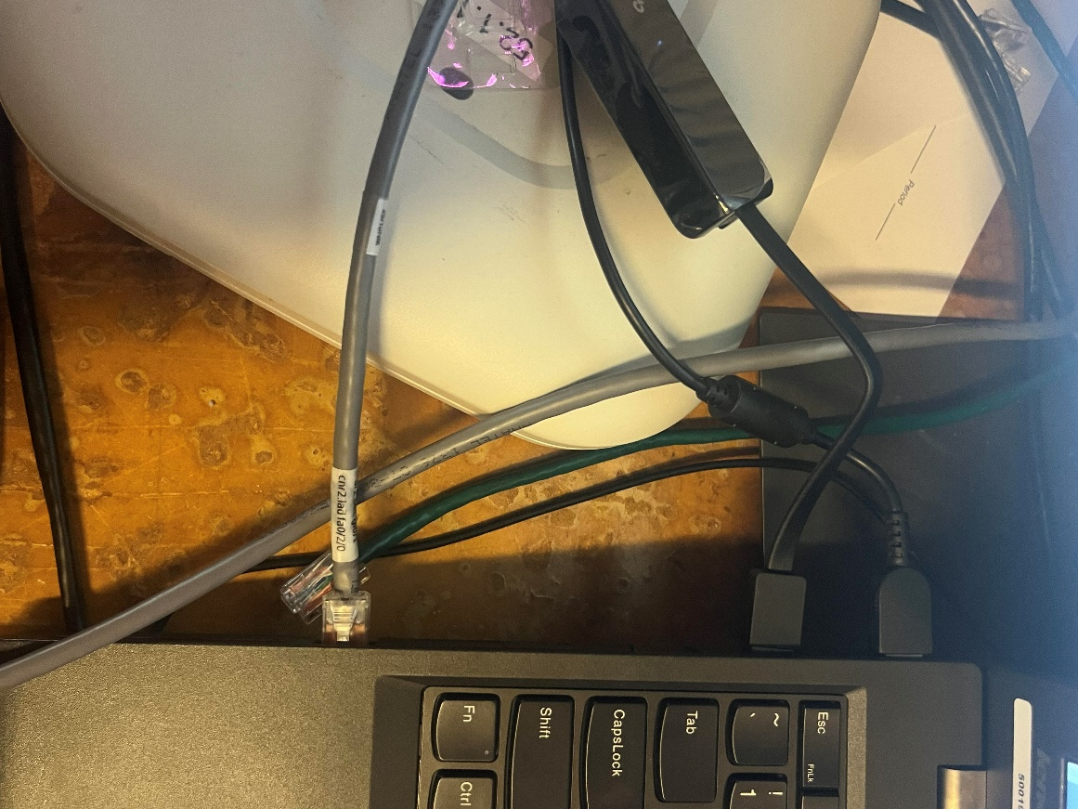

1. When asked “how would you like to partition your disk?”, select “Guided disk setup using UEFI boot method”

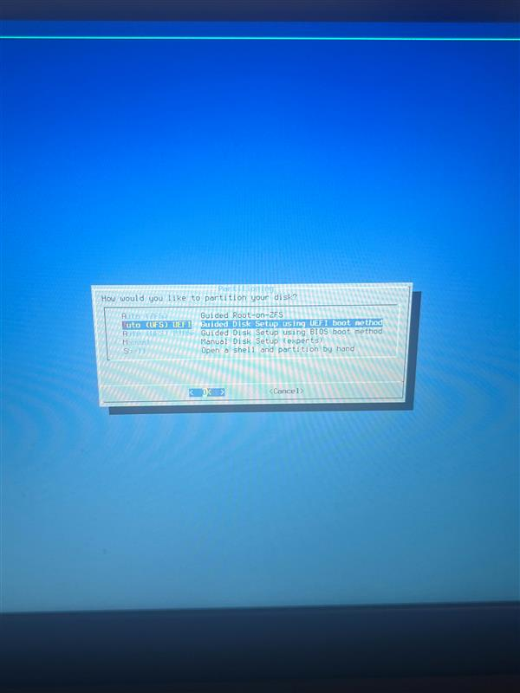

1. This screen should show:

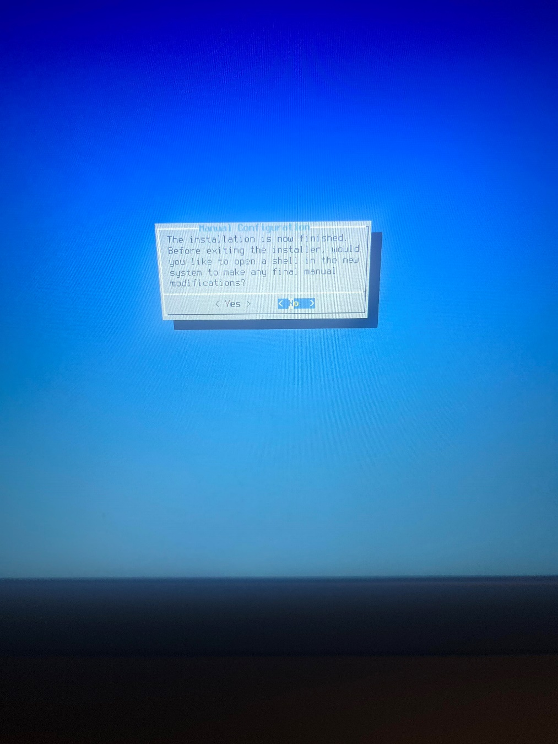

1. Reboot into the installed system:

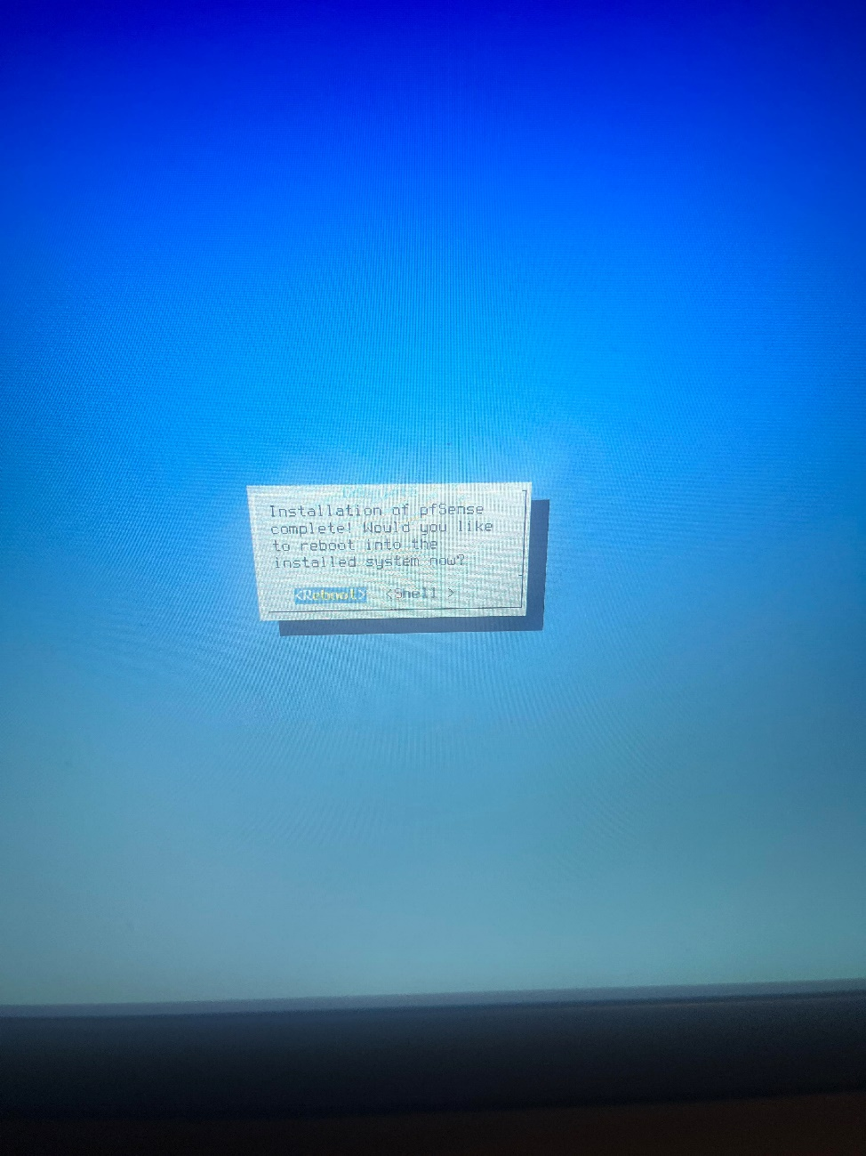

1. connect ue0 to LAN and em0 to WAN

should VLANs be set up?  
n

enter WAN interface name  
em0

enter LAN interface name   
ue0

assign interfaces:   
WAN as DHCP client  
LAN as DHCP server

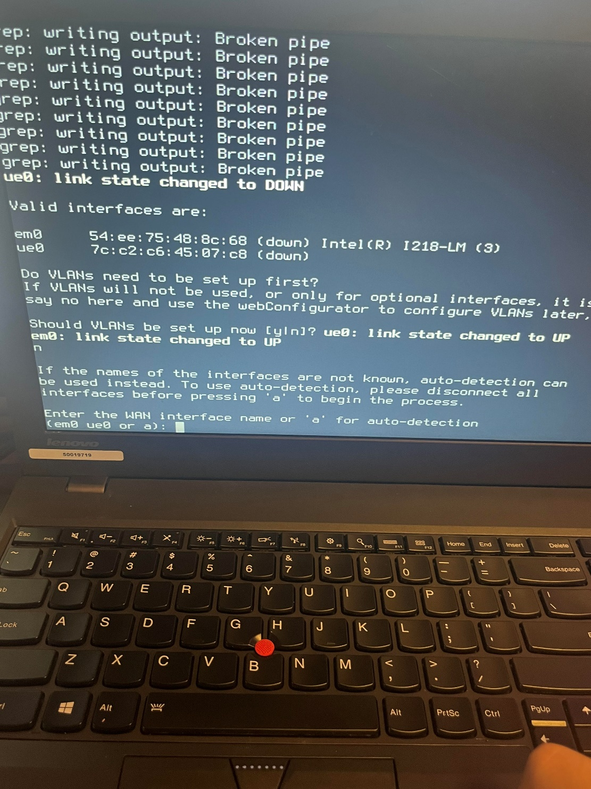

1. This screen should show:

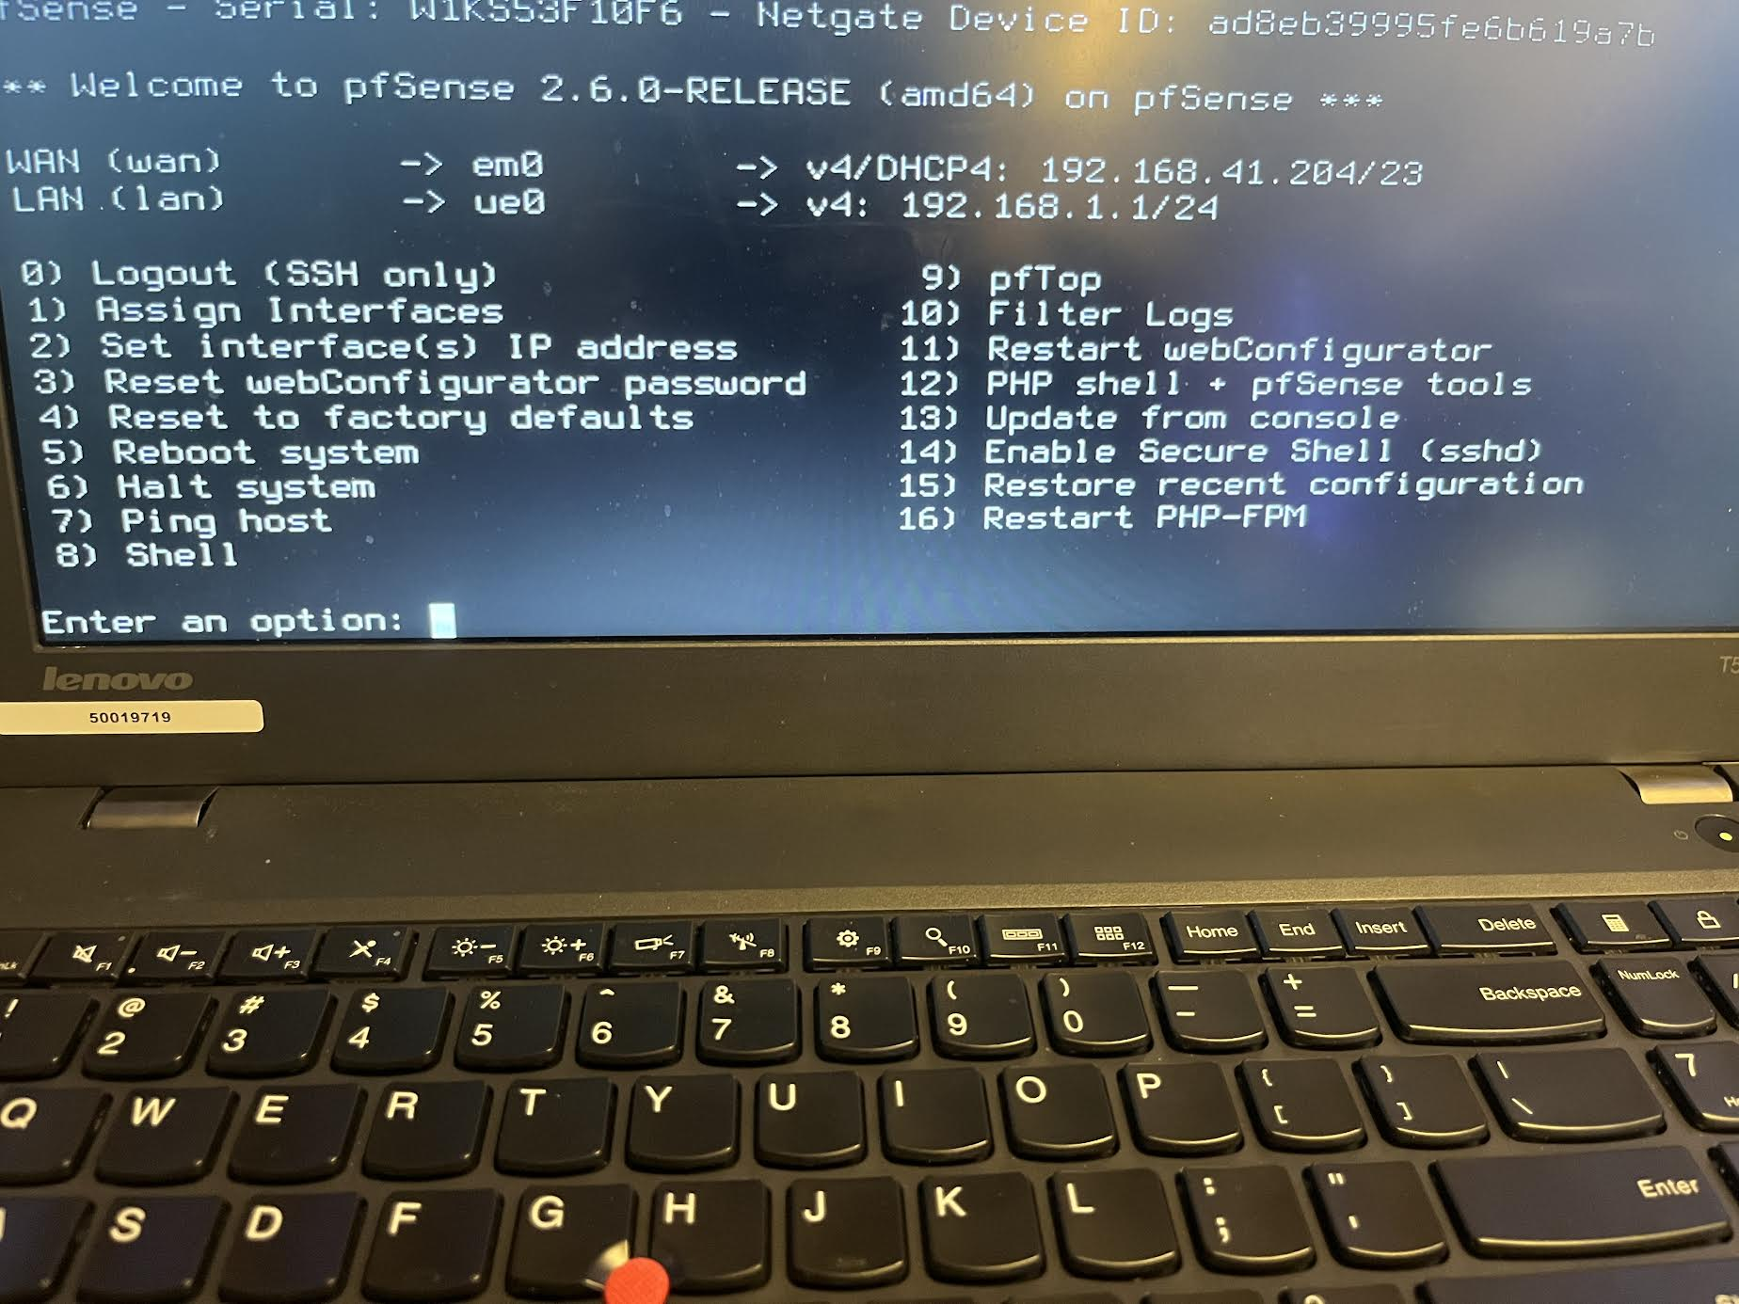

1. Go to firefox, and type in 192.168.1.1 into the search bar. The following screen should show. Enter your username and password:

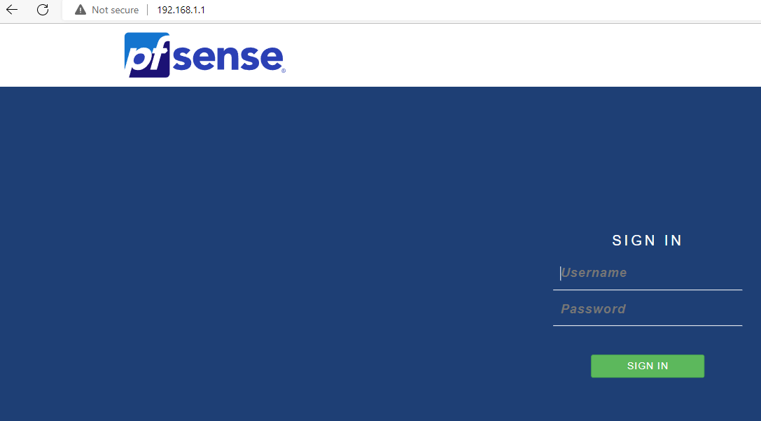

1. Go to Firewall, and select “NAT”

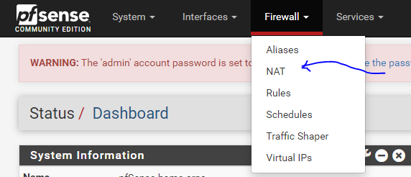

1. Configure as shown below:

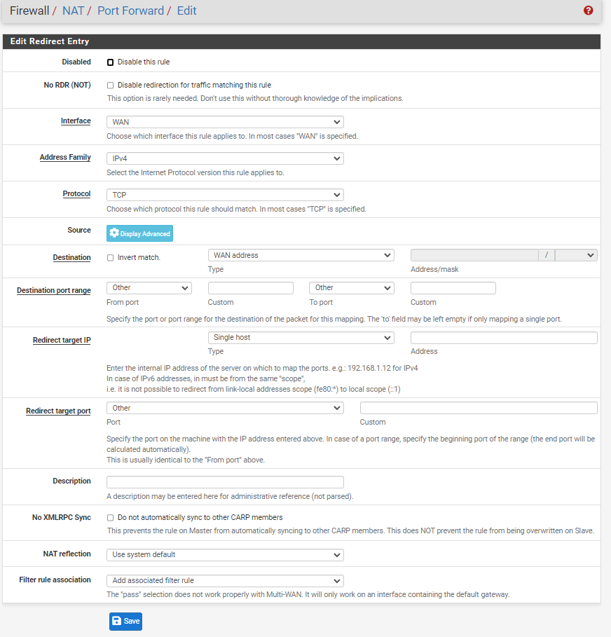

1. Enter the IP address:

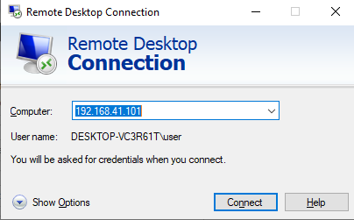

**Problems:**

In our initial attempt to configure PFSense on the Laptop after we set it up it kept crashing. One time it worked temporarily but then crashed again as soon as we tried to get it checked off so we had to get a new laptop and start over. After starting over the configuration was a lot more successful and we didn’t have too much trouble trying to configure it. The problem with the actual configuration was trying to get port forwarding to work. It took some fixes not directly related to the firewall, most notable a change to the version of the firewall. There was a mix of getting sick and also doing another lab first before going back to this lab which delayed the process of getting it done. Mostly having to restart was a big pain.

**Conclusion:**

In this lab, we downloaded PFSense, put it on a physical machine, and did the initial configuration steps as well as set up port forwarding of PFSense on a physical machine.