**MAP INFOGRAPHIC**

**Instructions:**

The developer should create a infographic with 3 hotspots: UAE, Bahrain and Kuwait. It should work on the latest versions of the main browsers.

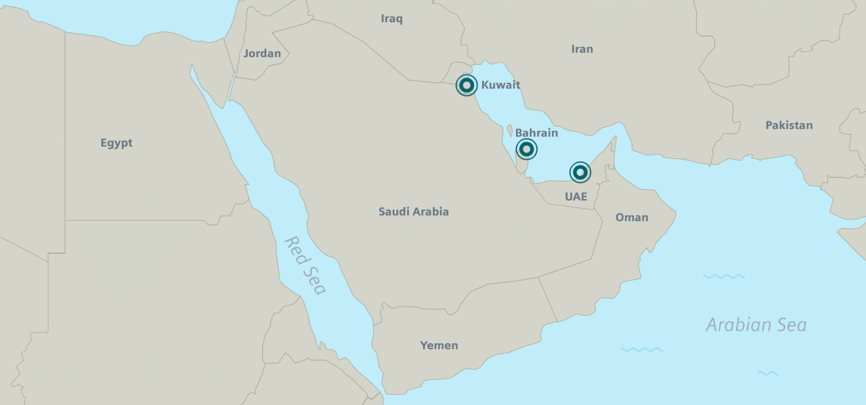

The infographic should be responsive and follow some rules.

1. To create the hotspots the developer can use the “marker.png”. The hotspots should expand asynchronous (Example video)

C:\Users\Jean\AppData\Local\Microsoft\Windows\INetCache\Content.Word\marker.png

**Optional - If you prefer, you can create two circle (svg), on mouse over the circle in the middle should fill completely.**

Color: #00636d;

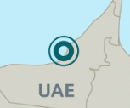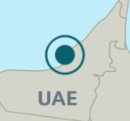

1. The Arabian Sea should contain waves gifs as in the example:

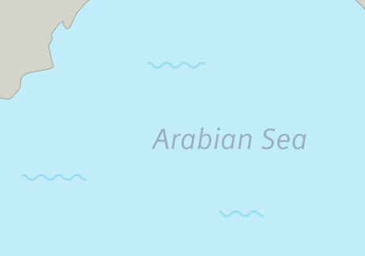

1. When the user clicks on the hotspots, the equivalent pop-up should open over a black layer. These pop-ups should contain title, subtitle and some information with gifs. It’s very important to respect the positioning of the elements. See the image (fonts.png) to find the font-size and color to be used.

Note: The developer should choose the font-family.

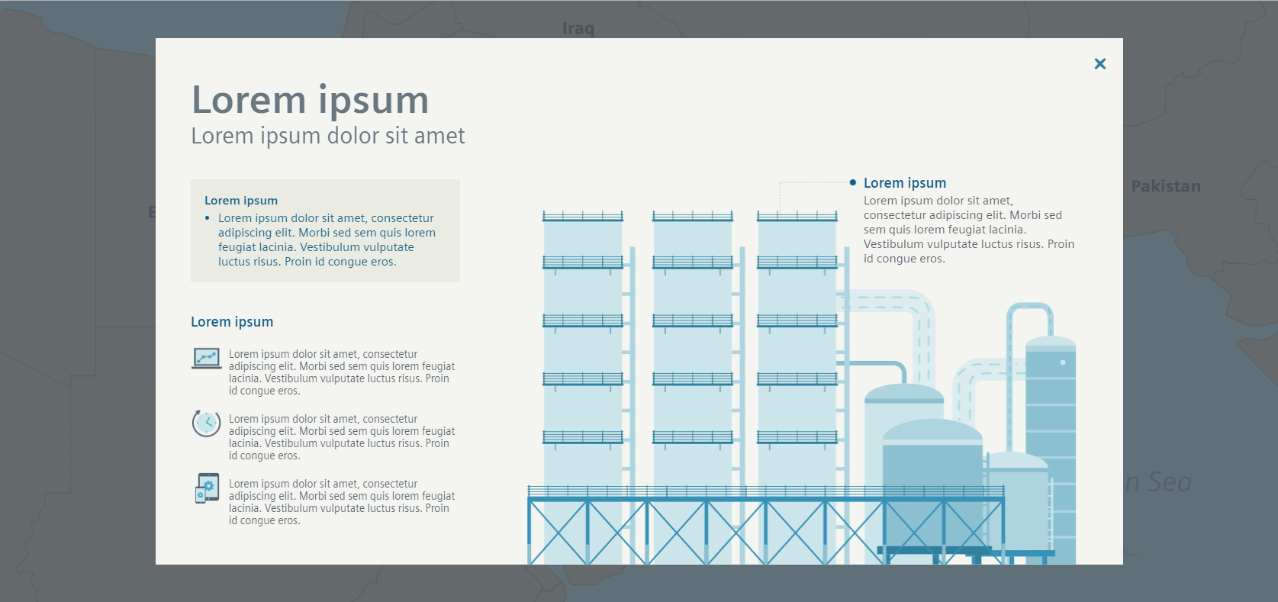

1. On the tablet and mobile version the map should change, according with the images that can be found in the assets folder. Note: Mobile map contain static waves, the gifs should be removed.

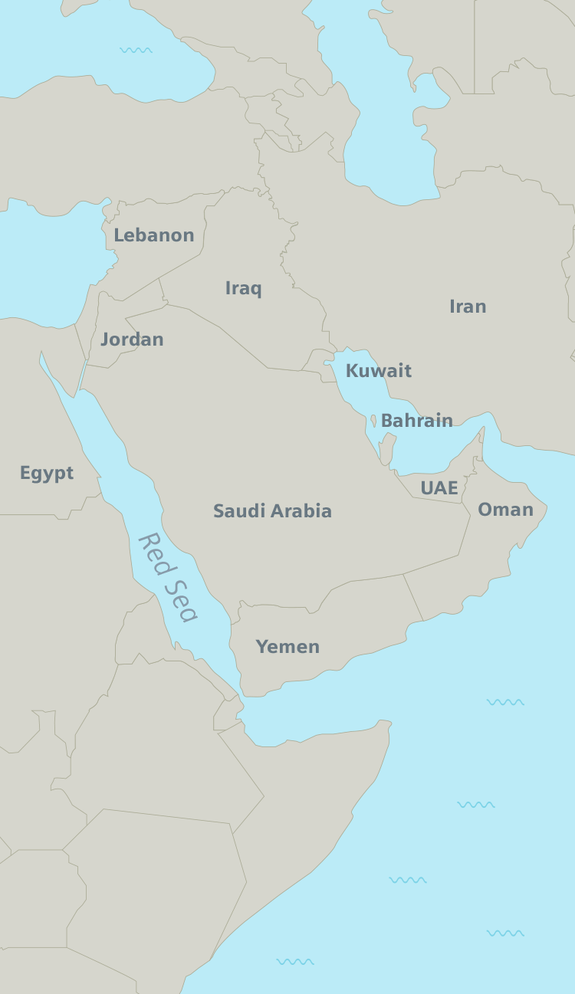

1. On the mobile version the content should be adjusted as the mobile-example video. The font color should be kept and the size can be defined according the developer. The pop-up main gif should be changed to an equivalent static image(mobile folder).

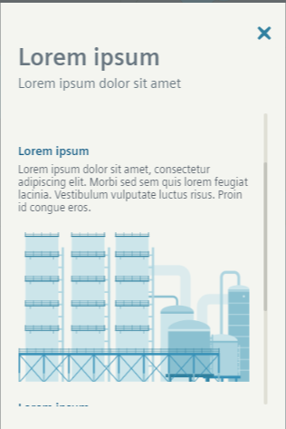

1. The content of the pop-ups must be loaded by a JSON file. The structure of the JSON can be found on the attached files.

**What should be delivered:**

• Project structure according to the developer preference.

• Infographic following all instructions and behaviors.

• Git organized with clear commits and README file.