Software Design Document

For

**Booking System**

**Version 1.0 approved**

**Prepared by B10815044 Hsieh, Jun-Yao**

**B10815054 Huang, Chen-En**

**B10815058 Pu, Chi-Hao**

**B10815057 Liao, Sheng-Hao**

**NTUST-SE-G8**

目錄

1. Introduction 1

I. Purpose 1

II. Scope 1

III. Overview 1

IV. Definition, Acronyms and Abbreviations 1

V. References 2

2. System Overview 2

3. System Architecture 3

I. Architectural Design 3

II. Decomposition Description 3

III. Design Rationale 7

4. Data Design 7

I. Data Description 7

II. Data Dictionary 8

5. Component Design 9

I. Book System 9

II. DataBase API 10

III. User Interface 12

IV. Google Calendar API 14

6. Human Interface Design 15

V. Overview of User Interface 15

VI. Screen Images 15

VII. Screen Object and Actions 18

7. Requirement Matrix 25

8. Appendices 27

I. Setup and Configuration 27

II. Tools 27

III. Environment 28

IV. Contribution of Team members 28

Revision History

|  |  |  |  |
| --- | --- | --- | --- |
| Name | Data | Reason for Change | Version |
| Draft | 2021/12/29 | First version | 1.0 |

# Introduction

## Purpose

The Software Design Document is a document that is supposed to provide documentation which will be used to focus on software development by providing the details for how the software should be built. Within the Software Design Document are narrative and graphical documentation of the software design for the project including use case models, sequence diagrams, collaboration models, object behavior models, and other supporting requirement information.

## Scope

This document is intended to give a detailed technical description of the Book System software project. It specifies the structure and design of some of the modules discussed in the SRS. It also displays some of the use cases that had transformed into sequential and activity diagrams. The class diagrams show how the programming team would implement the specific module.

## Overview

This document is written according to the “[SDDTemplate](https://moodle.ntust.edu.tw/mod/resource/view.php?id=428573)”.

Sections 3 – 5 contain discussions of the designs for the project with diagrams, section 6 shows samples of UI from the system, and section 7 contains the class diagrams.

The appendices contain the setup and configuration needed for the Book System, a list of tools and environment used in the entire project, along with the time contribution of team members.

## Definition, Acronyms and Abbreviations

|  |  |
| --- | --- |
| Term | Definition |
| API | Abbreviation of Application Interfaces |
| UI | Abbreviation of User Interface |
| Database | It’s a system that is used to save data |
| MySQL | One of SQL databases |
| User | Normal user can raise or modify a meeting, but can’t create meeting rooms |
| Manager | Manager is one of users, but the manager can create or delete meeting room |
| Room | Corresponds to the space where the entity exists, so only one event can exist at the same time |
| Event | Corresponding to a period of time, may be meetings, teaching activities, etc.. |
| Attendee | Participants of the meeting, save email address to send notification |
| FRP | Fast Reverse Proxy |

## References

* [example_design_SDD](https://moodle.ntust.edu.tw/mod/resource/view.php?id=428572)
* [SDDTemplate](https://moodle.ntust.edu.tw/mod/resource/view.php?id=428573)
* [Software Design Document](https://classes.engineering.wustl.edu/ese497/images/9/96/2004Schalk_BCI2000Implementation.pdf)
* [Software Design Document, Testing, and Deployment and Configuration Management](https://arxiv.org/ftp/arxiv/papers/1005/1005.0595.pdf)

# System Overview

Give a general description of the functionality, context and design of the Book System. In order to make the system as flexible as possible, the system is divided into 4 parts: Main system, UI, Database, Google calendar. So that we can explicitly know which part is responsible for who, and also it’s easier to debug.

# System Architecture

## Architectural Design

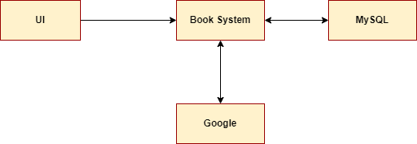

## Decomposition Description

Take modify event function to make a example:

User trigger the modify event function, the BooksystemUI send request to BookInterface, then BookInterface received the request, contact BookSystem to modify, Booksystem find the meeting room and designated event, and the Event class modity event, return the new event to Booksystem and return to BookInterface after modification, and the BooksystemUI display the new event.

**Object diagrams**

* **BookSystem**

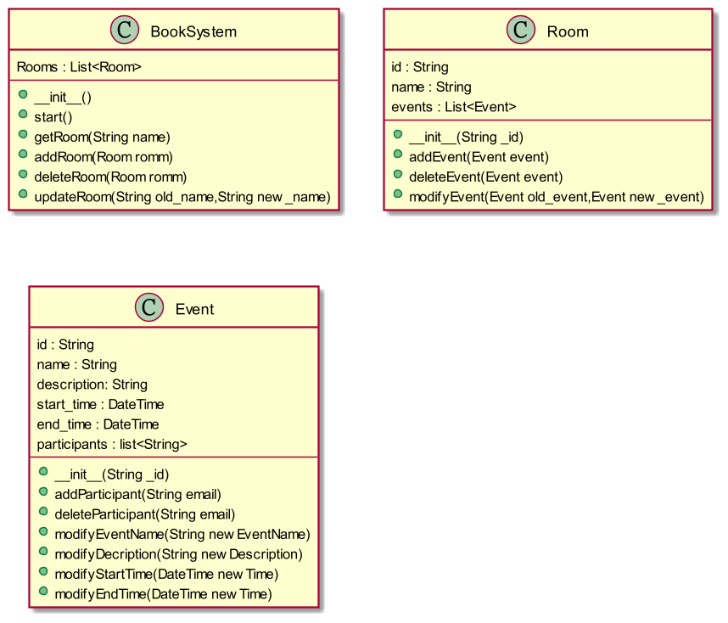

* **DataBase**

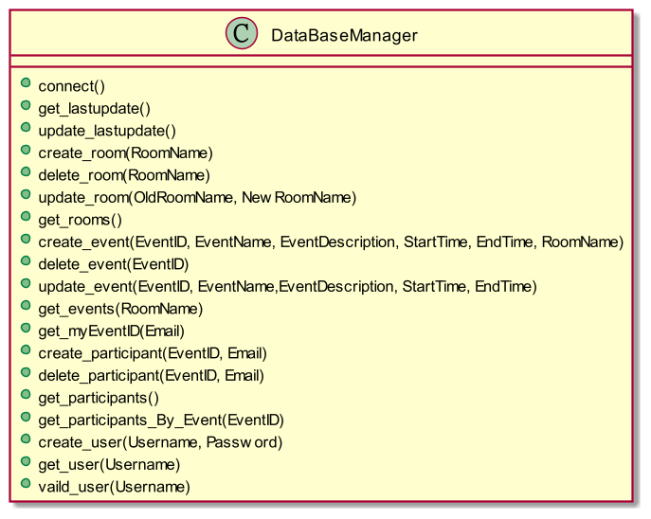

* **UI**

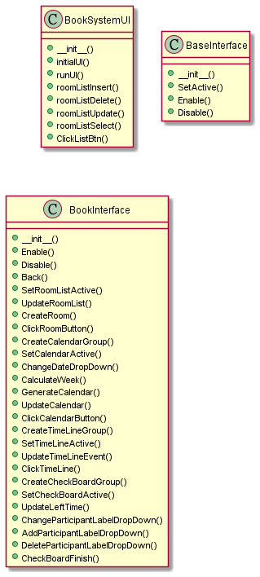

* **Google Calendar API**

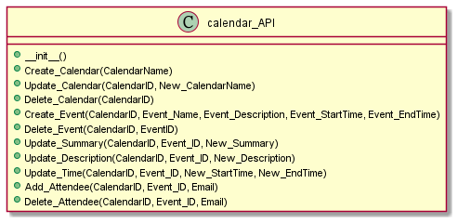

**Sequence diagram**

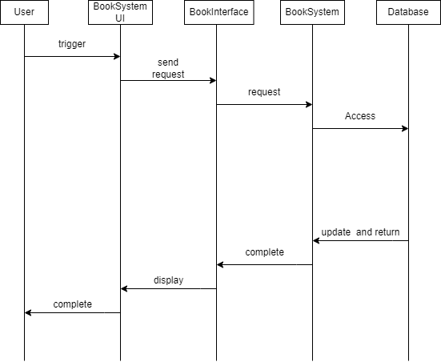

**Structural decomposition diagrams**

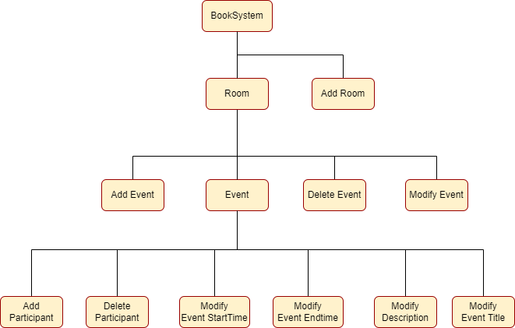

## Design Rationale

We use BookInterface class to be the core of the system, it connect most the class in system because it receive request from user operating UI, and send request to the class in application package, the class in application package will complete the request and send back to BookInterface class, then BookInterface send the consequence to BookSystemUI.

We make one class to be the core of the system instead of a separate system, because there are many functional requirements in the system, so it needs to have one central class to contact the other functional class.

# Data Design

## Data Description

The system uses MySQL as database and MySQL Connector for python to communicate with the database.

* **Rooms**: is used to store meeting rooms, RoomID is a serial number of Google Calendar’s calendar, RoomName is the meeting room’s name that shows in the UI.
* **Events**: is used to store meeting’s information, RoomID is a serial number of Google Calendar’s event, RoomName is used to search, others are regular records for the meeting.
* **Participants:** is used to store participant’s information, EventID is for searching, Email is user’s identification.
* **Users: i**s used to store user’s information.
* **Synchronize:** is used to Synchronize Main system and Database, the LastUpdate is used to check the last change’s time.

## Data Dictionary

|  |  |  |  |  |
| --- | --- | --- | --- | --- |
|  | **Field** | **Type** | **Null** | **Default** |
| **Rooms** | RoomID | varchar(60) | No |  |
|  | RoomName | varchar(20) | No |  |
|  |  |  |  |  |
| **Events** | EventID | varchar(30) | No |  |
|  | EventName | varchar(20) | No |  |
|  | EventDescription | varchar(400) | Yes | NULL |
|  | StartTime | datetime | No |  |
|  | EndTime | datetime | No |  |
|  | RoomName | varchar(20) | No |  |
|  |  |  |  |  |
| **Participants** | EventID | varchar(30) | No |  |
|  | Email | varchar(40) | No |  |
|  |  |  |  |  |
| **Users** | UserName | varchar(40) |  |  |
|  | Password | varchar(100) |  |  |
|  |  |  |  |  |
| **Synchronize** | LastUpdate | datetime | No | CurrentTimeStamp |
|  |  |  |  |  |

# Component Design

## Book System

**BookSystem**

|  |  |
| --- | --- |
| **Function** | **Description** |
| __init__ | Construct all needed member |
| start | Start the booksystem |
| update | Update all data from database |
| check_db_update | Check if need update then act |
| getRoom(name) | Return room by room’s name |
| getRoomById(id) | Return room by room’s id (google calendar generate) |
| getRoomEvents(room_name) | Return all event from room by room’s name |
| addRoom(room) | Add a room to system |
| deleteRoom(room) | Delete a room from system |
| updateRoom(old_name,new_name) | Update a room from system |
| addParticipant(email) | Add participant to global participant pool |
| getUserEvents(CurrentUser) | Get an user’s all event from database |
| garbage_event_collection | Delete past events |

**Room**

|  |  |
| --- | --- |
| **Function** | **Description** |
| addEvent(event) | add an event to room |
| deleteEvent(event) | delete an event from room |
| updateEvent(new_event) | update an event from room |
| getEvent(name) | return event by event’s name |
| getEventById(id) | return event by event’s id |
| getEventParticipant(event_id) | get all participant from an event |
| exist() | check if this room exist in database |

**Event**

|  |  |
| --- | --- |
| **Function** | **Description** |
| update_participants(_participants) | update participants to new participants |
| update(new_event) | update event info to new event |
| in_event(email) | check if email is one of participants |
| exist() | check if this event exist in database |

## DataBase API

|  |  |
| --- | --- |
| **Function** | **Description** |
| connect() | Initialize and connect to Database |
| get_lastupdate() | Get system’s last update time |
| update_lastupdate() | If data modify will call to update the last update time |
| create_room(RoomName) | Add a room record to the database |
| delete_room(RoomName) | Delete Room from the database |
| update_room(OldRoomName, NewRoomName) | Update RoomName from OldRoomName to NewRoomName |
| get_rooms() | Search and return all of rooms |
| create_event(EventID, EventName, EventDescription, StartTime, EndTime, RoomName) | Add a Event record to the database |
| delete_event(EventID) | Delete event from the database |
| update_event(EventID, EventName,EventDescription, StartTime, EndTime) | Update Event’s information with new values |
| get_events(RoomName) | Get all of rooms from specific room |
| get_myEventID(Email) | Get all of event’s by Email |
| create_participant(EventID, Email) | Add a participant to specific event |
| delete_participant(EventID, Email) | Delete a participant from specific event |
| get_participants() | Get all of participants from all of events |
| get_participants_By_Event(EventID) | Get all of participants from specific event |
| create_user(Username, Password) | Register an user to the Book System |
| get_user(Username) | Check whether user has already registered or not |
| vaild_user(Username) | Return user’s password to match user’s input |

## User Interface

**BookSystemUI**

|  |  |
| --- | --- |
| __init__(BookSystem) | Construct the UI |
| initial() | Construct GUI window and menu |
| runUI() | Start GUI main loop |
| roomListInsert(name) | Insert a new room name to ListBox |
| roomListDelete(name) | Delete a new room name from ListBox |
| roomListUpdate() | Update a new room name from ListBox |
| roomListSelect(index) | Select an item from ListBox |
| ClickListBtn(_btnNum) | Switch UI canvas |

**BaseInterface**

|  |  |
| --- | --- |
| __init__(_parent) | Construct the canvas |
| SetActive(_value) | Control interface display or off |
| Enable() | Show and setting the interface |
| Disable() | Hide the interface |

**LogInInterface(BaseInterface)**

|  |  |
| --- | --- |
| __init__(_parent,_bookSystem) | Construct the canvas |
| Enable() | Show and setting the interface |
| Disable() | Hide the interface |
| LogInAccount() | Login |
| SignAccount() | Sign an account |

**BookInterface(BaseInterface)**

|  |  |
| --- | --- |
| __init__(_parent,_bookSystem) | Construct the canvas |
| Enable() | Show and setting the interface |
| Disable() | Hide the interface |
| Back() | 退回至上一個介面 |
| UpdateRoomList() | Update the room list |
| CreateRoom() | Create the room button on room list |
| ClickRoomButton(_roomName) | 選擇會議室，並進入日曆介面 |
| ChangeDateDropDown(_mode) | 選擇年份或月份 |
| CalculateWeek(year,month) | 計算目標日期的星期 |
| GenerateCalendar() | Create the calendar |
| UpdateCalendar() | Update the calendar |
| ClickCalendarButton(_day) | 選擇日期，並進入時間軸介面 |
| UpdateTimeLineEvent() | Update the event on timeline |
| ClickTimeLine() | 選擇會議開始時間，並進入預約介面 |
| UpdateLeftTime() | 更新結束時間的list |
| CheckFormat() | 檢查使用者填入的資料格式 |
| CheckBoardFinish() | 完成預約 |

**UsersBookInterface(BaseInterface)**

|  |  |
| --- | --- |
| __init__(_parent,_bookSystem) | Construct the canvas |
| Enable() | Show and setting the interface |
| UpdateEventList() | Update the event list |
| CreateEvent() | Create event label on event list |

## Google Calendar API

|  |  |
| --- | --- |
| **Function** | **Description** |
| __init__() | Construct Google Calendar API service |
| Create_Calendar(CalendarName) | Create a calendar |
| Update_Calendar(CalendarID, New_CalendarName) | Update name of calendar |
| Delete_Calendar(CalendarID) | Delete calendar |
| Create_Event(CalendarID, Event_Name, Event_Description, Event_StartTime, Event_EndTime) | Create an event in calendar |
| Delete_Event(CalendarID, EventID) | Delete event |
| Update_Summary(CalendarID, Event_ID, New_Summary) | Update the summary of event |
| Update_Description(CalendarID, Event_ID, New_Description) | Update the description of event |
| Update_Time(CalendarID, Event_ID, New_StartTime, New_EndTime) | Update the time of event |
| Add_Attendee(CalendarID, Event_ID, Email) | Add attendee into event |
| Delete_Attendee(CalendarID, Event_ID, Email) | Delete attendee from event |

# Human Interface Design

## Overview of User Interface

The system interface will allow users to make reservations, browse all meeting rooms and ongoing events, and book meeting rooms.

The first screen after logging in is the reservation system, which displays a list of meeting rooms, and the reservation process uses a step-by-step approach that allows users to reserve a meeting room correctly.

Users can switch to the appointment interface or view their own events through the list on the left. If the user's login account is an administrator account, there will be an additional administrator option in the list, allowing the administrator to add or remove meeting rooms.

## Screen Images

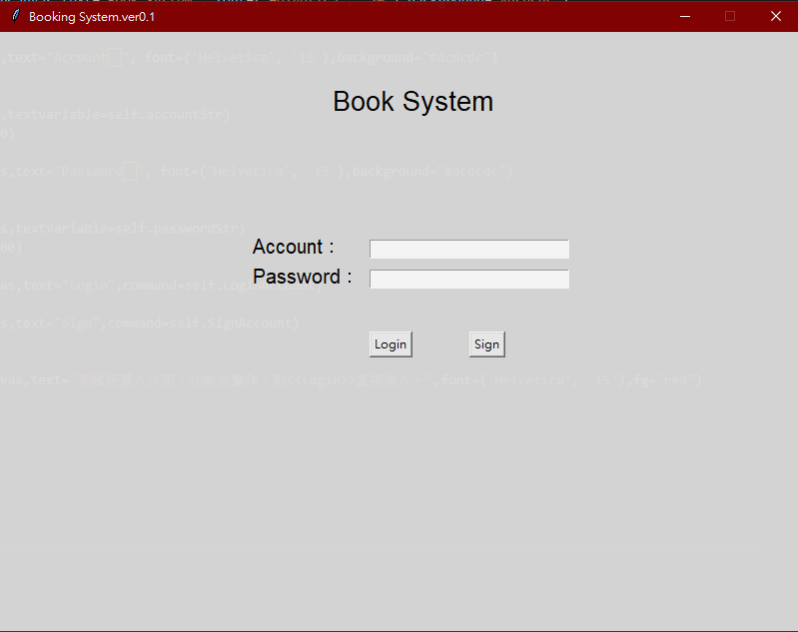

Figure 1.Login UI

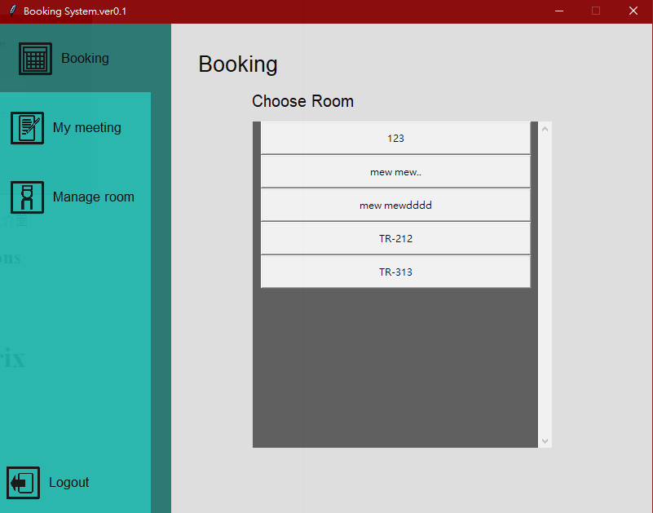

Figure 2. Room List

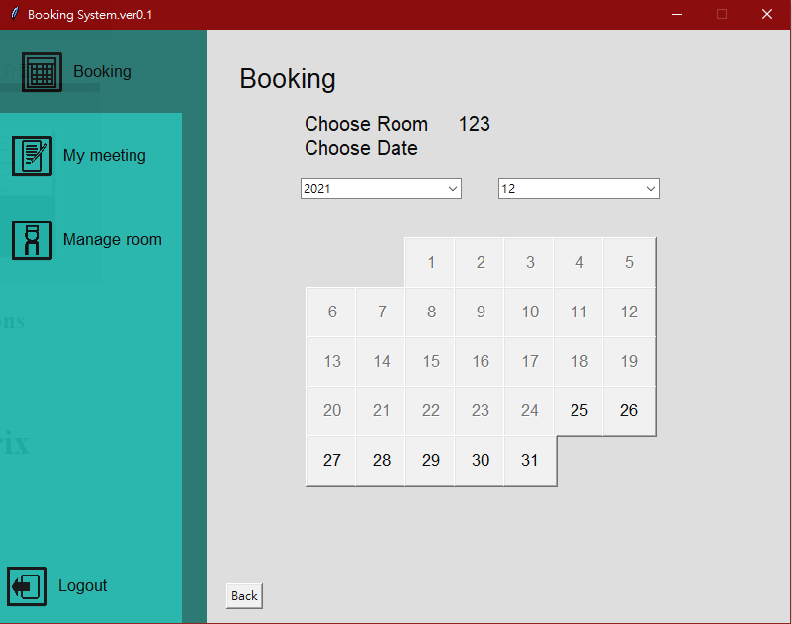

Figure 3. Calendar

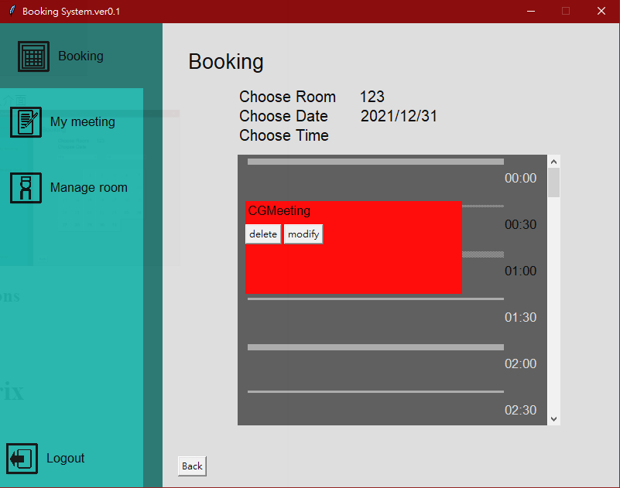

Figure 4. Timeline

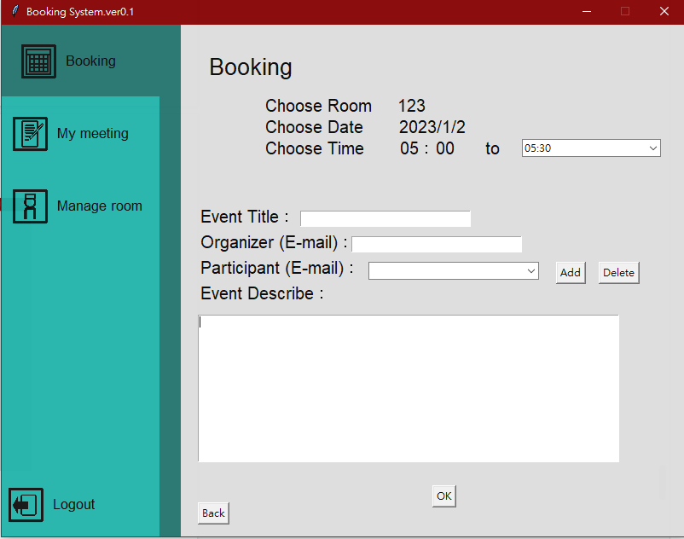

Figure 5. Booking

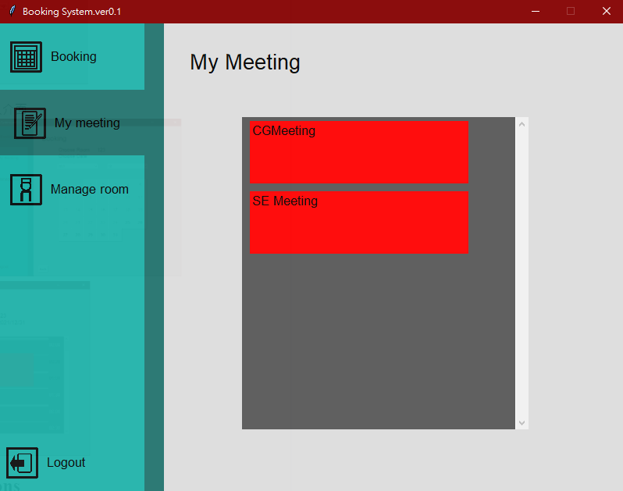

Figure 6. My Meeting

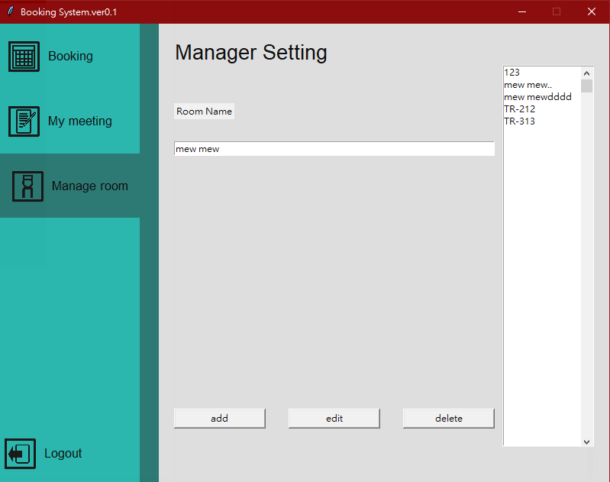

Figure 7. Manager Options

## Screen Object and Actions

1. Login UI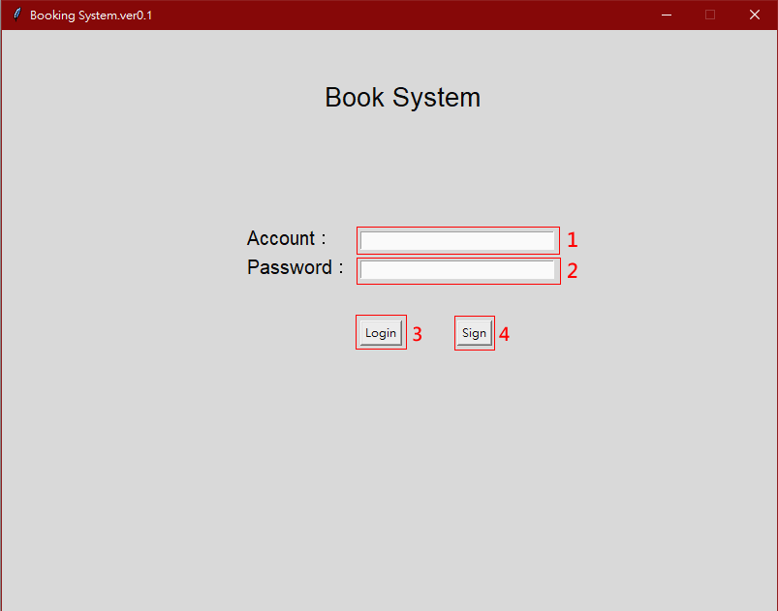

|  |  |
| --- | --- |
| 1.Account | Input Email account to register |
| 2.Password | Input password from the account |
| 3.Login Button | Click to login the system |
| 4.Register Button | Click to register account the system |

1. Initial UI

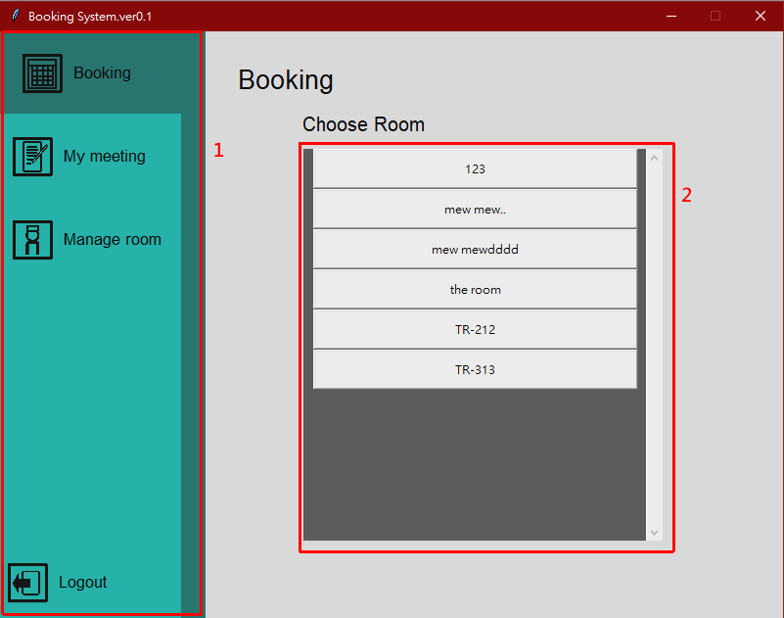

|  |  |
| --- | --- |
| 1. Function list | Through this list, you can switch to other functional interfaces |
| 2. Meeting rooms list | List all available meeting rooms and click on them to enter the reservation process. |

1. 日歷

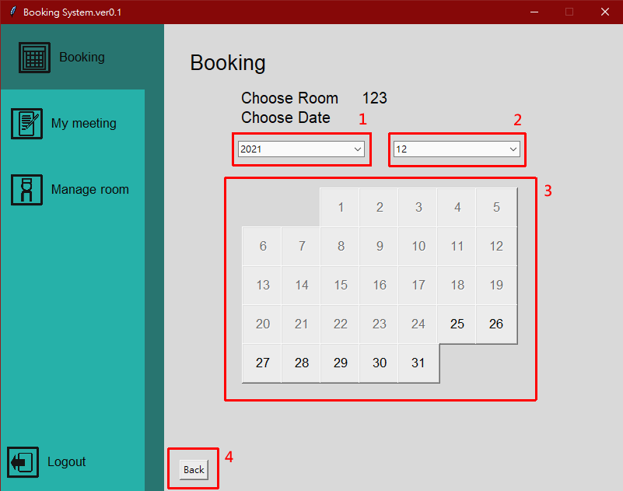

|  |  |
| --- | --- |
| 1. Dropdown(year) | Click to select the year you want to reserve |
| 2. Dropdown(Month) | Click to select the month you want to reserve |
| 3. Calendar | Click to select the date you want to reserve |
| 4. Back button | Back to previous UI |

1. Events Timeline

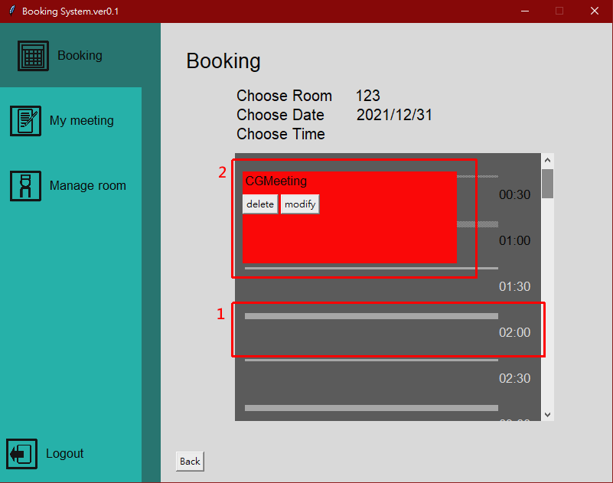

|  |  |
| --- | --- |
| 1. Timeline | Click to select the meeting start time |
| 2. EventStamp | Timelines that have already been booked will be covered by this red mark and can be modified or deleted if the owner of the event is the owner. |

1. Information of Meeting room

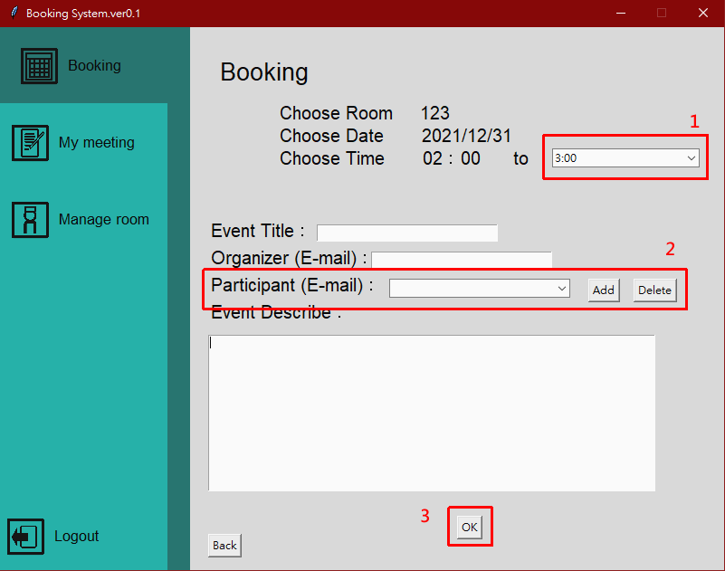

|  |  |
| --- | --- |
| 1. Dropdown(End time) | Click to select the end time of the meeting |
| 2. Participant | After entering the e-mail address of the participant in the left column, you can add the participant through the Add button, or click the drop-down list to select an existing participant and press Delete to remove it. |
| 3. OK button | Click to confirm change |

1. My meeting

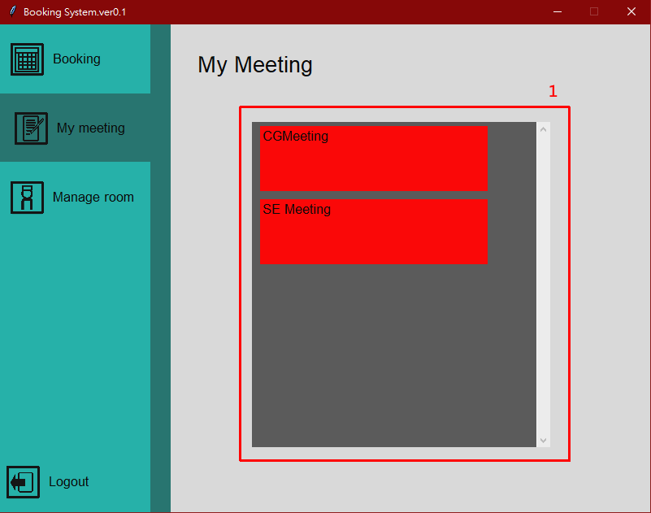

|  |  |
| --- | --- |
| 1. Event list | List events that the user owns or participates in |

1. Manage room

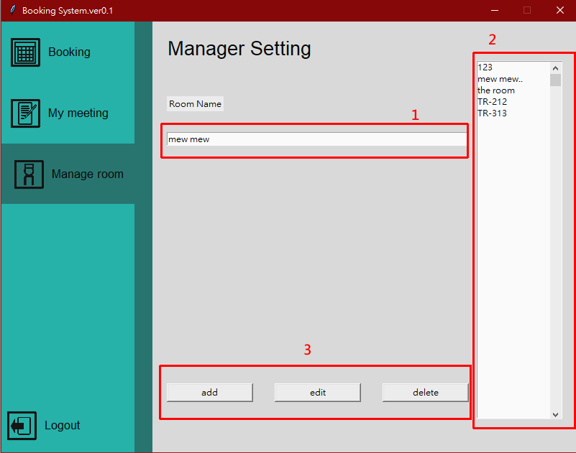

|  |  |
| --- | --- |
| 1. Room Name | Enter the name of the room you want to add or modify. |
| 2. Room list | Show all of rooms |
| 3. Change Options | Click on the three buttons below to add, modify the name, and remove actions respectively |

# Requirement Matrix

|  |  |  |  |
| --- | --- | --- | --- |
| **ID** | **functional**  **requirement name** | **Functional requirement description** | **Corresponding Function that implemented in system** |
| 1 | Create meeting room | Create a meeting room in database | BookSystem.addroom(Room room)  in application package |
| 2 | Create Meeting | create a upcoming meeting in the meeting room | Room.addEvent(Event event)  in application package |
| 3 | Update Meeting Title | modify the title of the meeting that already existed in meeting room | Room.modifyEvent(Event old_event,Event new_event)  Event.modifyEventName(String new EventName)  in application package |
| 4 | Update Meeting Description | modify the description of the meeting that already existed in meeting room | Room.modifyEvent(Event old_event,Event new_event)  Event.modifyDescription(String new Description)  in application package |
| 5 | Update Meeting Time | modify the time of the meeting that already existed in meeting room | Room.modifyEvent(Event old_event,Event new_event)  Event.modifyStartTime(DateTime new Time)  Event.modifyEndTime(DateTime new Time)  in application package |
| 6 | Add Attendee | Add participant into the meeting that already existed in meeting room | Room.modifyEvent(Event old_event,Event new_event)  Event.addParticipant(String email)  in application package |
| 7 | Remove Attendee | Remove the participant from the meeting that already existed in meeting room | Room.modifyEvent(Event old_event,Event new_event)  Event.deleteParticipant(String email)  in application package |
| 8 | Delete Meeting | Remove the meeting that already existed in meeting room | Room.deleteEvent(Event event)  in application package |
| 9 | Delete Meeting Room | Delete the Meeting Room | Booksystem.deleteRoom(Room room)  in application package |
| 10 | Update meeting room name | modify the name of the meeting room that already existed | BookSystem.updateRoom(String old_name,String new_name)  in application package |

# Appendices

## Setup and Configuration

* 1. **MySQL**
     1. Create a database for the system
     2. Add Manager to manage the Database
     3. Create Tables to store data
     4. Create some rules for data management
  2. **FRP**
     1. Because we don’t static IP address for server, so we need to access the service through FRP
     2. Need to find a server to activate the offer the service
     3. Use a local computer as DB server

## Tools

* [Git](https://git-scm.com/downloads)
* [GitHub Desktop](https://desktop.github.com/) :Not Required, but recommended
* [Visual Studio Code](https://code.visualstudio.com/): Not Required, but recommended
* [Google Calendar API](https://developers.google.com/calendar/api/v3/reference/events/delete)
* [MySQL](https://www.w3schools.com/python/python_mysql_getstarted.asp)

## Environment

* Windows 10 or above
* Python 3.7

## Contribution of Team members

|  |  |
| --- | --- |
| **Hsieh, Jun-Yao**  **(Project Manager)**  **(Developer)** | 1. Meeting Host 2. Documents Management 3. Develop and Manage Database 4. Help to develop the main system 5. System Test 6. Job assignment and coordinate |
| **Huang, Chen-En**  **(Developer)** | 1. Google Calendar API interface  2. Functional requirement implement  3. Technical writer |
| **Pu, Chi-Hao**  **(Art)**  **(Developer)** | 1. GUI design 2. Technical writer 3. System tester |
| **Liao, Sheng-Hao**  **(Program Manager)**  **(Developer)** | 1. Core component design 2. Core component implement 3. Run & Build manual writer 4. Google account provider 5. Technical writer 6. System tester |