High Dynamic Range Imaging

# Image alignment (Bonus)

Even though tripod can be used to anti-shake physically, but it’s still not perfect. So, we can use software to compensate image unaligned. In order to make sure our sampling point in different exposures can be at same point. Our aligned method base on Ward’s MTB algorithm, then I increased the layers from 6 to 8, because pictures that take from camera nowadays are high resolution, the origin method can only shift 2^5+1 pixel at most, it’s not enough for the present.

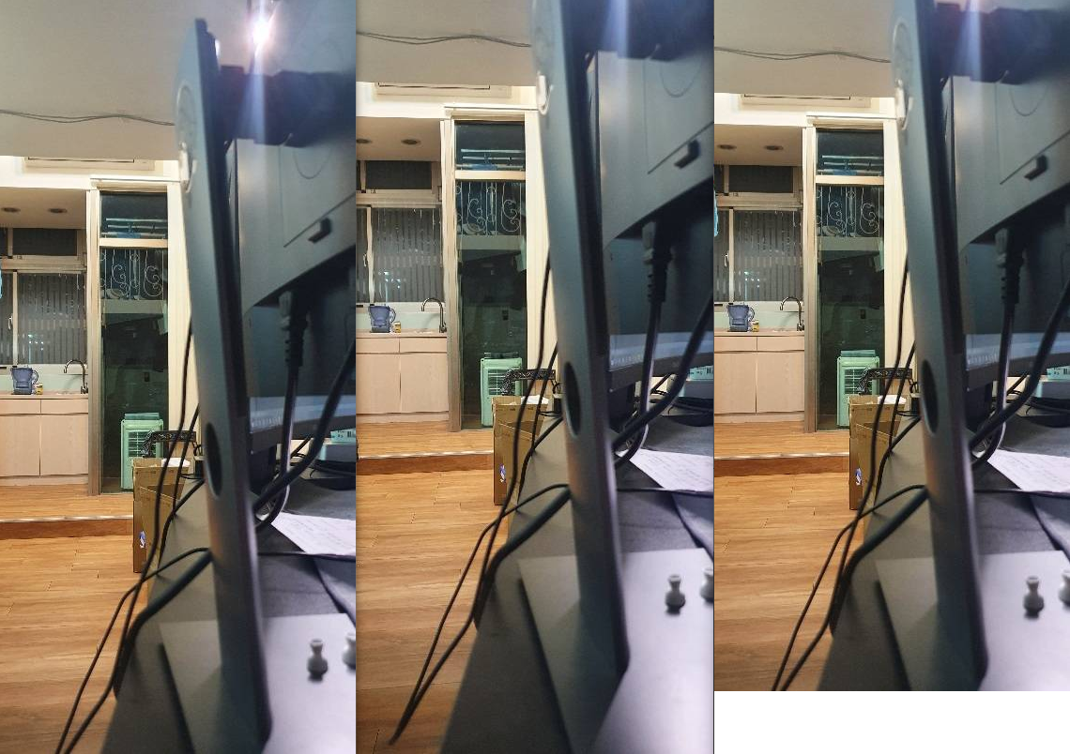

1) Left (Origin) Middle (Target) Right (Aligned)

# Recovering High Dynamic Range Radiance Maps from Photographs

I referred to the paper that proposed by Paul E. Debevec and Jitendra Malik, and implemented the algorithm provided in the paper to recover the Response curve.

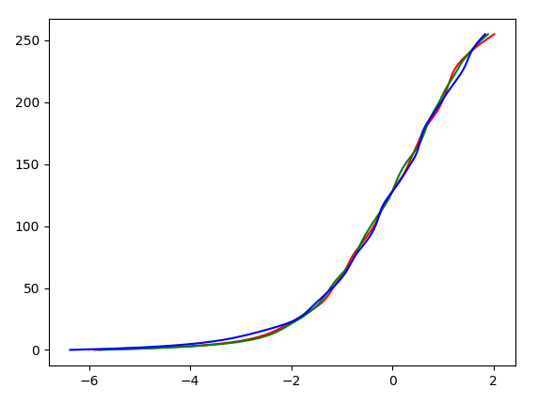

2) Response Curve we got

# Tone-mapping (Bonus)

The way human sees colors is nonlinear, thus we need to use tone-mapping to make colors closer to the way that human eyes process. I used Photographic to approach this, but I only implemented global operation.

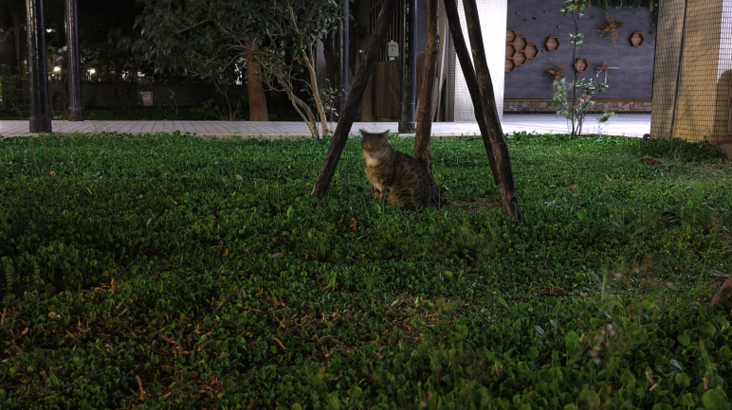

3) Result image

# What did I learn from the project?

1. I learned some coding skills in python because before I did the project, I wasn’t familiar with it especially for matrix computation, thus in the beginning I had many serious efficiency issues, but I am much better with python now.
2. I learned a clear concept of image process pipeline (From camera to display).

# References

* Greg Ward, [Fast, Robust Image Registration for Compositing High Dynamic Range Photographs from Handheld Exposures](https://www.csie.ntu.edu.tw/~cyy/courses/vfx/papers/Ward2003FRI.pdf), SIGGRAPH 2003.
* Paul E. Debevec, Jitendra Malik, [Recovering High Dynamic Range Radiance Maps from Photographs](https://www.csie.ntu.edu.tw/~cyy/courses/vfx/papers/Debevec1997RHD.pdf), SIGGRAPH 1997.
* Erik Reinhard, Michael Stark, Peter Shirley, Jim Ferwerda, [Photographics Tone Reproduction for Digital Images](https://www.csie.ntu.edu.tw/~cyy/courses/vfx/papers/Reinhard2002PTR.pdf), SIGGRAPH 2002.