Title

Multiple Smart Adapter Plugs

By

Brenn Ahren C. Hong

Category

Automation

**Introduction**

In homes or offices, there are wall power outlets that are not easily accessible. These outlets either may need a ladder to reach or are behind large obstructive objects like tables and sofas. However, usually the things that are plugged into these outlets normally don’t require unplugging by a person, may this be an electric fan, router, or extension cord. Nevertheless, there may still be moments or situations where we need to turn these off without having to do painstaking procedures in order to reach these outlets. Thus, this project aims to have a wireless way to restrict the flow of electricity from the power outlet onto the object it is plugged into through a smart adapter plug.

**Objectives**

* Create a configurable smart adapter that can restrict electricity flow
* Allow the adapter to be configured wirelessly via RFID
* Allow the adapter to be configured wirelessly via WIFI

**Project Description**

**Wifi Module**

The Wi-Fi module will allow wireless transmission which can be access from a device such as a computer or a phone.

**RFID Module**

The RFID module will allow RFID devices to interact with the device.

**Arduino**

The Arduino will be the brain and the main component in controlling and connecting all the different modules in the project.

**Relay Module**

The Relay Module will be the switch to allow and restrict the flow of current from flowing from the outlet.

Outlet

This where the Relay will be installed to control the flow of the current through WI-FI or RFID.

The Smart Adapter Plug is meant to allow users to restrict electricity from objects connected to an outlet remotely without the need to make physical contact.

**Block Diagram**

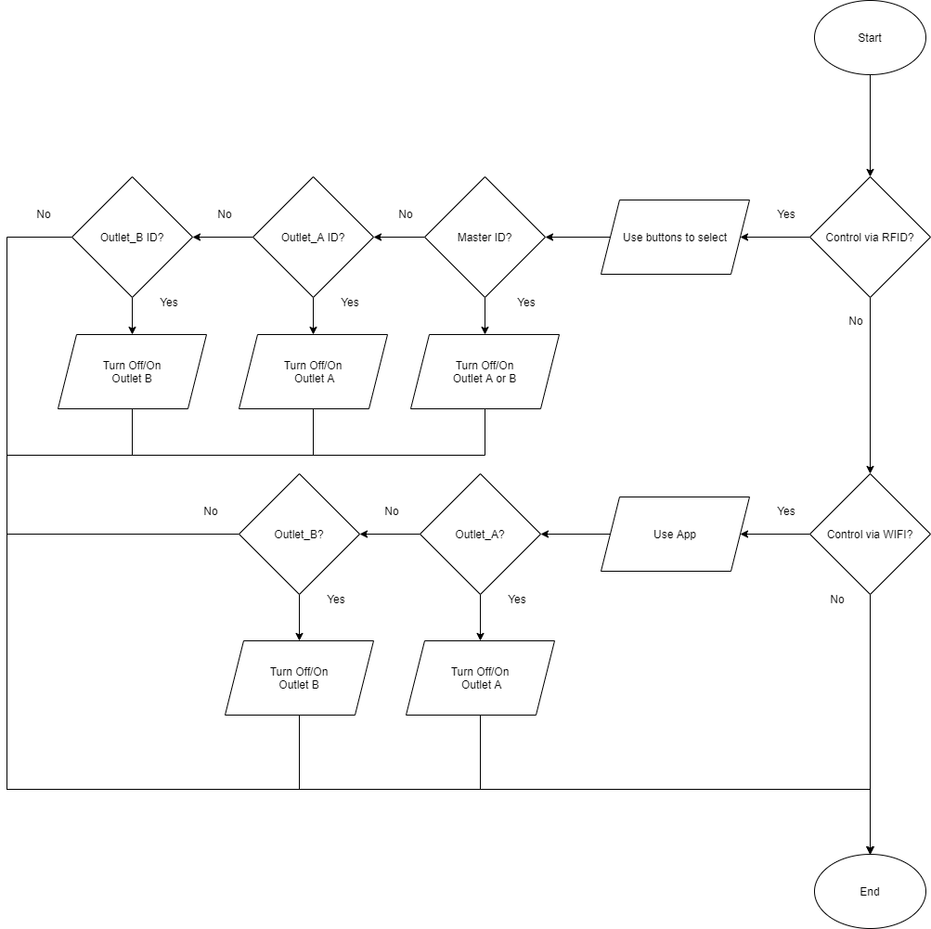Flow Chart

**Process Flow Explanation**

The program will start by checking if the user will be controlling via RFID or WIFI. If the user chooses RFID, they will need to pick which outlet to control and press the corresponding button and RFID card. The Master ID allows you to turn either outlet on and off. The Outlet A ID only allows control to Outlet A. The Outlet B ID only allows control to Outlet B. On the other hand, the WIFI only allows two options either to turn off or on Outlet A or Outlet B given it is much faster and easier to control using a digital interface.

**Scope and Delimitations**

The project will be limited to allowing the user to restrict the flow of the current and to be wirelessly controlled through either WIFI or RFID but not both at the same time.

**Findings**

The outlets could be remotely controlled via Wi-Fi and can also be controlled using RFID devices. However, it is more difficult to attempt to have both as an option at the same time since the WI-FI module needs to send data to the online server constantly regarding the state of the outlet if it is altered via RFID. Furthermore, the RFID module used had to be soldered as it could not work properly if it has loose pins on it’s input ports.

**Recommendations**

It is recommended to explore how to keep the data between the RFID and WI-FI modules to be in sync in order to have both available at the same time.

**Conclusion**

The project was a success despite not being able to control both at the same time given that it would cause a loss of synchronization between the WI-FI module and the present state of the outlets. Thus, there should be other methods that can overcome the problem to solve the synchronization issue.

**References**

https://lastminuteengineers.com/how-rfid-works-rc522-arduino-tutorial/

https://www.circuitbasics.com/build-an-arduino-controlled-power-outlet/

https://www.youtube.com/watch?v=X4gnZJsQ2aY