1. 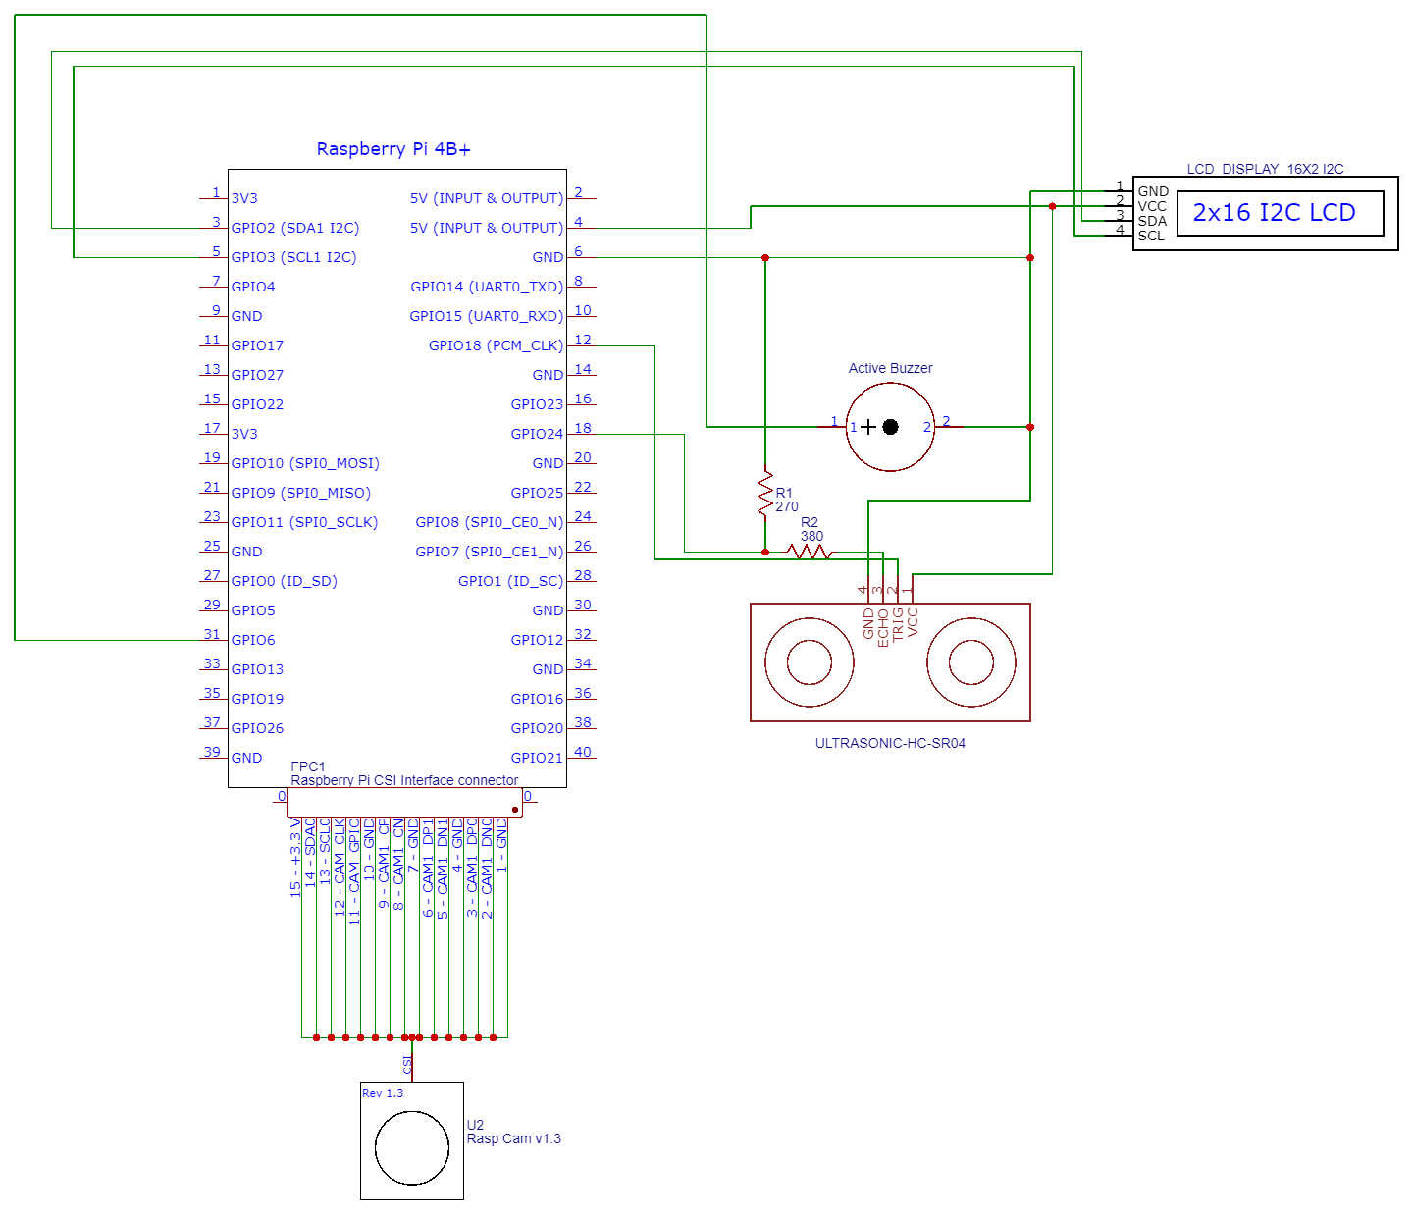Schematic Diagram
2. **Hardware Requirements & Bill of Materials**

Raspberry Pi Camera V1.3 – Php 899.00

Ultrasonic Sensor Distance Measuring Module (HC-SR04) – Php 49.00

Raspberry Pi 4 4B Metal Case with Dual Cooling Fan – Php 400.00

Total Cost

Php 1348.00

1. **Software Requirement**

* Telepot
* Telegram

1. **Project Design**

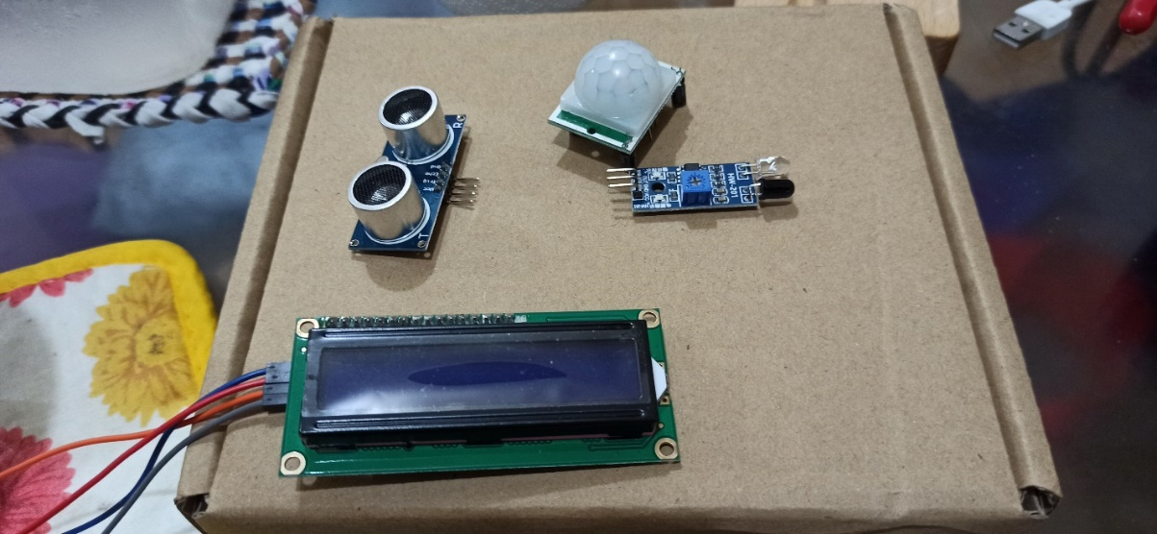

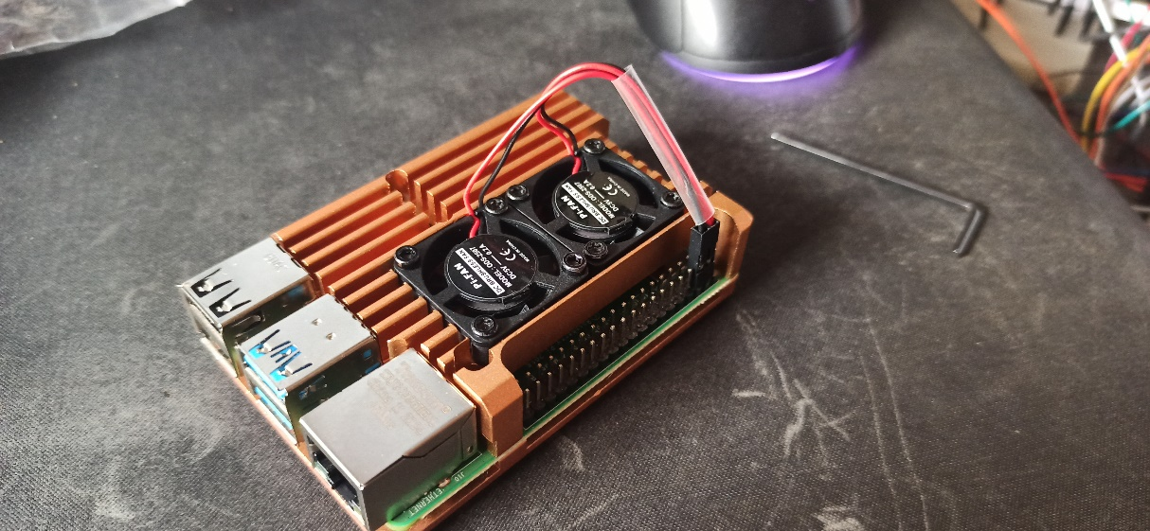

1. **Project Progress Documentation**
   1. 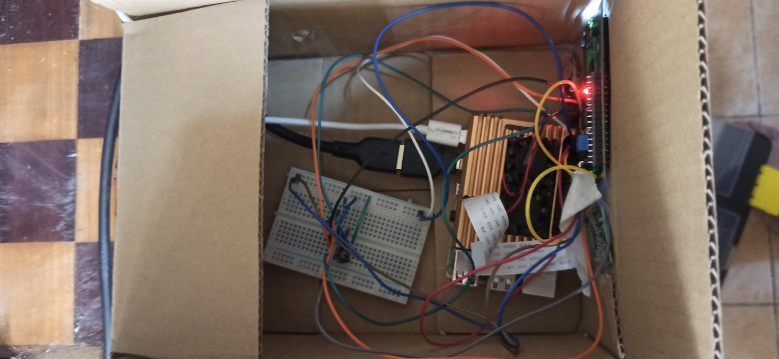**Project Creation**

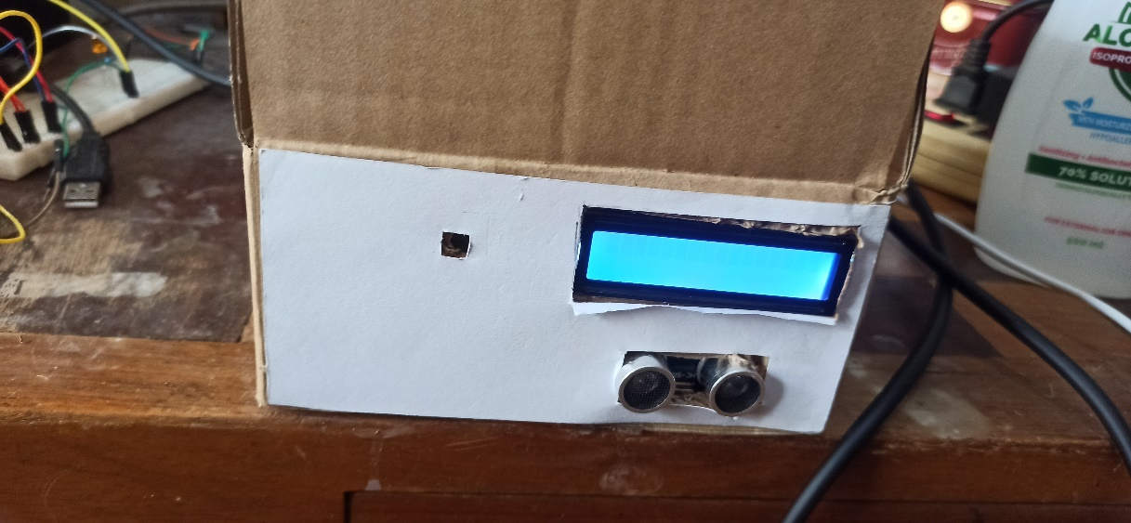

* 1. 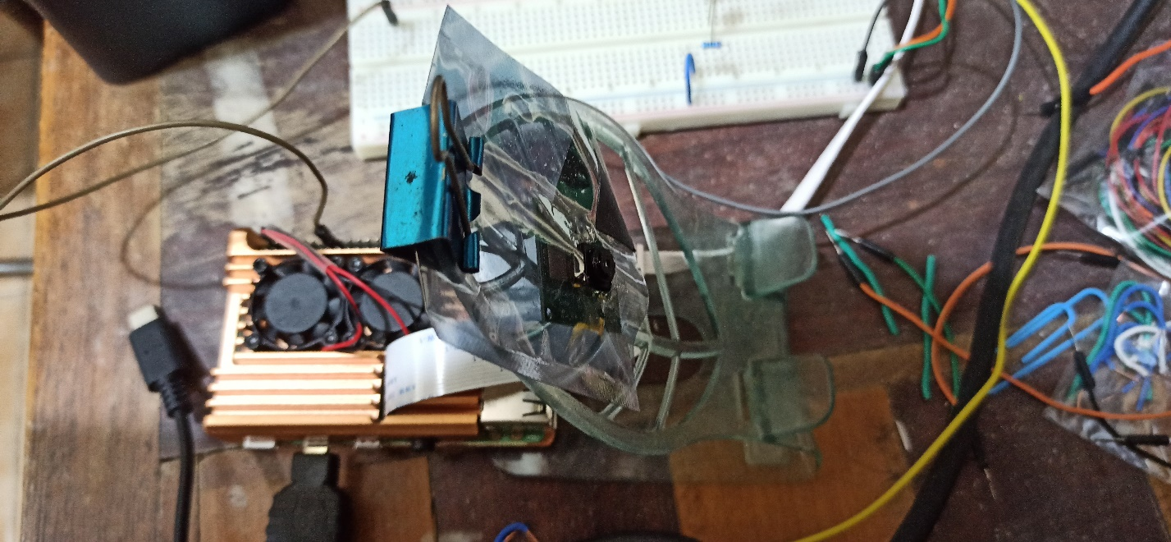**Testing and Debugging**

* 1. **Graphical user interface, application

     Description automatically generatedFinished Project**

