“LED BLINK”

1/29/2022

Brenn Ahren C. Hong

**Procedure**

1. Setup hardware and wiring.
2. Copy code given.
3. Run program.

**Materials**

* Raspberry PI 4
* Breadboard
* Jumper Wires
* LED
* Resistor

**Schematic Diagram**

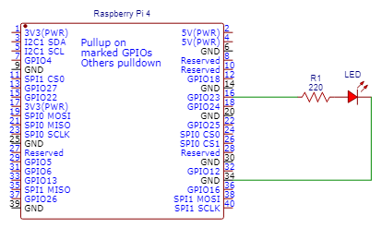

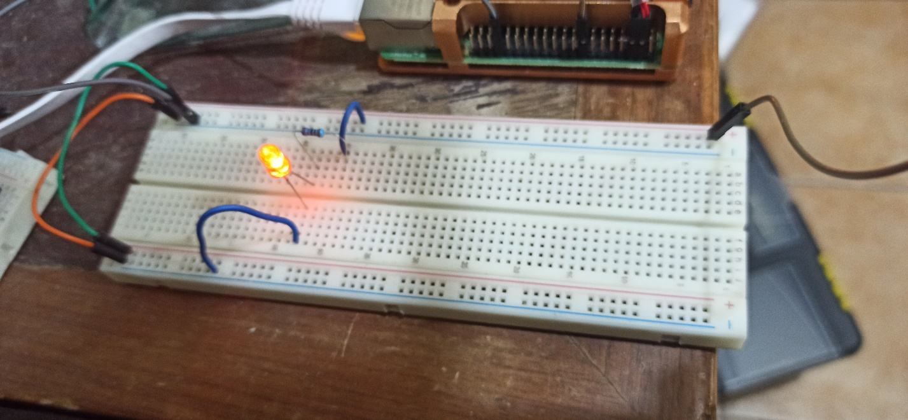**Activity Illustration**

**Observation**

I observed that coding the LED is similar to Arduino, there almost exactly no difference aside from the programming language when coding the LED to turn on and off in sequence.

**Conclusion**

The Raspberry Pi is not so different compared to other programmable microcontrollers.