“PUSH BUTTON CONTROLLED LED”

2/20/2022

Brenn Ahren C. Hong

**Procedure**

1. Setup hardware and wiring.
2. Copy the code.
3. Run program.

**Materials**

* Raspberry PI 4
* Breadboard
* Jumper Wires
* LED
* Push Button
* Resistors

**Schematic Diagram**

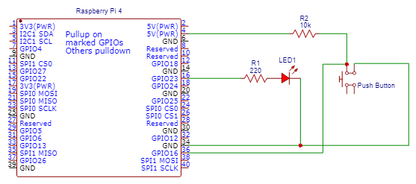

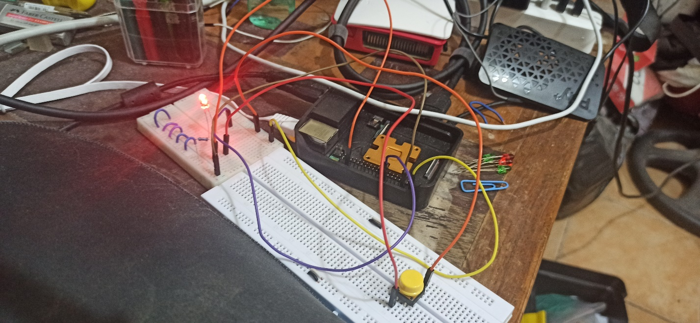**Activity Illustration**

**Observation**

The Push Button is the same as well compared to the Arduino.

**Conclusion**

Push button implementation can be easily done on the Raspberry Pi.