“SEQUENTIAL LEDS”

2/20/2022

Brenn Ahren C. Hong

**Procedure**

1. Setup hardware and wiring.
2. Code the program.
3. Run program.

**Materials**

* Raspberry PI 4
* Breadboard
* Jumper Wires
* LEDs
* Push Buttons
* Resistors

**Schematic Diagram**

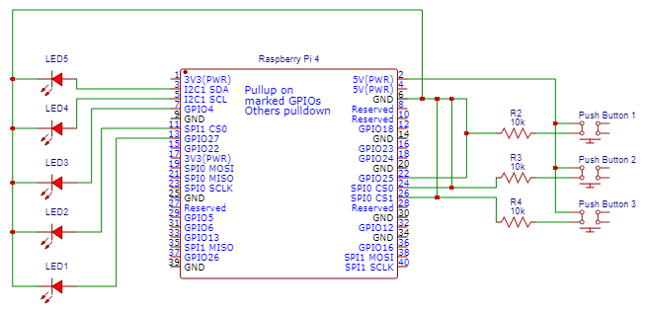

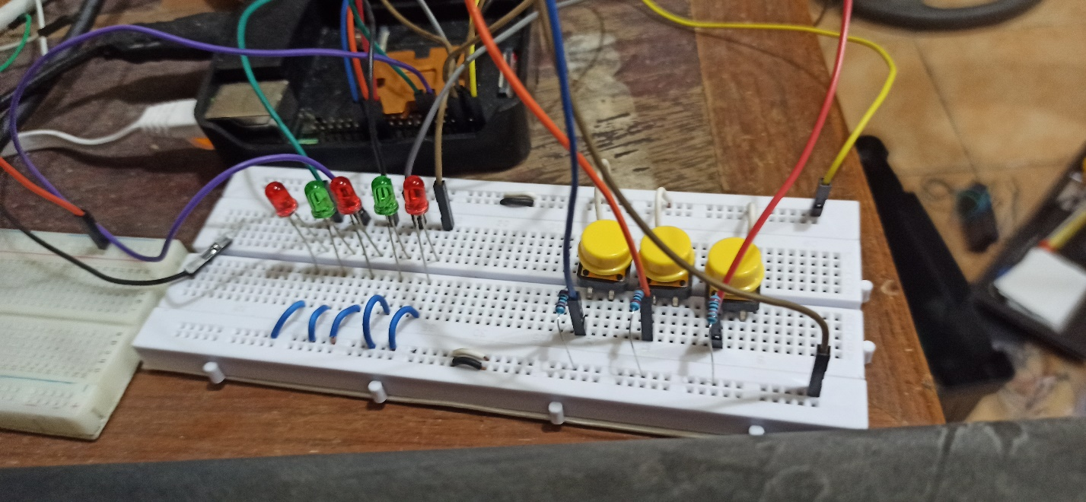**Activity Illustration**

**Observation**

The Raspberry Pi allows the ability to do complex circuits with LEDs and push buttons.

**Conclusion**

The Raspberry Pi is not limited to simple functionalities.