“SEVEN SEGMENT DISPLAY”

2/20/2022

Brenn Ahren C. Hong

**Procedure**

1. Setup hardware and wiring.
2. Code the program.
3. Run program.

**Materials**

* Raspberry PI 4
* Breadboard
* Jumper Wires
* Seven-Segment Display
* Resistors

**Schematic Diagram**

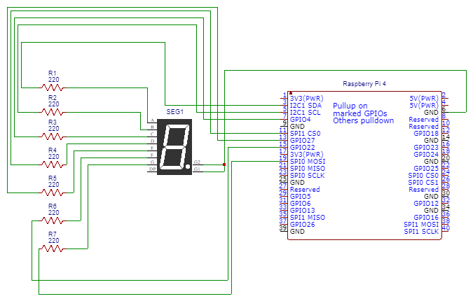

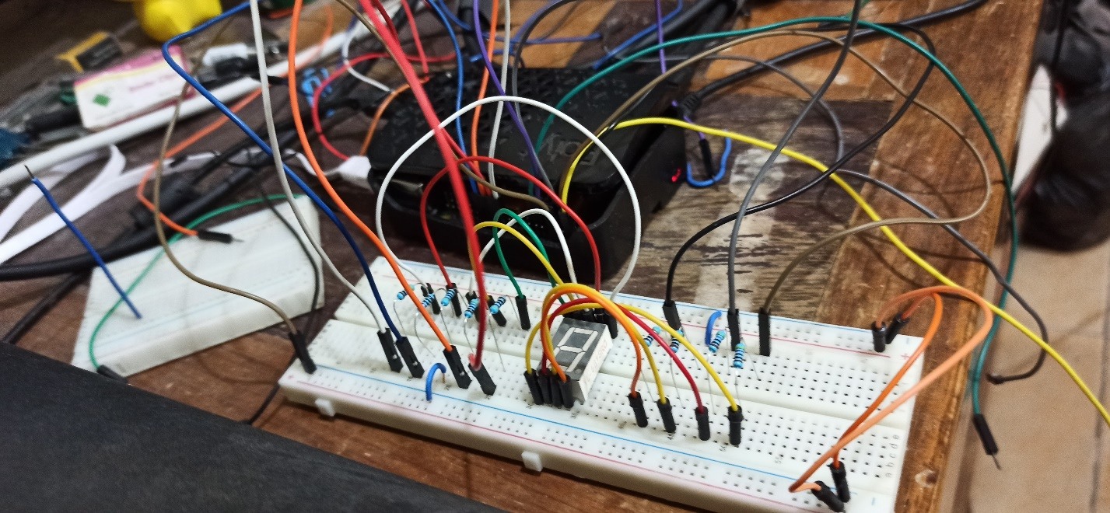**Activity Illustration**

**Observation**

The Raspberry Pi has plenty of pins available to implement a seven-digit segment with some spare left. Moreover, the seven-digit segment was able to easily display all the required alphanumeric characters.

**Conclusion**

Unlike like the Arduino, the Raspberry Pi has potential to allow more input from other devices given there are still a significant amount of vacant pins.