“SEVEN SEGMENT DISPLAY WITH PUSH BUTTON CONTROL”

2/20/2022

Brenn Ahren C. Hong

**Procedure**

1. Setup hardware and wiring.
2. Code the program.
3. Run program.

**Materials**

* Raspberry PI 4
* Breadboard
* Jumper Wires
* Seven-Segment Display
* Push Button
* Resistors

**Schematic Diagram**

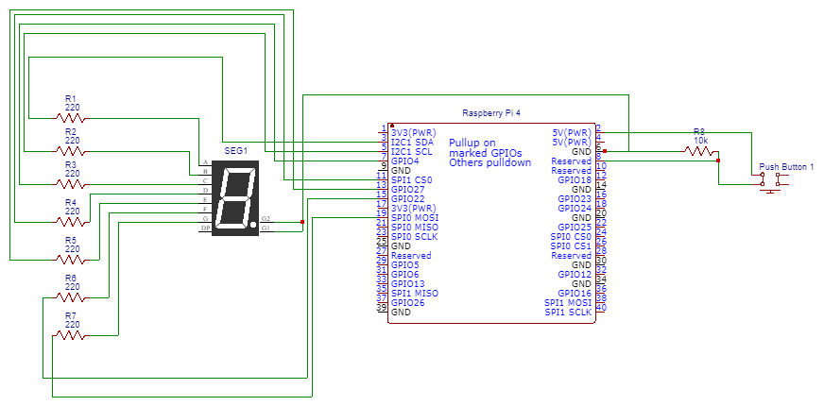

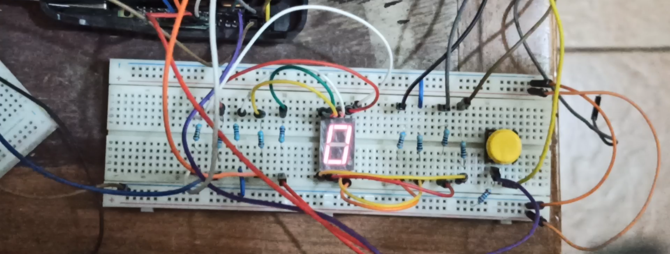**Activity Illustration**

**Observation**

The Raspberry Pi allowed the operation of a Seven Segment along a push button to influence the outcome of the seven-segment display.

**Conclusion**

This proves that the Raspberry Pi is more capable compared to other commonly used microprocessors.