

“I2C-LCD (LIQUID CRYSTAL DISPLAY)”

2/24/2022

Brenn Ahren C. Hong

**Procedure**

1. Enable I2C on Raspberry Pi.
2. Install I2C Tools.
3. Install I2C-LCD Driver/Library.
4. Copy given code.
5. Setup hardware.

**Materials**

* Raspberry PI 4
* Breadboard
* Jumper Wires
* I2C-LCD

**Schematic Diagram**

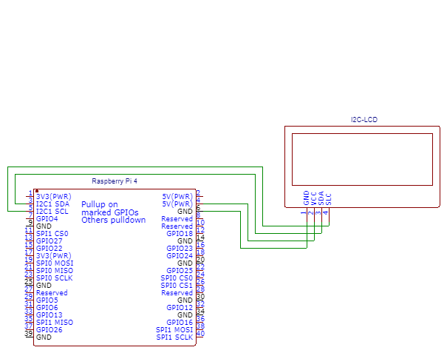

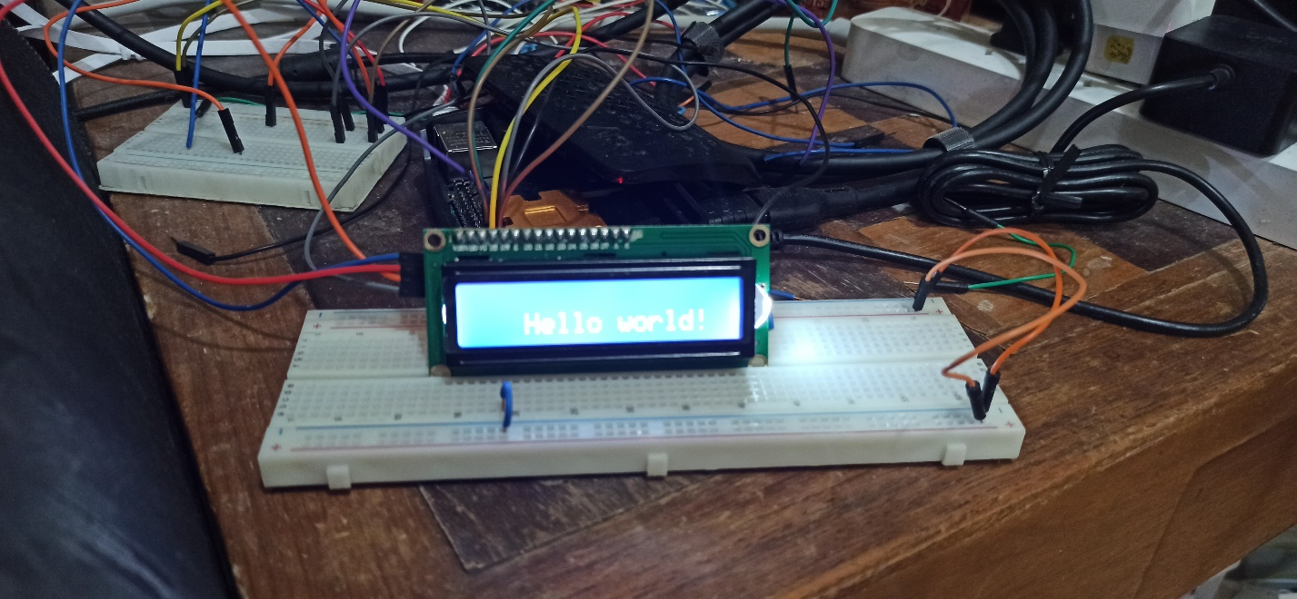**Activity Illustration**

**Observation**

I observed that the I2C-LCD works the same with the Arduino LCD, with the difference being, the Raspberry Pi 4 has more capacity to perform longer and complex coding.

**Conclusion**

Using the I2C-LCD on the Raspberry Pi is much simple to do compared to the Arduino Uno because of the simple and intuitive nature of the Python programming language and the larger memory capacity of the Raspberry Pi.