

“I2C-LCD (LIQUID CRYSTAL DISPLAY)”

2/24/2022

Brenn Ahren C. Hong

**Procedure**

1. Setup IC2-LCD.
2. Connect push buttons to Raspberry Pi.
3. Code the software.

**Materials**

* Raspberry PI 4
* Breadboard
* Jumper Wires
* I2C-LCD
* Push Buttons

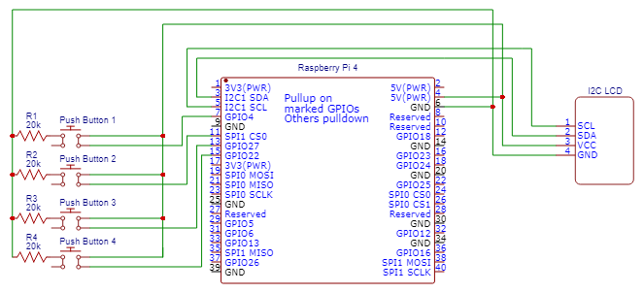**Schematic Diagram**

**Activity Illustration**

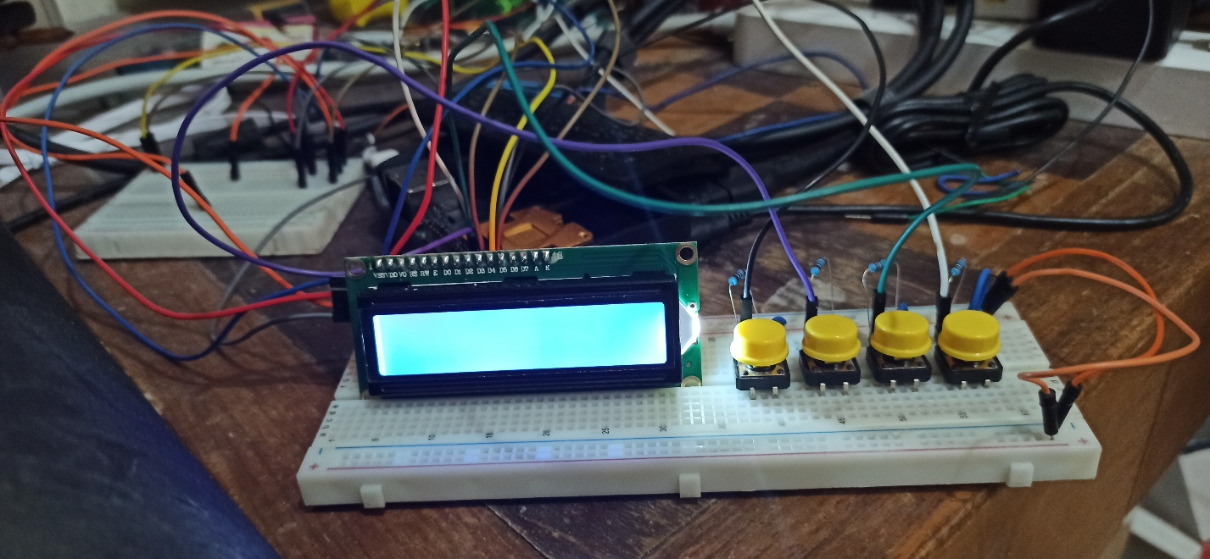

**Observation**

I observed that the experiment is similar to an Arduino Uno experiment I’ve conducted in a previous subject before and on the hardware side, it was very similar and I see no difference in the wiring. However, coding them was much easier to do.

**Conclusion**

Push buttons can be used together with the I2C-LCD to create complex setups for other kinds of applications.