

“I2C-LCD (LIQUID CRYSTAL DISPLAY)”

2/24/2022

Brenn Ahren C. Hong

**Procedure**

1. Enable I2C on Raspberry Pi.
2. Install I2C Tools.
3. Install I2C-LCD Driver/Library.
4. Copy given code.
5. Setup hardware.

**Materials**

* Raspberry PI 4
* Breadboard
* Jumper Wires
* I2C-LCD
* 4x4 Matrix Keypad

**Schematic Diagram**

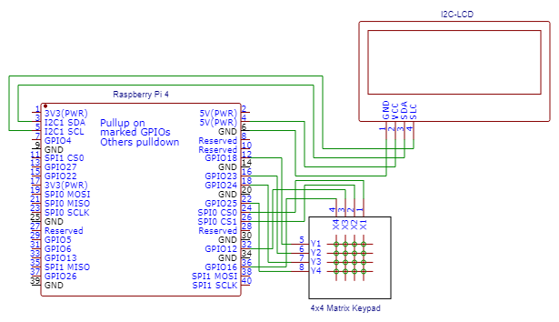

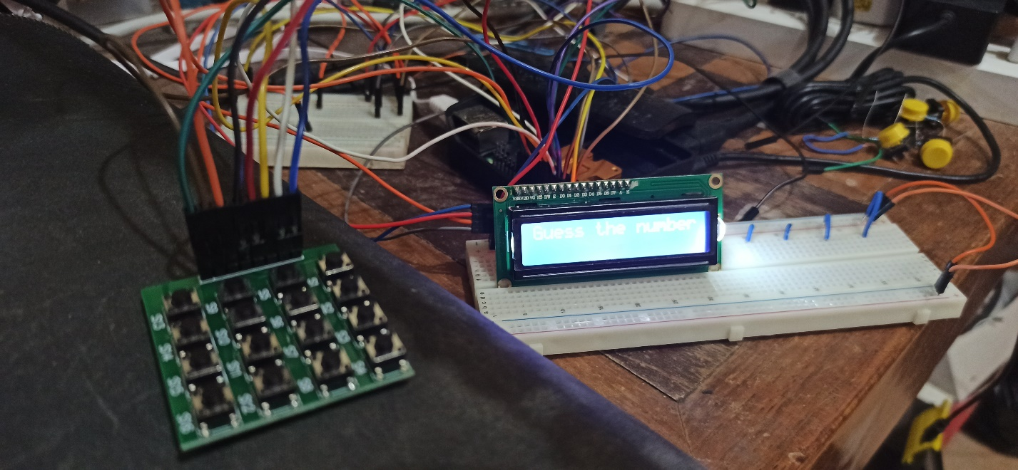**Activity Illustration**

**Observation**

Using the 4x4 Matrix Keypad and the I2C-LCD, I was able to create a somewhat simple game. The game was a number guessing game whereas the program would generate a random number from 1 to 16. The user would then guess the number and the program would give some hints regarding how close the user is, if the user guesses the number, the program will then generate another random number for the next game. On the other hand the game will also end if the user fails to guess 4 times, this will also trigger the game to generate another random number for the next game.

**Conclusion**

The 4x4 Matrix Keypad and the I2C-LCD demonstrates the possibilities of more complex applications of the Raspberry Pi.