“GUI CONTROLLED LED”

03/03/2022

Brenn Ahren C. Hong

**Procedure**

1. Setup hardware and wiring.
2. Copy the code.
3. Run program.

**Materials**

* Raspberry PI 4
* Breadboard
* Jumper Wires
* LED
* Resistor

**Schematic Diagram**

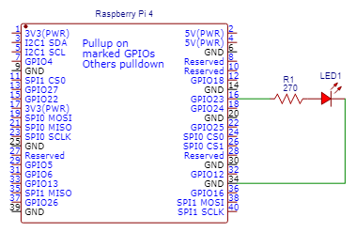

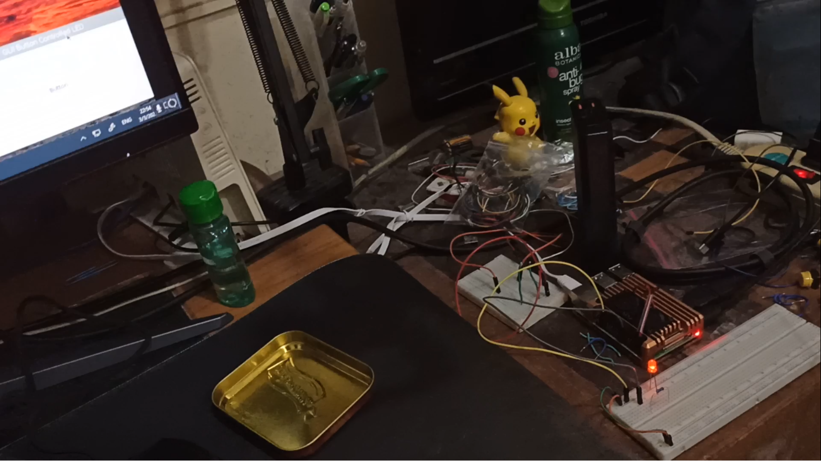**Activity Illustration**

**Observation**

Pressing the button on the GUI had a reaction with the LED as it turned the LED off.

**Conclusion**

This opens to more complex possibilities of allowing a user controlled GUI to control hardware devices.