“PUSH BUTTON GUI MONITOR”

03/03/2022

Brenn Ahren C. Hong

**Procedure**

1. Setup hardware and wiring.
2. Copy the code.
3. Run program.

**Materials**

* Raspberry PI 4
* Breadboard
* Jumper Wires
* Push Button
* Resistor

**Schematic Diagram**

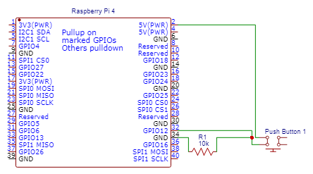

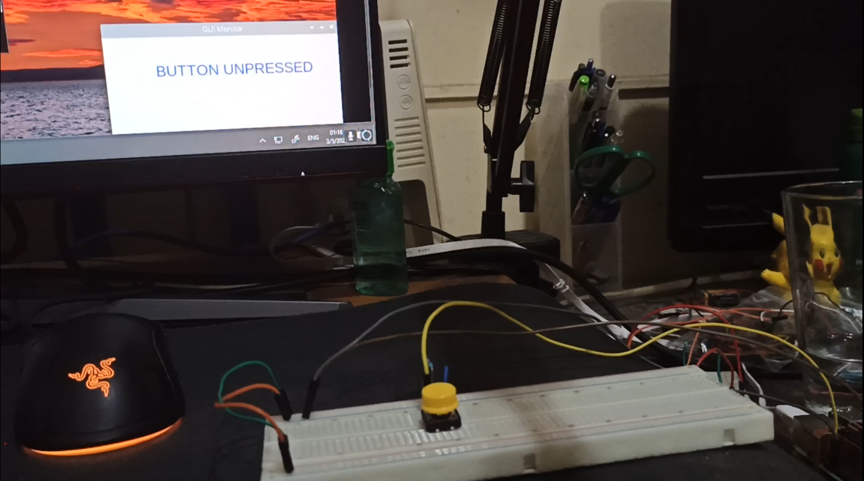**Activity Illustration**

**Observation**

Pressing the button changed the text on the GUI.

**Conclusion**

The communication between the Raspberry Pi software is not a one-way relationship. It is possible to code the Raspberry Pi to allow electrical input from a hardware to send signals to its pins and make changes on the GUI as a reaction to that input.