|  |
| --- |
| Door Notifier System |
| **Brenn Ahren C. Hong** |
| Home Security |



**Introduction**

There are many homes or houses that do not have working or properly implemented doorbell mechanisms and setting up a security camera or intercom system is quite tedious for many. With the Raspberry Pi, one can easily modify it to become a makeshift security system and it is highly modular in nature for additional modifications to be added to suit one’s preferences. If a person wants a system with a two-way or one-way communication, they may add a microphone and audio output on the Raspberry Pi along with a camera. So, with the rise of IoTs almost anyone at their home can make their own easy to use systems without needing to shell out a lot of money to purchase expensive systems that may have redundant features for them.

**Objectives**

The project will achieve the following:

* Person detection system
* LCD message display output
* User controllable GUI
* Auto photo capturing system
* System event log
* Telegram integration for user control and notification

**Project Description**

The project aims to create a system capable of notifying the user and taking a photograph of the person approaching the door with the ability to send a simple message via LCD display. Moreover, the project will have two different control systems, the first would be via a user interactive GUI and the other would be a text-controlled Telegram application. Furthermore, the system will automatically notify the user via an alarm or if the user enabled Telegram features, the system would send a message to the user with a photo of the person in front of the door.

**Block Diagram**

The only input sensor is the Ultrasonic Sensor Distance Measuring Module, this sensor will be performing the person detection at a set activation distance x and at the close proximity detection at 30cm. The Pi Camera used is the Pi Camera Rev 1.3 set to photograph at a fixed resolution of 1024x768. The Application GUI controls everything from pausing the system to shutting down the system itself. There are three possible outputs, the Telegram App, Display Monitor and I2C-LED. The Telegram App is meant to be a dual input/output software, it is used to notify the user and as medium to send commands by the user to the system application. The Display Monitor is there for the user to control and monitor the events in the system. Lastly, the I2C-LCD is there to display messages sent by the user for the person knocking on the door.

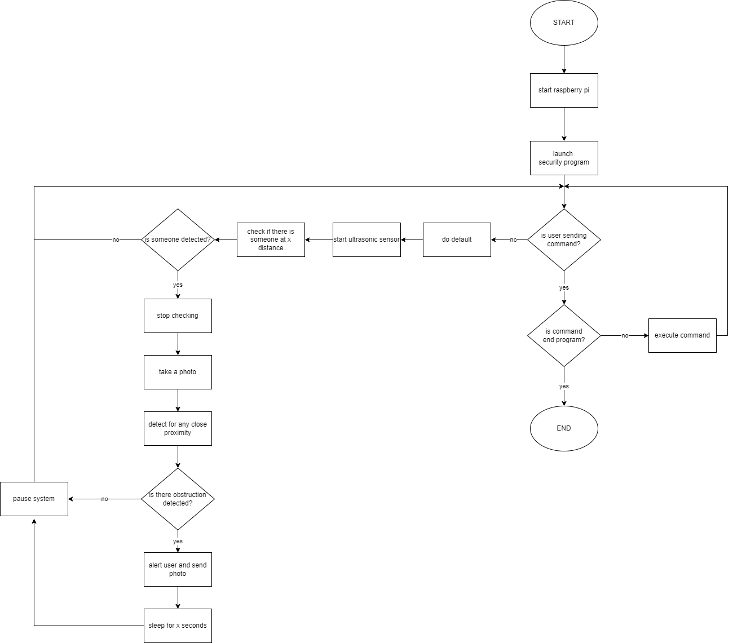**Program Flowchart**

The program will be always awaiting commands from the user GUI. When the ultrasonic sensor detects someone at a distance x, set by the user. The sensor would attempt to detect for anybody in the extremely close proximity of the system at about approximately 30cm, if it does not detect anyone within 20 seconds, it will automatically go back to default where it will once again detect someone at a distance x.

**Monitoring & Control Screen**

**Scope and Delimitations**

The system will not send or receive any commands from the Telegram application unless the user will type the “start” command from the Telegram Application. Also, the python script will only run from the Raspberry Pi and not anywhere remotely. Lastly, the system will limit the amount of text displayed on the LCD screen given that the LCD screen is small in size.

**Findings, Recommendations and Conclusions**

The system can be easily assembled and is cheap to create. The bottleneck in the system is that the code must not be dependent on the sleep method and loops as it freezes the whole system. It is recommended that to code a similar system, one should create it with flexibility in the code in mind in such a way that tasks should be properly integrated and not interfere with one another’s function.

**References**

[Using a Raspberry Pi distance sensor (ultrasonic sensor HC-SR04) (tutorials-raspberrypi.com)](https://tutorials-raspberrypi.com/raspberry-pi-ultrasonic-sensor-hc-sr04/)

[Set Up Telegram Bot on Raspberry Pi : 8 Steps - Instructables](https://www.instructables.com/Set-up-Telegram-Bot-on-Raspberry-Pi/)

[Graphical User Interfaces with Tk — Python 3.10.4 documentation](https://docs.python.org/3/library/tk.html)

[picamera — Picamera 1.13 Documentation](https://picamera.readthedocs.io/en/release-1.13/)