Brenna Manning

Computer Architecture Midterm

**Specification Document**

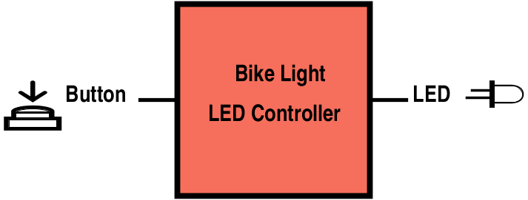

**Inputs:** Single button

**Outputs:** Single LED

**Light’s Behavior:**

The bike light has 4 states: off, on, flashing, and dim. The button input controls which state the system is in. (*See Finite State Machine.) As seen in the figure below, in the off state, the output is always low. In the on state, the output is always high. In the flashing state, the output alternates between high and low. In the dim state, the light alternates between on and off quicker than the human eye can detect, so it appears to be dimmer. The figure below shows a 50% duty cycle, though it could be more or less depending on how dim the light is supposed to be.

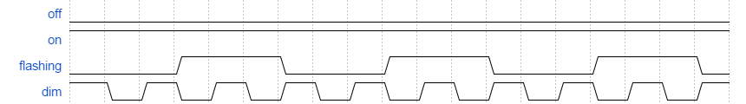

The observed frequency of the light’s *flashing mode* is approximately **3hz.**

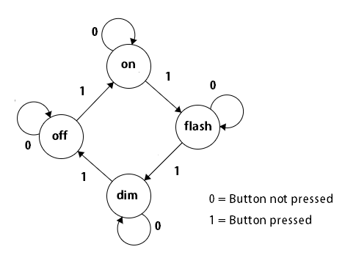**Finite State Machine:**