

We have 5 pages,

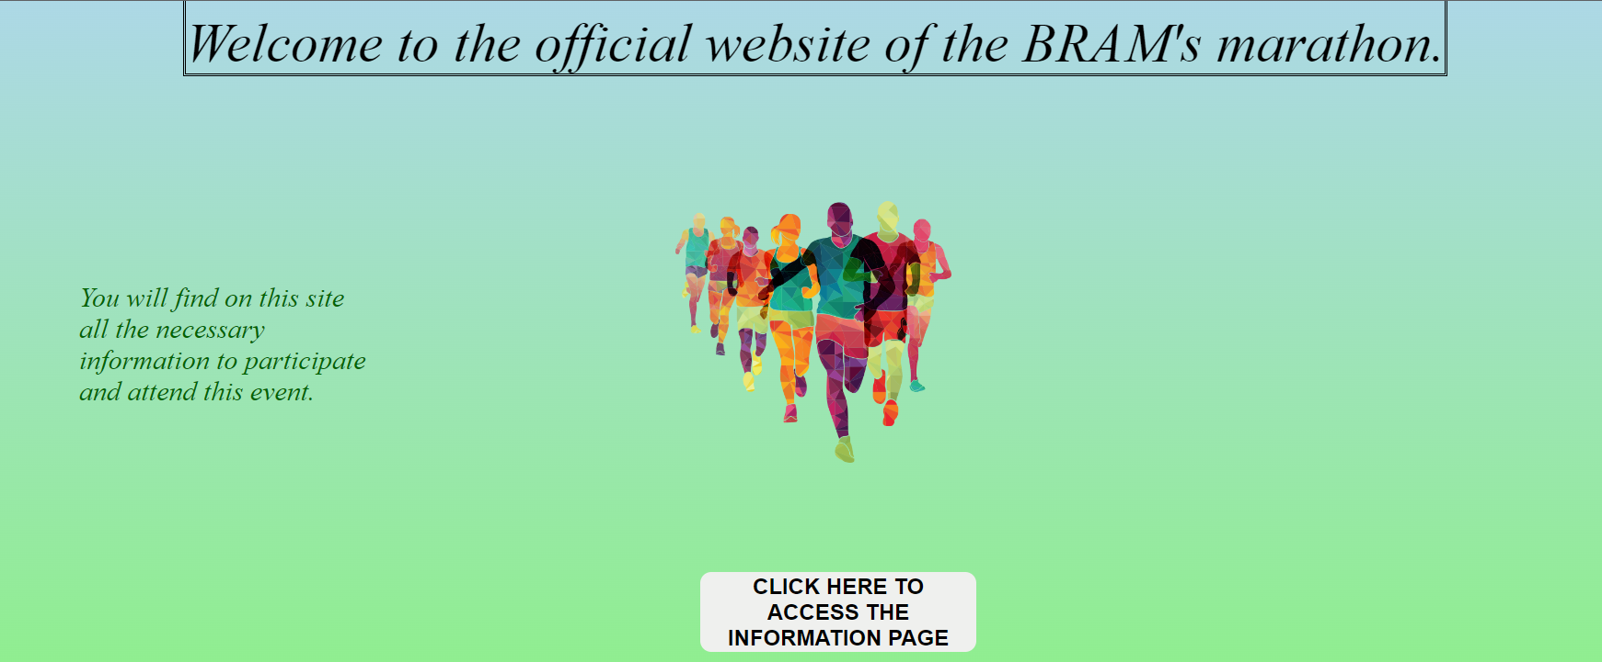First the presentation page :

link :

<https://csusm-my.sharepoint.com/:f:/g/personal/heurt001_csusm_edu/EqqsuFAAUlREmK9B4xNRfhQBmKLsamx94HrAUJOSS4TCXA?e=FdGwiX>

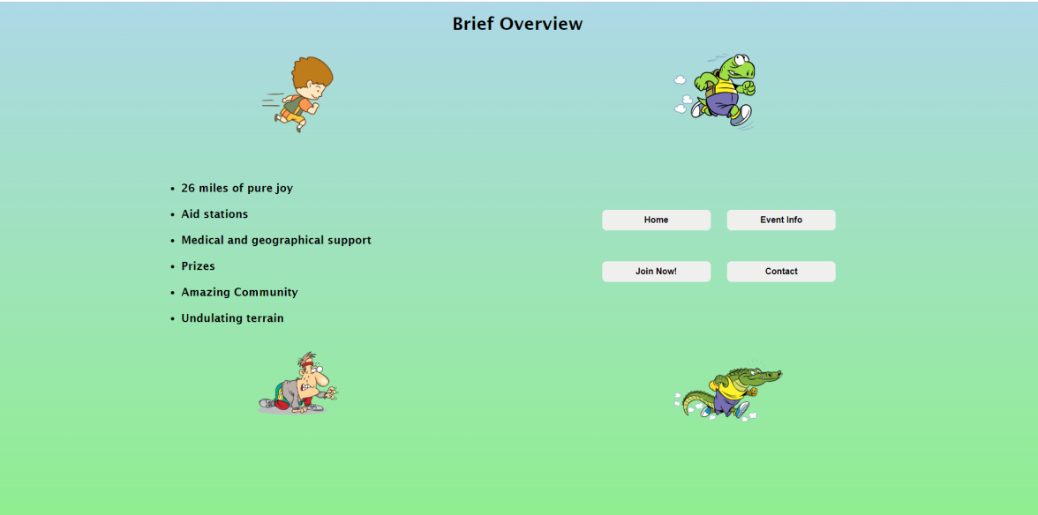Then the information page :

link :

<https://csusm-my.sharepoint.com/:f:/g/personal/heurt001_csusm_edu/EnYCC-QO4ptAuPmQdMWvt5UBCEztHj41nVtrLyP_wD5pjw?e=radEh2>

Then the event page :

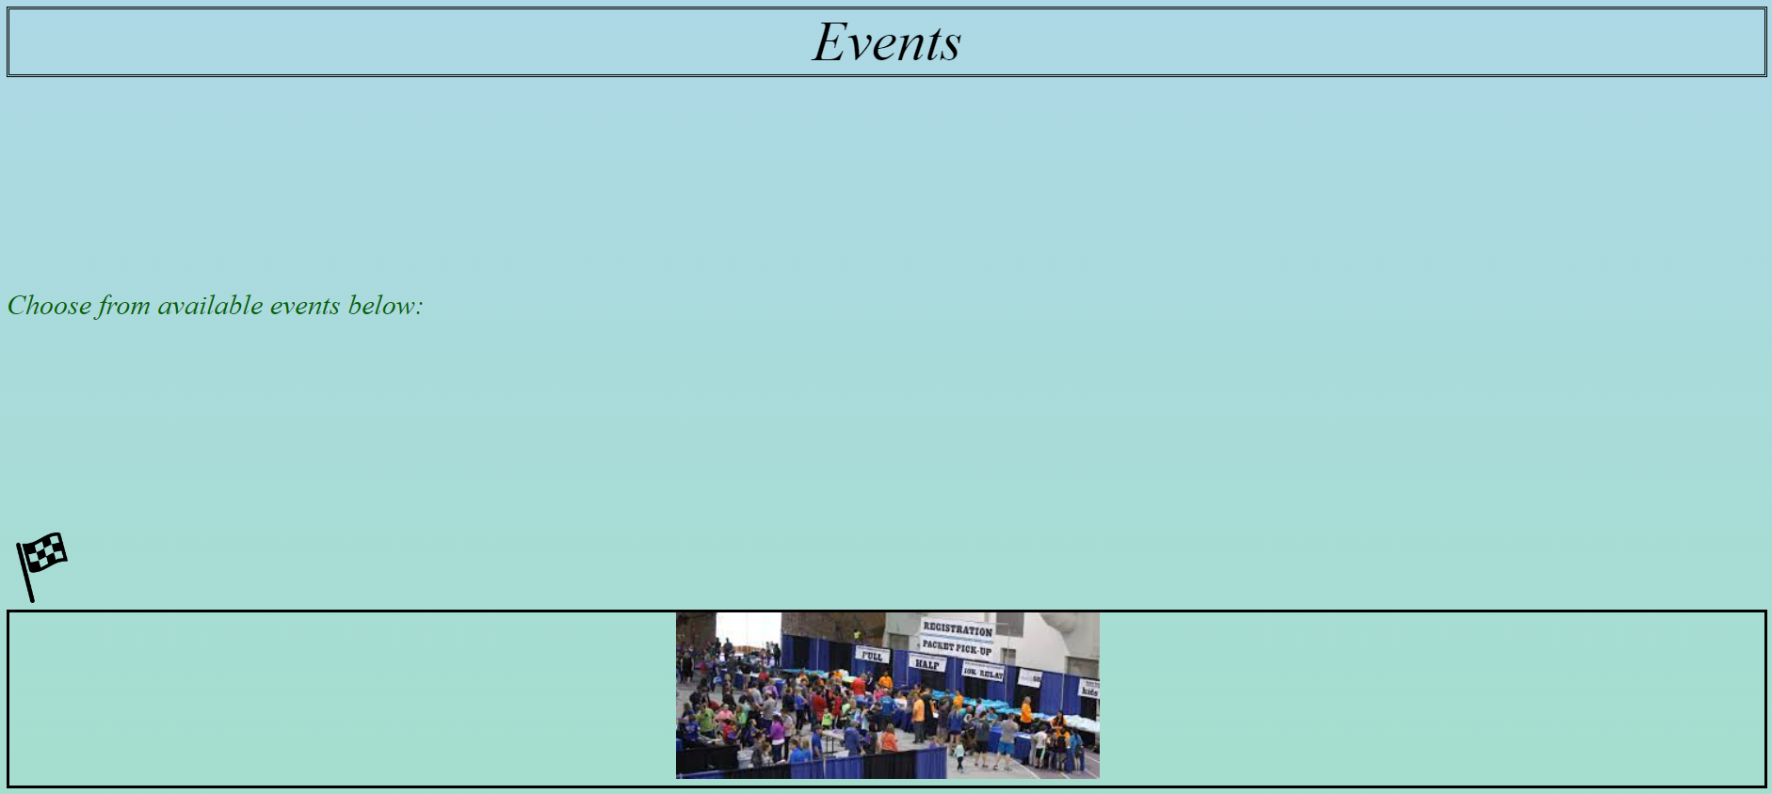

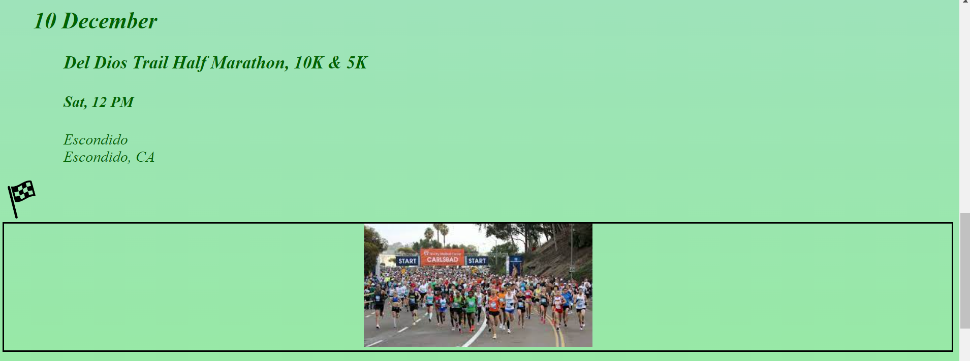

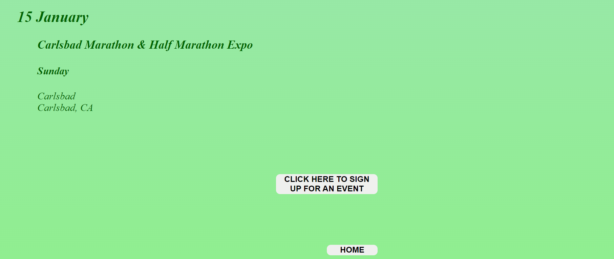

The link :

<https://csusm-my.sharepoint.com/:f:/g/personal/heurt001_csusm_edu/EhdoB9qTIAVJge0qPjnAfOYBPzAf_RLsRuCbXsSPqetrXg?e=NdvF7S>

The inscription page :

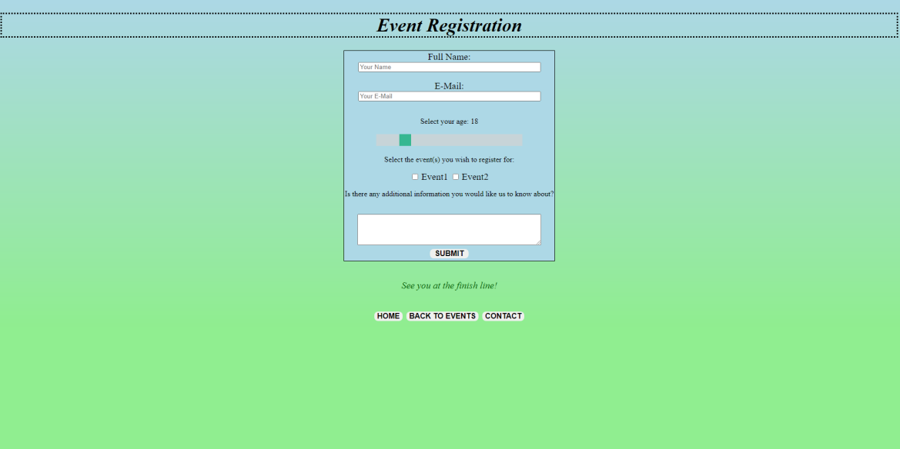

the link : <https://csusm-my.sharepoint.com/:f:/g/personal/heurt001_csusm_edu/Evj5im4cKNREonP0X5eXnloBMjBQ7Te1IbVBxqdd9KsUNA?e=FjwdOB>

And to finish the contact page :

The link :

<https://csusm-my.sharepoint.com/:f:/g/personal/heurt001_csusm_edu/EkRicfKqRstOmVCfpElLUc0BmL6dgYKT_KEBmaDVZvKbiw?e=GWzN6h>

## meeting SESSION:

* Monday, October 24: Discussion about the theme, the subject and, we start to do the plan as asked.
* Monday, October 31: Continue and finishing the plan.
* Monday, November 7: Division of the work to do, Rehydn the information page, Andréa the home and contact page, Brennan the inscription page, and Mykah the event page.
* Monday, November 14: Discussion about the avancement of the work, and the theme/ color to follow.
* Monday, November 20: Construction of this rapport.
* Plan for the following week : creating the link for the button of each page and the database.