Stephen... So… here is some food for though.

This weekend I have been continuing my research into using NameSpaces.

If someone is only writing a couple modules, or a single standalone module, a naming convention like “Abacus-ModuleName” works fine, and you see it done like this a lot because it is kind of natural and comfortable.

But when your code base grows in size and complexity, this quickly becomes unmanageable and un-scalable.

The reason they developed the NameSpace in .Net is because a lot of projects get large and complex really fast, especially in C#, and those guys needed a way to organize their code without stepping on their own code in other places, or each other’s code.

Here below, for an example, I created a couple example modules using namespaces.

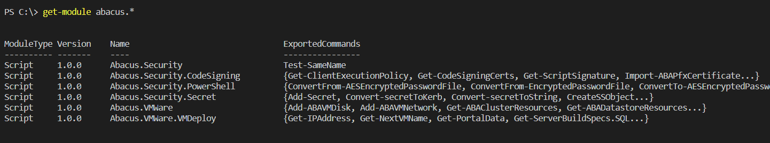

What’s cool is you don’t need the **ABA** prefix in front of functions names just to make them unique.

This is because the namespace where the function lives becomes part of the name, without needing to prefix them.

But prefixes do have uses in the right circumstances. For example, my function above called “Import-ABAPfxCertificate” has the ABA prefix because that is exactly what it does, it is importing the Abacus PFX Certificate.

You don’t see VMWare or Microsoft putting “New-vmwVM” or “New-msVM” in front of their commands. That would be an example of zero scalability if PowerShell worked that way.

Their developers are using name spaces and they don’t need to do that, they both just say "New-VM", and you can call it from whichever namespace you want to use it from.

* VMWare.VimAutomation.Core\New-VM
* Hyper-V\New-VM

It wasn’t out of stupidity that Microsoft and VMWare both have the same command named **New-VM.**

That happened because that is the right way to do it, and they use namespaces in order to manage it with a scalable architecture.

**This is scalable and manageable:**

* Abacus.Security
* Abacus.Security.CodeSigning
* Abacus.Security.PowerShell
* Abacus.Security.PowerShell.Encryption
* Abacus.Security.Secret
* Abacus.VMWare
* Abacus.VMWare.VMDeploy

**This is not scalable or manageable:**

* Abacus-Security
* Abacus-PowerShell
* Abacus-CodeSigning
* Abacus-Encryption
* Abacus-Secret
* Abacus-VMWare
* Abacus-VMDeploy

What is nice about namespaces is that you can organize your code into sets and subsets, especially when your code base gets large and complex.

And you can call only the pieces you want without loading a bunch of other crap and functions just to use one feature or subset of a module.

Right now, the way you guys do stuff, you would need to load **all 100 functions** in the Abacus-Office365 module just to use any part of it.

And with a namespace you can move functions around to other modules just by cut/paste without worrying about what module it currently is in or was in before, as long as it is in the root namespace, i.e. Abacus.Security.

So it becomes easier to organize, and a lot more manageable as well

**Abacus Module Sets:**

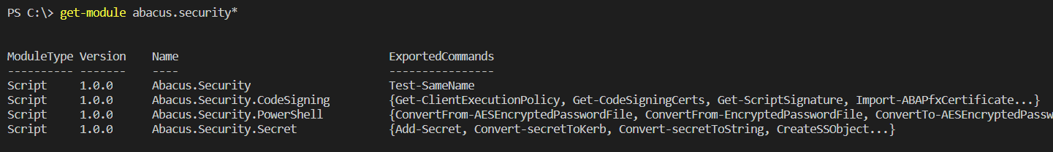

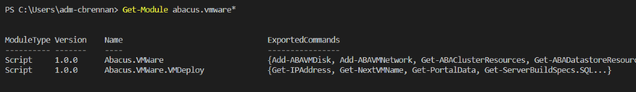

**Abacus Module Sub-Set:**

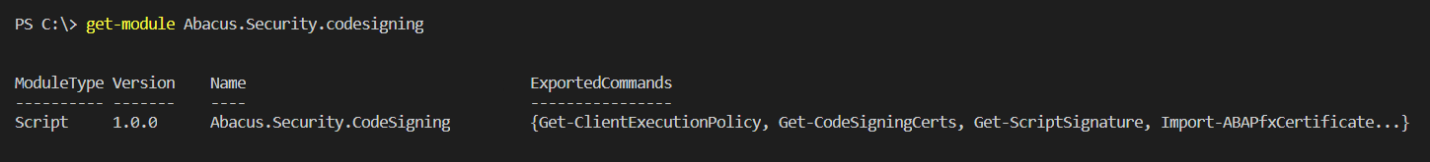

**Abacus Security Module Commands:**

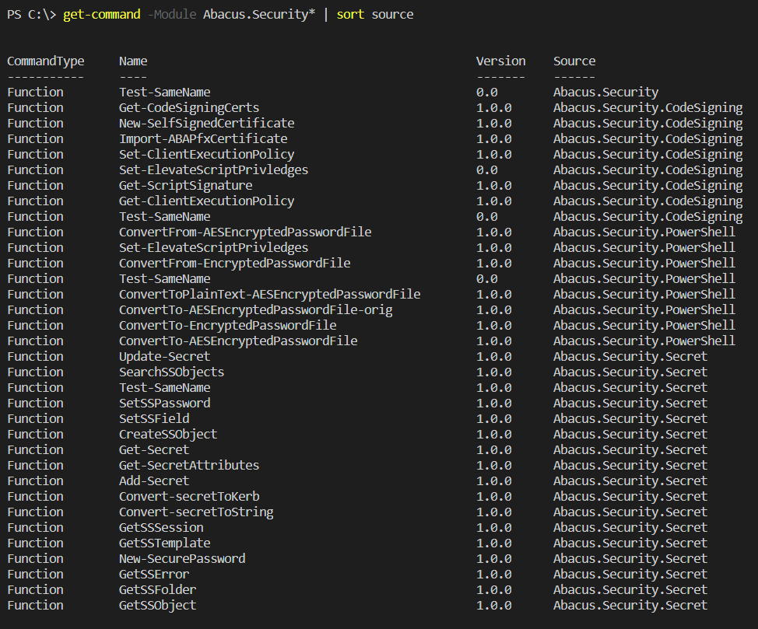

**Abacus CodeSigning Module Commands:**

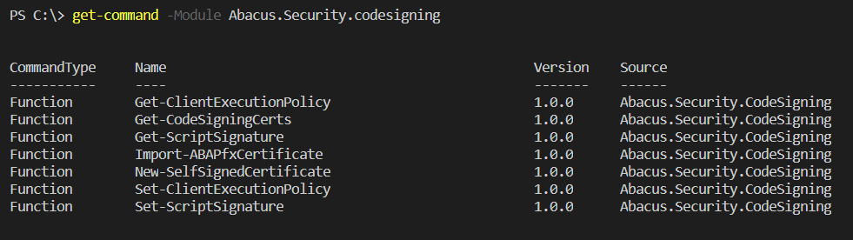

**Function Naming:**

Function names live in their own namespace, so you can write code without worrying about stepping on other function names.

Also, since the namespace where the function lives becomes part of the name, you don’t need to prefix any of them with ABA to make them unique.

Here I have an example of 4 functions all with the same name, and it works fine! By design.

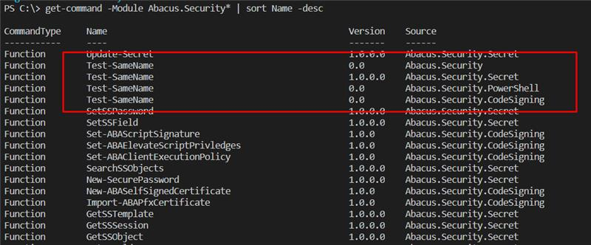

**This alleviates a huge naming problem!.**

For example, I was handcuffed and couldn't use the logical names I wanted to name my functions in my VM-Deploy module because Bryan had already used the most logical names in his Abacus-VMWare module.

Without a namespace to organize and manage the code in a hierarchical naming convention, I couldn’t name my functions in a natural way the way I wanted. Otherwise I would have been stepping on Bryan’s code (function names).

**Examples: from Microsoft/VMWare/Citrix**

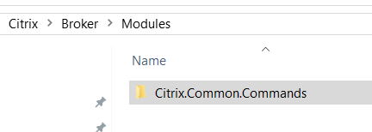

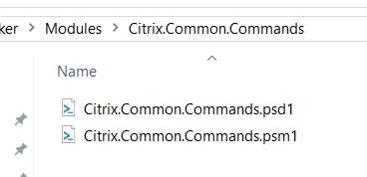

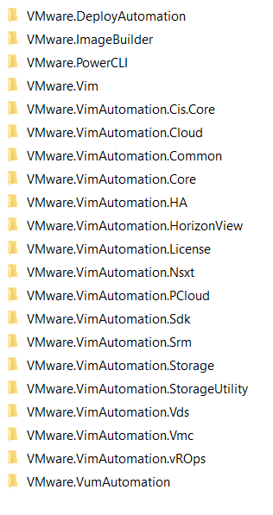

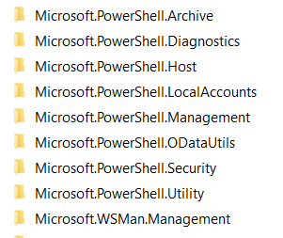

**Summary**

So now I know that a part of what I was starting to do before while I was at EZE was correct.

Using the namespaces as shown above to name and organize the module sets was the correct way to do it.

The one part I wasn’t sure about even as I was doing it was how I was naming my functions.

And I was wrong about what I was doing.

I was trying to mash the namespace in with the function name.

Like this:

New-ECI.EMI.Automation.VM

I knew what I wanted, which was to tie the function name into where the function lives in the module set. But what I was doing just felt wrong for some reason.

Well… it was wrong.

This is how it supposed to be done.

ECI.EMI.Automation\New-VM

or Abacus style:

Abacus.VMWare.VMDeploy\New-VM