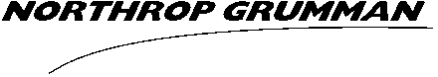  U.S. SECURITY CLEARANCE CITIZENSHIP CONFIRMATION  Form C-834A (12-15) | NORTHROP GRUMMAN  PRIVATE/PROPRIETARY - LEVEL I  (WHEN COMPLETED)

This form must be filled out completely to prevent return or delay.

APPLICANT STATUS
CURRENT EMPLOYEE NEW HIRE* CONSULTANT SUB-CONTRACTOR (SCI SPONSORED BY ES&CSO) | * START DATE  Jan. ⁸th 2019

APPLICANT PERSONAL INFORMATION
LAST NAME  Lee | FIRST NAME  Brennon |  | MI  P. | MyID OR SSN (IF NO MyID)  624887406
NORTHROP GRUMMAN EMAIL ADDRESS (IF ANY) |  | OTHER EMAIL ADDRESS (IF COMPANY ADDRESS NOT YET ESTABLISHED)  brle1617@colorado.edu
DATE OF BIRTH  4/1/96 | CITY AND STATE OR JUSRIDICTION OF BIRTH  Redlands, California |  | POSSESSION/COUNTRY OF BIRTH  USA

U.S. CITIZENSHIP VERIFICATION
Citizenship verification may be conducted by the employee’s manager or supervisor with the approval of the cognizant Security Officer; otherwise this verification should be conducted by authorized security personnel.
- All documents presented, as evidence of U.S. citizenship must be original or certified documents (see Note below).
- I have inspected the document(s) selected below and affirm that the person named below is a United States citizen.
SELECT ONE
Birth certificate U.S. Passport Other:
FULL NAME OF VERIFYING OFFICIAL | SIGNATURE* | DATE
* NOT REQUIRED IF EMAILED FROM A NORTHROP GRUMMAN EMAIL ACCOUNT

U.S. CITIZENSHIP VERIFICATION BY LICENSED NOTARY PUBLIC (IF VERIFICATION NOT DONE ABOVE)
- All documents presented, as evidence of U.S. citizenship must be original or certified documents (see Note below).
- I have inspected the document(s) selected below and affirm that the person named below is a United States citizen.
SELECT ONE  Birth certificate U.S. Passport Other: |  | STATE NOTARY SEAL
NAME OF VERIFYING OFFICIAL | DATE | STATE NOTARY SEAL
NOTARY COMMISSION NO. |  | STATE NOTARY SEAL
EXPIRATION DATE OF COMMISSION |  | STATE NOTARY SEAL
BUSINESS TELEPHONE NUMBER |  | NOTARY SIGNATURE

NOTE: ACCEPTABLE CITIZENSHIP DOCUMENTS CONSIST OF THE FOLLOWING:
- Birth Certificate issued by a state, county, municipal authority, or outlying possession of the United States, bearing an official seal
- Unexpired OR expired United States passport
- Certificate of United States citizenship (USCIS Form N-560 or N-561)
- Certificate of Naturalization (USCIS Form N-550 or N-570)
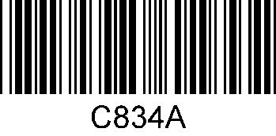
- Certificate of Birth Abroad issued by the US Department of State (Form FS-545 or DS-1350) or Report of Birth Abroad (Form FS-240)

