 | Document Number | EDCS-11714500
 | Based on Template | EDCS- 189226 Rev: 35  and  http://eng.ironport.com/docs/is/fs-template.rst
 | Created By | Andrii Ivaniuk

WBRS Rule UI 4.1

Release Functional Specification
VirusTotal/Umbrella support. Adding new statuses and resolution

Reviewers
Department | Name/Title
Talos West/Tech Lead | Don Owens doowens@cisco.com
Talos West/Ops Architect | Pawan Dube pawdube@cisco.com
Talos West/DBA | Suresh Penikalapati spenikal@cisco.com
Talos West/Eng Research | Jayme Carter jayme@cisco.com
Talos West/PM | Robert Frost rofrost@cisco.com
Talos West/Eng Research | Adam Mattern admatter@cisco.com
Talos West/Dev Lead | Yaroslav Hrabar ygrabar@cisco.com
Talos West/QA Lead | Viktor Malafey vmalafey@cisco.com
Talos West/OpsEng | Bogdan Okseniuk bokseniu@cisco.com
CC Talos West/PM | Liz Cooperrider ecooperr@cisco.com
CC Talos West/PM | Anthony Paredes anparede@cisco.com
CC Talos West/PM | Oleksii Petrovskyi opetrovs@cisco.com
CC Talos West/QA | Yevheniia Saviuk ysaviuk@cisco.com
CC Talos West/QA | Oleksandr Shutko oshutko@cisco.com

Modification History
Revision | Date | Originator | Comments
1 | 03 Aug 2017 | Andrii Ivaniuk | Initial version.
2 | 05 Sep 2017 | Stepan Sinkov | Added ‘VirusTotal Client’ and ‘Umbrella Client’ sections.
3 | 05 Sep 2017 | Stepan Sinkov | Added ‘Admin reputation complaint loader’ and ‘Beaker lookup client’ sections.
4 | 05 Sep 2017 | Stepan Sinkov | Added ‘Beaker lookup client’ section, updated ‘Admin reputation complaint loader’ section with detailed workflow.
5 | 14 Sep 2017 | Andrii Ivaniuk | Reputation Tool Client.
6 | 19 Sep 2017 | Andrii Ianushevskyi | Added details about Umbrella Client feature.
7 | 21 Sep 2017 | Stepan Sinkov | Updated VirusTotal Client section.
8 | 27 Sep 2017 | Stepan Sinkov | Updated ‘Admin reputation complaint loader’ section, added ‘Reputation complaint retract functionality’.
9 | 28 Sep 2017 | Andrii Ianushevskyi | Added details about Umbrella Client feature.
10 | 29 Sep 2017 | Stepan Sinkov | Updated ‘Beaker lookup client’ section.
11 | 06 Oct 2017 | Andrii Ivaniuk | Added a new Exception to RepTool client.
12 | 10 Oct 2017 | Stepan Sinkov | Added examples to ‘Retract functionality’.
13 | 13 Oct 2017 | Stepan Sinkov | Added diagram to ‘Admin reputation complaint loader’.
14 | 24 Oct 2017 | Stepan Sinkov | Typos fixed, glossary updated.
Table of Contents
1 Open Issues 5
2 Release Overview 5
3 Overall Architecture 5
4 Features 5
4.1 ‘Resolved Duplicate' resolution for categorization complaints 5
4.2 Locking out reputation complaints to prevent simultaneous review 8
4.3 VirusTotal Client. 12
4.4 Umbrella Client. 19
4.5 Reputation Tool Client 27
4.6 Admin reputation complaint loader. 36
4.7 Beaker lookup client. 42
4.8 Reputation complaint retract functionality. 45
5 Third Party Relationships 48
6 Patentability Considerations 48
7 Performance and Scalability 48
8 Bug Scrub 48
9 Physical Migration 48
10 Equipment Consideration 49
11 SysOps Environment/Equipment Requests 49
11.1 Production 49
11.2 Staging 49
12 Sysops New Product Guidelines 49
13 Access, Roles, and Security 49
14 Dependencies 49
14.1 This product --> x 49
14.2 x --> This product 50
15 Follow up 50
16 Glossary 50

Open Issues
N/A

Release Overview
WBRS Rule UI is the Web-based user interface intended for manual management of WBRS Categorization and WBRS Reputation rules.
The main purpose of this release is implementation of the functionality that allows automatic resolving of reputation complaints with aids of VirusTotal and Umbrella APIs as well as further submitting them to RepTool API.
Additionally, this release is going to contain changes related to new complaint’s status “RESOLVED DUPLICATE”.

Overall Architecture
VirusTotal API client will be implemented.
Umbrella API client will be implemented.
RepTool API client will be implemented.
Admin Reputation Complaint loader cron job will be updated to use newly added APIs.
Reputation complaints management screen will be updated with login dialog to provide ability of retracting previously submitted to Reptool entries.

Features

‘Resolved Duplicate' resolution for categorization complaints

Solution Overview
Feature request: “We have recently introduced a report running on a VM which identifies duplicates so it would make sense that the team members can cut and paste those CIDs into Rule UI and mark as “Resolved Duplicate” with the minimum of effort”.
Upon addressing this request, the user will be able to resolve categorization complaints as ‘duplicate’ using a new ‘Resolved Duplicate’ radio button added to ‘Process Complaints’ view on ‘WebCat Complaint Mgmt –> Complaint Management’ screen.
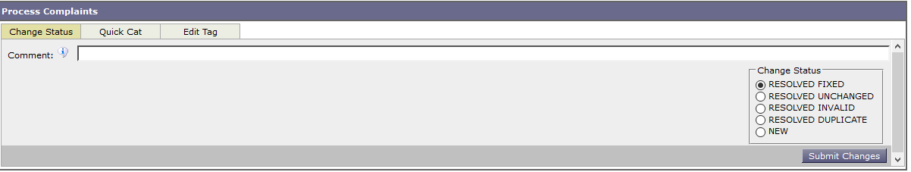

External Interfaces

CLIs
N/A

Programmatic interfaces (RPC, exported classes, etc.)
N/A

Databases
DB changes will be required due to introducing ‘duplicate’ resolution.
ALTER TABLE `complaint_history`
MODIFY `resolution` enum('fixed','invalid', 'unchanged', 'duplicate') default NULL;

User Interface
- Example usage (WebCat Complaint Mgmt->Complaint Management screen):
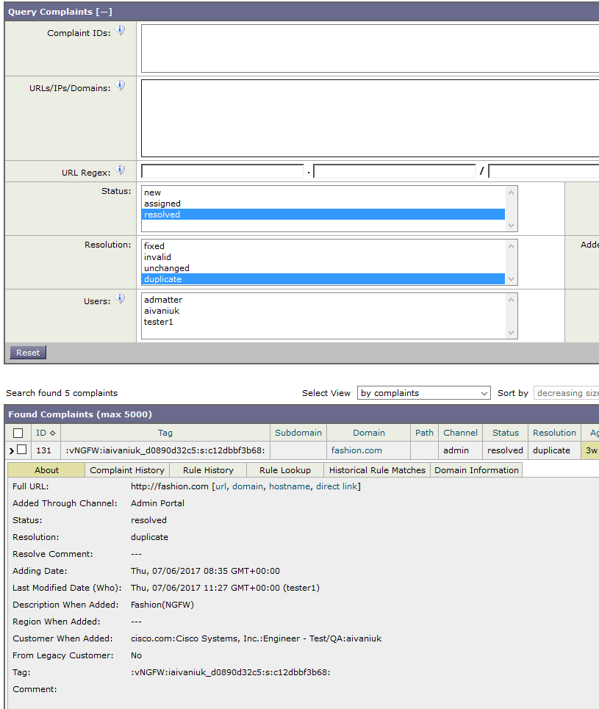
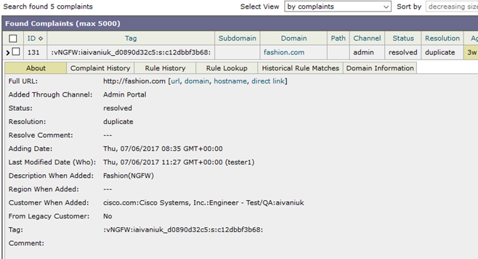

Capacity Requirements
No changes.

Configuration
N/A

Measurement and Monitoring
N/A

Testability
N/A

Failure Modes

Things which might break this feature
DB is not available - in this case, a new complaint status will not be stored.

Things this feature might break
N/A

Locking out reputation complaints to prevent simultaneous review

Solution Overview
Feature request: “As an SSO user, I would like WBRS Rule UI to lock out entries that are currently under review by other SSO Engineers”.
Upon addressing this request, each reputation complaint, that is under review by a particular SSO Engineer (SSO Engineer has navigated to Add WL/BL entry from WebRep Complaint Mgmt screen), will be assigned a new status ‘processing’. The complaint in ‘processing’ status cannot be taken under review by another Engineer until the previous Engineer has stopped processing it.
To support this functionality we will store user session data in binding to the screen, including IDs of complaints under review, to ‘wbrs_rule_ui.user_sessions’ DB table.
mysql> SELECT * FROM aivaniuk_wbrs_rule_ui.user_sessions where screen='wl_bl';
+----------+--------+---------------------+-----------------+
| username | screen | created | data |
+----------+--------+---------------------+-----------------+
| tester1 | wl_bl | 2017-08-01 07:51:46 | <cPickled data> |
+----------+--------+---------------------+-----------------+
Thus, navigating to Add WL/BL entry the user will start a new rule-writing session. The session will be dropped either when complaint(s) is fully processed or the user navigated to WebRep Complaint Mgmt screen.

External Interfaces

CLIs
N/A

Programmatic interfaces (RPC, exported classes, etc.)
N/A

Databases
ALTER TABLE `reputation_complaint_history`
MODIFY `state` enum('new','assigned','processing','resolved') NOT NULL default 'new';

User Interface
Starting new rule-writing session and checking the complaint status:
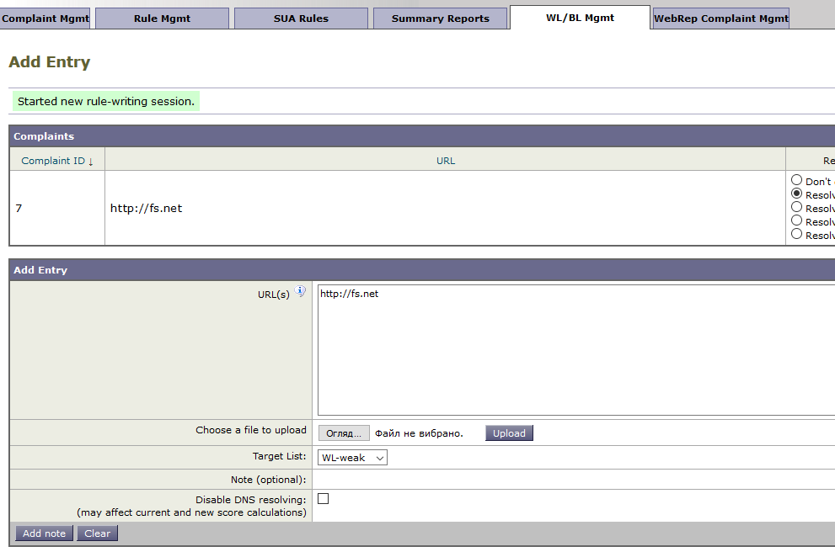
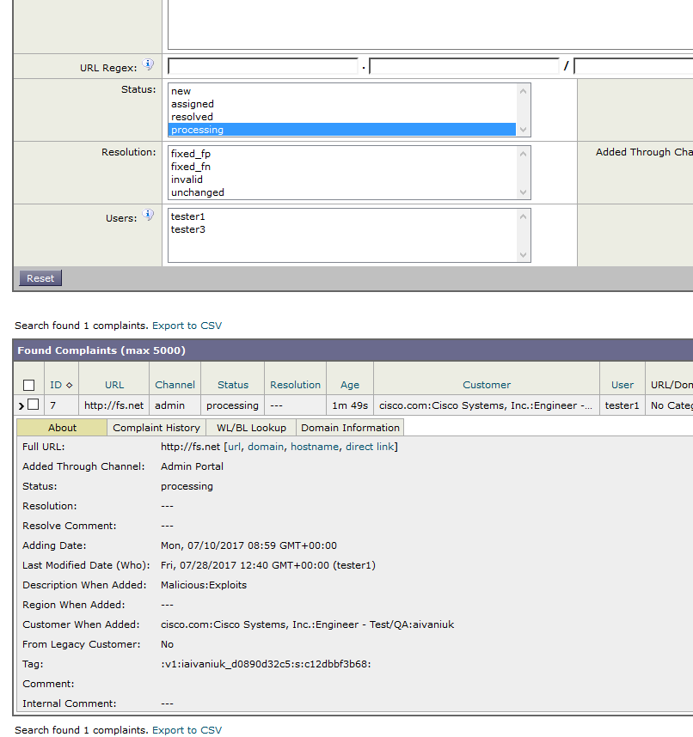
Cancelation of rule-writing session:
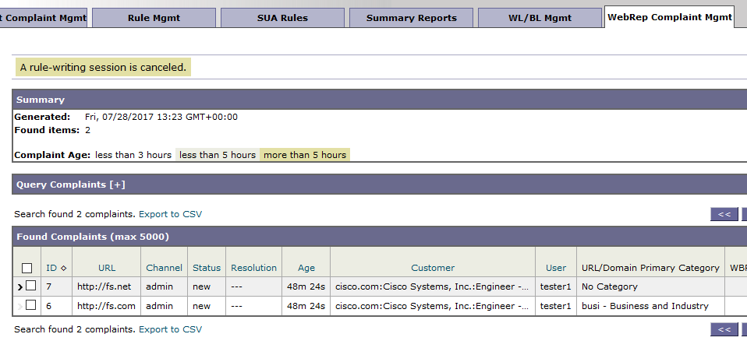

Capacity Requirements
No changes.

Configuration
N/A

Measurement and Monitoring
N/A

Testability
N/A

Failure Modes

Things which might break this feature
DB is not available - in this case, the user will not be able to process complaint(s).

Things this feature might break
N/A

VirusTotal Client.

Solution Overview
VirusTotal Client – is a layer which will be implemented to provide the convenient way of communication with VirusTotal API. It will check given URLs and provide results in a defined format.

External Interfaces

CLIs
CLI will be added into VirusTotal Client to provide ability to test it for QA engineers.
$ python $PRODROOT/src/python/wbrs_rule_ui/virustotal_client.py -h
Usage: virustotal_client.py --key <virus_total_api_key> [options] [urls]

Options:
-h, --help show this help message and exit
-k KEY, --key=KEY VirusTotal API key.
-u REPORT_URL, --report_url=REPORT_URL
VirusTotal API report url. Default:
'https://www.virustotal.com/vtapi/v2/url/report'.
-s SCANNERS, --scanners=SCANNERS
List of scanners to search for positives. Default:
'Kaspersky, Sophos, Avira, Google Safebrowsing,
BitDefender'.
-t TIMEOUT, --timeout=TIMEOUT
Seconds to wait for connection attempt. Default: 10.
-r RETRY, --retry=RETRY
Number of attempts to get response before give up.
Default: 3.
-b BATCH_SIZE, --batch_size=BATCH_SIZE
Number of urls to send in one request (0..25).
Default: 25.
-v, --verbose Verbose output.
VirusTotal Client response format:
{'198zc.com/f7ss3oy': {'error': None,
'scanners': {u'Avira': u'malware site',
u'BitDefender': u'malware site',
u'Kaspersky': u'malware site',
u'Sophos': u'malicious site'},
'score': -1,
'status': 'ok'},
'ayurvedic.by/087gbdv': {'error': None,
'scanners': {},
'score': 0,
'status': 'ok'},
'google.com': {'error': None, 'scanners': {}, 'score': 1,
'status': 'ok'}}

VirusTotal Client will send POST requests to specified REPORT_URL and process received the response, trying to extract results of given SCANNERS checks.
Several requests will be sent, depending on a number of given URLs: due to VirusTotal API limitation, it is possible to send no more than 25 URLs in one request. Number of URLs in one request is set by BATCH_SIZE option and can be less than or equal to 25. That means, if BATCH_SIZE=10 and 25 URLs provided, VirusTotal Client will send 3 requests with 10 URLs in 1st and 2nd and 5 URLs in the 3rd one.
The response is presented as a dictionary with checked URLs as keys and scan results as items. Each URL has a results dictionary with following fields:
- `score` field is an integer that represents overall verdict for given URL:
  - 1 for `good` URL, with no positives in specified scanners’ results,
  - 0 - result unknown, URL is either not found in VirusTotal DB or error occurred.
  - -1 - `bad` (malicious) URL, positives found in one of specified scanners’ results.
  - None - in case of error.
- `status` field is a string with a mnemonic of request result status. It can be `ok` in case of the successful request or one of following:
  - 'bad_report_err'
  - 'max_req_err'
  - 'api_key_err'
  - 'request_err'
  - 'resp_err'
  - 'timeout_err'
  - 'ssl_err'
  - 'unexp_resp_err'

- `error` field - string with detailed error description, if any. None if URL processed successfully e.g.: "Invalid VirusTotal API key", "Timeout error.", etc.
- `scanners` field is another dictionary with scanner name and original verdict as key-value pairs. Represents only scanners set in options with positive hits
In case of HTTP errors (except errors with code 403 (Forbidden) and 404 (Not found)) or timeout errors during requests to VirusTotal API server the requests will be retried 3 times in 3, 9 and 27 seconds with WARNING logging message. If all retries are unsuccessful ERROR message will be logged. For example:
2017-09-18 04:25:37,915 utils WARNING Operation failed 1 of 3 times due to `Timeout error` error. It will be retried in 3 seconds.
2017-09-18 04:26:40,949 utils WARNING Operation failed 2 of 3 times due to `Timeout error` error. It will be retried in 9 seconds.
2017-09-18 04:27:50,005 utils WARNING Operation failed 3 of 3 times due to `Timeout error` error. It will be retried in 27 seconds.
2017-09-18 04:29:17,048 utils ERROR Operation retries failed 3 of 3 times due to `Timeout error` error. No more retries will be made.

Programmatic interfaces (RPC, exported classes, etc.)
There is a class which holds all allowed methods:
class VirusTotalClient(object):

"""VirusTotal API client class."""

def __init__(self, api_key, report_url, logger, batch_size=MAX_BATCH_SIZE,
timeout=TIMEOUT, retry_num=RETRY_NUM, scanners=SCANNERS):
"""Initialize VirusTotal API client.

:Parameters:
- `api_key`: Virus Total API key.
- `report_url`: Virus Total API report URL address.
- `batch_size`: Number of URLs to send in one request (1..25).
- `timeout`: Seconds to wait for connection attempt.
- `retry_num`: Number of attempts to get response before give up.
- `scanners`: List of scanners names to search for positives.
- `logger`: Logger instance.
"""
def _prepare_url_batches(self, urls):
"""Create short lists of URLs.

Get list of URLs and break them into several lists of `batch_size`
length (or less if there are not enough URLs).

:Parameters:
- `urls`: List of URLs.

:Return:
List of lists of certain size.
"""

@retry((urllib2.URLError, timeout_error, SSLError), retries=MAX_RETRY,
logger=setup_logger())
def _send_request(self, request):
"""Execute request, return response

:Parameters:
- `Request`: urllib2.Request instance.

:Exceptions:
- `RequestRateLimitError`: VirusTotal returned 204
'Reached max number of API requests' response.

:Return:
API response.
"""

def _get_response(self, url_batch):
"""Create POST request and return JSON response.

:Parameters:
- `url_batch`: List of URLs to send in one request.

:Return:
Json object with API response.

:Exceptions:
- `BadReportURLError`: ValueError while opening report URL.
- `BadAPIKeyError`: VirusTotal returned 403 'bad API key' response.
- `APIResponseError`: Error while getting/processing response.
- `RequestRateLimitError`: VirusTotal returned 204
'Reached max number of API requests' response.
"""

def get_verdicts(self, urls):
"""Get verdicts for URLs

:Parameters:
- `urls`: List of URLs to check.

:Return:
Dict with URLs as keys and results as values.
"""

def _process_response(self, response, urls):
"""Process number of reports with `_extract_scans` method.

:Parameters:
- `response`: Response from Virus Total:
[{'response_code': 1, 'resource': 'badurl.com',
'scans': {'Kaspersky': {
'detected': True, 'result': 'malicious site'}}},
{'response_code': 1, 'resource': 'goodurl.com',
'scans': {"Avira": {"detected": False, "result": "clean site"}}}
{'response_code': 0, 'resource': 'unknownurl.com',
'verbose_msg': 'Resource does not exist in the dataset'}]

- `urls`: Batch of URLs that was checked.

:Return:
Dictionary with URLs as keys and scan results as values:
{'badurl.com': {'score': -1, 'status': 'ok', 'error': None,
'scanners': {'Kaspersky': 'malicious site'}},
'goodurl.com': {'score': 1, 'status': 'ok', 'error': None,
'scanners': {}},
'unknownurl.com': {'score': None, 'status': 'bad_report_err',
'error': 'Error processing report',
'scanners': {}}
"""
results_dict = {}

def _extract_scans(self, report):
"""Extract report results.

Get verdicts of specified scanners` positives (if any),
and URL score (1 = good, -1 = malicious, 0 = not found in db).

:Parameters:
- `report`: Json report from Virus Total.

:Return:
Dictionary with `score`, `status`, `scanners` (if any).
"""

Databases
N/A

User Interface
Use case: Get results for 2 URLs.
$ python $PRODROOT/src/python/wbrs_rule_ui/virustotal_client.py -k <API key> -v example.com another.com
2017-09-20 08:58:43,844 virustotal_client DEBUG Starting getting scores for 2 URLs.
2017-09-20 08:58:43,844 virustotal_client DEBUG 1 batch(es) created.
2017-09-20 08:58:43,845 virustotal_client DEBUG Sending POST request to 'https://www.virustotal.com/vtapi/v2/url/report'.
2017-09-20 08:58:44,434 virustotal_client INFO Response with result(s) for 2 URL(s) received.
2017-09-20 08:58:44,435 virustotal_client DEBUG Extracting results for scanner(s): ('Kaspersky', 'Sophos', 'Avira', 'Google Safebrowsing', 'BitDefender').
2017-09-20 08:58:44,435 virustotal_client DEBUG URL 'example.com' results: {'status': 'ok', 'score': 1, 'scanners': {}, 'error': None}.
2017-09-20 08:58:44,435 virustotal_client DEBUG URL 'another.com' results: {'status': 'ok', 'score': 1, 'scanners': {}, 'error': None}.
2017-09-27 04:52:26,459 virustotal_client INFO Scan finished. 2 URLs processed: 2 success, 0 failed.
{'another.com': {'error': None, 'scanners': {}, 'score': 1, 'status': 'ok'},
'example.com': {'error': None, 'scanners': {}, 'score': 1, 'status': 'ok'}}
2 URL(s) processed in 0.532347 seconds.

Use case: Get results for 5 domains using custom batch size and scanner.
$ python $PRODROOT/src/python/wbrs_rule_ui/virustotal_client.py -k <API key> -v -b 2 -s 'Avira' url1.com url2.com url3.com url4.com url5.com
2017-09-20 09:28:14,176 virustotal_client DEBUG Starting getting scores for 5 URLs.
2017-09-20 09:28:14,176 virustotal_client DEBUG 3 batch(es) created.
2017-09-20 09:28:14,176 virustotal_client DEBUG Sending POST request to 'https://www.virustotal.com/vtapi/v2/url/report'.
2017-09-20 09:28:14,639 virustotal_client INFO Response with result(s) for 2 URL(s) received.
2017-09-20 09:28:14,639 virustotal_client DEBUG Extracting results for scanner(s): ['Avira'].
2017-09-20 09:28:14,640 virustotal_client DEBUG URL 'url1.com' results: {'status': 'ok', 'score': 1, 'scanners': {}, 'error': None}.
2017-09-20 09:28:14,640 virustotal_client DEBUG URL 'url2.com' results: {'status': 'ok', 'score': 1, 'scanners': {}, 'error': None}.
2017-09-20 09:28:14,640 virustotal_client DEBUG Sending POST request to 'https://www.virustotal.com/vtapi/v2/url/report'.
2017-09-20 09:28:15,321 virustotal_client INFO Response with result(s) for 2 URL(s) received.
2017-09-20 09:28:15,321 virustotal_client DEBUG Extracting results for scanner(s): ['Avira'].
2017-09-20 09:28:15,321 virustotal_client DEBUG URL 'url3.com' results: {'status': 'ok', 'score': 1, 'scanners': {}, 'error': None}.
2017-09-20 09:28:15,321 virustotal_client DEBUG URL 'url4.com' results: {'status': 'ok', 'score': 1, 'scanners': {}, 'error': None}.
2017-09-20 09:28:15,321 virustotal_client DEBUG Sending POST request to 'https://www.virustotal.com/vtapi/v2/url/report'.
2017-09-20 09:28:15,619 virustotal_client INFO Response with result(s) for 1 URL(s) received.
2017-09-20 09:28:15,620 virustotal_client DEBUG Extracting results for scanner(s): ['Avira'].
2017-09-20 09:28:15,620 virustotal_client DEBUG URL 'url5.com' results: {'status': 'ok', 'score': 1, 'scanners': {}, 'error': None}.
2017-09-20 09:28:15,620 virustotal_client INFO Virus Total scan finished. 5 URLs processed: 5 success, 0 failed.
{'url1.com': {'error': None, 'scanners': {}, 'score': 1, 'status': 'ok'},
'url2.com': {'error': None, 'scanners': {}, 'score': 1, 'status': 'ok'},
'url3.com': {'error': None, 'scanners': {}, 'score': 1, 'status': 'ok'},
'url4.com': {'error': None, 'scanners': {}, 'score': 1, 'status': 'ok'},
'url5.com': {'error': None, 'scanners': {}, 'score': 1, 'status': 'ok'}}
5 URL(s) processed in 1.445150 seconds.

Capacity Requirements
No changes.

Configuration
N/A

Measurement and Monitoring

Measurement
N/A

Logging
Following logging messages will be added:
WARNING: 'Operation failed <n> of <n> times due to `<error>` error. It will be retried in 3 seconds.'
ERROR: 'Operation retries failed <n> of <n> times due to `<error>` error. No more retries will be made.'
INFO: `"'Batch size' = '%s' not in allowed range (1..25). Set to 25."`
INFO: `No URLs provided.`
DEBUG: `Starting getting scores for <n> URLs.`
DEBUG: `<n> batch(es) created.`
DEBUG: `Sending POST request to '<report_url>'.`
ERROR: `Reached max number of API requests.`
ERROR: `Invalid VirusTotal API key`
ERROR: `Error opening url: '<url>'.`
ERROR: `Timeout error.`
ERROR: `SSL error: <error>.`
ERROR: `Value Error: <error>.`
ERROR: `Unexpected error: <error>`
ERROR: `Error processing API response: <error>`
INFO: `Response with result(s) for <n> URL(s) received.`
DEBUG: `Extracting results for scanner(s): <scanners>.`
DEBUG: `URL '<url>' results: <results>.`
ERROR: `Error processing report for '<url>'.`
ERROR: `Invalid response for '<url>'.`
INFO: `Scan finished. <n> URLs processed: <n> success, <n> failed.`

Testability

Unit Tests
- $PRODROOT/unittest/python/wbrs_rule_ui/test_virustotal_client.py
- At least 80% of the module code should be covered by unit tests.

Component Tests
QA should verify:
- virustotal_client.py resolves URLs via command line.
- URLs are resolved through admin_reputation_complaints_loader run.

Failure Modes

Things which might break this feature
VT API is not available.
VT API key is not provided.

Things this feature might break
Admin_reputation_complaints_loader will not be able to do VirusTotal check.

Umbrella Client.

Solution Overview
Umbrella Client is a layer which will be implemented to provide convenient way of communication with Umbrella API. It will get scores (security statuses) for domains and provide results in defined format.
Client will use bulk POST request to get scores (security statuses) of domains by default. It will be also possible to use GET requests for each domain separately (for example if bulk POST requests are not allowed for the provided token).

External Interfaces

CLIs
CLI will be added into Umbrella Client to provide ability to test it by QA engineers.
python $PRODROOT/src/python/wbrs_rule_ui/umbrella_client.py -h
Usage: umbrella_client.py --api-token <umbrella_token> [options] [urls]

Options:
-h, --help show this help message and exit
-a API_TOKEN, --api-token=API_TOKEN
Umbrella API token.
-r API_ROOT, --api-root=API_ROOT
Umbrella API root URL
-n, --no-bulk Use GET requests for each domain separately. Needed
when bulk POST requests are not allowed for the token.
-v, --verbose Enables DEBUG level logging.
-s BULK_SIZE, --bulk-size=BULK_SIZE
Domains number in bulk request.
-t TIMEOUT, --timeout=TIMEOUT
Time of waiting for API response.
-m RETRY_NUM, --retry_num=RETRY_NUM
Requests retries number on timeout and retriable HTTP
errors.
-b, --bypass-verification
Bypass SSL verification.
When Umbrella Client is used from CLI it will log messages to console.
The default values for CLI options will be:
--api-root - 'https://investigate.api.umbrella.com/'
--no-bulk - True
--verbose - False
--bulk-size - 1000
--timeout - 60
--retry_num - 3
--bypass-verification - False

The results will be provided as dictionary with checked domains as keys and dictionaries of following format as values:
`score` field is a string that represents overall verdict for given URL:
- '1' - `bening` (good) URL
- '0' - not classified
- '-1' - `malicious` (bad) URL
- None (Boolean) - in case of error
`status` field is a string with a mnemonic of request result status. It can be one of the following values:
- 'ok' – Status OK
- 'auth_err' - Authentication failed
- 'http_err' - HTTP Error
- 'inv_api_path_or_domain_err' - Invalid API path or domain.
- 'inv_api_url_err' - Invalid API URL.
- 'ssl_error' - SSL error
- 'timeout_err' - Timeout error
- 'unexp_resp_err' - Unexpected response
- 'unexp_err' - Unexpected error
- 'url_err' - URL error (for example IO error)

`error` field - string with text error description in case of error. The field should have Boolean None value if Umbrella returns reply successfully. The field should not contain sensitive information (for example API token).

Values of `status` field may have following related values of `error` field:
- 'ok': None
- 'auth_err': 'Authentication failed.'
- 'http_err': 'Too many requests to Umbrella Server'
- 'inv_api_path_or_domain_err': 'Invalid API path or domain.'
- 'inv_api_url_err': 'Invalid API URL.'
- 'ssl_error': 'SSL error: %s'
- 'timeout_err': 'Timeout error'
- 'unexp_resp_err': 'Unexpected Umbrella Client Error.'
- 'unexp_err': 'Unexpected Umbrella response.', 'No score in Umbrella response.'
- 'url_err': 'URL error: %s'
Umbrella Client result example:
{'127.0.0.1': {'error': None, 'score': u'0', 'status': 'ok'},
'google.com': {'error': None, 'score': u'1', 'status': 'ok'},
'ihaveabadreputation.com': {'error': None, 'score': u'-1',
'status': 'ok'},
'wrong_url.com': {'error': None, 'score': u'0', 'status': 'ok'}}

In case of HTTP errors (except errors with code 403 (Forbidden) and 404 (Not found)) or timeout errors during requests to Umbrella server the requests will be retried --retry_num number of times in 3^{sequence number of retry} seconds (by default 3 times in 3, 9 and 27 seconds) with WARNING logging message. If all retries are unsuccessful ERROR message will be logged. For example:
2017-09-18 04:25:37,915 utils WARNING Operation failed 1 of 3 times due to `Timeout error` error. It will be retried in 3 seconds.
2017-09-18 04:26:40,949 utils WARNING Operation failed 2 of 3 times due to `Timeout error` error. It will be retried in 9 seconds.
2017-09-18 04:27:50,005 utils WARNING Operation failed 3 of 3 times due to `Timeout error` error. It will be retried in 27 seconds.
2017-09-18 04:29:17,048 utils ERROR Operation retries failed 3 of 3 times due to `Timeout error` error. No more retries will be made.
In case if HTTP error code 404 is received by Umbrella Client for POST request for batch containing more than one domain POST requests will be re-executed for each domain separately.

Programmatic interfaces (RPC, exported classes, etc.)
Module $PRODROOT/src/python/wbrs_rule_ui/umbrella_client.py will contain class UmbrellaClient which will encapsulate methods needed for communication with Umbrella Server and constants for default class initialization parameters and returned values. Module will also contain setup for default module logger.
API_ROOT = 'https://investigate.api.umbrella.com/'
BULK_SIZE = 1000
RETRY_NUM = 3
SCORE_PATH = 'domains/score/'
TIMEOUT = 60

OK_STATUS = 'ok'
AUTH_ERROR_STATUS = 'auth_err'
HTTP_ERROR_STATUS = 'http_err'
INVALID_API_PATH_OR_DOMAIN_STATUS = 'inv_api_path_or_domain_err'
INVALID_API_URL_STATUS = 'inv_api_url_err'
SSL_ERROR_STATUS = 'ssl_error'
TIMEOUT_ERROR_STATUS = 'timeout_err'
UNEXPECTED_RESPONSE_ERROR_STATUS = 'unexp_resp_err'
UNEXPECTED_ERROR_STATUS = 'unexp_err'
URL_ERROR_STATUS = 'url_err'

NOT_CLASSIFIED_SCORE = '0'

…

def _setup_logger():
"""Get default logger for module."""
return logging.getLogger(__name__)

…

class UmbrellaClient(object):

"""Umbrella Client."""

def __init__(self, api_root, api_token, bulk=True,
bulk_size=BULK_SIZE,
timeout=TIMEOUT, retry_num=RETRY_NUM,
bypass_verification=False, log=_setup_logger()):
"""Initialize Umbrella Client.

:Parameters:
- `api_root`: API root URL.
- `api_token`: API token.
- `bulk`: Use bulk POST requests. If False use GET requests for
each domain separately.
- `bulk_size`: Domains number in bulk request.
- `timeout`: Time of waiting for API response.
- `retry_num`: Requests retries number on timeout and retriable
HTTP errors.
- `bypass_verification`: Bypass SSL verification.
- `log`: Logger instance.
"""

def _process_reply(self, domains, contents):
"""Get scores from API contents.

:Parameters:
- `domains`: List of domains.
- `contents`: JSON Contents string.

:Return:
Dictionary of format:
{
<domain>: {
'score': <score>,
'status': <status>,
'error': <error>
}
...
}
where
- 'score': string value '-1' for malicious, '1' for bening,
'0' for not classified, None in case of error;
- 'status': status mnemonic;
- 'error': error message in case of error, None otherwise.
"""

def _execute_score_request(self, domains):
"""Send request to API server and get reply.

:Parameters:
- `domains`: List of domains.

:Return:
Contents of reply.

:Exceptions:
- `NoContentUmbrellaNoError`: Server returned NO CONTENT (204) code
(data for domain(s) is not available).
- `AuthUmbrellaClientError`: Authentication failed.
- `InvalidAPIPathOrDomainUmbrellaClientError`: Invalid API path or
domain.
- `HTTPUmbrellaClientError`: HTTP error.
- `TimeoutUmbrellaClientError`: Request timeout.
- `SSLUmbrellaClientError`: SSL error.
- `URLUmbrellaClientError`: URL error.
- `UnexpectedUmbrellaClientError`: Unexpected error.
"""

def get_scores(self, domains):
"""Get scores for domains.

:Parameters:
- `domains`: List of domains.

:Return:
Dictionary of format:
{
<domain>: {
'score': <score>,
'status': <status>,
'error': <error>
}
...
}
where
- 'score': string value '-1' for malicious, '1' for bening,
'0' for not classified, None in case of error;
- 'status': status mnemonic;
- 'error': error message in case of error, None otherwise.
"""

Databases
N/A

User Interface
N/A

Capacity Requirements
No changes.

Configuration
N/A

Measurement and Monitoring

Measurement
N/A

Logging
Following logging messages will be added:
INFO: 'Starting to get scores for <n> domains using bulk POST requests.'
INFO: 'Starting to get scores for <n> domains using single domain GET requests.'
INFO: 'Sending bulk POST request to Umbrella Server for scores for %d domains to URL `%s`.'
DEBUG: 'Sending bulk POST request to Umbrella Server for scores for domains: <domains>.'
INFO: 'Sending GET request to Umbrella Server for domain `<domain>` score to URL `%s`.'
DEBUG: 'No data for domains: <domains>'
DEBUG: 'Response contents: `<string>`'
CRITICAL: 'Authentication failed.'
WARNING: 'Operation failed <n> of <n> times due to `<error>` error. It will be retried in 3 seconds.'
ERROR: 'Operation retries failed <n> of <n> times due to `<error>` error. No more retries will be made.'
ERROR: 'Too many requests to Umbrella Server'
ERROR: 'Invalid API URL.'
ERROR: 'SSL error: <error>'
ERROR: 'URL error: <error>'
ERROR: 'Unexpected Umbrella Client Error.'
ERROR: 'Wrong API path or not valid domain for scores request for <n> domains. Getting scores for every domain separately...'
ERROR: 'Wrong API path or not valid domain `<domain>`.'
INFO: 'Finished to get scores for <n> domains.'
INFO: 'Finished to get scores for %d domains. Got scores for %d domains successfully. Failed to get scores for %d domains. '
DEBUG: 'Final scores: `<scores>`'

Testability

Unit Tests
- $PRODROOT/unittest/python/wbrs_rule_ui/test_umbrella_client.py
- At least 80% of the module code should be covered by unit tests.

Component Tests
QA should verify:
- umbrella_client.py resolves domains via command line.
- URLs are resolved through admin_reputation_complaints_loader run.

Failure Modes

Things which might break this feature
- Umbrella API is not available
- Invalid Umbrella API key is provided

Things this feature might break
Admin_reputation_complaints_loader will not be able to get Umbrella results for URLs.

Reputation Tool Client

Solution Overview
Reputation Tool client (RepTool client, for short) – is an API client in a separate module that will be used in WBRS Rule UI to communicate with Reputation Tool service. It will provide only four Reputation Tool routes that process blacklist entries:
- /blacklist/add/
- /blacklist/get/
- /blacklist/expire/
- /blacklist/classifications/
The client may be extended to support other routes in future.
In addition, the module will be used to implement retract functionality.

External Interfaces

CLIs
It will be added CLI support to provide an ability for QA engineers to test the client.
$ python $PRODROOT/src/python/wbrs_rule_ui/reptool_client.py -h
usage: reptool_client.py [-h] [-r REP_TOOL_URL] -a ACTION -u USER
[-b VERIFY_SSL] [-t TIMEOUT] [-n RETRY_NUM] [-v]
[urls [urls ...]]

Communication with RepTool.

positional arguments:
urls IP address(es), domain(s) or URL(s) to process.

optional arguments:
-h, --help show this help message and exit
-r REP_TOOL_URL Reputation Tool URL address for blacklist entries.
Default: `https://fmd-rep-
01dev.vrt.sourcefire.com/blacklist` Note: schema is
required.
-a ACTION Action to conduct [get|add|expire|classifications].
-u USER Username to communicate with RepTool.
-c CLASSIFICATION Classification to be assigned. Default: `malware`.
-m COMMENT The reason this host is being added or modified. Default:
`TE SecHub-Auto`.
-b VERIFY_SSL False to Disable SSL Cert verification, True or path to
the certificate bundle file (.crt) to Enable. Default:
`/etc/ssl/certs/talos_ca.crt`
-t TIMEOUT Request timeout. Default: 30 sec.
-n RETRY_NUM Request retry number. Default: 3.
-v Verbosity.

Programmatic interfaces (RPC, exported classes, etc.)
RepToolClient interface:
class RepToolClient(object):

"""Reputation Tool API client class."""

def __init__(self, rep_tool_bl_url, username, passwd,
verify_ssl, logger=None, retry_num=3, timeout=30):
"""Initialize RepTool API client.

:Parameters:
- `rep_tool_bl_url`: Reputation Tool URL address for blacklist
entries.
- `username`: User login on Reputation Tool.
- `passwd`: User password.
- `logger`: Logger instance.
- `verify_ssl`: True - to enable SSL certificate verification,
False - to disable SSL certificate verification,
path to certificate bundle file(e.g.
'/etc/ssl/certs/talos_ca.crt')
- `retry_num`: Request retry number.
- `timeout`: Request timeout.

Notes: There are a few ways to specify our certificate bundle file
location where we've included our certificates for the internal
sites we would like to access.

  - Define the environment variable REQUESTS_CA_BUNDLE which points
to your certificate bundle file. For example: /etc/ssl/certs/ca-
certificates.crt. When this variable has been defined, requests
will use it as the default for all connections, and so you don't
need to modify any of your code.
  - Modify your code to point to the certificate bundle file like
so:
import requests
r = requests.get("https://internalsite/api", verify="/etc/ssl/certs/cert.crt")
"""

def get(self, entries):
"""Retrieve data for entry/entries from the blacklist DB.

:Parameters:
- `entries`: list of hosts(ip addresses, domains or fully-qualified
URLs) to search for.

:Return:
data for entry/entries from the blacklist database.
{
"NOT_FOUND" : [
"unknowndomain.com",
"0.0.0.0"
],
"1.1.1.1" : {
"primary_source" : "SymantecIP",
"disposition" : 3,
"classifications" : [
"malware"
],
"ip" : "1.1.1.1",
"stale" : "false",
"_rev" : 21,
"public" : "false",
"last_seen" : "2013-05-01T10:05:02",
"expiration" : "2013-05-08T10:05:02",
"first_seen" : "2013-04-10T10:05:01",
"metadata" : {
"SymantecIP" : {
"timestamp" : 1367399544,
"consecutive_listings" : 49,
"classifications" : [
"malware"],
"reputation" : 10
}
},
"class_id" : 2,
"seen_by" : {
"SymantecIP" : 21
}
}
}

:Exceptions:
- `RepToolClientError`: Error while handling request.
- `TypeError`: If `entries` is not a list.
"""

def add(self, entry, classification='malware', comment='TE SecHub-Auto'):
"""Add an entry to the blacklist DB or update its classification and
expiration.

:Parameters:
- `entry`: An IP address, domain or URL to add to the DB as a string.
Entry will be given basic sanity checking on Rep Tool side
to ensure it conforms to proper dotted-quad/domain name/URI
format.
- `classification`: classification as a string to assign to the entry.
This must be a valid classification as retrieved
from the /blacklist/classifications route.
- `comment`: The reason this host is being added or modified.

:Exceptions:
- `RepToolClientError`: Error while handling request.
- `RepToolClientInvalidEntry`: The entry is invalid in some way.
- `TypeError`: If `entry` is not a string.
- `ValueError`: If `entry` or `classification` has inappropriate
value.
- `requests.exceptions.Timeout`: The request timed out.
"""

def classifications(self):
"""Returns a list of valid classifications allowed by the blacklist.

:Return:
list of valid classifications.
:Exceptions:
- `RepToolClientError`: Error while handling request.
"""

def expire(self, entries):
"""Immediately expire entries from the blacklist DB.

:Parameters:
- `entries`: list of hosts (IP addresses, domains or URLs) to expire
from the blacklist DB.

:Return:
None or dict:
{'not_found': [entry_1, entry_2, ..., entry_n],
'expired': [ex_entry_1, ex_entry_2, ..., ex_entry_n]
}

:Exceptions:
- `RepToolClientError`: Error while handling request.
- `TypeError`: If `entries` is not a list.
"""

Databases
N/A

User Interface
Use case: Retrieve a list of available classifications.
$ python reptool_client.py -a classifications -u aivaniuk -v
Password:
2017-09-14 02:15:49,623 reptool_client DEBUG Retrieving a list of valid classifications allowed by the blacklist.
2017-09-14 02:15:49,624 reptool_client DEBUG Route: https://fmd-rep-01dev.vrt.sourcefire.com/blacklist/classifications
2017-09-14 02:15:49,628 connectionpool DEBUG Starting new HTTPS connection (1): fmd-rep-01dev.vrt.sourcefire.com
2017-09-14 02:15:50,788 connectionpool DEBUG https://fmd-rep-01dev.vrt.sourcefire.com:443 "GET /blacklist/classifications HTTP/1.1" 200 147
2017-09-14 02:15:50,791 reptool_client DEBUG Retrieving a list of valid classifications allowed by the blacklist.
2017-09-14 02:15:50,791 reptool_client DEBUG Route: https://fmd-rep-01dev.vrt.sourcefire.com/blacklist/classifications
2017-09-14 02:15:50,793 connectionpool DEBUG Starting new HTTPS connection (1): fmd-rep-01dev.vrt.sourcefire.com
2017-09-14 02:15:51,941 connectionpool DEBUG https://fmd-rep-01dev.vrt.sourcefire.com:443 "GET /blacklist/classifications HTTP/1.1" 200 147
2017-09-14 02:15:51,942 reptool_client INFO List of valid classifications:
[u'attackers',
u'bogon',
u'bots',
u'cnc',
u'dga',
u'exploitkit',
u'malware',
u'open_proxy',
u'open_relay',
u'phishing',
u'response',
u'spam',
u'suspicious',
u'tor_exit_node']

Use case: Get information about a specific entry.
$ python reptool_client.py -a get -u aivaniuk -v bad.com.ua
Password:
2017-09-14 02:20:06,484 reptool_client DEBUG Retrieving a list of valid classifications allowed by the blacklist.
2017-09-14 02:20:06,484 reptool_client DEBUG Route: https://fmd-rep-01dev.vrt.sourcefire.com/blacklist/classifications
2017-09-14 02:20:06,486 connectionpool DEBUG Starting new HTTPS connection (1): fmd-rep-01dev.vrt.sourcefire.com
2017-09-14 02:20:07,422 connectionpool DEBUG https://fmd-rep-01dev.vrt.sourcefire.com:443 "GET /blacklist/classifications HTTP/1.1" 200 147
2017-09-14 02:20:07,424 reptool_client DEBUG Retrieving data for entries {'entry': ['bad.com.ua']} from the blacklist DB.
2017-09-14 02:20:07,424 reptool_client DEBUG Route: https://fmd-rep-01dev.vrt.sourcefire.com/blacklist/get
2017-09-14 02:20:07,425 connectionpool DEBUG Starting new HTTPS connection (1): fmd-rep-01dev.vrt.sourcefire.com
2017-09-14 02:20:08,364 connectionpool DEBUG https://fmd-rep-01dev.vrt.sourcefire.com:443 "POST /blacklist/get HTTP/1.1" 200 524
2017-09-14 02:20:08,365 reptool_client INFO Data from the blacklist database:
{u'bad.com.ua': {u'_id': u'59afbce41ced1fd839bdfc8e',
u'_rev': 6,
u'class_id': 2,
u'classifications': [u'malware'],
u'disposition': 3,
u'excluded': u'true',
u'expiration': u'2017-10-11T15:13:08',
u'first_seen': u'2017-09-06T09:16:20',
u'hostname': u'bad.com.ua',
u'last_seen': u'2017-09-11T15:13:08',
u'manual_classifications': [u'malware'],
u'metadata': {u'VRT': {u'added_by': u'aivaniuk',
u'comment': u'Testing add',
u'last_modified_by': u'aivaniuk'}},
u'primary_source': u'VRT',
u'public': u'false',
u'seen_by': {u'VRT': 6},
u'seen_since_exclude': {u'VRT': 1},
u'stale': u'false',
u'status': u'EXCLUDED'}}

Use case: Add an entry to the blacklist DB or update its classification and expiration.
$ python reptool_client.py -a add -c phishing -m 'My comment' -u aivaniuk -v bad.com.ua
Password:
2017-09-14 02:40:25,868 reptool_client DEBUG Retrieving a list of valid classifications allowed by the blacklist.
2017-09-14 02:40:25,868 reptool_client DEBUG Route: https://fmd-rep-01dev.vrt.sourcefire.com/blacklist/classifications
2017-09-14 02:40:25,870 connectionpool DEBUG Starting new HTTPS connection (1): fmd-rep-01dev.vrt.sourcefire.com
2017-09-14 02:40:27,218 connectionpool DEBUG https://fmd-rep-01dev.vrt.sourcefire.com:443 "GET /blacklist/classifications HTTP/1.1" 200 147
2017-09-14 02:40:27,221 reptool_client DEBUG Adding an entry {'comment': 'My comment', 'entry': 'bad.com.ua', 'classification': 'phishing', 'author': 'aivaniuk'} to the blacklist DB.
2017-09-14 02:40:27,222 reptool_client DEBUG Route: https://fmd-rep-01dev.vrt.sourcefire.com/blacklist/add
2017-09-14 02:40:27,224 connectionpool DEBUG Starting new HTTPS connection (1): fmd-rep-01dev.vrt.sourcefire.com
2017-09-14 02:40:28,844 connectionpool DEBUG https://fmd-rep-01dev.vrt.sourcefire.com:443 "POST /blacklist/add HTTP/1.1" 202 113
2017-09-14 02:40:28,847 reptool_client INFO The entry `bad.com.ua` was successfully updated in the blacklist DB.
2017-09-14 02:40:28,847 reptool_client DEBUG Response: [{u'MSG': u'Entry updated', u'entry': u'bad.com.ua', u'expiration': u'2017-10-14T09:40:28'}, {u'MSG': u'All entries processed'}]

$ python reptool_client.py -a get -u aivaniuk bad.com.ua
Password:
2017-09-14 02:41:11,807 reptool_client INFO Data from the blacklist database:
{u'bad.com.ua': {u'_id': u'59afbce41ced1fd839bdfc8e',
u'_rev': 8,
u'class_id': 5,
u'classifications': [u'phishing'],
u'disposition': 3,
u'excluded': u'true',
u'expiration': u'2017-10-14T09:40:28',
u'first_seen': u'2017-09-06T09:16:20',
u'hostname': u'bad.com.ua',
u'last_seen': u'2017-09-14T09:40:28',
u'manual_classifications': [u'phishing'],
u'metadata': {u'VRT': {u'added_by': u'aivaniuk',
u'comment': u'My comment',
u'last_modified_by': u'aivaniuk'}},
u'primary_source': u'VRT',
u'public': u'false',
u'seen_by': {u'VRT': 8},
u'seen_since_exclude': {u'VRT': 3},
u'stale': u'false',
u'status': u'EXCLUDED'}}

Use case: Immediately expire entries from the blacklist DB.
$ $ python reptool_client.py -a get -u aivaniuk test11.com
Password:
2017-09-14 02:44:01,268 reptool_client INFO Data from the blacklist database:
{u'test11.com': {u'_id': u'59b1284e1ced1fd839bdfc8f',
u'_rev': 5,
u'class_id': 2,
u'classifications': [u'malware'],
u'disposition': 3,
u'expiration': u'2017-10-12T13:31:02',
u'first_seen': u'2017-09-07T11:06:54',
u'hostname': u'test11.com',
u'last_seen': u'2017-09-12T13:31:02',
u'manual_classifications': [u'malware'],
u'metadata': {u'VRT': {u'added_by': u'aivaniuk',
u'comment': u'',
u'last_modified_by': u'aivaniuk'}},
u'primary_source': u'VRT',
u'public': u'false',
u'seen_by': {u'VRT': 5},
u'stale': u'false',
u'status': u'ACTIVE'}}

$ python reptool_client.py -a expire -u aivaniuk -v test11.com
Password:
2017-09-14 02:45:10,536 reptool_client DEBUG Expiring entries {'entry': ['test11.com']} from the blacklist DB.
2017-09-14 02:45:10,536 reptool_client DEBUG Route: https://fmd-rep-01dev.vrt.sourcefire.com/blacklist/expire
2017-09-14 02:45:10,538 connectionpool DEBUG Starting new HTTPS connection (1): fmd-rep-01dev.vrt.sourcefire.com
2017-09-14 02:45:13,061 connectionpool DEBUG https://fmd-rep-01dev.vrt.sourcefire.com:443 "POST /blacklist/expire HTTP/1.1" 200 113
2017-09-14 02:45:13,062 reptool_client DEBUG Response: [{u'MSG': u'Entry set to expired.', u'entry': u'test11.com'}, {u'MSG': u'All entries processed, 1 entries set to expired.'}]
2017-09-14 02:45:13,062 reptool_client INFO Information on the expired entries:
{'expired': [u'test11.com'], 'not_found': []}

$ python reptool_client.py -a get -u aivaniuk test11.com
Password:
2017-09-14 02:46:00,080 reptool_client INFO Data from the blacklist database:
{u'test11.com': {u'_id': u'59b1284e1ced1fd839bdfc8f',
u'_rev': 5,
u'class_id': 2,
u'classifications': [u'malware'],
u'disposition': 3,
u'expiration': u'2017-09-14T09:45:13',
u'first_seen': u'2017-09-07T11:06:54',
u'hostname': u'test11.com',
u'last_seen': u'2017-09-12T13:31:02',
u'manual_classifications': [u'malware'],
u'metadata': {u'VRT': {u'added_by': u'aivaniuk',
u'comment': u'',
u'last_modified_by': u'aivaniuk'}},
u'primary_source': u'VRT',
u'public': u'false',
u'seen_by': {u'VRT': 5},
u'stale': u'false',
u'status': u'EXPIRED'}}

Capacity Requirements
No changes.

Configuration
N/A

Measurement and Monitoring

Measurement
N/A

Logging
The following exceptions can be raised:
- requests.exceptions.Timeout – The request timed out.
- RepToolClientError('Invalid response data.') – Response body does not contain valid json.
- RepToolClientUnauthorized(‘Invalid authentication credentials.’) – Invalid RepTool credentials.
- TypeError('The `entries` argument must be a string.') – Entry passed in has invalid type.
- RepToolClientError("Occurred while handling `/<route>` request.") – requests.RequestException error .
- RepToolClientError('Failed to connect to RepTool host. Please, try again later.') – requests.exceptions.ConnectionError error .
- RepToolClientError('Unsuccessful request. Status code: {}') – Response code is not acceptable.
- RepToolClientInvalidEntry('Bad Request: {}') – Response code is 400 when adding an entry to the blacklist DB.
- ValueError('No `entry` was specified to add.') – Entry passed in ‘add()’ method is an empty string.
- ValueError('Invalid `classification` value: {}.') – Classification to be assigned is invalid one.

Testability

Unit Tests
- $PRODROOT/unittest/python/wbrs_rule_ui/test_reptool_client.py
- Unit tests will be written with planned code coverage of >= 85%

Component Tests
QA should verify:
- `$PRODROOT/src/python/wbrs_rule_ui/reptool_client.py` via command line interface.

Failure Modes

Things which might break this feature
Reputation Tool API is not available.

Things this feature might break
The `admin_reputation_complaints_loader` will not be able to submit entries on Reputation Tool.

Admin reputation complaint loader.

Solution Overview
Admin reputation complaint loader will be updated to perform automatic URLs (and domains) check using BLS, VirusTotal, and Umbrella APIs. Checked records will be imported to WBRS Rule UI with scans results and submitted via Reputation tool API if positive results found.
Overall reputation complaints loading flow diagram:
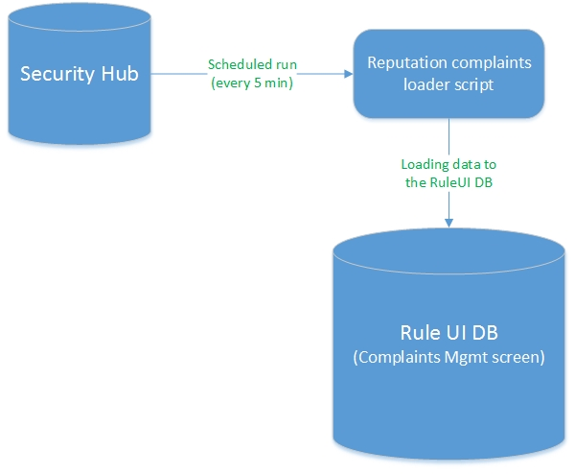
Automatic Reputation Complaints resolving workflow:
1. Scan URL with WBRS Lookup (via BLS) on complaint loading.
2. IF Good Sensor hit exists THEN import complaint to WBRS Rule UI as ‘new’ with ‘internal comment’: ‘BLS positive hit(s): tuse, suwl, vsvd;’. In case of BLC configuration errors or BLS unavailability ‘BLS: error;’ comment will be written to ‘internal comment’.
3. ELSE (no Good Sensor hits for URL) ‘internal comment’ is ‘BLS: -;’. URL will be scanned with Virus Total. Only 5 specific AV vendors will be used when retrieving results from VT: 'Kaspersky', 'Sophos', 'Avira', 'Google Safebrowsing', 'BitDefender'.
4. IF VT scanners positives >=1 THEN submit URL to RepTool blacklist DB via API with auto user credentials, ‘malware’ classification and ‘TE SecHub-Auto’ comment AND import complaint to WBRS Rule UI as ‘resolved’. Scan results with listed scanners’ positives specified will be added to ‘internal comment’: ‘VT: 'Google Safebrowsing: malicious site, BitDefender: malware site';’
‘VT: error;’ comment will be written to ‘internal comment’ in case of any VirusTotal Client errors.
5. IF no positives from mentioned VT scanners found (URL is clean or not found) THEN
6. ‘VT: -;’ is added to ‘internal comment’. AND scan domain (extracted from URL) with Umbrella.
7. IF Umbrella result is ‘-1’ (malicious domain detected) THEN submit URL to RepTool blacklist DB via API with auto user credentials, ‘malware’ classification and ‘TE SecHub-Auto’ comment AND import complaint to WBRS Rule UI as “resolved” with “Umbrella: malicious domain.” verdict added to “internal comment”.
8. IF Umbrella shows domain as clean (or not found in DB) THEN import complaint to WBRS Rule UI as “new” with “internal comment”: “BLS: -; VT: -; Umbrella: -;”. This means complaint must be resolved manually.
Auto-resolving flow:
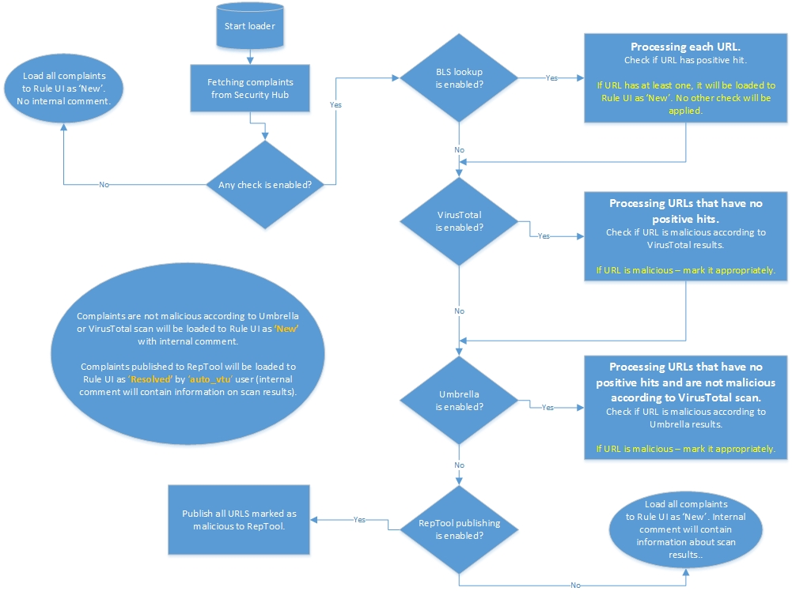

Complains automatically resolved via the flow described above will be visible on “WebRep Complaint Mgmt” screen of the WBRS Rule UI when searching by “Users”: “auto_vtu”.

External Interfaces

CLIs
New CLI options will be added to admin reputation complaint loader so new features, including automatic checks and Reputation tool, will be turned off by default. This will also improve backward compatibility.
python $PRODROOT/src/python/wbrs_rule_ui/bin/admin_reputation_complaint_loader.py -h
Usage: admin_reputation_complaint_loader.py [OPTIONS]

Options:
-h, --help show this help message and exit
-v VERBOSE, --verbose=VERBOSE
Verbose output.
-b, --bls Enable BLS positive hits scan.
-t, --virustotal Enable VirusTotal scan.
-u, --umbrella Enable Umbrella scan.
-r, --reptool Enable submission to RepTool.
New reputation complaints are loaded into WBRS Rule UI DB:
"SELECT state, user_name, internal_comment FROM wbrs_rule_ui.reputation_complaint_history \G;"
*************************** 1. row ***************************
state: resolved
user_name: auto_vtu
internal_comment: BLS: -; VT: 'Sophos: malicious site, Avira: malware site, Kaspersky: malware site, BitDefender: malware site';
*************************** 2. row ***************************
state: new
user_name:
internal_comment: BLS positive hit(s): suwl, a500;
*************************** 3. row ***************************
state: new
user_name:
internal_comment: BLS positive hit(s): tuse, suwl, vsvd;
*************************** 4. row ***************************
state: resolved
user_name: auto_vtu
internal_comment: BLS: -; VT: 'Google Safebrowsing: malicious site, BitDefender: malware site';
*************************** 5. row ***************************
state: new
user_name:
internal_comment: BLS: -; VT: -; Umbrella: -;

Programmatic interfaces (RPC, exported classes, etc.)
N/A

Databases
N/A

User Interface
N/A

Capacity Requirements
No changes.

Configuration
New configuration variables with following default values will be added to ‘wbrs_rule_ui.conf’:
...
[bls]
host=stage-bls-vip.sv4.ironport.com
token=wbrs_rule_ui
feed_server=prod-feeds.vega.ironport.com
feed_name=wru_good_wbrs_rules
feed_file=wru_good_wbrs_rules.csv
client_name=BLS
timeout=eval(30)

[virustotal]
key=<VirusTotal API key>
report_url=https://www.virustotal.com/vtapi/v2/url/report
scanners=['Kaspersky', 'Sophos', 'Avira', 'Google Safebrowsing', 'BitDefender']
batch_size=eval(25)
timeout=eval(30)

[umbrella]
api_token=<Umbrella API token>
api_root=https://investigate.api.umbrella.com/
bulk_size=eval(1000)
timeout=eval(30)

[reptool]
username=<RepTool user name>
password=<RepTool user password>
blacklist_url=<RepTool API URL for blacklist entries>
verify_ssl='/etc/ssl/certs/talos_ca.crt'
timeout=eval(30)
...

Measurement and Monitoring

Measurement
N/A

Logging
Following logging messages will be added:
WARNING: 'Automatic checks are disabled.'
INFO: 'Initialising BLC.'
DEBUG: '`<URL>`: positive hit(s): <hits>.'
INFO: 'Initialising VT.'
DEBUG: 'Malicious URL found with VirusTotal: `<URL>.`'
INFO: 'Initialising Umbrella.'
DEBUG: 'Malicious domain found with Umbrella: `<URL>`'
INFO: 'Initialising RepTool.'
ERROR: 'Error submitting url `<URL>` to Reptool: <error>.'
ERROR: 'Unexpected RepTool error: <error>.'
DEBUG: '`<URL>` submitted to Reptool.'
INFO: '<n> records were submitted to Reptool.'
INFO: 'Nothing to send to RepTool.'
WARNING: 'Reptool is disabled.'

Testability

Unit Tests
- $PRODROOT/unittest/python/wbrs_rule_ui/bin/test_admin_reputation_complaint_loader.py
- At least 80% of the module code should be covered by unit tests.

Component Tests
QA should verify:
- Reputation complaints are loaded with automatic checks disabled.
- Internal comment is written for checked records.
- Internal comments includes results for enabled automatic checks (BLS, VirusTotal, Umbrella)
- Malicious URLs have ‘resolved’ state and ‘auto_vtu’ user if Reputation tool is enabled.
- VirusTotal and Umbrella checks are skipped for URLs with BLS positive hits.
- Umbrella check is skipped for URLs that are malicious according to VirusTotal.

Failure Modes

Things which might break this feature
- Positive hits feed is not available.
- Beaker Lookup Server host is not available.
- Umbrella API is not available.
- Umbrella API key is not provided.
- VirusTotal API is not available.
- VirusTotal API key is not provided.
- RepTool API is not available.
- RepTool credentials not provided.

Things this feature might break
New reputation complaints will not be loaded to Rule UI database.
New reputation complaints will be loaded without automatic check and/or submission to RepTool.

Beaker lookup client.

Solution Overview
Simple BLC interaction method will be added to admin reputation complaint loader to perform automatic URLs check for positive hits (Good Sensor hits).
It will retrieve rule hits for given URLs and compare them with Positive (Good) WBRS rules from the corresponding feed.
See 4.6.1 for detailed workflow.

External Interfaces

CLIs
N/A

Programmatic interfaces (RPC, exported classes, etc.)
There will be two new methods in admin_reputation_complaint_loader.py:
def get_positive_hits(feed_hostname, feed_name, feed_file, client_name):
"""Load positive hits from feed.

:Return:
Dict of positive hits as keys and their mnemonics as values.
"""

def get_bls_results(urls):
"""Get BLS positives for URLs.

:Return:
Dictionary of format:
{
<URL>: {
'score': <score>,
'status': <status>,
'error': <error>
}
...
}
where
- 'score': -1 if no positive hits, 1 for positives,
None in case of error;
- 'status': status mnemonic;
- 'error': error message in case of error, None otherwise.
"""

Databases
N/A

User Interface
N/A

Capacity Requirements
No changes.

Configuration
See 4.6.5

Measurement and Monitoring

Measurement
N/A

Logging
Following logging messages will be added:
DEBUG: 'Getting positive hits from feed: `<feed>`.'
ERROR: 'Feeds Web client error: <error>.'
EXCEPTION: 'Unexpected feeds error: <error>.'
ERROR: 'No hits found in feed.'
DEBUG: 'Initialising BLC.'
ERROR: 'BLS error: <error>.'
EXCEPTION: 'Unexpected BLS error: <error>.'

Testability

Unit Tests
- $PRODROOT/unittest/python/wbrs_rule_ui/bin/test_admin_reputation_complaint_loader.py
- At least 80% of the module code should be covered by unit tests.

Component Tests
QA should verify:
- ‘Internal comment’ is written properly. (according to workflow, described in 4.5.1)

Failure Modes

Things which might break this feature
- Positive hits feed is not available.
- Beaker Lookup Server host is not available.

Things this feature might break
Admin Reputation Complaint Loader will be not able to perform URL check with WBRS Lookup (via BLS) on complaint loading.

Reputation complaint retract functionality.

Solution Overview
WBRS Rule UI ‘WebRep Complaint Mgmt’ screen will be updated to provide the ability to retract corresponding RepTool entries and reopen the complaint as ‘New’.
RepTool API uses Talos (VRT) credentials, so Rule UI user will need to enter his credentials when retracting RepTool entries. Thus, when the user chose complaints resolved by ‘auto_vtu’ user and tries to change their status to ‘new’, click ‘Submit Changes’ button, a dialog window ‘Please, enter RepTool credentials’ with fields for username and password will be shown. After successful authorization, RepTool entries for checked URLs will be marked as ‘expired’ via Reputation tool client (see 4.5) and message with operation status will be shown.
Note: auto-resolved complaints will be not reopened in case RepTool expire operation was unsuccessful.
Both auto-resolved and regular complaints can be market via one request. In this case, regular complaints will be reopened as ‘New’ even if auto-resolved ones will fail due to RepTool error.

External Interfaces

CLIs
N/A

Programmatic interfaces (RPC, exported classes, etc.)
N/A

Databases
N/A

User Interface
Changing auto resolved complaints status to ‘new’:
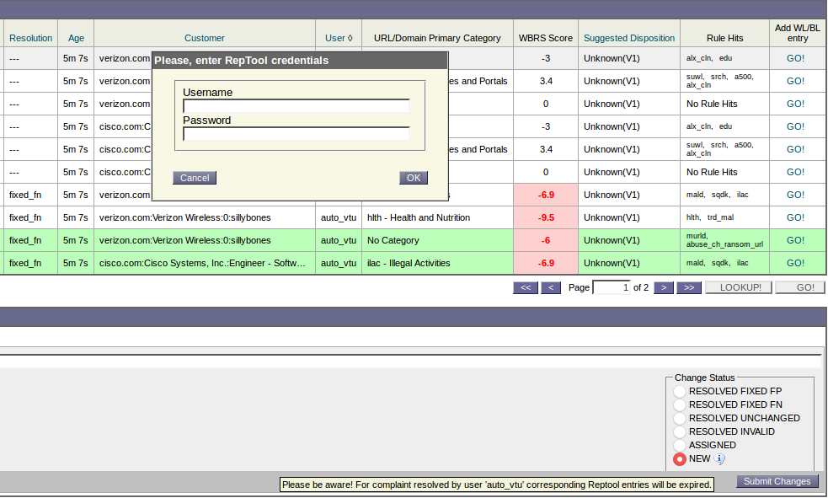

Operation result status message:
Message on RepTool authentication error. Regular complaints reopened successfully, auto-resolved complaints reopening failed.
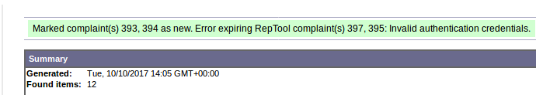
Message on RepTool error. Complaints’ status unchanged.
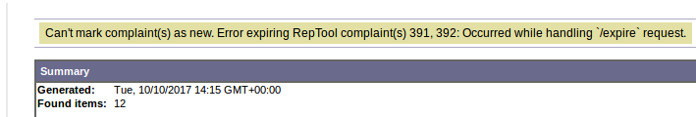

Capacity Requirements
No changes.

Configuration
N/A

Measurement and Monitoring

Measurement
N/A

Logging
Following logging messages will be added:
DEBUG 'Getting reputation complaints from DB by IDs: <IDs>'
INFO 'Initialising RepTool client.'
DEBUG 'Expiring RepTool complaint(s): `<URLs>`.'
ERROR 'RepTool error expiring complaints `<URLs>`: <error>.'
ERROR 'Unexpected RepTool error: <error>.'
DEBUG 'RepTool results: <n> expired, <n> not found.'
DEBUG "'None' response received from RepTool."

Testability

Component Tests
QA should verify:
- ‘Please, enter RepTool credentials’ dialog window is shown on marking auto-resolved complaint(s) as ‘new’.
- Corresponding RepTool entries are marked as ‘expired’ after a complaint is reopen as ‘new’ on ‘WebRep Complaint Mgmt’ screen.
- Message with expiration operation status is shown.

Failure Modes

Things which might break this feature
RepTool API is not available.

Things this feature might break
RepTool entries will be still active even when Rule UI complaint will be marked as ‘New’.

Third Party Relationships
Beaker Lookup Server
VirusTotal API
Umbrella API
RepTool API

Patentability Considerations
N/A

Performance and Scalability
N/A

Bug Scrub
The following bug(s) will be addressed in this release:
Bug | Description
RULEUI-1086 | Traceback occurs during submission of BL-BTF item
RULEUI-1089 | Buttons "GO!" is unavailable on WebRep Complaint Mgmt for complaints with status "Assigned"

Physical Migration
N/A

Equipment Consideration
N/A

SysOps Environment/Equipment Requests

Production
No changes expected.

Staging
No changes expected.

Sysops New Product Guidelines
No changes.

Access, Roles, and Security
No changes.

Dependencies

This product --> x
The following is a list of products that WBRS Rule UI depends on:
Consumer | Protocol | Description
Feeds* | HTTP | API
wbnp_vector | DB
wbrs_rule_lib | RPC | API
weblookup_server | RPC | API
XBRS | HTTP | API
BLS | HTTP | API
VirusTotal | HTTPS | API
Umbrella | HTTPS | API
RepTool | HTTPS | API
py27-pycurl |  | python library
py27-requests |  | python library
py27-urllib3 |  | python library
* Good wbrs rules feed will be requested:
http://prod-feeds-app1.vega.ironport.com/wru_good_wbrs_rules/data/wru_good_wbrs_rules.csv

x --> This product
No new dependencies. The following is a list of products that depend on WBRS Rule UI:
Consumer | Protocol | Description
catbayes | DB
feeds | DB
security_hub | HTTPS | API

Follow up
- It is the spec author’s responsibility to review the Test Plan written by QA.
- It is the spec author’s responsibility to review the Project Plan written by OpsEng.

Glossary
N/A | Not Available
BLS | Beaker Lookup Server
BLC | Beaker Lookup Client
VT | VirusTotal

End of Document

