**Comp1168 LabNo02**

Name: Lopes Mafra, Breno

CRN: 50143

Student Id: 101485572

Date: 2024/01/18

**Question1**

use om;

select artist, title

from om.items

WHERE artist = 'Umami'

ORDER BY title asc;

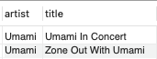

**Question2**

use om;

select customer_first_name, customer_last_name, customer_zip

from om.customers

WHERE customer_zip LIKE '9%'

ORDER BY customer_first_name asc;

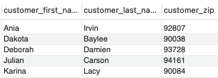

**Question3**

[copy the SQL Code for the query here!]

**.... Question?**