KITSUNE is a open-source and command-line-based file explorer made using Python and its technologies.

1 – Running
1.1 – Installing Python 3
1.1.1 – Windows/Mac
Go to python.org and click select download
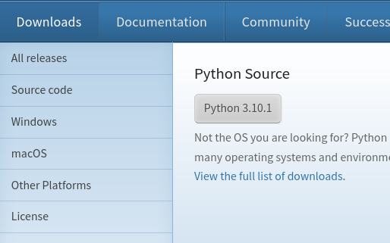

Then, follow the instructions
1.1.2 – Linux/FreeBSD
It is already preinstalled.
1.2 – Installing the necessary libraries
At this moment, all libraries used are bult-in, but, if you are using windows or some third party library are being used on the future, write this command on script's directory:
This will install all necessary libraries
2 – Basic navigation
2.1 – Getting current path with "path" command
path is a command that output the current directory

ARGS: no args
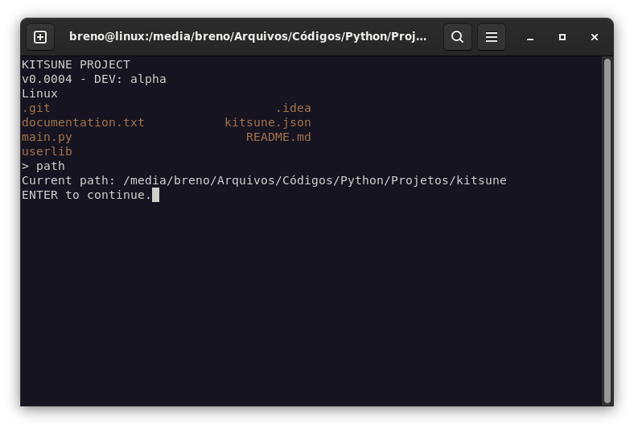

2.2 - Changing current path using "cd"
You can change the current path using "cd" command

ARGS: cd <path>
Which path can be a folder on the current path or a full path

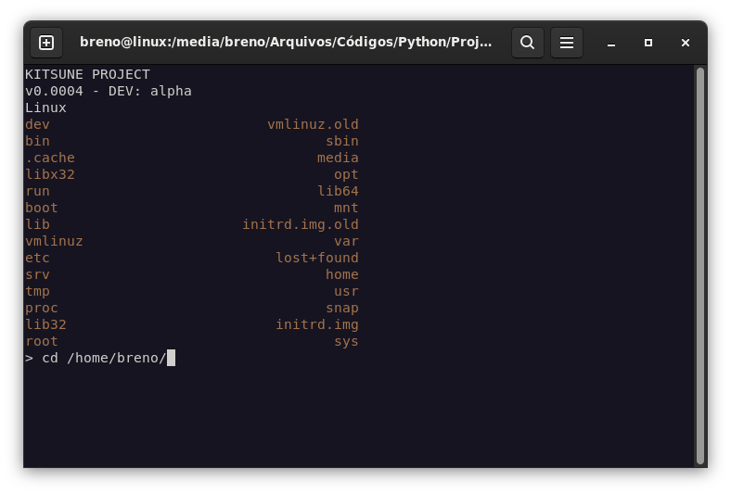
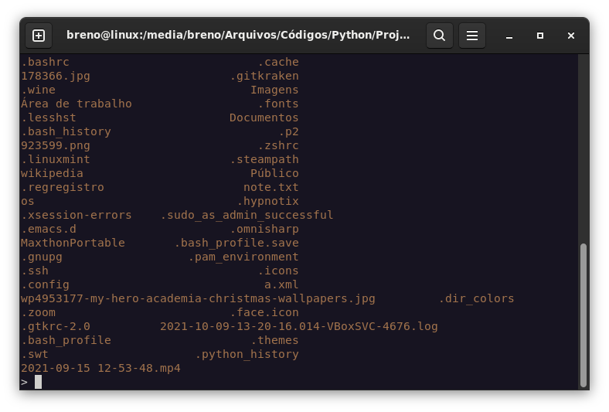
Typing:
. as argument, nothing will happen
.. as argument, the current path will be the father directory
3 – Filesystem manipulation
3.1 – Command "make"
3.1.1 – Make command
The make command is used to create file and directories.

ARGS: make <type> <path>
Which type can be "dir" or "file" and path a full path or just the name (if it is just the name, the file/directory will be created on the current path)
3.1.2 – Creating directories using "make dir":
As specified on the past topic, to make directories you need to use the "dir" argument.

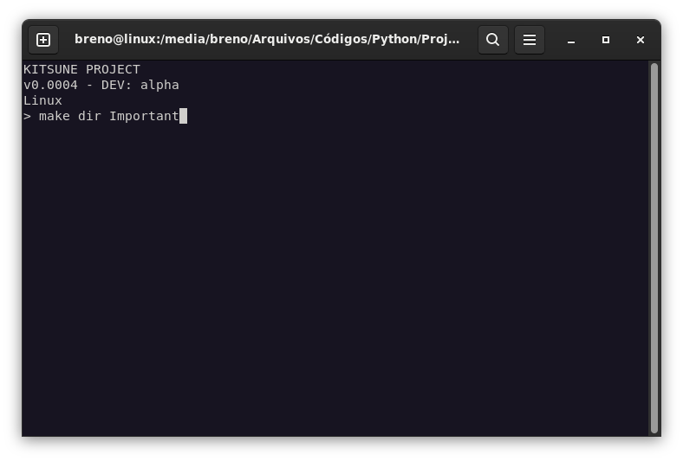
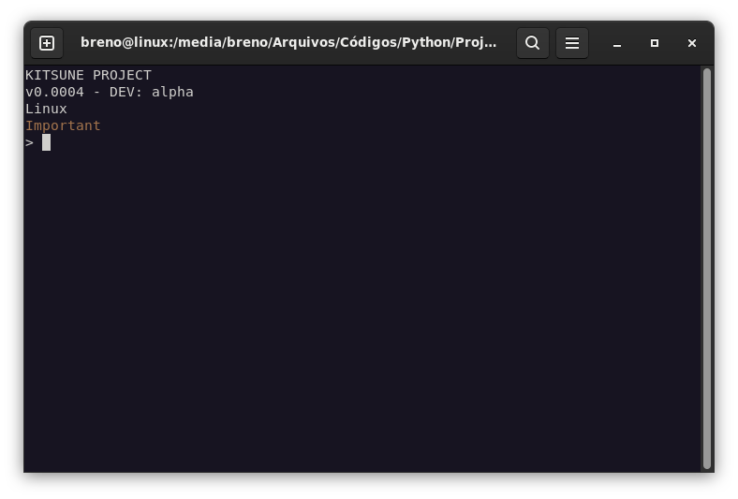
3.1.3 – Creating files using "make file"
Same for file
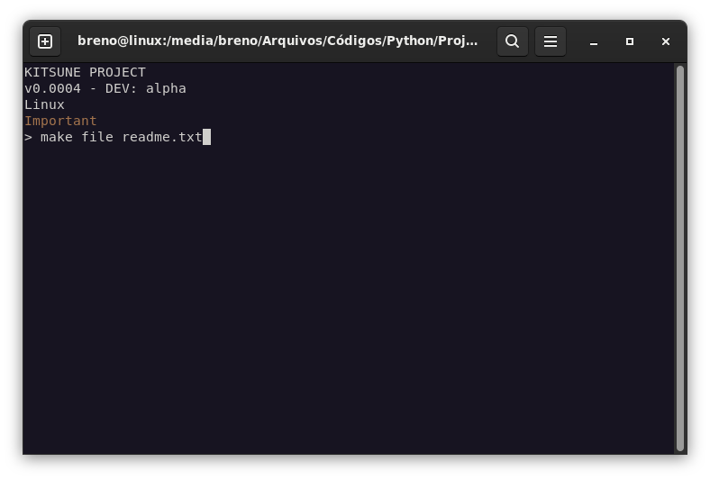

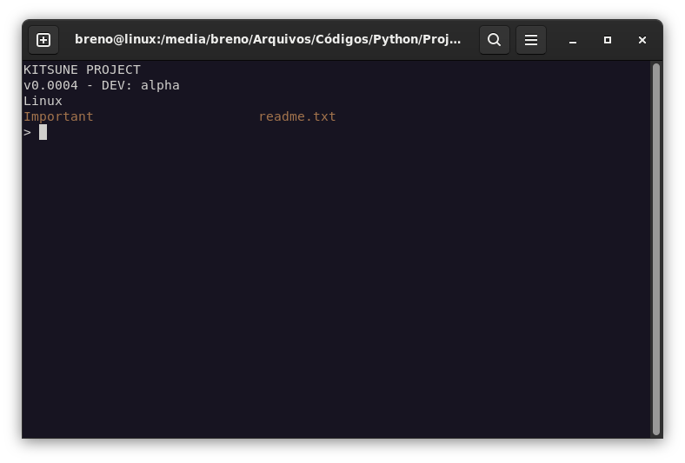
2.2 – Command "file"
2.2.1 – Command file
This comand manipulates a file

ARGS: file <action> <path> <args>
Which:
Action: write, append, read
write:
Will overwrite all the content of a file and write a text
append:
Will add a text at the end of a file
read:
Will output the content of a file
Path: file on current directory or full path
Args: Text if aplicable
2.3 – Command "copy
2.3.1 – Command copy
Will copy a file or directory

ARGS: copy <source> <target>
Which:
source: origin
target: target path (full path)
2.4 – Command remove
2.4.1 – Command remove
Delete a folder or a directory
ARGS: remove <path>
Which path is a full path or a entity on the current directory
3 – Visual elements
3.1 – Apparence
When you run it, you will se something like that:

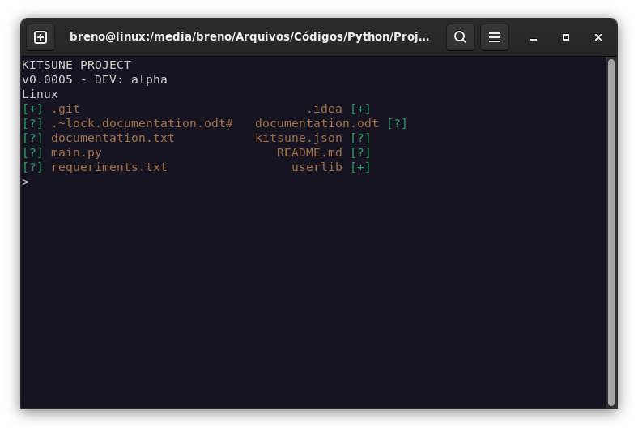
Basically, the interface is separated in 3 parts:
Software info: On the top, in white. It shows informations like the version, operating system and etc
Folder content: The content of the current directory
Input area: where you write the command
3.2 – Software info area
On the first line, it will show software's name.

Second line, it shows the version and the current state of development. The version number is defined by the number of releases since the last major version

The third line is the current operating system, it will be removed later
3.3 – Folder content area
It contains the name of the content and its type. The type is the symbol next to the content name

Symbols:
+ - Directory
? - Uknown file type

