**B R E N T J E R E M Y N E L S O N**

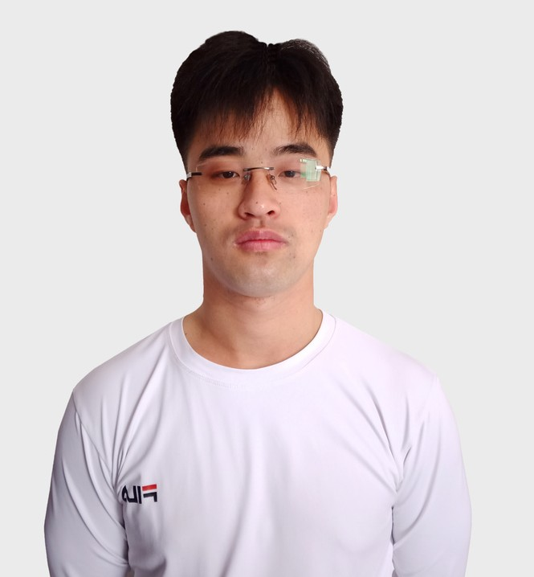

B L O C K C H A I N | W E B D E V E L O P E R

**P R O F I L E**

A proficient blockchain developer with 5+ years of experience, interested in contributing expertise in web and blockchain development.

Capable of excelling as part of a team or individually in a fast- paced environment.

Deeply knowledgeable in distributed ledger, blockchain security, blockchain architecture patterns, and different blockchain standards and ecosystems.

I have experience developing DeFi, DEX, DApp, Trading Bot, Token, autonomous systems and artificial intelligence. I am fluent in Solidity, Web3.js, Python and JavaScript ,and have worked on a variety of projects as a consultant, helping clients achieve their goals.

I have a lot experience efficiently coding websites and applications with modern Framework like Angular, React and Vue.

I am continuously trying to improve, learn more and gain new experiences.

+1 561 501 0926

[brentjeremynel@gmail.com](mailto:brentjeremynel@gmail.com) <https://brent-jeremy.github.io/>

**S K I L L S**

# React Solidity Rust Python

DEVOPS

**W O R K E X P E R I E N C E**

NodeJS

## PROLOCALIZE, CTO

Prolocalize - Thailand

## AUG, 2019 — PRESENT

**L A N G U A G E S**

English

Prolocalize is Thailand’s most innovative and fastest growing company founded in 2017 with the aim of boosting the reach ofbusinesses andinformationaccessibilityacross theglobal community.

We are a team of young talented experts with passion and dedication for helping companies to promote their businesses and reach a worldwide audience via the provision of quality and speedy services with the aid of cutting-edge technologies.

We observe a high standard of professionalism by cultivating a strong work ethics geared towards continuous research and development.

# Thai

**S O C I A L L I N K S**

Our work principle is quality focused and our management system supported by ERP is compliant with PMBOK, ISO 17001:2015, ISO 9001:2015 and GDPR 2016/679. In this company I have worked in ML such as ,NMT,AutoML,and so on.

I have developed our own translator and make one translator platform for company work with AWS Amplify + Angular.

And when I have some part time I developed some services for marketing youtube downloaders, transcribers, and so on.

The company's live site is https://prolocalize.com but it is on maintenance now.

We are training with big data now.

**E D U C A T I O N**

**Master's Degree**

King Mongkut's University of Technology Thonburi

*AP R , 20 1 3 — MA R , 20 1 8*

I graduated from King Mongkut’s University of

## LUCKY SHIBA, CTO

Lucky Shiba - United Kingdom

## AUG, 2021 — PRESENT

Technotlogy Thonbun.

King Mongkut's University of Technology

And from last year I have worked for Luckyshiba company. It is England company and the site is https://luckyshiba.org/ It is a Blockchain game company.

We are developing a shooting game and all are ready to the lunch game.

In this company , I was a solidity developer.

So I have worked from token deploy and game logic with solidity.

You can check our company members from https://docs.luckyshiba.org/team.

## FULLSTACK DEVELOPER 2019-2021

https://prolocalize.com

This site was developed in Wordpress by an old developer. I have updated this site to react and added NMT translators such as Google translator.

The backend was developed with python Django. And the frontend was developed with react.

Now we are training more and more languages.

Also ,there is a task management system such as smart cat. It will be very popular in a few years.

## BLOCKCHAIN DEVELOPER-DEX JAN, 2021 -FEB, 2021

https://rskswap.com/ Uniswap dex site.

We deployed the router solidity contract to ETH network. And developed a site with react and interact to contract using web3js.

Thonburi or colloquially "Bangmod is an engineering and technology university in Thailand n this university I mastered in Computer sicence. So my software development was started from university.

In the university I learned web and Machin Learning.

So I worked easily in Porolocalize company after leave the university.

Thai Solutions School in Bangkok

*Apr, 2011— Mar, 2013*

I have studied at Thai Solutions School in Bangkok for 2 years.

There are about 3 courses in the school and to graduate school, I should pass these courses.

I learned basic programming and mathematics in this school.

I love my school.



## BLOCKCHAIN DEVELOPER-DEX JUL, 2021 -AUG, 2021

https://admin.usth.finance/ Pancakeswap dex site.

I deployed PRX token on BSC network.

Deployed router solidity contract to BSC network. So this is dex site for only PRX/BNB pair.

I developed a site with react and interact to contract using web3js.

## BLOCKCHAIN DEVELOPER-STAKING MAR, 2021

https://bnbstaker.xyz/ This is BNB staking site

So If any user will deposit bnb then they will get a reward with bnb.

As you can see from the site there are 3 plans. 14days lock plan,21days lock plan,28 days lock plan.