Natural Resource Stewardship & Science

Business Architecture Part Deux

IPData

Invasive Plant Data Management Solution v1

General Requirements

**Table of Contents**

1 User Roles 1

2 Setup and Loading 1

3 Reporting 2

3.1 Park Summary 2

3.2 Management Area Summary 2

3.3 Project Summary 2

3.4 Crew Operations Summary 3

3.5 Target Species Summary 4

User Roles

System Roles

* **Anonymous** – Lacking any IRMA role
* **Partner** –IRMA Partner; No other role with IPDATA
* **Staff** – Any NPS user with an Active Directory Account
* **Unit Data Manage**r – Can be shared by multiple users. Associated with an NPS unit. Can be anointed by other IPData Manager for that specific unit.
* **Administrator** – Inherits all rights of all roles

|  |  |  |  |  |  |
| --- | --- | --- | --- | --- | --- |
|  | Anonymous | Partner | Staff | UDM | Admin |
| View Public Reports | Yes | Yes | Yes | Yes | Yes |
| View Internal Reports |  |  | Yes | Yes | Yes |
| View All UDM Reports |  |  |  | Yes | Yes |
| View Admin Reports |  |  |  |  | Yes |
| Upload Unit Data |  |  |  | Yes; for specific Unit | Yes |
| Download Submitted Unit Data |  |  | Yes | Yes | Yes |
| Grant UDM Rights Specific to a Unit |  |  |  | Yes; for specific Unit | Yes |
| Can be granted UDM Rights | No | Yes | Yes | N/A | N/A |

Setup and Loading

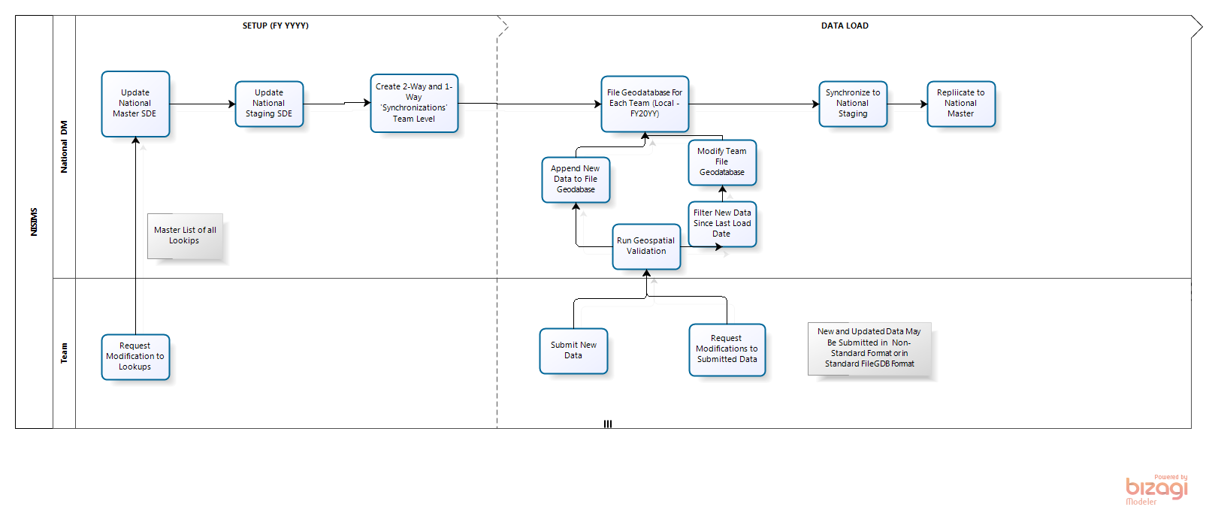

Notification

|  |  |  |
| --- | --- | --- |
| Action/Event | Recipients | Notification Message |
| Data Successfully Uploaded | UDM(s) for respective unit; Admin |  |
| Data Successfully Loaded to Database | UDM(s) for respective unit; Admin |  |
| Data Failed Load to Database | UDM(s) for respective unit; Admin |  |
| Requested edits were applied to database | UDM(s) for respective unit; Admin |  |
| Lookup values adjusted/updated | UDM(s) for respective unit; Admin |  |
| UDM Added | UDM(s) for respective unit; Admin |  |

Reporting

Park Summary

* Park Summary (by Date Range) –Effectively equivalent to the Management Area Summary, except that it applies to the geospatial extent of an entire park.

Management Area Summary

* Management Area Summary (by Date Range) – Summarizes inventory/trends of invasive plant populations, crews/affiliations that have worked in the area, type/amount of work accomplished, and type/amount of herbicide products applied within the boundaries of a Management Area.

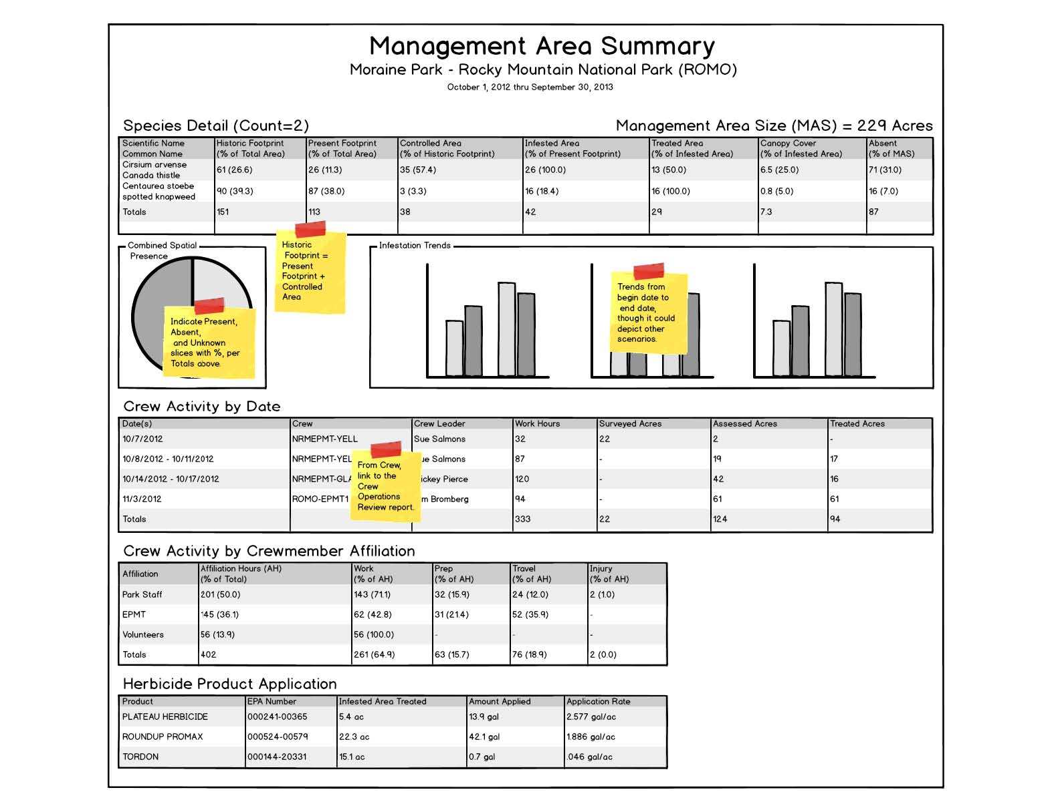

Project Summary

* Project Summary (by Date Range) – Summarizes the activities (Survey/Assessment/Treatment) and employed resources associated with a particular management effort (i.e. Project). This body of work is not bound by geospatial extent, date range, or Crew / Crew Affiliation.

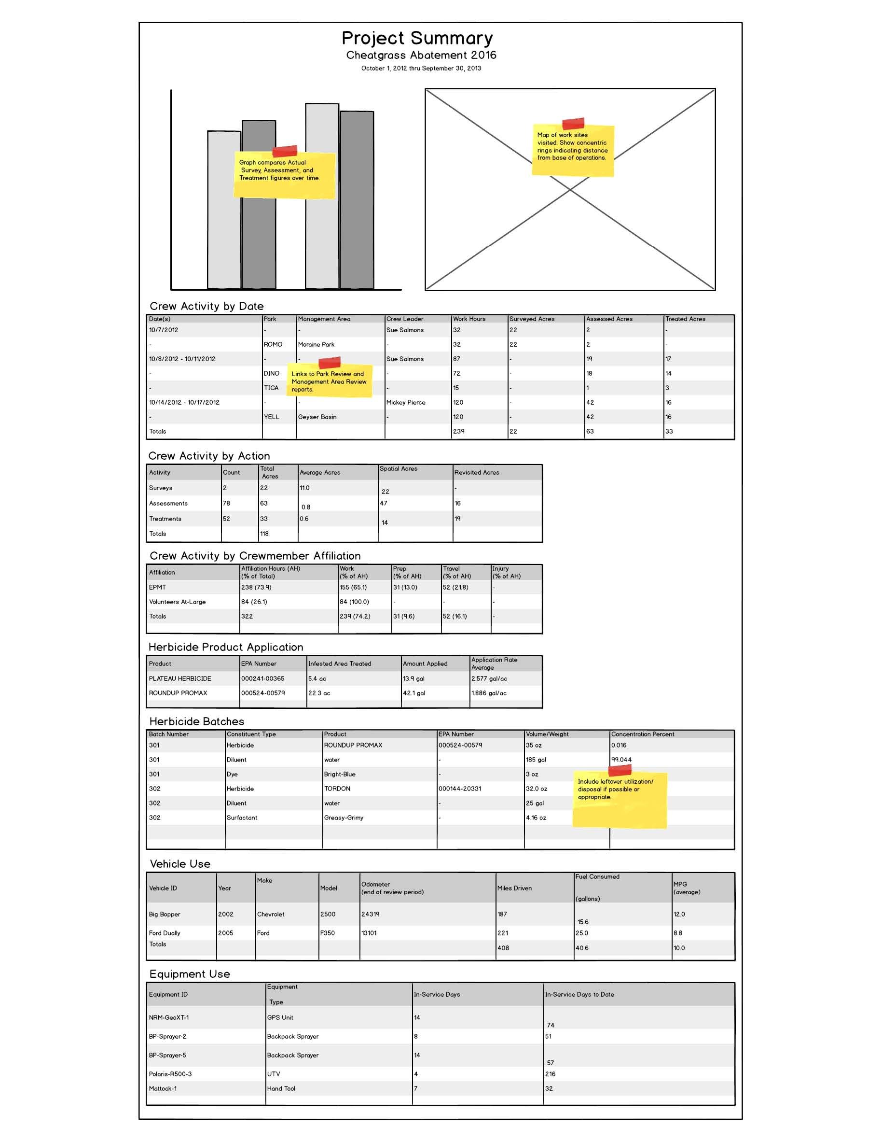

Crew Operations Summary

* Crew Operations Summary (by Date Range) – Summarizes the type, amount, and location of work accomplished by a Crew. It also describes and quantifies the resources employed to accomplish the work (i.e. vehicles, equipment, and herbicide products).

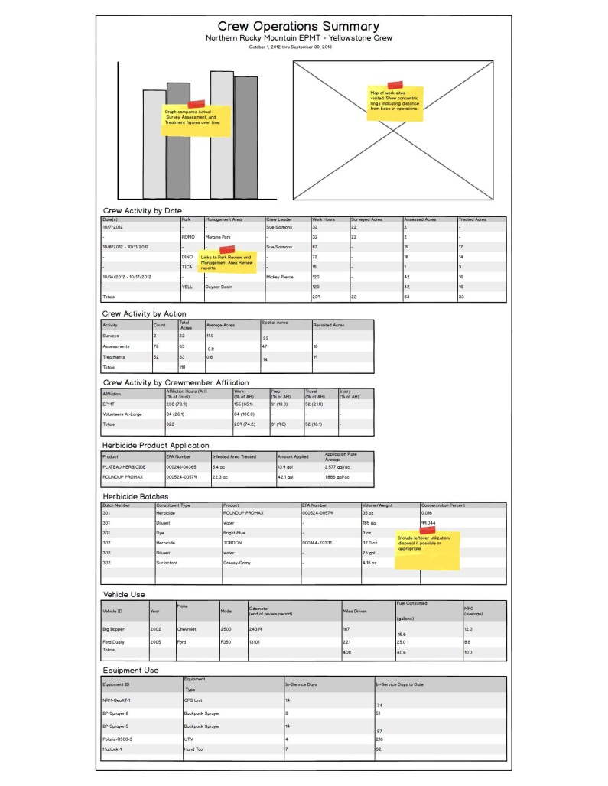

Target Species Summary