Inserted picture from file

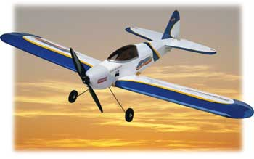

Picture pasted from clipboard, by default embedded as an object.

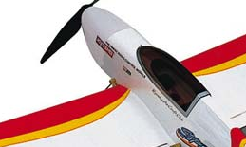

Pictures pasted from clipboard selected As Picture format.

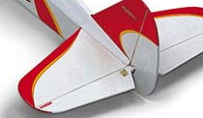

Word art:

Embedded object



This is a metafile:

