**Name:** _____________________________________________ **Date:** _____________________

**Username:** _____________________________ **Password:** ______________________________

**Email:** _________________________________ **FCP: ­**­___________________________________

**Login Instructions and My Dashboard Overview**

1. Open any major Internet browser. Google Chrome is recommended. Type **www.clearworks4ears.com** into your search engine.
2. Click on the blue “**Sign Up/Login**” box in the upper-right hand corner of the screen.
3. Enter your **email address** and **password** and click on the “**Log In**” button.

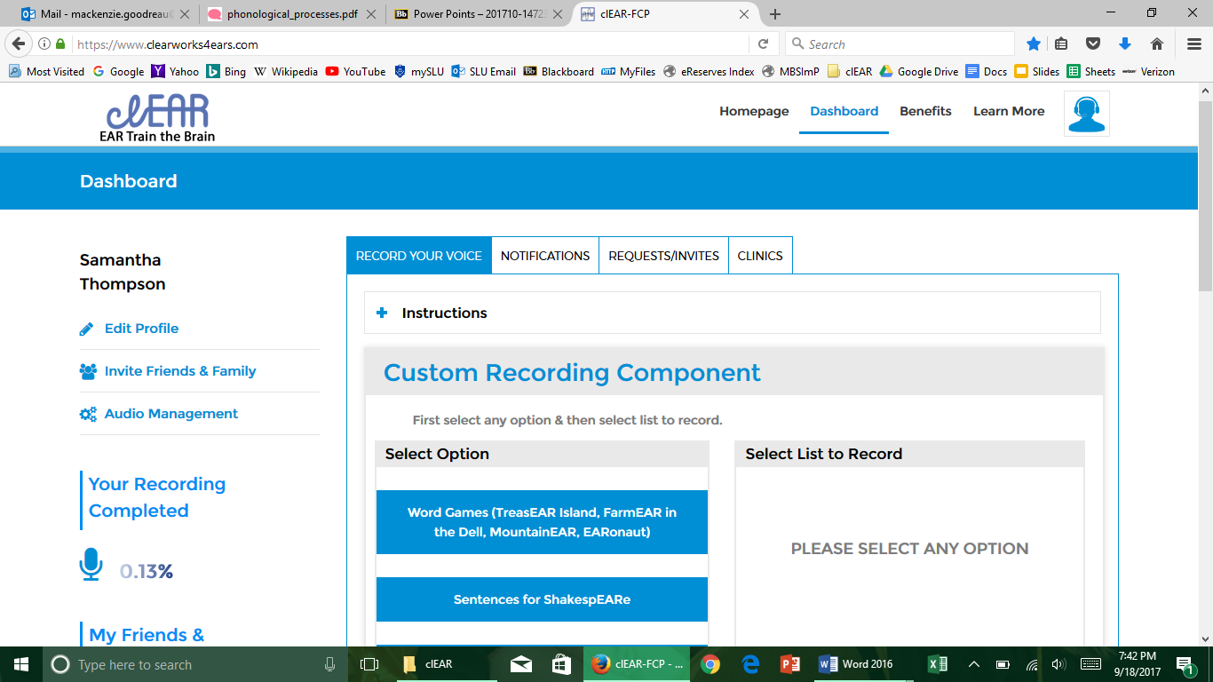

1. You will now see **Dashboard**. There are four tabs that you can navigate within your dashboard. Listed below is each tab with their description.
   1. **Record Your Voice** – Under this tab, you will find instructions about recording your voice. You will also find three different options to record in. Each option contains a different number of lists. A solid blue list indicates that you have already completed the recordings for that list. If you see any gray, that means you still have some recordings to finish.
   2. **Notifications** – This tab will show you any new notifications you receive from the hearing health professional.
   3. **Requests/Invites** – This tab will probably not be utilized often, unless you’re recording your voice for multiple communication partners.
   4. **Clinics** – This tab will provide you with information about our clinic.

**Recording Your Voice**

1. Click the **Record Your Voice** tab under “Dashboard.”
2. Select which option you would like to record in. Options include: “**Word Games**,” “**Sentences for ShakespEARe**,” and “**Phrases for pEARl Crunch**.”
3. Each option has lists to record. The number of lists will vary under each option:
   1. **List #** – Click which list you want to record when you are ready to begin.
   2. You will see a **red** box with a word, sentence, or phrase in it. When that box turns **green**, you are ready to record. Simply say the word, sentence, or phrase as it appears on the screen.
   3. After you’re done speaking, the blue microphone will disappear and a box with a waveform will appear. You can click “**I want to hear it again**” to listen to what you just recorded. If you decide to keep the recording, click “**Accept**.” If you would like to record again, click “**Reject**.”
   4. When you have finished recording a list, you can either “**Continue**” to the next list, or “**Exit**” back to your “Dashboard.”

Comments: ___________________________________________________________________________  
_____________________________________________________________________________________

**Hearing Healthcare Provider Information**

Name, Degree Name, Degree

Title Title   
Email Email