**Name:** _____________________________________________ **Date:** ____________________

**Username:** _____________________________ **Password:** ______________________________

**Email:** _________________________________ **Code:** __________________________________

**Login Instructions and My Dashboard Overview**

1. Open any major Internet browser. Google Chrome is recommended. Type **www.clearworks4ears.com** into your search engine.
2. Click on the blue “**Sign Up/Login**” box in the upper-right hand corner of the screen.
3. Enter your **email address** and **password** and click on the “**Log In**” button.

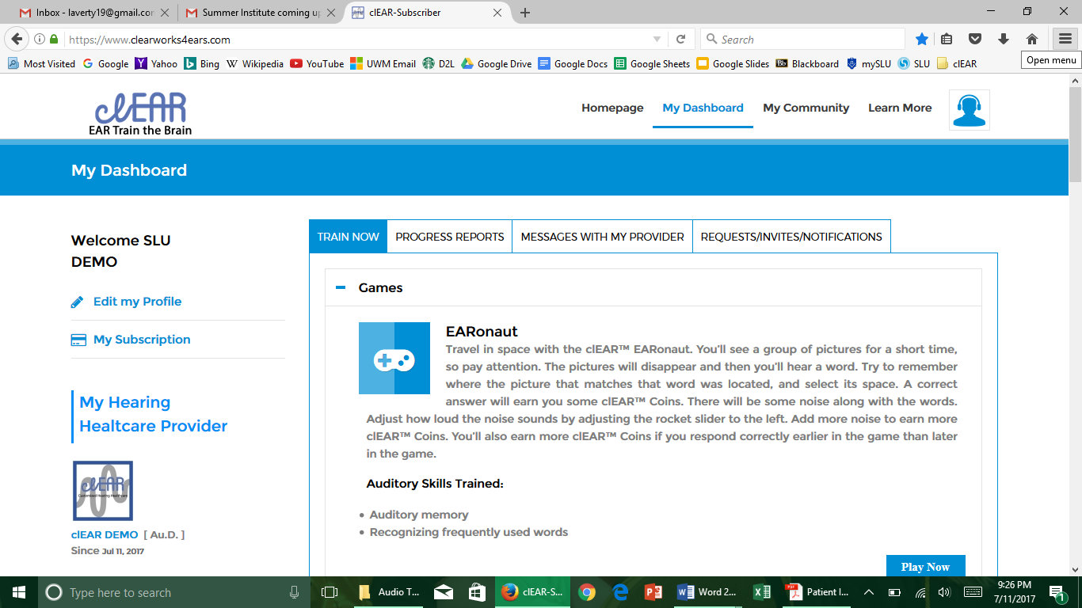

1. You will now see **My Dashboard**. There are four tabs that you can navigate within your dashboard. Listed below is each tab with their description.
   1. **Train Now** – Under this tab, you will find the six games that correspond with the weekly lesson plans. Each game has a description and the auditory skills that are being trained. Later in the document, we will discuss how to play the games.
   2. **Progress Reports** – This tab allows you to follow your own progress. As you play the different games, the site will automatically track your progress. Your hearing healthcare provider will also track your data and check-in with you about your progress.
   3. **Messages With My Provider** – In this tab, you can send messages to your hearing healthcare provider. Type your message in the box and click the blue “**Send**” button to send your message/email. We will receive a notification that you messaged us, and respond to you as soon as possible.
   4. **Requests/Invites/Notifications** – This tab will probably not be utilized often.

**Playing the Games**

1. Click the **Train Now** tab under “My Dashboard.”
2. Find the game you would like to play and click the blue “**Play Now**” box.
3. Each game has a home screen. You will find five options on the home screen:
   1. **Start Game** – Click this button when you are ready to begin your game.
   2. **Select Talker** – Before beginning, you will need to choose which talker you would like to listen to.
   3. **Statistics** – You can learn about your past game plays (what level you’re on, how many coins you have collected, etc.)
   4. **Instructions** – This button will explain how to play each game.
   5. **Exit** – Click this if you would like to go back to “My Dashboard.”

Comments: __________________________________________________________________________  
_______________________________________________________________________________________________________________________________________________________________________________________________________________________________________________________________

**Hearing Healthcare Provider Information**

Name, Degree Name, Degree

Title Title  
Email Email

clEAR Username clEAR Username