MIDTERM PROJECT SUBMISSION CHECKLIST
Student Name: Brent Lawrence C. Bernardo
Section / Group: ITE231
Professor: Paul John Cabance
Project Title: EverCare
Submission Date: August 19, 2026
Project Progress Submission Requirements
A. Project Documentation
☑ Project Title and Description
☑ Project Objectives Defined
☑ Scope and Limitations Identified
☐ Updated System Flowchart / Architecture Diagram (In Progress)
☑ Database Design (ERD or Schema)
☑ Project Progress Report (Current Accomplishments)
B. System Implementation
☑ User Interface (UI) Developed
☑ Navigation and Routing Functional
☑ Core Features Implemented
☑ Forms and Data Validation Working
☑ Error Handling Implemented
C. CRUD Functionality
☑ Create Operation Working
☑ Read/View Operation Working
☑ Update Operation Working
☑ Delete Operation Working
☑ Search/Filter Feature (if applicable)
D. API Integration and Testing
☑ API Connection Successfully Established
☑ GET Requests Tested
☑ POST Requests Tested
☐ PUT/PATCH Requests Tested
☐ DELETE Requests Tested
☑ API Responses Properly Displayed
☑ Error Responses Properly Handled
☑ Authentication/Authorization Implemented (if applicable)
☑ API Documentation Available
E. Project Demonstration Materials
☑ Source Code Available and Organized
☑ System Ready for Live Demonstration
☑ Presentation Slides Prepared (if required)
☐ Sample Data Available for Testing
☑ Project Repository Updated
F. Midterm Progress Evidence
☑ Screenshots of Implemented Features
☑ API Testing Screenshots/Logs
☐ Database Screenshot
☑ Source Code Samples for Key Features
☑ List of Completed Features
☑ List of Remaining Features for Final Project
Project Completion Status
Status: In Progress - UI/navigation, Supabase CRUD, OpenStreetMap API, and automated tests are complete; final evidence items remain.
Component | Complete | In Progress | Not Started
UI/UX Development | ☑ | ☐ | ☐
Navigation & Structure | ☑ | ☐ | ☐
CRUD Features | ☑ | ☐ | ☐
API Integration | ☑ | ☐ | ☐
Documentation | ☐ | ☑ | ☐
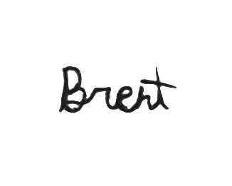
Declaration
I certify that the submitted project update, source code, documentation, and demonstration materials are my/our current work and accurately reflect the progress achieved as of the midterm evaluation.
Student Signature: ________________________________
Date: August 19, 2026
Note: This checklist aligns with the evaluation areas in Midterm_Examination_Week6, particularly the requirements for system checking, progress presentation, CRUD functionality, and API integration.

