K01 Gate04E
FEM / FEMM Verification Report
Revision 1 | 2026-09-06
Project | K01 Calibration Module
Scope | P006 service structural screening + current-position FEMM magnetic screening
Evidence root SHA-256 | c0b78d820237f75b173c6c67ca61a273fdfd45297be325dad19658b06d7e6e03
Document class | Internal engineering verification / design-screen evidence

Executive decision
Structural FEM: PASS — adequate for the defined linear-static P006 service load case.
FEMM field/automation screen: PASS_WITH_LIMITATIONS — both 1 A-turn cases solved and produced field evidence; absolute force extraction is not verified.
Gate04E engineering screen: PASS TO CONTINUE — current evidence is sufficient to proceed to downstream engineering nodes.
Production release: NOT READY — tolerance chain, CalculiX cross-check/reconciliation, drawings and BOM remain controlled downstream work.

1. Structural FEM — SolidWorks Simulation
Source: latest K01-A-001_GATE04E_P006_SERVICE_VERIFY static report. The revised study now assigns both analyzed solid bodies to one material: 1.4404 (X2CrNiMo17-12-2).
Item | Value | Engineering interpretation
Material | 1.4404 (X2CrNiMo17-12-2) | Consistent assignment to both analyzed bodies
Yield strength | 400 MPa | Acceptance reference used for simple yield margin
Elastic modulus / Poisson | 200 GPa / 0.28 | Linear elastic isotropic model
Normal force | 300 N | Service load
Pressure | 0.02 MPa on 5 faces | Adds small resultant to support reaction
Bolts | 3 × M2.5, 300 N preload each | Connector representation
Contact | No penetration, surface-to-surface | Global contact

1.1 Mesh
Metric | Value
Nodes | 102,923
Elements | 63,800
Nominal element size | 1.12755 mm
Maximum aspect ratio | 13.093
Elements with AR < 3 | 92.3%
Elements with AR > 10 | 0.00313%
Distorted Jacobian elements | 0%

1.2 Results and margin
Metric | Result | Acceptance view
Max von Mises stress | 40.66 MPa | 10.17% of 400 MPa yield
Simple yield factor of safety | 9.84 | Large static yield margin
Max resultant displacement | 0.002171 mm (2.171 µm) | Small global deformation
Max equivalent strain | 1.207×10⁻⁴ | Consistent with elastic response
Support reaction | 302.262 N | Consistent with 300 N force plus pressure resultant
Bolt axial force | 307.4–307.9 N | Close to applied preload; shear ~2.06–2.07 N
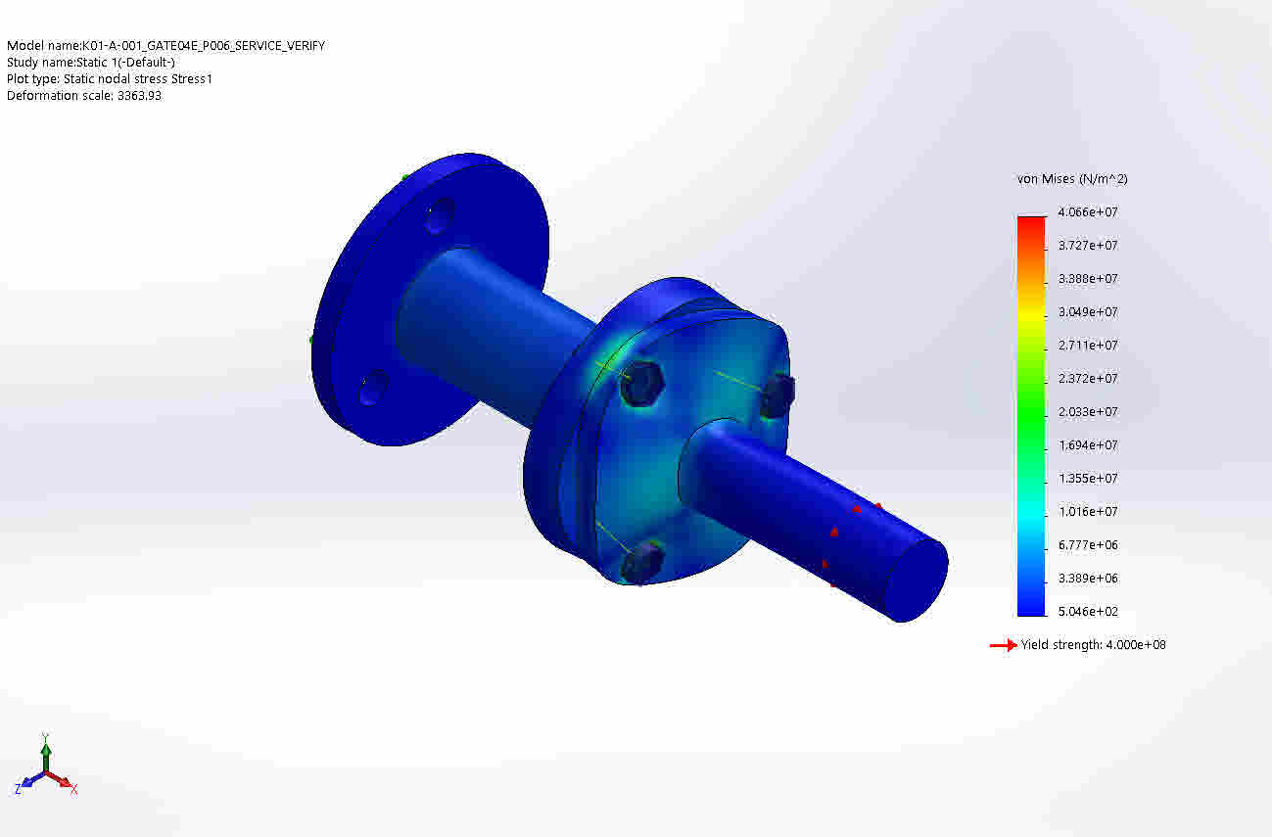
Figure 1 — SolidWorks von Mises stress field from the current verified study.
Structural verification: PASS — the current geometry is adequate for the defined static service load case. The verdict is scoped to linear static behavior; it does not assert thermal-cycle, nonlinear, fatigue, frictional-contact, or formal mesh-convergence release verification.

2. FEMM current-position screening
Two controlled 1 A-turn cases were executed: Coil A active / Coil B off, and Coil B active / Coil A off. Both DONE markers report PASS_SCRIPT_COMPLETED.
Evidence | Coil A | Coil B
Excitation | IA=1, IB=0 | IA=0, IB=1
Br / μ316 | 1.00 T / 1.005 | 1.00 T / 1.005
DONE marker | PASS_SCRIPT_COMPLETED | PASS_SCRIPT_COMPLETED
Reported Fz_N | 0 | 0
CSV completeness | Complete row; FluxB=2.624496529278694e-006 | Incomplete row; terminates at FluxA=
The field-density images confirm that FEMM completed a field solve and rendered a magnetic field distribution for both excitation cases. No controlled numerical Bmax extraction is present in the evidence set; therefore the plotted color scale is not used as a quantitative acceptance criterion.
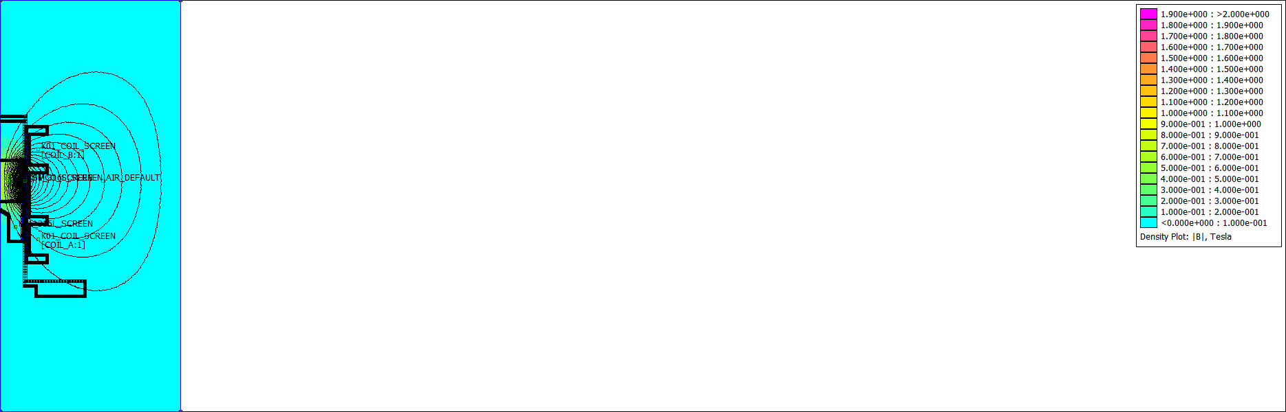 | 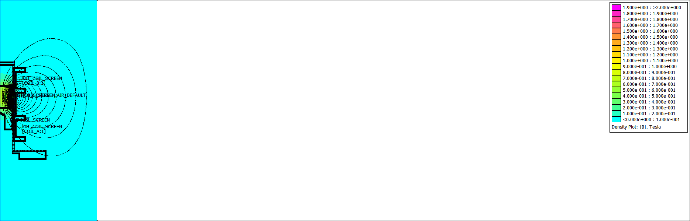
Figure 2 — FEMM field-density outputs for Coil A and Coil B 1 A-turn screening cases.

2.1 Controlled limitations
ID | Observation | Disposition
FEMM-GEO-001 | DXF import warning: orphaned endpoints | Non-blocking for this screening because solve completed; must be cleaned in production pipeline.
FEMM-OUT-001 | Coil B CSV record is incomplete | Exporter/parser evidence defect; fix before automated numeric acceptance.
FEMM-FORCE-001 | Fz_N=0 in both cases is not independently validated | Treat force as UNKNOWN/NOT VERIFIED until force integral/group selection is validated; do not use zero as physical release evidence.
FEMM verification: PASS_WITH_LIMITATIONS — solver launch, automation, solve and qualitative field evidence are demonstrated. Absolute force quantification remains NOT VERIFIED.

3. Engineering integration and next gates
The current evidence is sufficient to proceed without further optimization of dimensions at this stage. The next work must be managed as an Engineering Build Graph, with MEDTAS deriving state rather than preserving manual status flags.
Node | Current engineering role | Release expectation
Canonical CAD semantic snapshot | Root normalized engineering state | Required
Tolerance chain | Functional variation verification | Required for production release
SolidWorks structural FEM | Primary current static screen | PASS for Gate04E
CalculiX | Independent cross-solver structural branch | Required before production release unless formally waived
FEMM | Magnetic field/automation screen | Current screen passes; force evidence remains open
Drawing | Derived production definition from canonical semantics | Must be generated + verified
BOM | Derived assembly/material/make-buy definition | Must be generated + verified

3.1 Two-hash evidence control
MEDTAS v1 uses two first-class hashes: STATE_HASH for semantic/build-dependency identity and ARTIFACT_HASH for exact output bytes/tree identity. A verification PASS is tied to both. This allows the system to distinguish a real engineering change from a harmless binary re-save or an evidence-file modification.

3.2 Formal conclusion
Decision: GATE04E ENGINEERING SCREEN — PASS TO CONTINUE.
Do not interpret this as Production Release. Production Release remains dependent on tolerance-chain closure, CalculiX reconciliation, verified drawings, verified BOM, and closure/substitution of the FEMM force-quantification evidence according to the controlled release policy.

References / evidence
- K01-A-001_GATE04E_P006_SERVICE_VERIFY-Static 1-4.docx — current SolidWorks Simulation evidence.
- K01_FEMM_CURRENT_COIL_A_DONE(1).txt; K01_FEMM_CURRENT_COIL_B_DONE(1).txt; K01_FEMM_CURRENT_RESULTS(1).csv; field-density PNGs — current FEMM evidence.
- A. A. Alyamovsky, SolidWorks Simulation: Engineering Analysis for Professionals, 2015 — analysis workflow and interpretation reference.
- John R. Brauer, Magnetic Actuators and Sensors, 2nd ed., 2014 — finite-element method and magnetic-force analysis reference.
- Edward P. Furlani, Permanent Magnet and Electromechanical Devices, 2001 — magnetostatic field analysis, force/torque and finite-element analysis reference.

