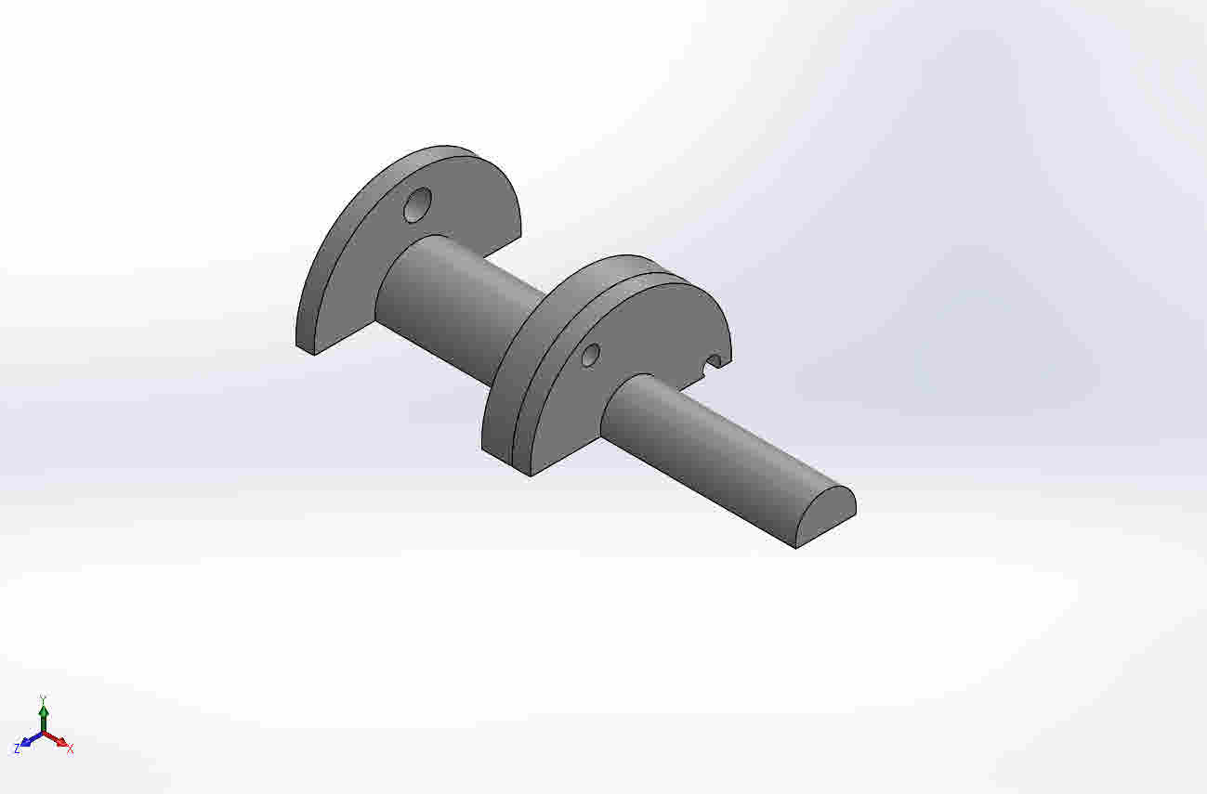
  Simulation of K01-A-001_GATE04E_P006_SERVICE_VERIFY
  Date: 6 сентября 2026 г.
  Designer: Solidworks
  Study name: Static 1
  Analysis type: Static
  Table of Contents
  Description 1
  Assumptions 2
  Model Information 2
  Study Properties 4
  Units 4
  Material Properties 5
  Loads and Fixtures 6
  Connector Definitions 7
  Contact Information 8
  Mesh information 9
  Sensor Details 10
  Resultant Forces 10
  Beams 11
  Study Results 12
  Conclusion 15
  Appendix 15

Description
No Data

Assumptions

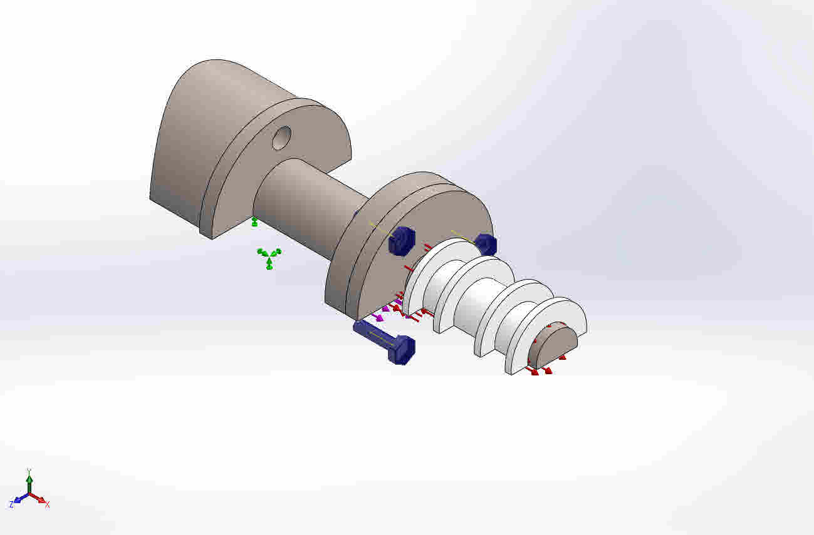  Original Model | Model Analyzed

Model Information

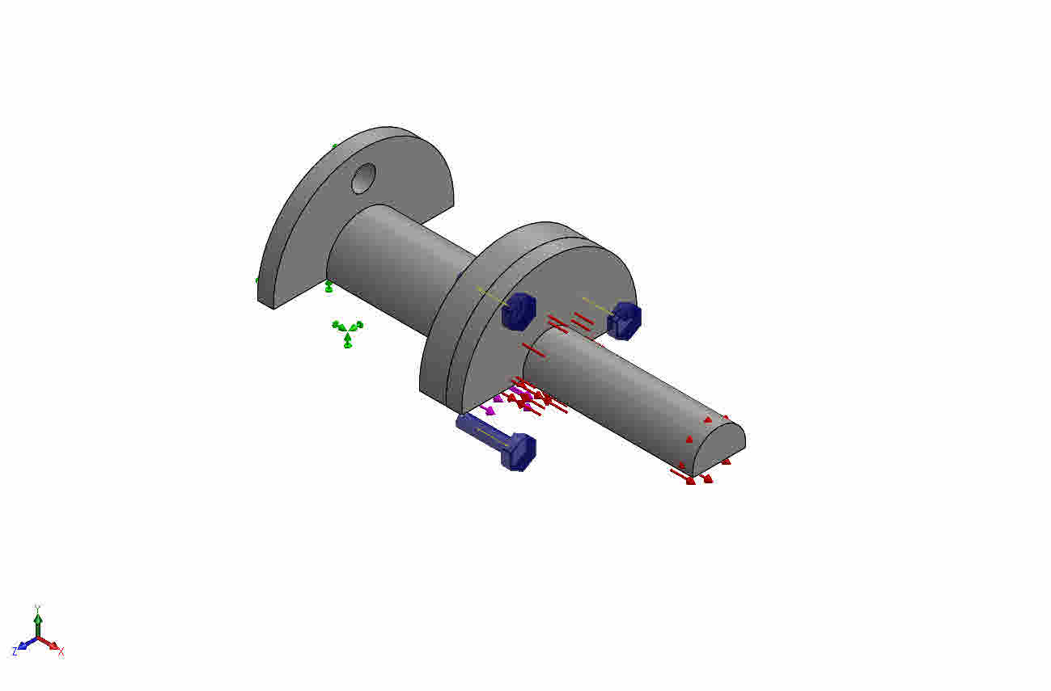
Model name: K01-A-001_GATE04E_P006_SERVICE_VERIFY
Current Configuration: Default
Solid Bodies
Document Name and Reference | Treated As | Volumetric Properties | Document Path/Date Modified
K01_F_J2_C2R1_PILOT_D14p10_ID12p00_g6_L1p50  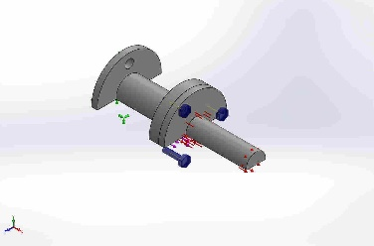 | Solid Body | Mass:0.0717482 kg  Volume:8.96852e-06 m^3  Density:8000 kg/m^3  Weight:0.703132 N | D:\Marvilon\K01\cad\candidates\gate04d_c2r1\K01-P-003_Cartridge_Body_GATE04D_C2R1_CANDIDATE.SLDPRT  Sep 6 00:00:47 2026
Cut-Extrude1  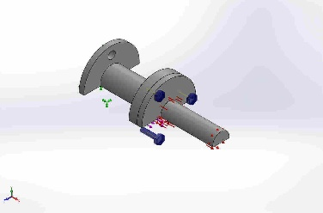 | Solid Body | Mass:0.0198927 kg  Volume:2.48659e-06 m^3  Density:8000 kg/m^3  Weight:0.194949 N | D:\Marvilon\K01\cad\candidates\gate04d_c2r1\K01-P-007_Hermetic_Magnetic_Can_GATE04D_C2R1_CANDIDATE.SLDPRT  Sep 6 00:00:47 2026

Study Properties
Study name | Static 1
Analysis type | Static
Mesh type | Solid Mesh
Thermal Effect: | On
Thermal option | Include temperature loads
Zero strain temperature | 298 Kelvin
Include fluid pressure effects from SOLIDWORKS Flow Simulation | Off
Solver type | FFEPlus
Inplane Effect: | Off
Soft Spring: | Off
Inertial Relief: | Off
Incompatible bonding options | Automatic
Large displacement | Off
Compute free body forces | On
Friction | Off
Use Adaptive Method: | Off
Result folder | SOLIDWORKS document (D:\Marvilon\K01\cad\candidates\gate04e_p006_service\verification)

Units
Unit system: | SI (MKS)
Length/Displacement | mm
Temperature | Kelvin
Angular velocity | Rad/sec
Pressure/Stress | N/m^2

Material Properties
Model Reference | Properties | Components
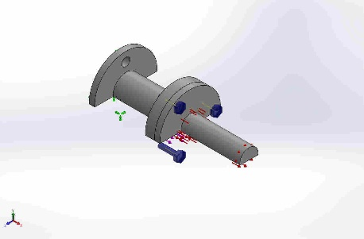 |  | SolidBody 1(K01_F_J2_C2R1_PILOT_D14p10_ID12p00_g6_L1p50)(K01-P-003_Cartridge_Body_GATE04D_C2R1_CANDIDATE-1),  SolidBody 1(Cut-Extrude1)(K01-P-007_Hermetic_Magnetic_Can_GATE04D_C2R1_CANDIDATE-1)
  Name: | 1.4404 (X2CrNiMo17-12-2)
  Model type: | Linear Elastic Isotropic
  Default failure criterion: | Max von Mises Stress
  Yield strength: | 4e+08 N/m^2
  Tensile strength: | 6e+08 N/m^2
  Elastic modulus: | 2e+11 N/m^2
  Poisson's ratio: | 0.28
  Mass density: | 8000 kg/m^3
  Shear modulus: | 7.9e+10 N/m^2
  Thermal expansion coefficient: | 1.1e-05 /Kelvin
Curve Data:N/A

Loads and Fixtures
Fixture name | Fixture Image | Fixture Details
Fixed-1 | 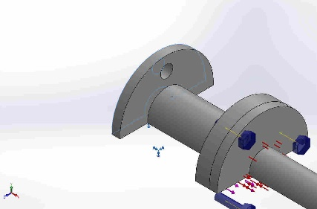
  Entities: | 1 face(s)
  Type: | Fixed Geometry
Resultant Forces
Components | X | Y | Z | Resultant
Reaction force(N) | -302.262 | -0.0386331 | -0.0211849 | 302.262
Reaction Moment(N.m) | 0 | 0 | 0 | 0

Load name | Load Image | Load Details
Pressure-1 | 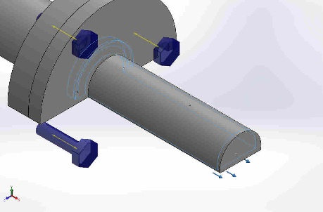
  Entities: | 5 face(s)
  Type: | Normal to selected face
  Value: | 0.02
  Units: | N/mm^2 (MPa)
  Phase Angle: | 0
  Units: | deg
Force-1 | 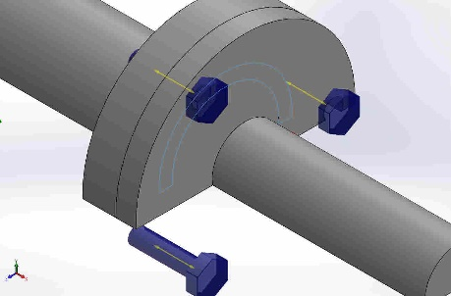
  Entities: | 1 face(s)
  Type: | Apply normal force
  Value: | 300 N

Connector Definitions

Pin/Bolt/Bearing Connector
Model Reference | Connector Details | Strength Details
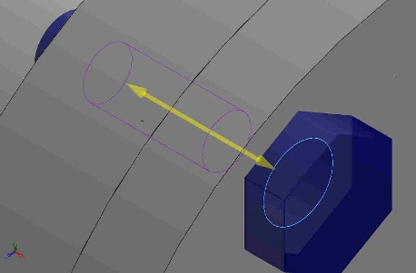  Counterbore Screw-1 |  | No Data
  Entities: | 1 edge(s), 1 face(s)
  Type: | Bolt(Head/Nut diameter)(Counterbore screw)
  Head diameter: | 4.5 mm
  Nominal shank diameter: | 2.5
  Preload (Axial): | 300
  Young's modulus: | 2.90075e+07
  Poisson's ratio: | 0.265
  Preload units: | N
Connector Forces
Type | X-Component | Y-Component | Z-Component | Resultant
Axial Force (N) | 307.44 | 0 | 0 | 307.44
Shear Force (N) | 0 | 1.7533 | 1.084 | 2.0613
Bending moment (N.m) | 0 | 0.00022229 | 8.438e-05 | 0.00023777

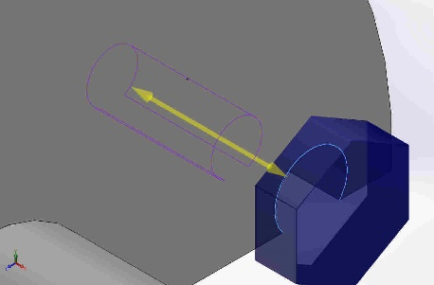  Copy[ 1 ] Counterbore Screw-1 |  | No Data
  Entities: | 1 edge(s), 1 face(s)
  Type: | Bolt(Head/Nut diameter)(Counterbore screw)
  Head diameter: | 4.5 mm
  Nominal shank diameter: | 2.5
  Preload (Axial): | 300
  Young's modulus: | 2.90075e+07
  Poisson's ratio: | 0.265
  Preload units: | N
Connector Forces
Type | X-Component | Y-Component | Z-Component | Resultant
Axial Force (N) | 307.91 | 0 | 0 | 307.91
Shear Force (N) | 0 | 0.0037299 | -2.0703 | 2.0703
Bending moment (N.m) | 0 | -0.00013989 | -1.3483e-05 | 0.00014054

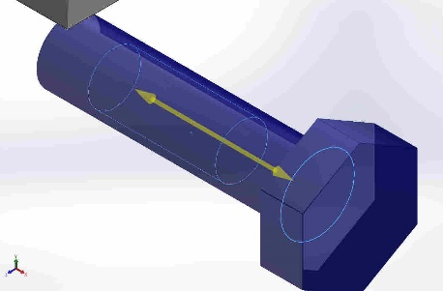  Copy[ 1 ] Counterbore Screw-1{1} |  | No Data
  Entities: | 1 edge(s), 1 face(s)
  Type: | Bolt(Head/Nut diameter)(Counterbore screw)
  Head diameter: | 4.5 mm
  Nominal shank diameter: | 2.5
  Preload (Axial): | 300
  Young's modulus: | 2.90075e+07
  Poisson's ratio: | 0.265
  Preload units: | N
Connector Forces
Type | X-Component | Y-Component | Z-Component | Resultant
Axial Force (N) | 307.43 | 0 | 0 | 307.43
Shear Force (N) | 0 | -1.7808 | 1.0323 | 2.0584
Bending moment (N.m) | 0 | 4.1405e-05 | -8.8912e-06 | 4.2349e-05

Contact Information

Contact | Contact Image | Contact Properties
Global Contact | 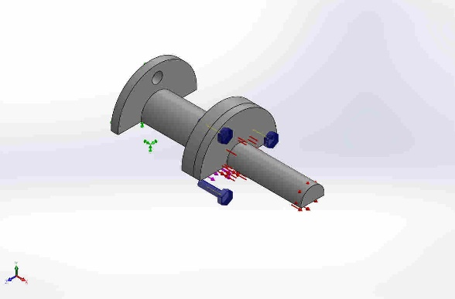
  Type: | No penetration (Surface to surface)
  Components: | 2 Solid Body (s)

Mesh information
Mesh type | Solid Mesh
Mesher Used: | Standard mesh
Automatic Transition: | Off
Include Mesh Auto Loops: | Off
Jacobian points | 4 Points
Element Size | 1.12755 mm
Tolerance | 0.0563773 mm
Mesh Quality Plot | High
Remesh failed parts with incompatible mesh | Off

Mesh information - Details
Total Nodes | 102923
Total Elements | 63800
Maximum Aspect Ratio | 13.093
% of elements with Aspect Ratio < 3 | 92.3
% of elements with Aspect Ratio > 10 | 0.00313
% of distorted elements(Jacobian) | 0
Time to complete mesh(hh;mm;ss): | 00:00:07
Computer name:
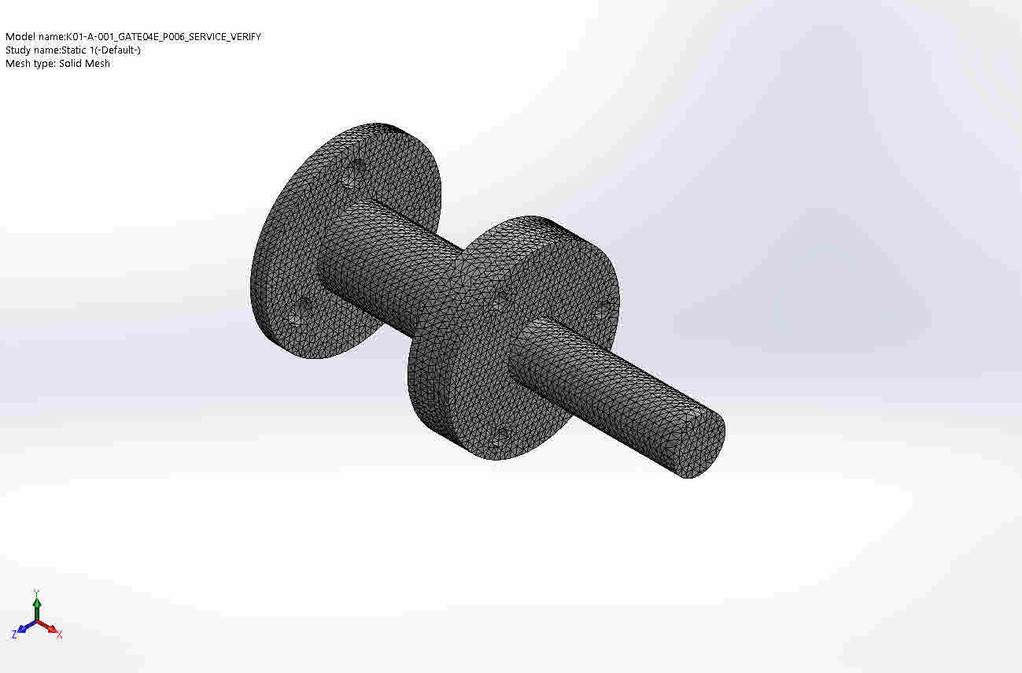

Sensor Details
No Data

Resultant Forces

Reaction forces
Selection set | Units | Sum X | Sum Y | Sum Z | Resultant
Entire Model | N | -302.262 | -0.0386331 | -0.0211849 | 302.262

Reaction Moments
Selection set | Units | Sum X | Sum Y | Sum Z | Resultant
Entire Model | N.m | 0 | 0 | 0 | 0

Beams
No Data

Study Results

Name | Type | Min | Max
Stress1 | VON: von Mises Stress | 5.046e+02 N/m^2  Node: 68081 | 4.066e+07 N/m^2  Node: 141
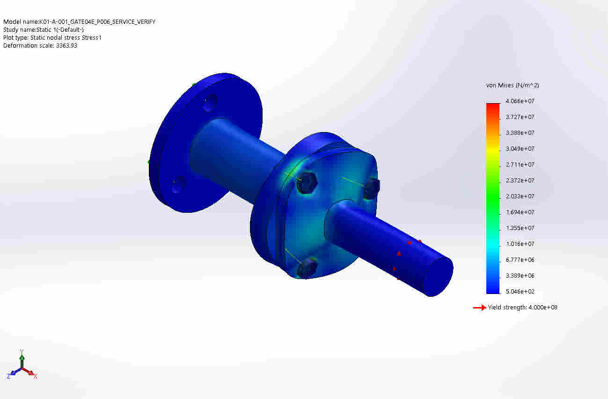
K01-A-001_GATE04E_P006_SERVICE_VERIFY-Static 1-Stress-Stress1

Name | Type | Min | Max
Displacement1 | URES: Resultant Displacement | 0.000e+00 mm  Node: 673 | 2.171e-03 mm  Node: 84042
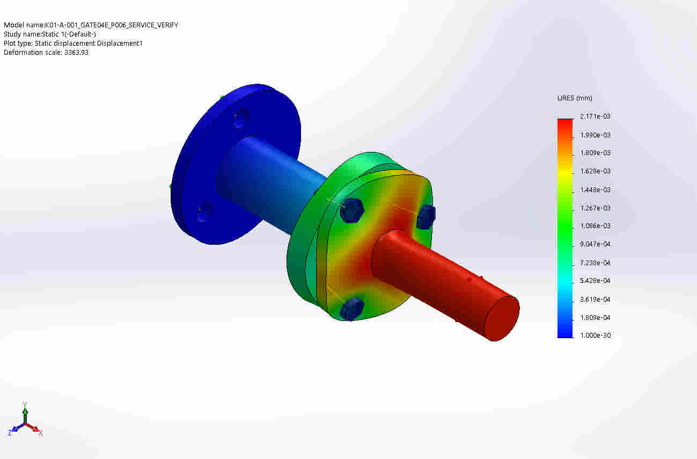
K01-A-001_GATE04E_P006_SERVICE_VERIFY-Static 1-Displacement-Displacement1

Name | Type | Min | Max
Strain1 | ESTRN: Equivalent Strain | 3.422e-09  Element: 28369 | 1.207e-04  Element: 54395
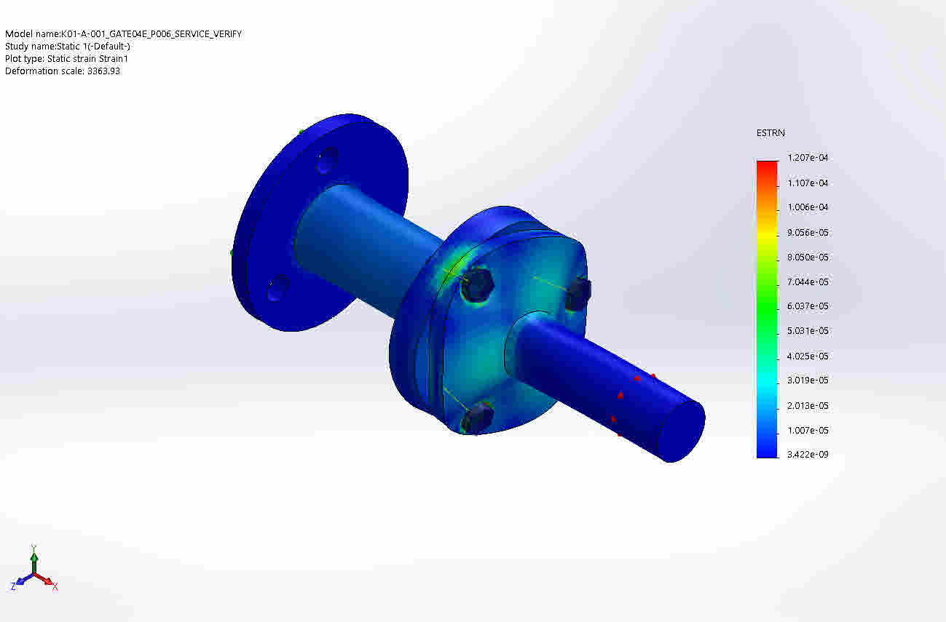
K01-A-001_GATE04E_P006_SERVICE_VERIFY-Static 1-Strain-Strain1

Name | Type
Displacement1{1} | Deformed shape
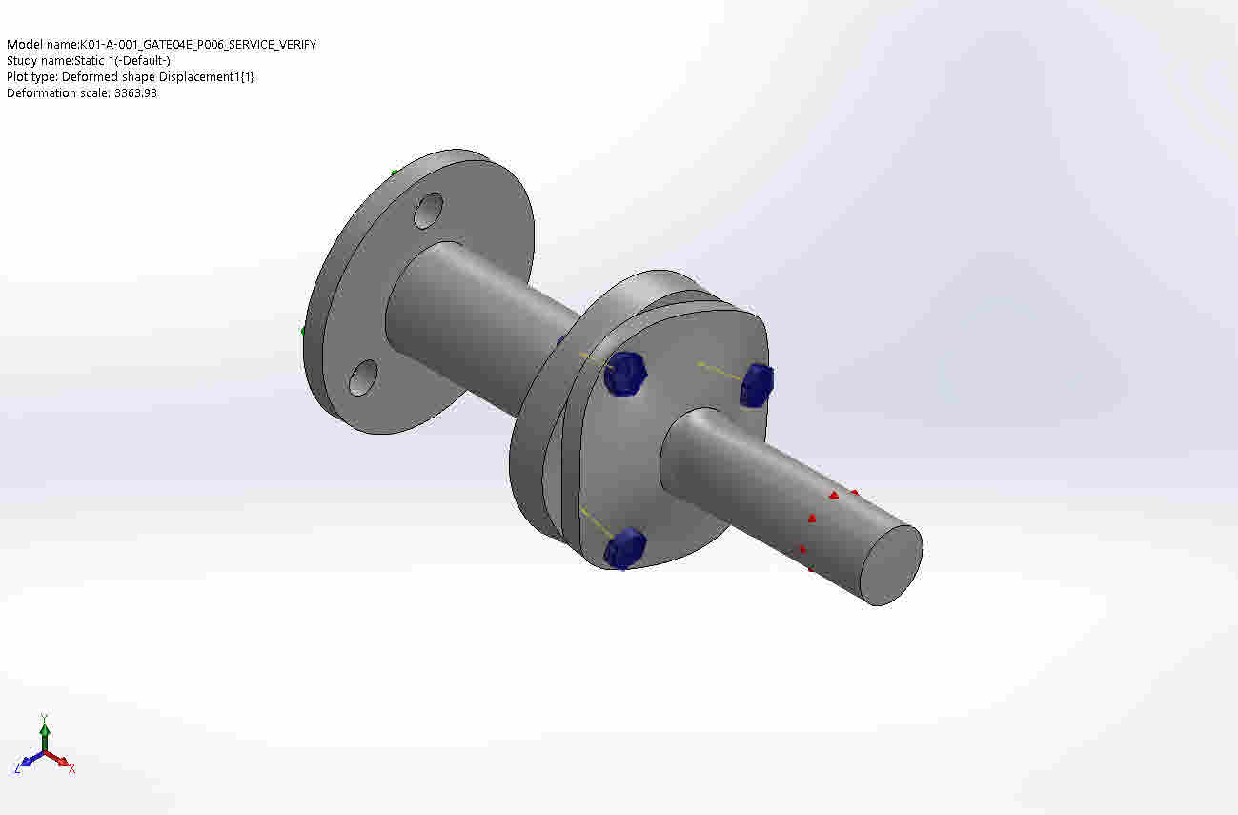
K01-A-001_GATE04E_P006_SERVICE_VERIFY-Static 1-Displacement-Displacement1{1}

Conclusion

Appendix

