Travel for company
Introduction
Required Web-application for work with employees, who chose voucher and get sale from company at vacation in the system.
Application can to implement the following functions:
● Showing list vouchers: country, price, discaunt with opportunity edit/delete/add data in a bd.
● Showing list employees: name, surname, idVouchers, vacation (Date) with opportunity edit/delete/add data
● Showing list: name, surname and price for everybody in the system.

! Regard : here used not real figures, only for presentation

1. Vouchers

1.1. Showing list vouchers
Showing list vouchers: country, price, discaunt with opportunity edit/delete/add data in a bd.
The main scenario add:
● User selects a menu «Voucher».
● Showing list vouchers: country, price, discaunt

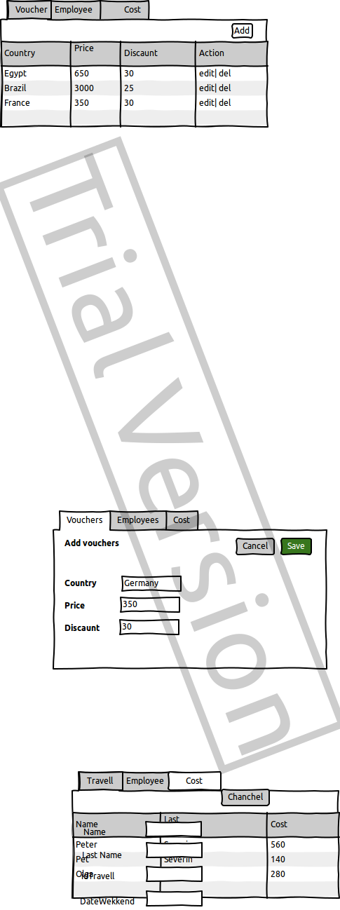

img. 1.1 Showing list vouchers
Showing list vouchers:
● country – name country for vacation;
● price – full price voucher ;
● discaunt– discaunt for employee;

1.2 Add Voucher
The main scenario:
● User click the botton “Add”;
● Displays the form to add a new voucher;
● User enter data and click the botton “Save”, data are saved successfully in the bd;
● Can cancel "Save" click the botton "Cancel", data aren't saved;

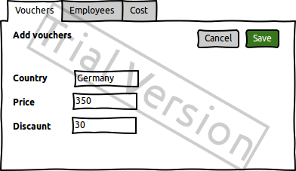

img. 1.2 Add Voucher
User enter data:
● country – name country for vacation;
● price – full price voucher ;
● discaunt– discaunt for employee;

1.3 Edit Voucher
The main scenario:
● User click the botton “Edit”;
● Displays the form to edit the voucher;
● User edit data and click the botton “Save”;
● If user enter correct data, data will updated in the bd;
● If server don't save data, window will show the error;
● If edit successfully, page will update with new data.

The main scenario cancel edit:
● User click the botton “Edit”;
● Displays the form to edit the voucher;
● User edit data and click the botton “Cancel”;
● Data aren't saved, page update .

Рис. 1.3 Edit voucher
Edit data:
● country – name country for vacation;
● price – full price voucher ;
● discaunt– discaunt for employee;

1.4 Delete vourcher
The main scenario:
● User click the botton “Delete” ;
● If delete successfully, page will update with new data.

2. Employee
2.1 Showing list vouchers
Showing list employees: name, surname, idVouchers, vacation with opportunity edit/delete/add data
The main scenario add:
● User select a menu «Employee».
● Showing list employees: name, surname, idVoucher, vacation, count.

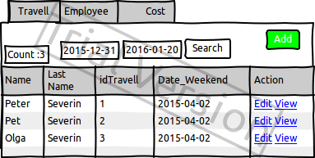

img. 2.1 Showing list employees
Showing list:
● name – name;
● surname – surname ;
● idVoucher – idVoucher ;
● vacation – date vacation.
Count all employees.
Search
Search employee by dateVacation from first date till second date. Result show all date which included in the interval. First date can be less than second. Two dates can be filled.

2.2. Add employee
The main scenario:
● User click the botton “Add”;
● Displays the form to add a new employee;
● User enter data and click the botton “Save”, data are saved successfully in the bd;
● Can cancel "Save" click the botton "Cancel", data aren't saved;

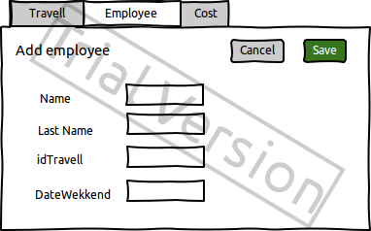

img. 2.2 Add employee
Showing list:
● name – name;
● surname – surname ;
● idVoucher – idVoucher ;
● vacation – date vacation.

2.3. Edit employee
The main scenario:
● User click the botton “Edit”;
● Displays the form to edit the employee;
● User edit data and click the botton “Save”;
● If user enter wrong data, data will not updated in the bd;
● If user enter correct data, data will updated in the bd;
● If server don't save data, window will show error;
● If edit successfully, page will update with new data.

The main scenario cancel edit:
● User click the botton “Edit”;
● Displays the form to edit the employee;
● User edit data and click the botton “Cancel”;
● Data aren't saved, page update .

img. 2.2 Edit employee
Showing list:
● name – name;
● surname – surname ;
● idVoucher – idVoucher ;
● vacation – date vacation.

Restrictions for data validation

● idVoucher – existing vouchId number voucher ;
● date vacation – first day vacation .

2.4. Delete employee
The main scenario delete:
● User click the botton “Delete” ;
● If delete successfully, page will update with new data.

3. Cost
3.1. Showing list employee and price his voucher
Showing list: name, surname and price for everybody in the system.
The main scenario:
● User select a menu «Cost».
● Showing list: name, surname and cost for everybody in the system.

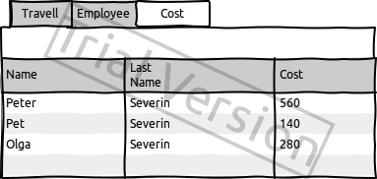

img. 3.1 Showing list: name, surname and cost for everybody in the system.
Showing list:
● name – name;
● surname – surname ;
● price - price;

