NBA Player Salary Prediction Using Machine Learning
COSC 325 — Midterm Report
Spring 2026
I. PROBLEM & MOTIVATION
Player salaries in the National Basketball Association (NBA) are determined by a complex mix of on-court performance, market conditions, team salary cap constraints, and contract timing. Despite this complexity, a persistent question among fans, analysts, and front offices alike is whether a player's statistical output can meaningfully predict their market value.

This project applies supervised machine learning to predict the 2025–26 NBA player salary (in millions of dollars) from a rich set of performance statistics. We combine traditional per-game stats (points, rebounds, assists) with advanced metrics (PER, Win Shares, VORP, BPM) scraped from Basketball-Reference to build and compare multiple regression models.

Beyond prediction accuracy, we aim to identify which statistics teams actually pay for, providing interpretable insights into how player value is quantified in the modern NBA. This is a regression problem: our target variable is continuous salary in USD millions.
II. DATASET & EXPLORATORY DATA ANALYSIS
A. Dataset Description
Data was scraped from Basketball-Reference using Python's pandas.read_html(). Three tables were merged: (1) advanced stats, (2) per-game stats, and (3) 2025–26 contract salaries. After removing players with fewer than 10 games played and deduplicating traded players using their combined season totals ("TOT" rows), the final dataset contains 438 players and 29 features.

Key features include:
- Advanced: PER, TS%, USG%, OWS, DWS, WS, WS/48, OBPM, DBPM, BPM, VORP
- Per-game: PTS, TRB, AST, STL, BLK, TOV, FG%, 3P%, FT%
- Metadata: Age, Position, Games Played, Minutes Played

The only notable missing data is 3P% (15 players, ~3.4%), corresponding to big men who did not attempt any three-pointers. This will be imputed with 0 during preprocessing.

B. Salary Distribution
Figure 1 shows the raw and log-transformed salary distributions. The raw distribution is strongly right-skewed: the majority of players earn $2–8M (minimum/mid-level contracts) while a small number of max-contract players earn $40–60M. The log transformation produces a more symmetric distribution, confirming that training models on log(Salary) will be beneficial.
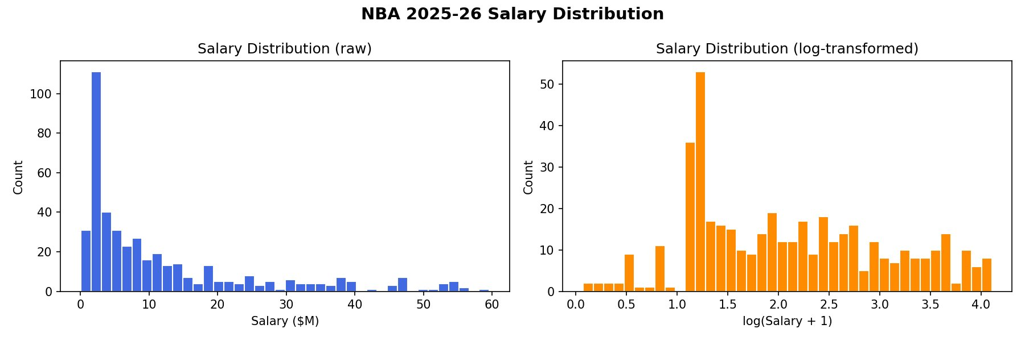
Fig. 1. NBA 2025-26 salary distribution (raw and log-transformed).

C. Feature Correlations
Figure 2 presents a Pearson correlation heatmap of all features against salary. PTS shows the strongest individual correlation with salary (r = 0.76), followed by USG% (r = 0.64) and VORP (r = 0.59). This suggests that scoring volume and overall usage are the statistics most directly rewarded in the market.
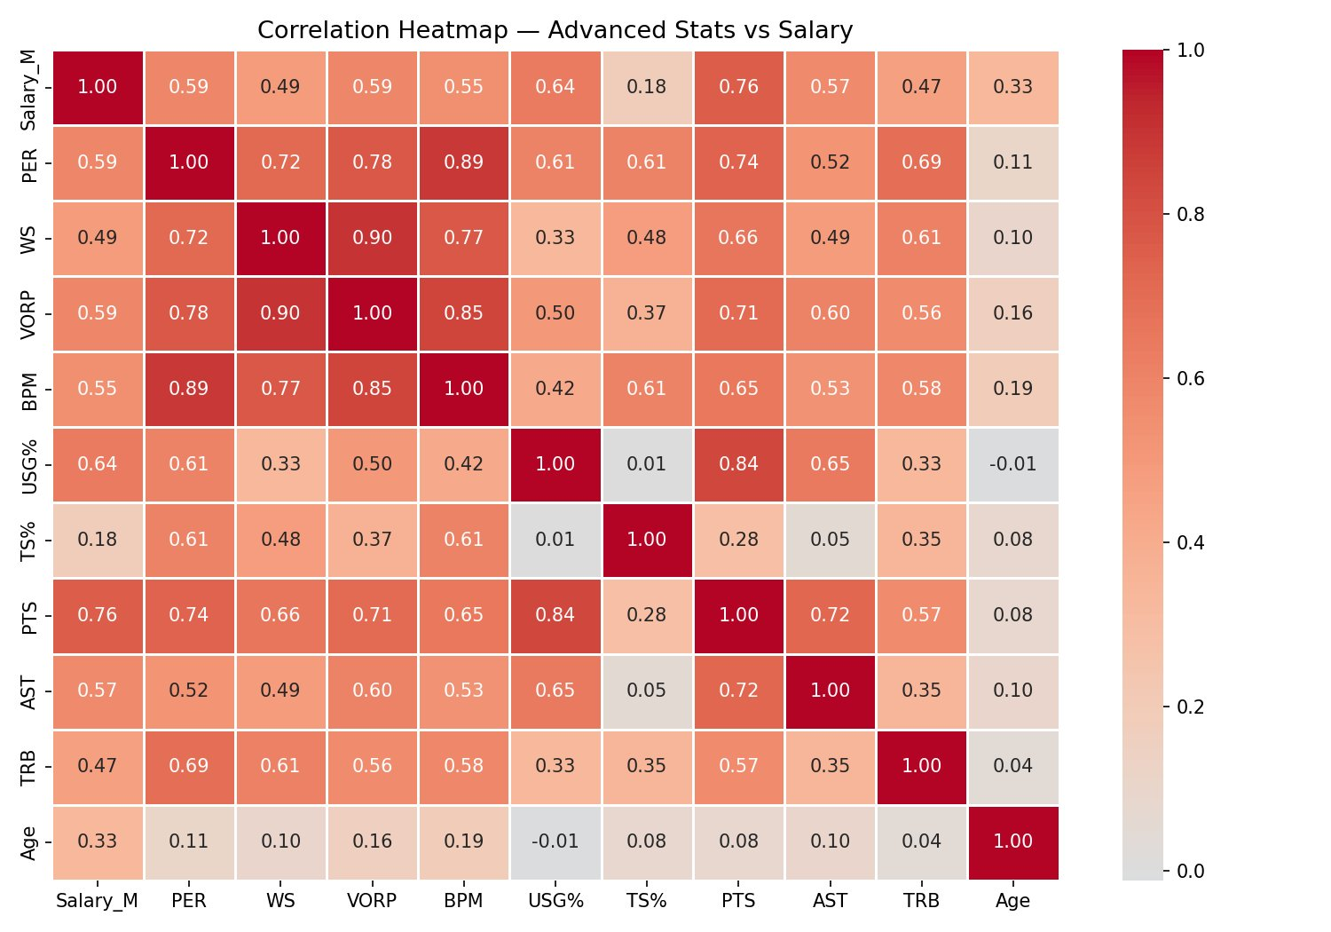
Fig. 2. Correlation heatmap of advanced stats and per-game stats vs. salary.

Figure 3 ranks features by their Pearson correlation with salary. Notably, TS% (true shooting efficiency) has the weakest correlation (r = 0.18), suggesting that efficiency alone does not drive salary — volume metrics dominate. Age shows a moderate positive correlation (r = 0.33), reflecting that veterans on long-term contracts tend to earn more regardless of current output.
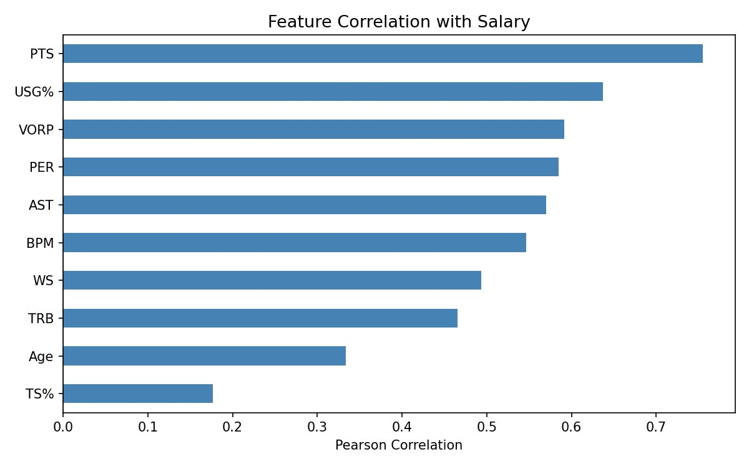
Fig. 3. Ranked feature correlations with salary (Pearson r).

D. Key Observations
- Right-skewed target: salary is heavily skewed; log transformation will be applied.
- Multicollinearity: WS, VORP, and BPM are highly inter-correlated (r > 0.85), which may inflate variance in linear models — motivating Ridge regularization.
- Volume over efficiency: PTS and USG% outperform efficiency stats (TS%) in salary correlation, consistent with how NBA contracts are negotiated.
- Minimal missing data: Only 3P% has missing values (3.4%), easily handled by zero-imputation.
III. PROPOSED APPROACHES
A. Preprocessing Plan
- Log-transform Salary_M: apply log1p() to normalize the right-skewed target.
- Impute 3P% missing values with 0 (players who never attempted a three-pointer).
- One-hot encode the Pos column (PG, SG, SF, PF, C).
- Standardize all numeric features using StandardScaler so models sensitive to scale (Linear Regression, MLP) perform correctly.
- 80/20 train/test split with a fixed random seed for reproducibility.

B. Models
- Linear Regression (Baseline): establishes a performance floor; interpretable coefficients show which stats matter most.
- Ridge Regression: adds L2 regularization to handle the multicollinearity observed between WS, VORP, and BPM.
- Random Forest Regressor: captures non-linear relationships and provides built-in feature importance rankings.
- MLP (Neural Network): explores whether deeper non-linear modeling improves predictions beyond Random Forest.

C. Evaluation Metrics
Since this is a regression task, accuracy is not an appropriate metric. We will evaluate all models using:
- RMSE (Root Mean Squared Error): primary metric; penalizes large prediction errors, reported in $M.
- MAE (Mean Absolute Error): easier to interpret as average dollar miss per player.
- R² (Coefficient of Determination): measures the proportion of salary variance explained by each model.
IV. TEAM ROLES AND TENTATIVE SCHEDULE
This project is being completed as a collective. The dataset and visualizations were collected made by Brett and writing was done together for the midterm report. Brett did the problem and motivation, Camden did the proposed approaches, Nick did the evaluation metrics, and Jackson did the roles, scheduling, and coordinating. The tentative timeline is as follows:

Dates | Task
Apr 6 -12 | Data preprocessing & feature engineering
Apr 13-19 | Baseline: Linear & Ridge Regression
Apr 20-26 | Random Forest + feature importance
Apr 27- May 3 | MLP implementation & tuning
May 4th | Model comparison & final report writing

