Construction Kit for

Digital Voltmeter ADM 2001

Stavebnice Číslicového Voltmetru ADM 2001

January 1988

TESLA ROŽNOV, corporate enterprise, Vrchlabí plant
(Brett Hallen, Port Macquarie, Australia, Dec 2025)

Table of Contents (Obsah)
Main Technical Specifications (Hlavní technické údaje) 3
Main Dimensions (Hlavní rozměry) 3
Informative Dimensions and Wiring of the Display 6
Wiring 6
Dear Customer 7
User Manual for the Digital Voltmeter Kit ADM 2001 8
Návod k použití stavebnice číslicového voltmetru ADM 2001 8
1. General Description (Všeobecný popis) 8
2. Basic Measurement Range (Základní měřicí rozsah) 8
3. Display of Decimal Points and Auxiliary Symbols (Zobrazení desetinných teček a pomocných znaků) 8
4. Clock Pulse Source (Zdroj hodinových impulsů) 8
5. Reference Voltage (Referenční napětí) 8
6. Power Supply (Napájecí zdroj) 9
7. Input Filter (Vstupní filtr) 9
8. Protection Circuits (Odhranné obvody) 9
9. Board Population (Osazení desky) 9
10. Activation (Oživení) 11
11. Adjustment (Nastavení) 11
12. Installing the Kit into a Cabinet (Vestavění stavebnice do skříňky) 11
Applications (Aplikace) 13
1. Multi-Range Voltmeter (Vícerozsahový voltmetr) 13
2. Multi-Range Ammeter (Vícerozsahový ampérmetr) 13
3. AC Voltage Measurement (Měření střídavého napětí) 14
4. Resistance Measurement (Měření odporu) 14
5. Temperature Measurement (Měření teploty) 14
Warranty Certificate (Záruční list) 15

Main Technical Specifications (Hlavní technické údaje)
Measured voltage range ± 200.0mV (for V_{REF} = 100.0mV)
Smallest measurable voltage ± 100µV
The value of the displayed data ÚDAJ =
Input resistance approx. 10⁹Ω
Zeroing automatic
Polarity change & indication automatic
Measurement tepetition time approx. 0.3s
Supply voltage 8 to 12V
(plate battery type 51D)
Current draw from source approx. 2mA
Indication of insufficient power supply voltage automatic, in the range of 7 to 8V,
illuminated or flashing symbol ==>
Reference voltage source internal or external
Dimensions 130 x 90 x 25mm

Main Dimensions (Hlavní rozměry)

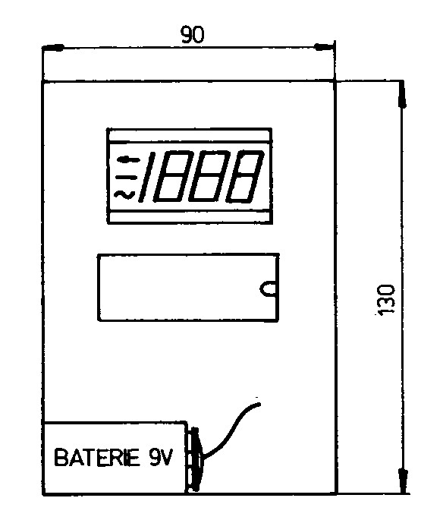

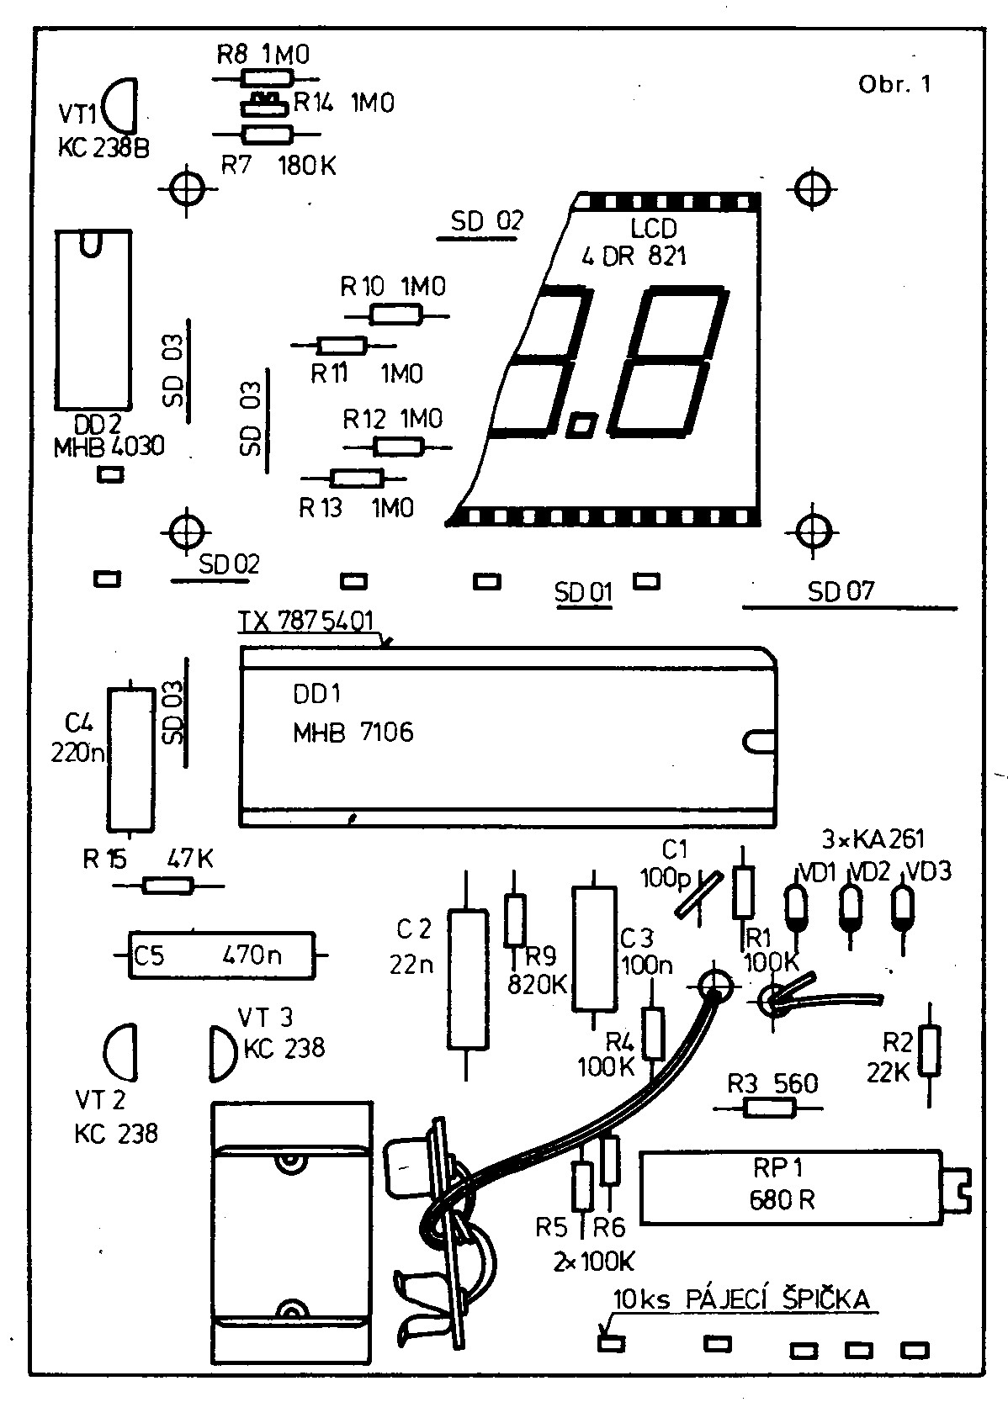

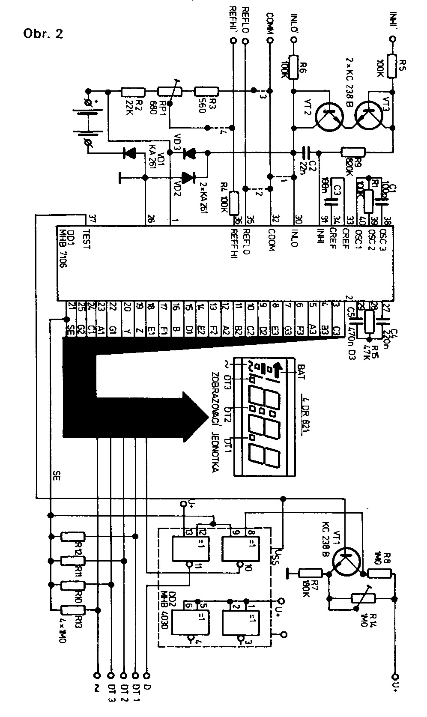

Informative Dimensions and Wiring of the Display
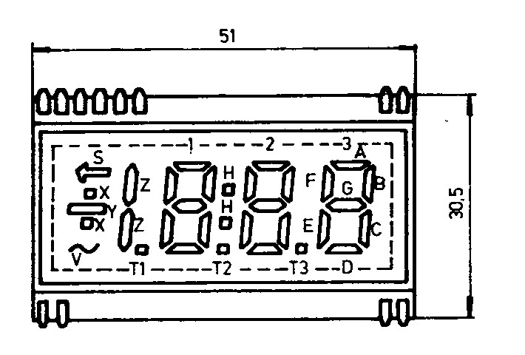

Wiring
1 - V 14 - D2 28 - H
2 - Y 15 - C2 29 - B1
3 - Z 16 - T3 30 - A1
4 - free 17 - E3 31 - F1
5 - free 18 - D3 32 - G1
6 - free 19 - C3 33 - free
7 - free 20 - B3 34 - free
8 - T1 21 - A3 35 - free
9 - E1 22 - F3 36 - free
10 - D1 23 - G3 37 - free
11 - C1 24 - B2 38 - S
12 - T2 25 - A2 39 - X
13 - K2 26 - F2 40 - common
27 - G2 electrode

Dear Customer
You have purchased our construction kit for a portable digital voltmeter.
This kit uses the latest TESLA components from the field of microelectronics.
The integrated circuit TESLA MHB7106 is the first integrated circuit of this type developed in our country and intended for a 3½ digit digital panel meter. It is designed to work with a liquid crystal display.
To assemble a portable panel meter with automatic zeroing and automatic polarity indication, only a display, four capacitors, and five resistors need to be added to the integrated circuit MHB7106. The other components used serve for displaying auxiliary symbols and protection against voltage spikes and static charges.
A necessary prerequisite for successful construction is familiarising yourself with this manual, especially section 9.

User Manual for the Digital Voltmeter Kit ADM 2001

Návod k použití stavebnice číslicového voltmetru ADM 2001

1. General Description (Všeobecný popis)
The digital voltmeter kit ADM 2001 is a complete converter of input DC voltage, or voltage ratio, into a 3½ digit digital reading on a liquid crystal display.
The converter function is provided by the integrated circuit MHB7106, which includes, among other things, a BCD to seven-segment display decoder, display driver, clock pulse source, and reference voltage source. The module further includes protection circuits and circuits for displaying auxiliary symbols and the decimal point.
The circuits used in the kit are manufactured using CMOS technology.
The kit is designed to allow universal use. Therefore, there are four jumpers on the printed circuit board that can be disconnected if needed. This allows the use of either symmetrical or asymmetrical input for the measured and reference voltage, and setting the reference voltage with a built-in resistor or externally.

2. Basic Measurement Range (Základní měřicí rozsah)
The components used determine the basic measurement range of ±200.0mV. The fact that the last digit does not flicker on this range illustrates the excellent noise characteristics of the MHB7106 circuit. The actual noise level does not exceed about 15µV (max. 95% of the time).

3. Display of Decimal Points and Auxiliary Symbols (Zobrazení desetinných teček a pomocných znaků)
The display of decimal points and auxiliary symbols is controlled by signals on the TEST and SE outputs of the integrated circuit MHB7106.
To control the symbol ← (indication of low supply voltage - labeled BAT), transistor VT1 and one of the four EXCLUSIVE-OR gates of the integrated circuit MHB4030 are used. Another EXCLUSIVE-OR gate generates the drive signal for displaying the decimal point (input D).

4. Clock Pulse Source (Zdroj hodinových impulsů)
The structure of the MHB7106 circuit includes a simple RC oscillator with resistor R1 and capacitor C1. The oscillator frequency is set to about 50kHz, achieving maximum suppression of interference voltages at the mains frequency (50Hz). This also sets about 3 measurements per second.

5. Reference Voltage (Referenční napětí)
In terms of reference voltage usage, the kit is designed completely universally. The possibility of easily selecting individual alternatives is provided by the printed circuit layout, where 4 jumpers are prepared.
Without modifying the printed circuit board, the internal reference voltage of about 2.8V between outputs U+ and COMM can be used, to which a divider consisting of resistors R2, R3, and RP1 is connected via jumpers 3 and 4. The divider sets the reference voltage to 100.0mV. The temperature coefficient of the internal reference voltage is about 0.1%/°C.
After disconnecting jumpers 3 and 4 (possibly also 2), the kit can be used with an internal reference voltage, which is connected to inputs REF HI and REF LO. The reference inputs are floating. The external reference voltage can be a maximum in the range of supply voltages U- to U+. When using a high-quality external reference voltage source, greater temperature stability of the voltmeter can be achieved.

6. Power Supply (Napájecí zdroj)
The kit can be powered from a 9V battery or a separate stabilized source. If it is powered from a common source with other electronic circuits, it must be taken into account that the input voltage at each of the input terminals must not exceed the range U- to U+.

7. Input Filter (Vstupní filtr)
One of the important features of the integrated circuit MHB7106 is the minimally low input current. This allows the use of an input filter with high impedance. The error caused by the phase shift of such a filter is on the order of units of µV. The input filter is formed by resistors R5, R6, R9, and capacitor C2.

8. Protection Circuits (Odhranné obvody)
To prevent damage from static electricity, high voltage, or voltage outside the allowed range, the module input is protected by transistors VT2 and VT3 and diodes VD2 and VD3. This protection is especially suitable for demonstration purposes and experiments with the kit. If it is necessary to utilise the peak parameters of the MHB7106 converter, diodes VD2 and VD3 must be omitted. Diode VD1, serving as protection against reverse polarity of the supply voltage, can remain in the circuit.

9. Board Population (Osazení desky)
First read this entire manual carefully and study Fig. 1 (placement plan) and Fig. 2 (schematic). Only then start assembly. All components supplied have already been tested at the factory.
Step 1 – Prepare the battery lead
Separate the two wires of the twin lead by 15mm at one end, strip and tin them. Solder to the battery snap (+ to large contact, − to small contact), tie a knot for strain relief and pass the lead through the hole in the snap plate – see Fig. 3.
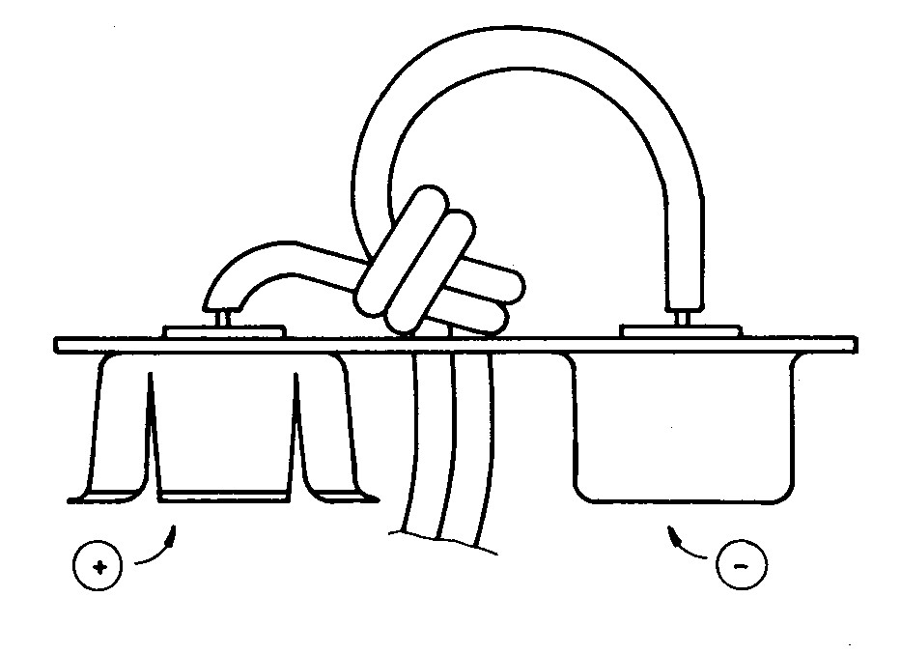

Fig. 3 Method of connecting the cable to the connector
At the other end separate the wires by 10mm. Shorten the negative wire by 4 mm and strip both ends.
Step 2
Rivet the battery-snap plate to the PCB using the supplied Ø 3×5mm tubular rivets. Thread the twin lead through the two holes in the PCB and solder, observing correct polarity.
Step 3
Solder all mechanical parts (test pins, wire links, IC socket). Orient the socket so that pin 1 (marked by a bevelled corner) corresponds to the “1” marked on the PCB.
Step 4
Solder all passive components (capacitors, resistors, trimmer RP1).
Step 5
Solder the active components (diodes VD1–VD3, transistors VT1–VT3). Observe correct orientation according to the placement plan.
Mount all components (passive and active) flush to the board. Leave transistor leads ≈3–4 mm long. Trim excess leads and solder every joint properly using only rosin flux and tin solder. Do not heat semiconductor leads longer than 3 seconds.
Step 6 – Handling of ESD-sensitive parts
The components supplied in conductive foam (MHB4030, MHB7106 and the LCD) must be removed from the foam only immediately before insertion. Avoid synthetic clothing (nylon, polyester, etc.). Use a low-voltage soldering iron with a grounded tip (e.g. TESLA Liptovský Hrádok).
Before touching the ICs, discharge yourself by touching a grounded object (water pipe, radiator, etc.) or wear a grounded wrist strap. Then touch the PCB and the foam so that everything is at the same potential.
Step 7 – Insert the MHB4030
Remove the MHB4030 from the foam, insert into its socket (observe orientation), and solder carefully (max 3 seconds per joint).
Step 8 – Mount the LCD
Orient the LCD according to the placement plan. Insert the bottom row of pins first, then the top row (a pair of tweezers helps). Treat the LCD with great care – it is a glass plate.
If you intend to use the plastic frame and bezel (section 12), assemble the frame first, slide it onto the PCB, push fully home, align the LCD parallel to the board edges and solder. Solder the LCD in the same careful way as the MHB4030.
Final checks before inserting the MHB7106
Double-check orientation of all semiconductors and values of passive components. Inspect every solder joint for shorts or cold joints. Wash the solder side with pure alcohol to remove flux residue. When dry, protect with a thin layer of clear lacquer or rosin dissolved in alcohol/toluene. Do not wash or lacquer until the LCD is fitted – alcohol damages it.
Only now insert the MHB7106 into its socket (observe orientation – the socket holes are numbered). Press gently so that every pin seats correctly. If necessary, open a stubborn hole with a needle.
Note:
If you plan to power the meter from an external source instead of the 9V battery, the twin lead and battery-snap plate are not required. For maximum accuracy at the cost of reduced protection (see section 8), omit diodes VD2 and VD3.

10. Activation (Oživení)
When the board is fully populated (including LCD), connect power. Digits must appear on the display. Shorting IN HI and IN LO must show 000 (a minus sign may flash briefly).
If nothing appears, immediately disconnect power. Check:
- correct battery polarity
- supply voltage present at IC pins 1 (+) and 26 (GND)
If everything is correct, test the auxiliary symbols: connect test point D to the desired symbol pad – the corresponding decimal point or arrow must appear.
Finally test the low-battery indication: reduce supply voltage to 7.8–8V (e.g. with a variable resistor in series with the battery). The low-battery arrow must appear in the top-left corner (adjustable with R14 if needed).
When everything works, peel off the protective film from the LCD.

11. Adjustment (Nastavení)
Adjustment is simple. For highest accuracy use a calibrator or reference voltmeter at least one order better than the ADM 2001 (i.e. at least 4½ digits).
Connect a precise ≈190.0mV (or exactly 100.0mV) between IN HI and IN LO. Adjust trimmer RP1 until the display exactly matches the calibrator reading.

12. Installing the Kit into a Cabinet (Vestavění stavebnice do skříňky)
The kit can be installed into the device in two basic ways:
- on the panel,
- on the subpanel.
The mounting method is evident from Fig. 4. Insert the protective glass (2) into the frame (1), so that it is held by the clamping clips on the bottom part of the frame and the thicker part of the glass fits into the hole in the frame. Place the frame with the protective glass onto the board with printed circuits (3) with the display facing the frame, no column (4) not inserted. Push the board until it stops.
The mounting on the subpanel is in Fig. 5. In the subpanel (1) with thickness 1.6 to 2mm, drill and countersink holes for plastic rivets (2). Mount according to the placement plan.
Also, make a rectangular hole for the display. The procedure is the same as for mounting on the panel, instead of the frame, use four rivets. The protective glass (4) serves as protection for the display, inserted into the hole in the sub-panel. This completes the mechanical assembly.
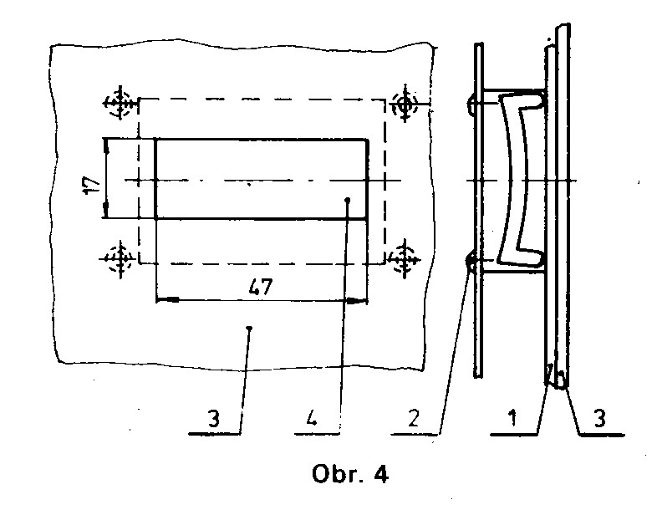

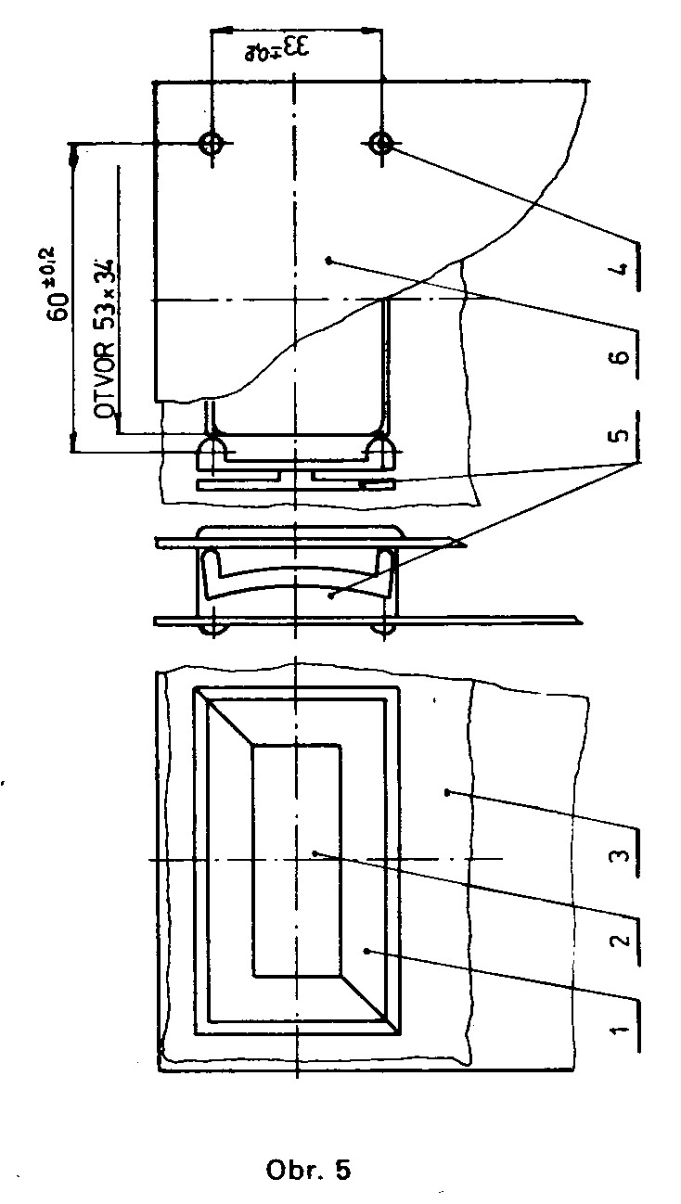

Applications (Aplikace)
Whoever finds the device's measurement range of ±200mV too small can expand their measuring instrument according to the following suggestions. If we want to maintain the corresponding accuracy of the A/D converter, the deviation of the resistors used should not exceed 0.1%. Suitable are chip resistors type WK681XX or resistors TR191 to 164. Those satisfied with lower accuracy can make do with resistors TR191 to 194.

1. Multi-Range Voltmeter (Vícerozsahový voltmetr)
Two commonly used connections are in Fig. 6a and 6b. The circuit according to 6a has the advantage that any transition contact resistance is in series with the input resistance of MHB7106. Since the input resistance IO is greater than 10¹² Ω, errors caused by the switch are negligible. In this connection (6b), there are used dividing variable resistors. The advantage of this connection lies in the fact that the resistors of individual ranges are not mutually dependent. In this connection, mechanical switches can also be replaced by electronic ones (analog switches or FET transistors).

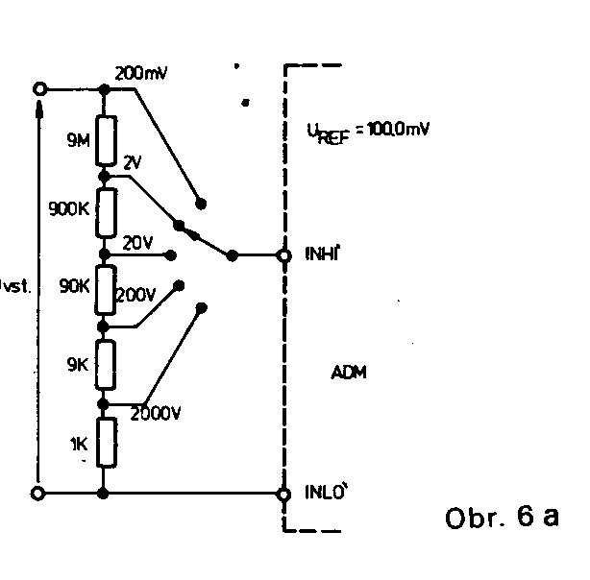
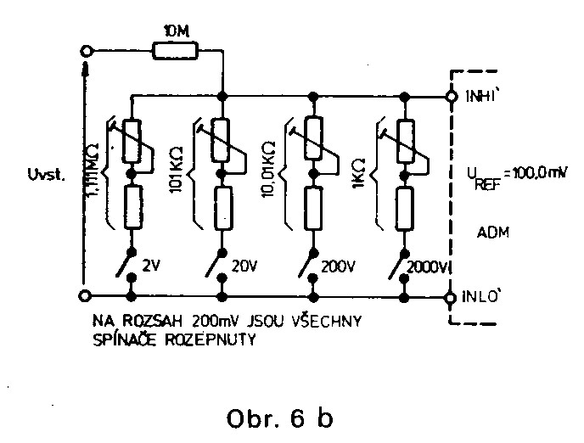

2. Multi-Range Ammeter (Vícerozsahový ampérmetr)
By using a suitable shunt, current measurement is converted to voltage measurement. The relationship between current and the displayed value (ZÚ) in the circuit according to Fig. 7 is given by the formula:
ZÚ =
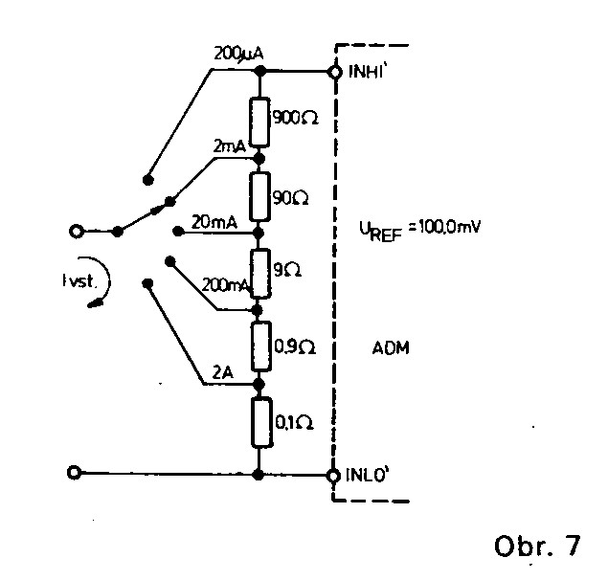

3. AC Voltage Measurement (Měření střídavého napětí)
For measuring AC voltage, it is necessary to create an AC to DC converter. Fig. 8 shows a suitable circuit for 3½ digit digital voltmeters. The circuit processes a sine wave signal with low distortion in the frequency range of 20Hz to 2kHz. The circuit has an input impedance of 10MΩ.
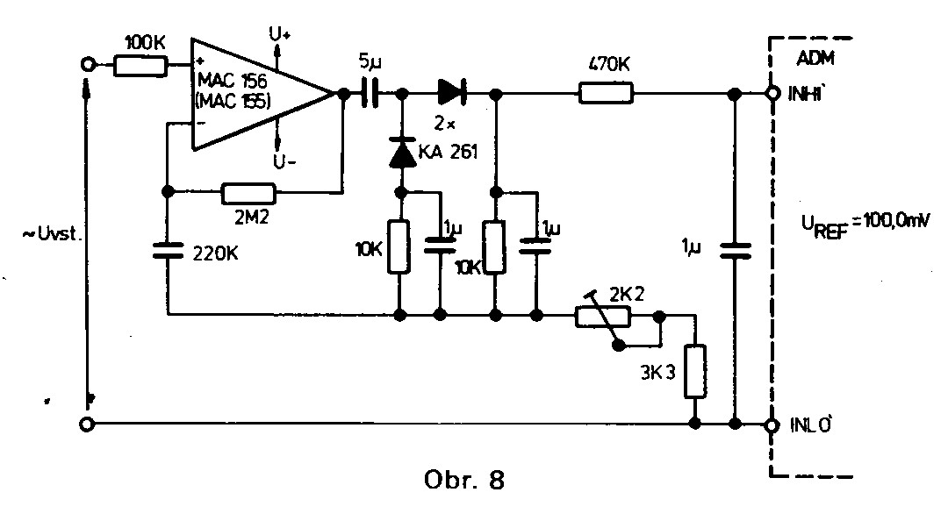

4. Resistance Measurement (Měření odporu)
This measurement uses the ratio method. The unknown resistance is connected in series with the normal one, and current is allowed to flow through them. The voltage on the unknown resistance is applied between the IN HI and IN LO tips; the voltage on the normal resistance is applied to the reference inputs REF HI and REF LO. If the unknown resistance equals the normal one, the display shows 1000. The displayed value (ZÚ) is determined from the following formula:
ZÚ =
Fig. 9 shows a typical measurement circuit. The advantage of this ratio method is that a precisely defined reference voltage is not necessary. For this connection, we must modify the printed circuit board by scratching the printed connections at points 2, 3, and 4.

5. Temperature Measurement (Měření teploty)
A transistor can be used as a temperature sensor, where we measure the base-emitter forward voltage. The voltage U_{SE} has a temperature coefficient of about -2mV/°C. Fig. 10 shows a connection for temperature measurement with 0.1°C accuracy. For this connection, we must modify the printed circuit board by scratching the printed connections at points 1, 3, and 4. The thermometer is adjusted at two temperatures: at 0°C (immerse the sensor in water with ice) using variable resistor RP1 and at 100°C (boiling point of water) using variable resistor RP2. For easier adjustment, we recommend using multi-turn trimmers for RP1 and RP2, e.g., WK677912.
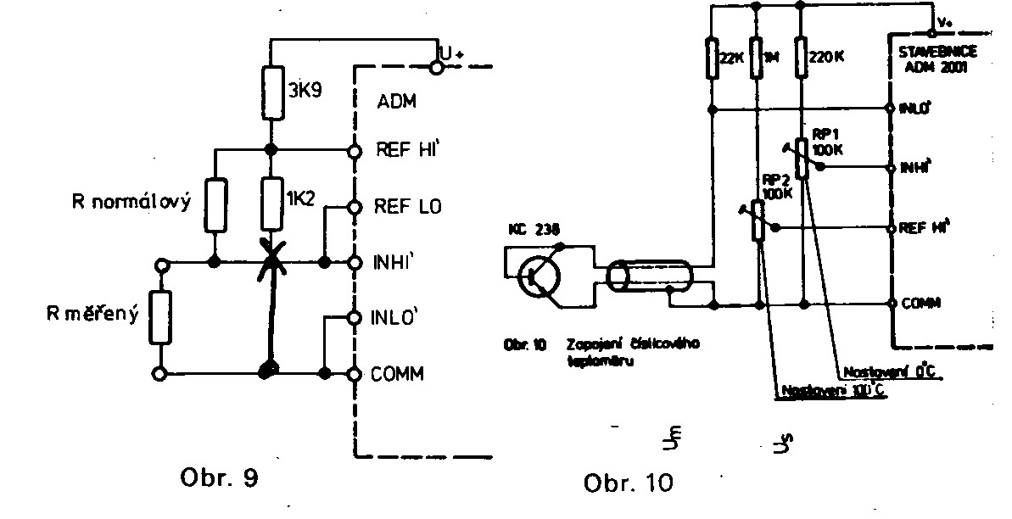

Warranty Certificate (Záruční list)
Warranty Conditions:
The manufacturer is responsible for the design and execution of the supplied modules. Based on this, in the event of functional part defects, it provides a warranty for six months from the date of putting into operation, but no longer than eight months from the date of sale. The manufacturer is not responsible for defects caused by improper handling, mechanical damage, incorrect use of the product contrary to the instructions, or use in an unsuitable environment (humid, dusty, chemically aggressive).
Service is provided by Tesla Eltos through selected repair shops.
Manufacturer: Tesla Rožnov, state enterprise, Vrchlabí plant

Type: ADM 2001
Packaging Date: Packaged by:
Date of Sale:
Seller's Signature:
Seller's Stamp:

