Brett Settle

CS 115 Computer Simulation

Diffusion Simulation

**Question:**Do the calcium diffusion sites (puffs) provide satisfactory information about the calcium activity in a cell, or are there invisible, individual receptor sites in the cell that create the uniform calcium wave we see in diffusion?

**Method:**

I am basing my initial simulation parameters on the paper “Hindered cytoplasmic diffusion of inositol trisphosphate restricts its cellular range of action” by George D. Dickinson, Kyle L. Ellefsen, Silvina Ponce Dawson, John E. Pearson, and Ian Parker, Science Signaling Nov 2016  
Paper available at: [http://stke.sciencemag.org/content/9/453/ra108](http://stke.sciencemag.org/content/9/453/ra108%20)

Calcium ions diffuse from sites within the cell, and release IP3 ions as they do, creating a “puff” of luminescence that can be used to measure the strength and duration of calcium release. While most sites are large enough to measure and track, some hidden sites have been recognized throughout the cell, altering the visible diffusion of calcium. My model simulates this effect by randomly generating sites with fractional amplitudes in between normal sites and comparing the resulting wave.

Puffs open for a small range of time and emit a uniform amount of calcium at each time step, resulting in a peak like in Figure 1. Puffs open by some exponential distribution, such that the probability of any puff opening in a given interval with a calcium concentration C is P(t, C), where t specifies the simulation time. Puffs also close by a similar distribution, whereas most sites only stay open for a short amount of time. A puff can only open once, and remains inactive after closing.

**Fig 1. Puff Fluorescence Trace at Opening Fig 2. Model of Puff Entities:**

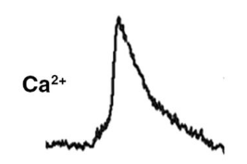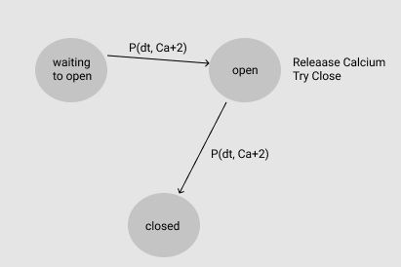

**Simulation**

My simulation would generate a cell (as a rectangle) with uniform IP3 distribution, and randomly generate N puff sites across the cell. The activation of puffs can be modeled by an exponential distribution of time and , where most puffs excite within the first hundred milliseconds. Puff sites open and generate uniform calcium at every time step, then close by some exponential distribution. As the calcium from the puff diffuses, it increases the concentration within the cell, increasing the likelihood of other sites becoming excited. This chain reaction of events has been seen to create a uniform “wave” effect.

**Model:**Parameters:

* Cell shape: default to rectangle [width, height]
* Iterations: Number of iteration intervals to simulate
* Number of Clusters: Cluster count within cell, uniformly distributed as X,Y coordinates
* Diffusion coefficient: the coefficient to use in the diffusion equation
* Distribution for initial calcium levels throughout the cell, as well as calcium levels in clusters
* Which cluster to activate first

**Results:**

