OpenDCS

Hydrologic Database (HDB)

Time Series Alarms

Document Revision 3

August, 2022

This Document is part of the OpenDCS Software Suite for environmental data acquisition and processing. The project home is: <https://github.com/opendcs/opendcs>

See INTENT.md at the project home for information on licensing.

Table of Contents

1 Introduction 1

2 Database Tables for Alarms 3

3 Alarm Editor 5

3.1 Screenings and Limit Sets 5

3.2 Email Groups 7

4 Alarm Screening Computations 8

4.1 Missing Data Checks 10

4.2 Configure Computation Process for Email Notifications 11

5 Import and Export Screening Records 14

5.1 Export Alarm Records to XML File 14

5.2 Import Alarm Records from XML File 15

5.3 XML File Format 15

6 Alarm Flags 16

7 Display Alarms 18

8 File Monitors and Process Monitors 19

8.1 BC Hydro Alarm Mailer 20

# Introduction

This document describes an enhancement added to the OpenDCS Computation Processor for use by the United States Bureau of Reclamation. The enhancement supports data screening and the generation of automated Alarms based on the results of the screening.

There are four types of screening checks:

* Value Limits
* Rate of Change Limits
* Stuck Sensor Checks
* Missing Data Checks

For both Value and Rate of Change (ROC) Limits, the user can specify different severities which divide the range into seven possibilities:

* Reject High: Value or ROC is impossibly high – bad data
* Critical High: Value or ROC is in a critical high range
* Warning High: Value or ROC is somewhat high
* (Good Range – No Limits Violated)
* Warning Low: Value or ROC is somewhat low
* Critical Low: Value or ROC is in a critical low range
* Reject Low: Value or ROC is impossibly low – bad data

Any or all of the limits can be specified. E.g., perhaps you just need a Value-Warning-High limit and leave the others undefined.

To detect stuck sensors, you specify the following:

* Duration over which to check, e.g., check to see if a sensor value is stuck for more than “1 day”, “48 hours”, “5 days”.
* Tolerance: Defines what it means to be stuck. A value changing by more than this is considered unstuck. Zero or NULL means any change is considered unstuck.
* Minimum Value to Check: Below this, no stuck sensor checking is done.
* Max Gap: This prevents missing data from being interpreted as a stuck sensor. If you have a gap longer than this in the period being checked, then no alarm is asserted.

For Missing Data Checks, you specify the following:

* Missing Period: The period over which to check for missing data. E.g. “1 day”, “48 hours”
* Missing Interval: The Interval of the time series to check for missing values. This cannot be an INSTANT time series, otherwise the system does not know how many values to expect. The system will check for missing data at this interval.
* Max Missing Values: The maximum number of missing values in the period to accept before declaring an alarm. Missing values do not have to be contiguous.

For example, if Missing Period is “48 hours”, interval is “Hour”, and Max Missing is 3, this means that if more than three missing hourly values are detected within any 48 hour period, declare a missing data alarm. Note that missing values do not need to be contiguous within the period.

When an alarm condition is detected, a “ALARM_CURRENT” record is stored in the database. Later, the alarm may be resolved in a number of ways:

* Value or ROC returns to normal range.
* A stuck sensor becomes unstuck.
* New data is received for a time series that was previously declared Missing.
* A user manually cancels an alarm.

When an alarm is resolved it is moved to the “ALARM_HISTORY” table and an end time is assigned.

Email Notifications may optionally be sent when alarm conditions are detected and resolved. An ALARM_GROUP defines a list of email addresses.

The enhancment to OpenDCS presented here expands on previous work done for a different client. That client required alarms to be generated when certain conditions were detected on files or on the event messages being generated by some process.

# Database Tables for Alarms

The Entity Relationship Diagram for Alarms is shown below.

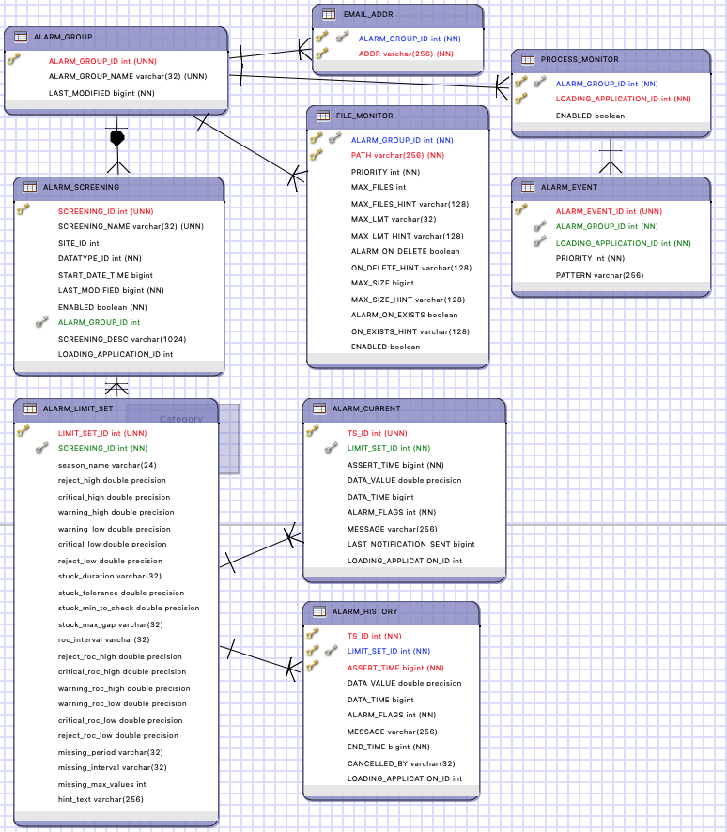

An ALARM_GROUP contains a list of EMAIL_ADDR records. It is also associated with PROCESS_MONITOR and FILE_MONITOR records described elsewhere.

An ALARM_SCREENING is associated with a DATATYPE and optionally a SITE. Records without SITE assignment can define a kind of default for a data type. For example, you might define a screening with datatype=Incremental Precip and no site assignment.

When checking a value, the system looks first for a screening with matching SITE and DATATYPE. Then if not found, a match for only DATATYPE will be used.

An ALARM_SCREENING may have a START_DATE_TIME. If so, only values after the specified start will be checked with this screening. For example, you may have limits that evolve over time for a given Site/DataType. There may be a series of ALARM_SCREENING records with different START_DATE_TIMEs. The appropriate record will be used depending on the data time.

A screening may have multiple seasonal ALARM_LIMIT_SET records. If you do not need seasonal checks, simply leave SEASON_NAME undefined. A limit set with no SEASON_NAME will be the default for data that does not occur within a named season.

The Limit Set holds all of the limits that control how checks are done. The names in the ERD above are self explanatory.

ALARM_CURRENT holds currently-asserted alarms. ALARM_HISTORY holds alarms that have been asserted and resolved in the past. In these tables:

* TS_ID is a foreign key to CP_TS_ID in HDB, or the time series *code* in CWMS.
* LIMIT_SET_ID is a foreign key to ALARM_LIMIT_SET containing the limits used to generate this alarm.
* ASSERT_TIME is a Java millisecond time (milliseconds since the Unix epoch Jan 1, 1970 midnight UTC. This is the time that the alarm was initially generated—that is, the time the value limits were first violated.
* DATA_TIME is the time-stamp (Java msec) of the first value that violated the limits.
* END_TIME is one of the time-stamp (Java msec) of the first value where the value went back within limits and the alarm was moved from the current table to the history table.

Note that ALARM_SCREENING is associated with a Site/Datatype but not the other parameters that specify a unique time series such as Interval, Real/Modeled, Model ID. Assigning specific time series is done in the normal way for the Computation Processor: By assigning a time series to a computation.

For OpenDCS 6.8, LOADING_APPLICATION_ID was added to ALARM_SCREENING, ALARM_CURRENT, and ALARM_HISTORY. The ID must be set in ALARM_SCREENING and must match the application ID assigned to the screening algorithm.

# Alarm Editor

The program “alarmedit” will allow you to maintain all of the screening records in a GUI. It is structured like the computations editor and the DECODES database editor. At the top level there are two tabs:

* Email Groups – a list of named Email groups in the database from which you can open, create new, copy, or delete
* Screenings – a list of named screenings in the database

In both cases you can sort the list in various ways by clicking the column header.

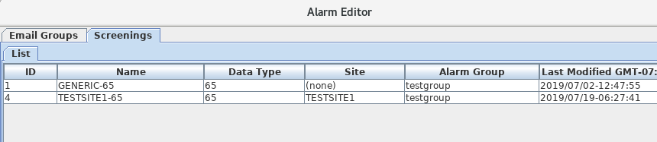

## Screenings and Limit Sets

The snapshot below shows a screening open in the editor. You can see that the fields shown in the GUI match the columns in the database tables shown in section 2. Note the following:

* The screening shown is named “GENERIC-65”. All screenings have a unique name.
* It is called GENERIC-65 because the datatype is 65 (in HDB this refers to instantaneous stream stage) and no site is defined. This mean that this screening will be used when the algorithm can’t find a screening with a matching site.
* This screening is associated with Email Group “testgroup”, meaning that when an alarm is generated an email will be sent to the recipients in that group.
* The Units field shows you the units in which alarms are specified. In HDB, these are always the database storage units for the DATATYPE specified.
* No Effective Start is applied, meaning that there is no lower bound on the time range for this screening.
* The screening has a single Season Tab labeled “default”. The “default” season is used for date/times not within any of the other seasons. If you don’t need seasonal limits, use only the default season. You can Add, Delete, or Sort the season tabs with the buttons on the right.
* For Value and ROC limits, only specify the limits you need.
* The screening shown does not define a missing data alarm because the required Check Every field is left blank.

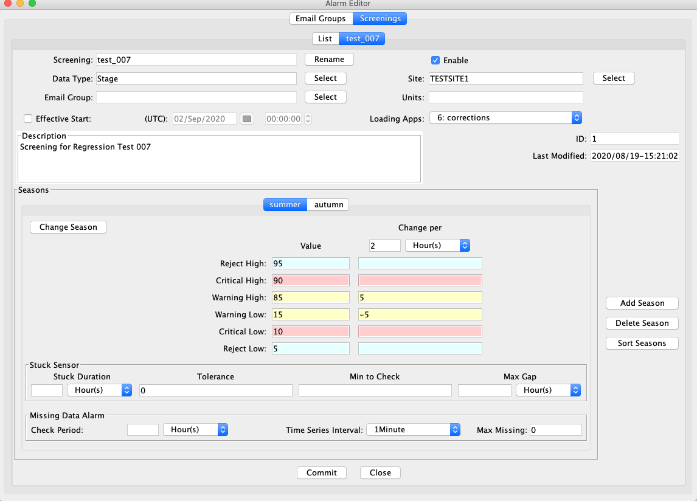

## Email Groups

Email groups let you specify a list of email addresses. This feature builds on a previous OpenDCS feature added for another client that allows you to send Email alarms based on file and event conditions.

The snapshot below shows an email group with 3 email addresses. When an alarm is generated or resolved that is assigned to this group, email notifications will be sent to each recipient.

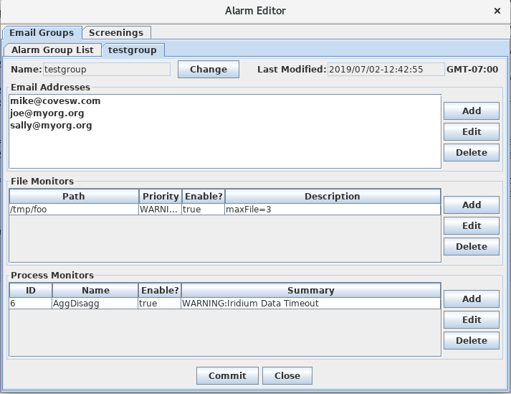

# Alarm Screening Computations

For OpenDCS 6.6 RC04 there is a new Alarm Screening Algorithm. If you do not have this algorithm in your database yet, import it as follows:

compimport $DCSTOOL_HOME/imports/comp-standard/AlarmScreening.xml

After import, restart the computation editor GUI and the Alarm Screening will now appear on the Algorithms tab.

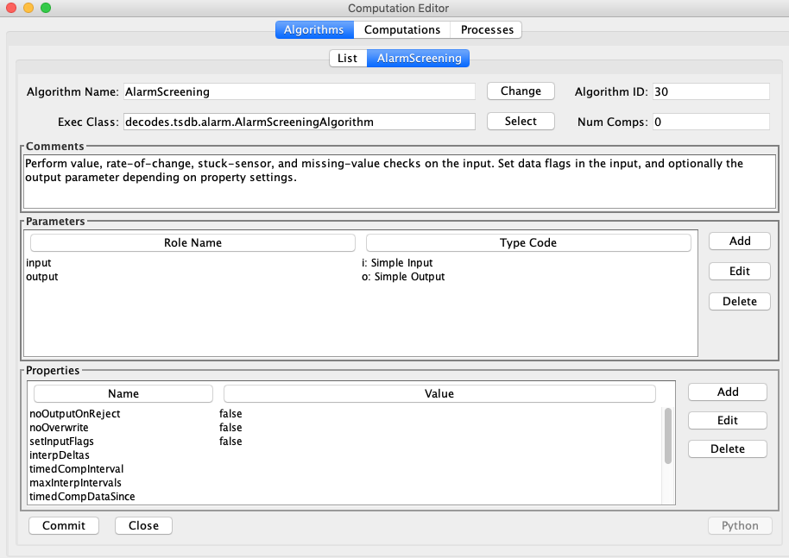

The AlarmScreening algorithm has one input and one optional output. They may refer to the same time series or you can leave the output undefined. Properties control how flags are set on input and output parameters.

Properties specific to the algorithm are:

|  |  |  |
| --- | --- | --- |
| Name | Type | Description |
| setInputFlags | Boolean | (default=false) Normally the flags are set on the output only. Set this to true to have flags set on the input values as well. Recall that the output parameter is optional. If undefined, then you should set ‘setInputFlags’ to TRUE. |
| noOutputOnReject | Boolean | (default=false) If set, and if the input value is in a rejected value or rate-of-change range, then the output value is *not* written. |
| noOverwrite | Boolean | (default=false) If true, then the output is *not* written if there is already an output value at that time. This allows you to manually modify a value’s flags in HDB without fear that reprocessing will overwrite your manual changes. |
| setDataFlags | Boolean | (default=true) Normally, you want the flags resulting from screening to be saved with each time series value. An exception would be if you have multiple *different* screenings assigned to the same time series to be executed by different loading applications. In this case, you only want one of the screenings to write flags. Set this property to false to the *other* screening to prevent it from writing flags. |

The algorithm does the following when an input value arrives and triggers the computation:

* Lookup the applicable screening and limit set according to the input’s datatype and site designation. The screening start date/time and the limit set’s season assignment are also taking into account.
  + *Note: in OpenDCS 6.8, LOADING_APPLICATION_ID in the screening must also match the ID assigned to the computation. This was added to allow you to have multiple different screenings for each TSID, as long as they’re assigned to different loading applications.*
* Perform the value, rate-of-change, and stuck-sensor checks. This results in a set of bit flags.
  + If (setInputFlags == true), then the flags are set on the input value
  + If an output is defined, set the flags on the output value
* If a *new* alarm condition is detected, create or update an entry in the ALARM_CURRENT table.
  + Do not rewrite existing identical records. E.g. if a Value-Warning-High alarm was already in effect and this value is also Value-Warning-High, no change is made to the ALARM_CURRENT record.
* If a previous alarm condition is now resolved (e.g. a stuck sensor becomes un-stuck), move the alarm record to ALARM_HISTORY.
* When ALARM_CURRENT records are created, updated, or moved to the history table, if an email group is assigned to the screening, send email to the recipients in the group.

The Alarm Computation assigns specific time series to be screened. The example below is rather contrived. It shows a computation that does a screening on datatype 65 (instantaneous stream stage) at a site TESTSITE1, and writes the output to TESTSITE2.

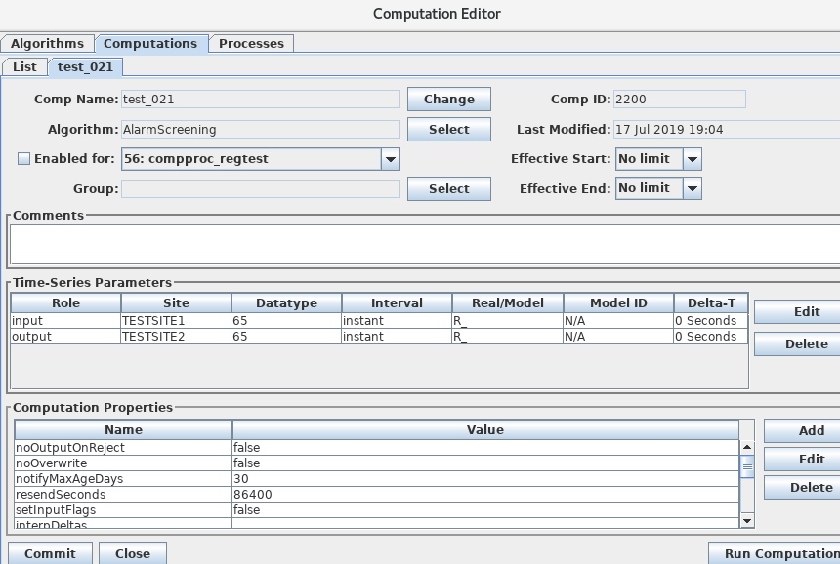

## Missing Data Checks

Missing Data Checks are specified by:

* The period over which the check is done. You specify this with a string like “72 hours” or “1 day”.
* The time series interval: this tells the algorithm the interval of the time series to check. It also implicitly tells the system how often to expect a value.
* Maximum number of Missing Values to tolerate before generating an alarm. If you set to 0, then any missing data generates an alarm. If you set to 4, then an alarm is generated on 5 or more missing values in the period.

Missing Checks are done by the computation process at the specified time series interval. Each time, it scans backward over the specified period and determines the number of missing values. If this is greater than the specified threshold, a missing data alarm is asserted.

## Configure Computation Process for Email Notifications

The following properties control the connection to the mail SMTP server. These properties are set in the Loading Application Record. In the Computations Editor, click the Processes Tab. Open the process that will run the alarm computations. You may apply the following properties.

Assigning these to the application means that all alarm computations assigned to the same application will use the same mail server settings.

If you want email notifications to come from the computation editor when running an alarm computation, be sure to also set these properties in the “compedit” process record.

|  |  |  |
| --- | --- | --- |
| ***Property Name*** | ***Default*** | ***Description*** |
| mail.smtp.host | no default | This is required in order to send alarm email. The host name or IP address of the mail server.  Remove this property or set it to blank to disable email output altogether. |
| mail.smtp.port | 587 | TCP port for connecting to mail server |
| mail.smtp.auth | false | (true/false) if true, then perform an authenticated connection to the mail server. If true, then you must also set smtp.username and smtp.password. |
| mail.smtp.starttls.enable | false | (true/false) if true, then use TLS (SSL) for a secure connection to the mail server. |
| smtp.username | no default | Required if mail.smtp.auth is true, this is the user name for connecting to the mail server. |
| smtp.password | no default | Required if mail.smtp.auth is true, this is the password for connecting to the mail server. |
| fromAddr | no default | Set this to the email address to be used in the ‘from’ field of the header. |
| fromName | no default | Set to the name for the from field of the header. |
| resendSeconds | 86400 | Number of seconds. Resend email for existing alarms after they have been asserted for this long. Set to -1 to disable resend. |
| notifyMaxAgeDays | 30 | Do not send email notifications for alarms on data older than this. |
| resendSeconds | 86400 | Normal email is not sent when an existing alarm is re-asserted, e.g. a WARNING-HIGH value is detected but the previous value was also WARNING-HIGH. Email will be only be sent if the last notification was longer than this many seconds ago (default = 1 day worth of seconds). If you never want repeat emails, set to -1. |
| notifyMaxAgeDays | 30 | Do not send email notifications for alarm conditions on data older than this. |
| mailer.class |  | If you require a particular format or special mail handling, set this to the class name to handle the actual sending of mail.  If not set, the default class “decodes.tsdb.alarm.mail.AlarmMailer” will be used.  BC Hydro applications should use:  decodes.tsdb.alarm.mail.BCHydroAlarmMailer |

# Import and Export Screening Records

The alarmexport and alarmimport utilities can export screening records to and import from XML files.

## Export Alarm Records to XML File

alarmexport [*options...]*

The following arguments can be used in combination to filter which screenings are written to the output XML file.

As with most opendcs programs, the –x argument will result in a help message containing all allowable options.

-C Export current alarm screenings only. I.e. not those superseded with a later start date.

-T *datatype* Export only screenings for a given data type.

-F Include file and process alarms in the output.

-G *alarmGroupName* Export only screenings assigned to the named group.

-S *siteName* Export only screenings for a given site.

The –d, -g, and –s arguments may occur multiple times for multiple data types, groups, and sites, respectively.

Data Types may be simple strings to match the preferred data type, or of the form:

*Standard:Code*

to specify data types of a given standard. For example:

SHEF-PE:HG

CWMS:Stage-Tailwater

HDB:65

Likewise, Site Names may be simple names to match the preferred name type or may be specified as *nametype:namevalue*. E.g.

NWSHB5:M1DRN

CWMS:PatapscoJunction

## Import Alarm Records from XML File

alarmimport [*options...]* filename(s)

Include the file name(s) to be imported at the end of the command line.

## XML File Format

Here is an example alarm file that demonstrates the format:

<?xml version="1.0" encoding="UTF-8" standalone="yes"?>

<AlarmDefinitions>

<AlarmGroup name="test-group">

<Email>mike@covesw.com</Email>

<FileMonitor path="somepath" priority="WARNING">

<OnDelete hint="7"/>

<MaxFiles hint="2">1</MaxFiles>

<MaxSize hint="4">3</MaxSize>

<MaxLMT hint="6">5 Seconds</MaxLMT>

<Enabled>true</Enabled>

</FileMonitor>

<ProcessMonitor name="compproc">

<Enabled>true</Enabled>

<AlarmDef priority="FAILURE">failure</AlarmDef>

<AlarmDef priority="WARNING">WARNING</AlarmDef>

</ProcessMonitor>

</AlarmGroup>

<AlarmScreening name="test screening">

<alarmGroupName>test-group</alarmGroupName>

<desc>a description of a test screening</desc>

<datatype standard="SHEF-PE">HG</datatype>

<Enabled>true</Enabled>

<AppName>compproc</AppName>

<AlarmLimitSet season="spring">

<RejectHigh>100.0</RejectHigh>

<CriticalHigh>80.0</CriticalHigh>

<WarningHigh>60.0</WarningHigh>

<WarningLow>40.0</WarningLow>

<CriticalLow>20.0</CriticalLow>

<RejectLow>0.0</RejectLow>

<stuckDuration>1 day</stuckDuration>

<stuckTolerance>0.0</stuckTolerance>

<stuckMinToCheck>0.0</stuckMinToCheck>

<stuckMaxGap>5 hours</stuckMaxGap>

<rocInterval>2 hours</rocInterval>

<RejectRocHigh>100.0</RejectRocHigh>

<CriticalRocHigh>80.0</CriticalRocHigh>

<WarningRocHigh>60.0</WarningRocHigh>

<WarningRocLow>40.0</WarningRocLow>

<CriticalRocLow>20.0</CriticalRocLow>

<RejectRocLow>0.0</RejectRocLow>

<missingPeriod>1 day</missingPeriod>

<missingInterval>15Minutes</missingInterval>

<missingMaxValues>4</missingMaxValues>

</AlarmLimitSet>

</AlarmScreening>

</AlarmDefinitions>

# Alarm Flags

Each time series value in the database also stores a set of flags. These flags indicate whether the value was screened, and if so, what the results of the screening were.

The flags are stored with each record in the time series tables in the database. They are also stored in the ALARM_CURRENT and ALARM_HISTORY tables when alarms are asserted. (Obviously the “missing value” code will only be in the alarm tables because there is no time series record.)

The following alarm definitions are applicable to HDB and OpenTSDB:

|  |  |  |  |
| --- | --- | --- | --- |
| ***Condition*** | ***Bits (hex)*** | ***Display*** | ***Description*** |
| Screened | 00010000 | S(*codes*) | Indicates that the value has been screened. Any error codes will be contained within the parentheses. |
| Value Code Mask | 000E0000 |  | Mask used to extract the value results from the flags word. |
| Value Reject High | 00020000 | R+ | Value was >= reject high limit |
| Value Crit High | 00040000 | ++ | Value was >= critical high limit |
| Value Warn High | 00060000 | + | Value was >= warning high limit |
| Value Warn Low | 00080000 | - | Value was <= warning low limit |
| Value Crit Low | 000A0000 | -- | Value was <= critical low limit |
| Value Reject Low | 000C0000 | R- | Value was <= reject low limit |
| ROC Code Mask | 00700000 |  | Mask used to extract the rate-of-change results from the flags word. |
| ROC Reject High | 00100000 | R^ | ROC was >= reject high limit |
| ROC Crit High | 00200000 | ^^ | ROC was >= critical high limit |
| ROC Warn High | 00300000 | ^ | ROC was >= warning high limit |
| ROC Warn Low | 00400000 | v | ROC was <= warning low limit |
| ROC Crit Low | 00500000 | vv | ROC was <= critical low limit |
| ROC Reject Low | 00600000 | Rv | ROC was <= reject low limit |
| Stuck Sensor | 00800000 | ~ | Stuck sensor was detected |
| Missing Data | 01000000 | m | Missing data threshold was reached |

In HDB, the Display codes are stored in the “derivation_flags” values in the R_*interval* tables.

Display codes are also used in GUIs and command-line utilities that display the results of validation. Multiple codes are possible resulting from a screening. For example, the following indicates that after a screening, a time series value exceeded the high warning value limit *and* the critical rate-of-change limit:

S(+ ^^)

The bits in the above table are used internally inside the computation processor. You will need to use these if you are writing algorithm code in either Java or Python and you need to use screening results.

In OpenTSDB, the flag word associated with each value uses the bit definitions in the above table.

In CWMS, the screening conditions will have to be mapped to existing CWMS flag bit definitions. this work is TBD.

# Display Alarms

The ‘showAlarms’ utility can be used to show currently asserted and historical alarms. Running without any arguments will display all alarms:

showAlarms > allAlarms.csv

To display only alarms for particular time series, add a list of time series identifiers:

showAlarms TESTSITE1.66.hour.R_ TESTSITE2.66.hour.R_ > someAlarms.csv

The format is a comma-separated value format that can be easily imported into Excel. The following shows that there are no currently-asserted alarms and several recent (but historical) alarms for TESTSITE1-66.hour.R_:

All times in UTC

Current Alarms(0):

tsid,screening,season,assertion,value,data_time,flags,msg,last_notify,loading_app

Historical Alarms (9):

tsid,screening,season,assertion,value,data_time,flags,msg,end_time,cancelled_by,loading_app

TESTSITE1.66.hour.R_, TESTSITE1-66, default, 2019/08/28-10:47:07, 34.45, 2019/08/28-09:00:00, 0x90000, Value 34.45 at time 2019/08/28-02:00:00: value in WARNING_LOW range., 2019/08/28-10:00:00,compproc

TESTSITE1.66.hour.R_, TESTSITE1-66, default, 2019/08/28-07:47:07, 34.5, 2019/08/28-07:00:00, 0x70000, Value 34.5 at time 2019/08/28-00:00:00: value in WARNING_HIGH range., 2019/08/28-07:00:00,compproc

TESTSITE1.66.hour.R_, TESTSITE1-66, default, 2019/08/28-00:47:08, 34.5, 2019/08/28-05:00:00, 0x70000, Value 34.5 at time 2019/08/27-22:00:00: value in WARNING_HIGH range., 2019/08/28-06:00:00,compproc

TESTSITE1.66.hour.R_, TESTSITE1-66, default, 2019/08/27-22:47:08, 34.52, 2019/08/27-22:00:00, 0x70000, Value 34.52 at time 2019/08/27-15:00:00: value in WARNING_HIGH range., 2019/08/27-23:00:00,compproc

TESTSITE1.66.hour.R_, TESTSITE1-66, default, 2019/08/27-21:47:15, 34.52, 2019/08/27-20:00:00, 0x70000, Value 34.52 at time 2019/08/27-13:00:00: value in WARNING_HIGH range., 2019/08/27-21:00:00,compproc

TESTSITE1.66.hour.R_, TESTSITE1-66, default, 2019/08/27-19:47:09, 34.5, 2019/08/27-19:00:00, 0x70000, Value 34.5 at time 2019/08/27-12:00:00: value in WARNING_HIGH range., 2019/08/27-19:00:00,compproc

# File Monitors and Process Monitors

These are legacy features and have nothing to do with the Computation Processor. A special “Alarm Monitor” task can be started with the “alarmmonitor” script. The AlarmMonitor daemon will look in the database for Email Groups, File Monitors, and Process Monitors and then run in the background performing the indicated checks.

The AlarmMonitor process record should be given the same properties described above for the Computation Processor in section 4.2.

A File Monitor allows you to watch a directory or normal file for abnormal conditions, and then to send email notifications when they are detected. A record in the GUI is shown below.

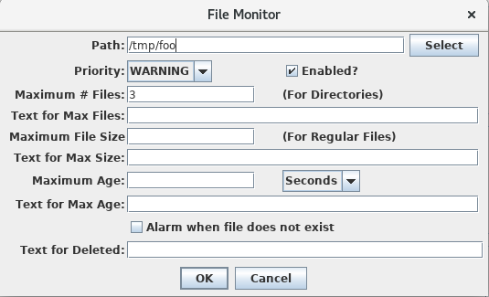

You can cause email notifications to be sent on the following conditions.

* If the Path specifies a directory, you can specify the maximum number of files that can be in the directory before an email notification is sent.
* If the Path specifies a regular file, you can specify the maximum file size.
* For either file or directory you can specify the maximum age, that is, the amount of time elapsed since the file or directory was last modified.
* You can alarm if the file does not exist (i.e. was deleted.

For each notification you can specify additional text to be included in the email notifications.

For Process Monitors, the alarm monitor task will connect to one of the supported OpenDCS processes and collect events as they happen. It searches for events with a matching priority that contains the specified pattern. If these are detected then become email notifications.

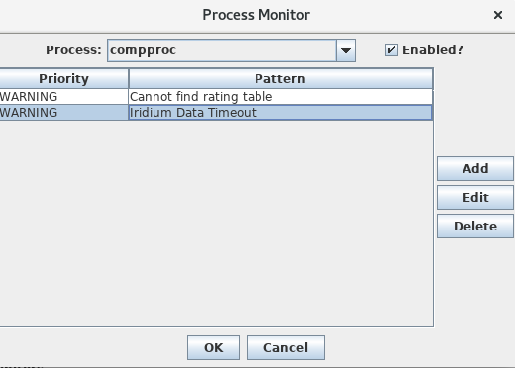

In the above example, the Alarm Monitor task will connect to the application named “compproc” and monitor the events being generated by it. (Note: only INFO, WARNING, FAILURE, and FATAL events will be monitored, not DEBUG messages.)

When it sees a WARNING message containing the string “Cannot find rating table”. The event message will be emailed to the members of the group.

## BC Hydro Alarm Mailer

For version 7.0.2, a special alarm mailer class was added to support the special alarm email format required by BC Hydro. To activate this, add a property “mailer.class” to the process record and set the value to:

decodes.tsdb.alarm.mail.BCHydroAlarmMailer