OpenDCS 6

DCP Monitor User Guide

Document Revision 1

February, 2016

This Document is part of the OpenDCS Software Suite for environmental data acquisition and processing. The project home is: <https://github.com/opendcs/opendcs>

See INTENT.md at the project home for information on licensing.

Table of Contents

1 Overview 1

1.1 Glossary and List of Acronyms 2

2 DCP Monitor Screens 3

2.1 The Opening Screen 3

# Overview

The OpenDCS-Azul DCP Monitor is a web-based tool for monitoring your data collection activities.

## Glossary and List of Acronyms

CP Computation Processor – the background program that executes computations as new data arrives.

CCP CWMS Computation Processor – i.e. the CP configured for CWMS.

CWMS Corps Water Management System (pronounced ‘swims’) - A system for hydrologic data storage and analysis used by USACE.

DAS Data Acquisition Server – responsible for collecting raw DCP messages via a variety of satellite and internet links.

DBMS Database Management System

DCP Data Collection Platform – equipment in the field that collects and transmits raw environmental measurements.

DCS Data Collection System

DECODES DEviceCOnversion and DElivery System – A collection of software for decoding raw environmental data, and converting it to a time-series in a variety of formats.

ERD Entity Relationship Diagram

GUI Graphical User Interface

HDB Hydrologic Database – A system for hydrologic data storage an analysis used by USBR.

LRGS Local Readout Ground Station – This is synonymous with DAS. It is the legacy name for a Data Acquisition Server.

NWIS National Water Information System - A system for hydrologic data storage an analysis used by USGS.

SDI Site Data-type ID. In HDB this is used to denote a particular parameter at a particular site. It is stored as a numeric ID.

SQL (a.k.a. “sequel”) Structured Query Language

TSDB Time Series Database

USACE U. S. Army Corps of Engineers

USBR U. S. Bureau of Reclamation

USGS U. S. Geological Survey

XML Extensible Markup Language

# DCP Monitor Screens

## The Opening Screen

The top level screen is shown below in the DCP Monitor for Alberta ESRD. The header and footer are customizable for each installation. These would typically contain the name of the organization and links to the organization’s main web site.

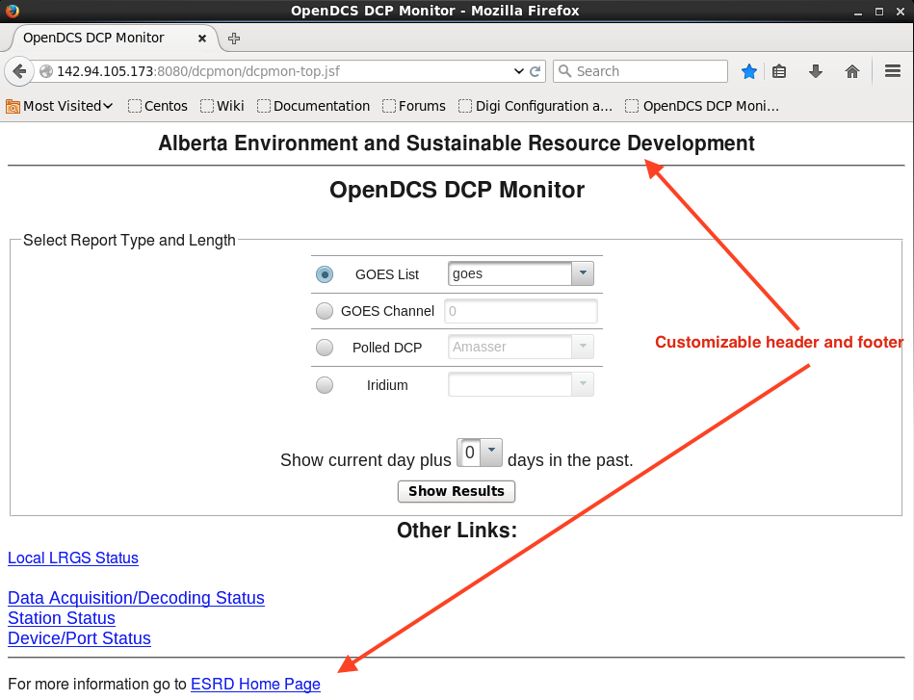

In the center area of the screen you select the DCP group that you want to monitor and the number of days to display. You can select by:

* GOES List: You can create any number of lists of DCPs, segregated by basin, region, etc.
* GOES Channel
* Polled DCP: These are modem, cell-modem, and network DCPs that are polled dynamically by the system. Again, you can create names groups.
* Iridium

The snap below shows that the Polled DCPs contains groups that we have defined for the type of DCP:

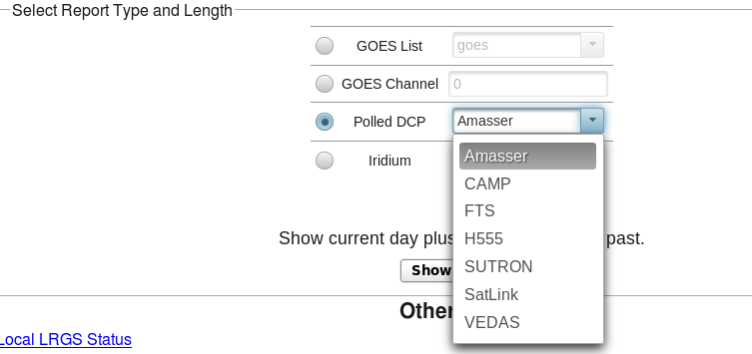

Once you have made your selection, click “Show Report”. This generates the high-level view of the data. The following snap shows the current day’s data for GOES platforms.

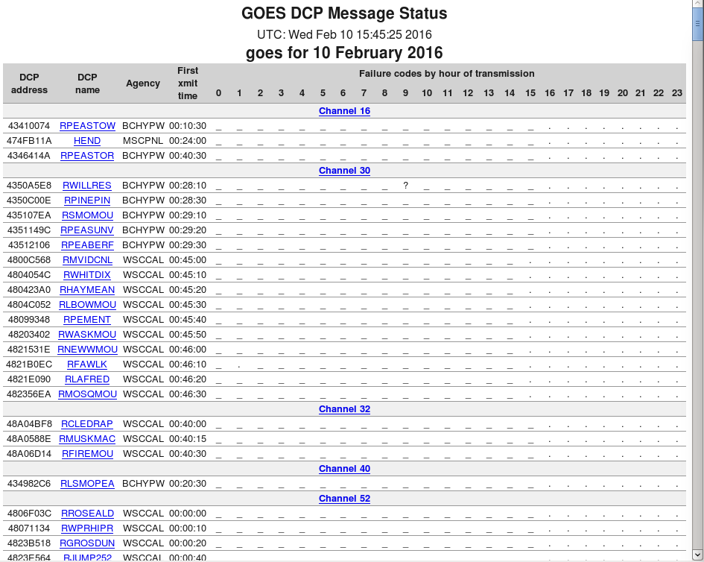

The columns of the report are:

* DCP Address
* DCP Name – as defined in your DECODES database
* Agency – as defined in the NOAA Platform Description Table
* First Transmit Time of Day – as assigned by NOAA
* 0...23 hour of day

Data is sorted by channel and by time within the channel. This way, you see adjacent time slots so that you can easily detect cases where one DCP transmits late (or early) and interferes with another.

The main body of the report shows codes for messages received within the hour. The underscore means a good message. Period means no message received (yet) for that your. This way, any error codes pop out.

A field of underscores = GOOD!

At the bottom of the report you find a legend explaining all the possible codes:

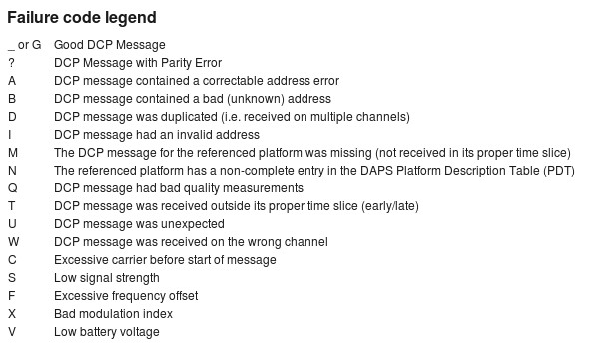

Note the ‘?’ code for RWILLRES during the 9 o’clock hour. This means that the message arrived with parity errors.

Here’s another section of the same report:

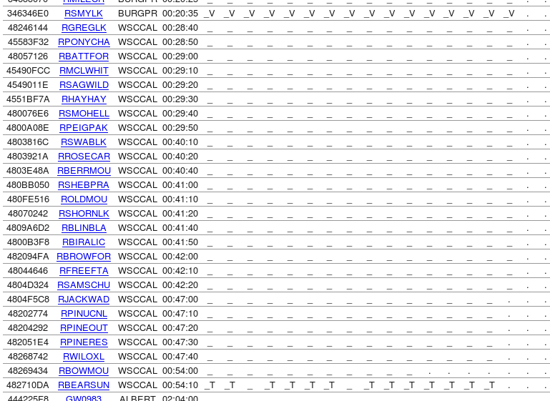

We see that RSMYLK is reporting low battery voltage on every message.

We also see the RBEARSUN is transmitting outside its NOAA-assigned window on most messages. Let us dig down to find out why. Click the link on platform name ‘RBEARSON’ to get a detailed report for that platform:

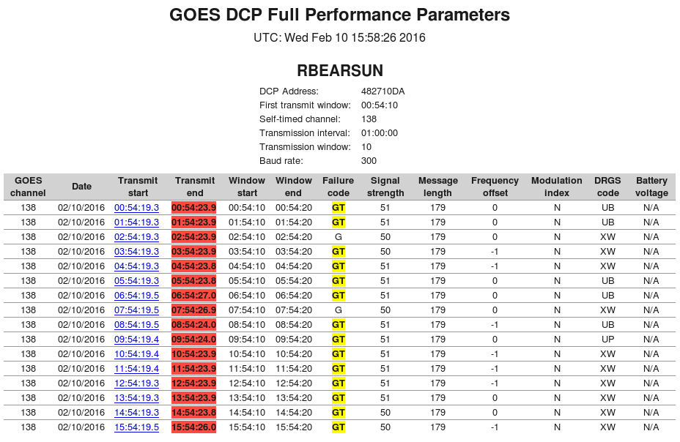

The report above shows more detail on each message received for a single platform. Hear each row represents a message.

Here we can easily see that the platform is transmitting late. It is starting its transmission just before the end of its assigned window, meaning that the transmit-end (highlighted in red) is several seconds into the adjacent window.

* This platform is probably interfering with another platform on this channel!

Click on one of the Transmit Start links to see an individual message:

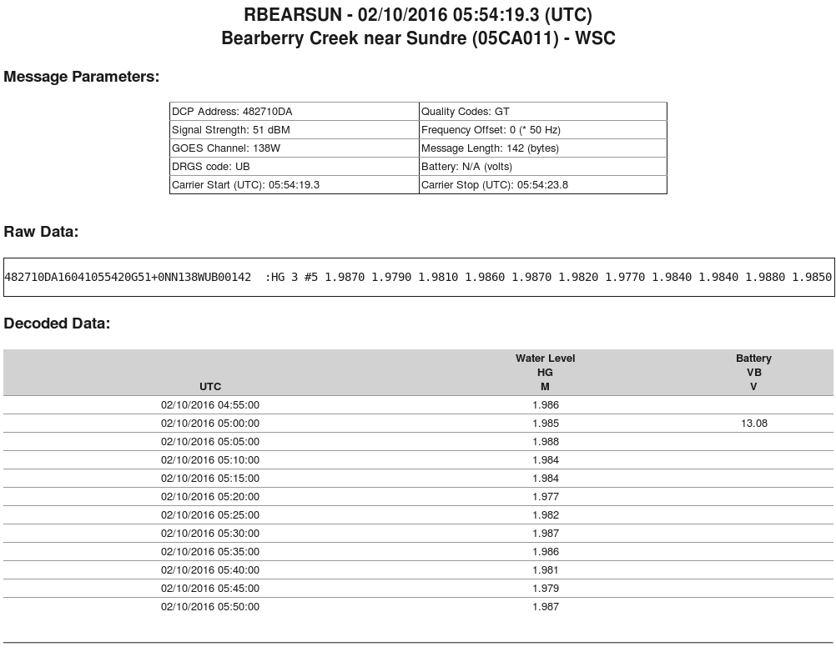

The Screens work for Non-GOES Platforms also. Here is a screen where the group AMASSER polled DCPs has been selected:

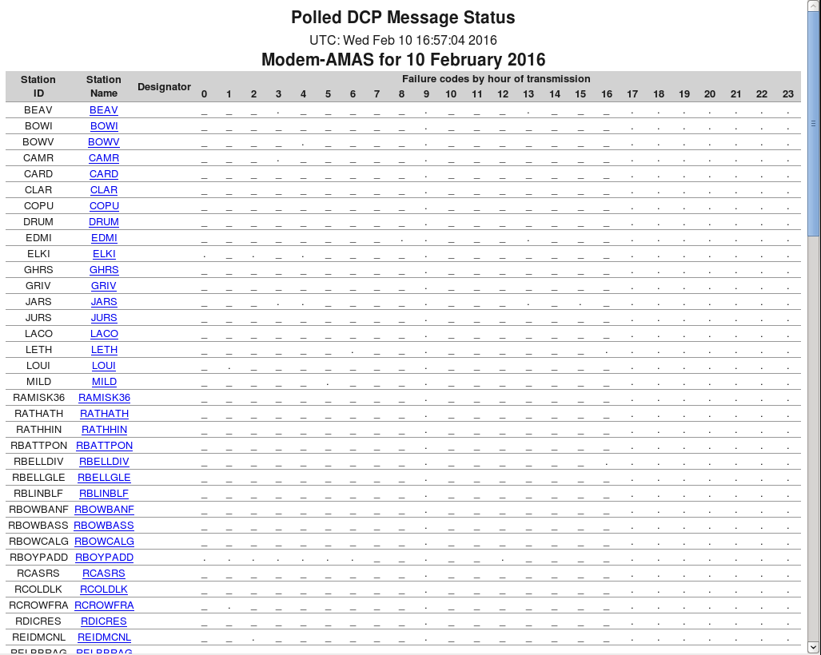

The same legend applies. Click on a platform name for details.

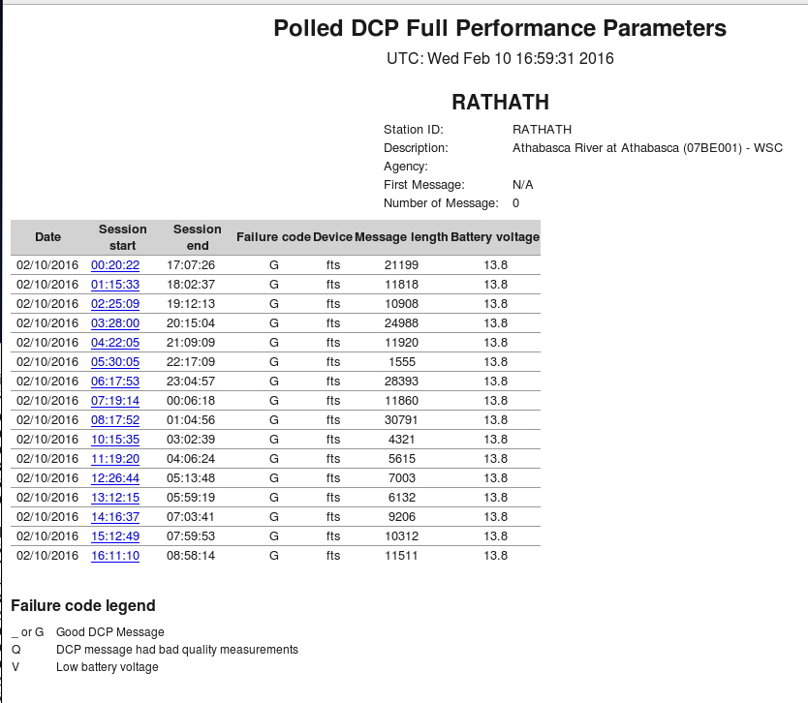

The header fields for polled DCPs are different than for GOES DCPs. Note that message lengths can be significantly larger because a longer time range is typically polled.

As above, click the session start time to see an individual message:

