OpenDCS 6

Installation Guide

Document Revision 7

April, 2020

This Document is part of the OpenDCS Software Suite for environmental data acquisition and processing. The project home is: <https://github.com/opendcs/opendcs>

See INTENT.md at the project home for information on licensing.

Table of Contents

1 Overview 1

1.1 Document Revision History 1

1.2 Glossary and List of Acronyms 2

2 Installing OPENDCS 3

2.1 Single User OPENDCS Installation 3

2.2 Multiple User Installation (Unix/Linux) 7

2.2.1 Setup OPENDCS Owner and Group 7

2.2.2 Permissions on Installation Directories 8

2.2.3 Install OpenDCS 8

2.2.4 Giving a Normal User Access to OpenDCS 9

2.2.5 Customizing the User’s Configuration 10

2.3 Installing from a Compressed Tar Image 11

3 Upgrading Database for a Previous Release 13

4 Starting and Configuring OPENDCS 14

4.1 Configuring From the Database 17

4.2 Accessing Multiple Database Profiles from the GUI 20

5 Creating a DECODES Database 23

5.1 XML Database 23

5.2 OpenDCS Database under PostgreSQL 23

5.3 Creating OPENDCS DECODES Database under Oracle 26

5.4 Using OPENDCS with CWMS 31

5.5 Using OPENDCS with USBR HDB 34

5.6 Encrypted Password File for Database Connection 34

5.7 Initialize from an Export of Another Database 35

6 Reference List Editor 36

6.1 Enumerations 37

6.2 Engineering Units 39

6.3 Engineering Unit conversions 40

6.4 Data Type Equivalencies 41

6.5 Seasons 42

# Overview

OPENDCS is a collection of tools for collecting hydrometeorologic data. It was developed originally for use with the GOES (Geostationary Operational Environmental Satellite) DCS (Data Collection System). These tools have been developed over the last decade (starting in 1999) and are used heavily by several U.S. Federal government agencies.

Included in OPENDCS:

* LRGS (Local Readout Ground Station) – a background server process and collection of GUI tools for collecting raw data via satellite links and over the network from other LRGS systems.
* Client-side GUI tools for LRGS – DCP Message Browser connects to any LRGS server, retrieve raw DCP messages based on a variety of search criteria. Display raw and/or decoded messages on the screen and/or save to file.
* DECODES (DEvice COnversion and DElivery System) – A sophisticated collection of GUI and background process to decode data from any platform and reformat into a large number of standard formats.
* OPENTSDB (Open Time Series Database) – will be released with OPENDCS 6.1, this is a powerful time series database engine modeled on CWMS (Corps Water Management System).
* Computation Processor – Can be used with CWMS, HDB (USBR’s Hydrologic Database), or OPENTSDB. A collection of GUIs and background processes that perform real-time computations and validations on a time series database.

## Document Revision History

Revision 6, September 2016:

* Added section 4.1 on configuring from the database.

Revision 7, April 2020:

* Added section 4.2 on the Launcher’s Multiple Profiles feature.

## Glossary and List of Acronyms

CP Computation Processor – the background program that executes computations as new data arrives.

CCP CWMS Computation Processor – i.e. the CP configured for CWMS.

CWMS Corps Water Management System (pronounced ‘swims’) - A system for hydrologic data storage and analysis used by USACE.

DAS Data Acquisition Server – responsible for collecting raw DCP messages via a variety of satellite and internet links.

DBMS Database Management System

DCP Data Collection Platform – equipment in the field that collects and transmits raw environmental measurements.

DCS Data Collection System

DECODES DEviceCOnversion and DElivery System – A collection of software for decoding raw environmental data, and converting it to a time-series in a variety of formats.

ERD Entity Relationship Diagram

GUI Graphical User Interface

HDB Hydrologic Database – A system for hydrologic data storage an analysis used by USBR.

LRGS Local Readout Ground Station – This is synonymous with DAS. It is the legacy name for a Data Acquisition Server.

NWIS National Water Information System - A system for hydrologic data storage an analysis used by USGS.

SDI Site Data-type ID. In HDB this is used to denote a particular parameter at a particular site. It is stored as a numeric ID.

SQL (a.k.a. “sequel”) Structured Query Language

TSDB Time Series Database

USACE U. S. Army Corps of Engineers

USBR U. S. Bureau of Reclamation

USGS U. S. Geological Survey

XML Extensible Markup Language

# Installing OPENDCS

There are two types of installations:

* Single User Installation. Only one user will use OpenDCS. This user will own all the installation files and directories.
* Multiple user Installation appropriate for Unix or Linux systems where multiple user accounts must use OpenDCS. A central designated user (we recommend user name “opendcs”) will own the installation files and directories. Other users may run OpenDCS from their own accounts.

## Single User OPENDCS Installation

This is the simplest type of installation. It is appropriate for Windows and other systems where a single-user will run the software.

Install OpenDCS *as the user who will run the utilities*. This user owns OpenDCS files. This ensures there will be no issues with permissions. This user will have full access to all utilities and configurations.

Start the installation by executing the downloaded installer JAR (Java Archive) file. On Windows, you can likely double-click the file icon in the windows explorer. On other system, CD to the directory where you downloaded the file and execute the following command:

java –jar *downloaded-file-name*

The installer guides you through a series of screens:

Welcome Screen:

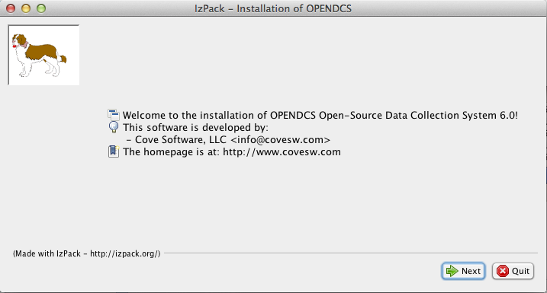

Select an installation location. The installer will create a tree of files under the location that you specify.

* For Unix/Linux installations, we recommend that you run the installer as the user that will own the installation files.
* For Windows installations, we recommend that you avoid directory names that have embedded spaces. For example, do not place the software under ‘C:\Program Files’.

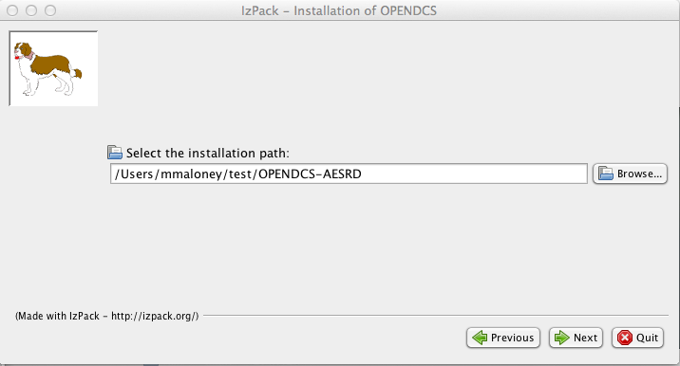

Select the packages that you want to install.

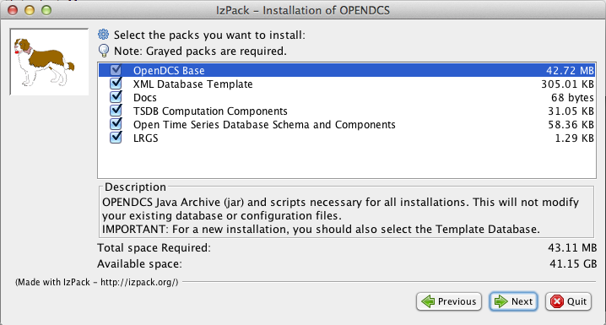

Allow the installation to complete:

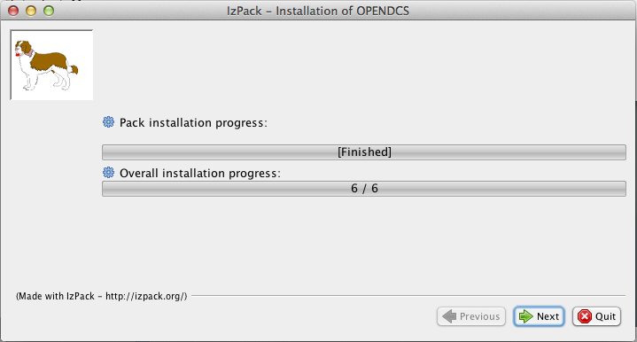

Go all the way to the final screen and hit ‘Done’. *Warning: Exiting the installer prior to the final screen may leave the software in an unusable state!*

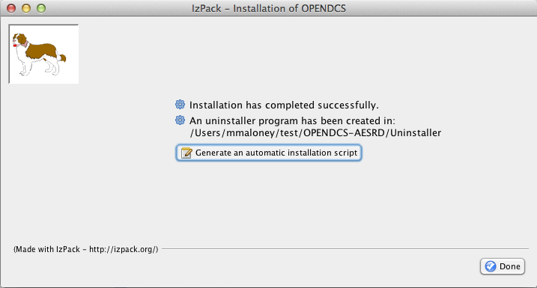

After installation we recommend that you establish an environment variable DCSTOOL_HOME pointing to the installation directory. Then place OPENDCS’s *bin* directory in your path.

So, for example, if you are running bash under a linux system, add this to your .bash_profile:

DCSTOOL_HOME=***insert complete path to installation here!***

export DCSTOOL_HOME

PATH=$DCSTOOL_HOME/bin:$PATH

After modifying this file, log out and back in so that the environment is now set.

## Multiple User Installation (Unix/Linux)

OPENDCS may be installed on a Unix/Linux system in a multi user environment.

A designated user (typically “opendcs”) owns the installation. Follow instructions below for creating this account and installing OpenDCS as this user.

Other users must become members of the “opendcs” Unix user group. They then run a script to set their environment for running the software. These users may customize a subset of the software configuration. Log and other types of files are placed in a subdirectory under each user’s HOME directory. See subsections below for details.

### Setup OPENDCS Owner and Group

An account must be designated as the OPENDCS toolkit owner. This should *not* be root! Also, a user group will be created allowing members read-only access to toolkit files and directories.

We suggest that the OpenDCS owner and group should both be called “opendcs”.

Before running the OPENDCS Toolkit installation, do the following:

* Login as root.
* Create the owner group account (e.g. “opendcs”)
* Create owner user account (e.g. “opendcs”). For login shell, specify ‘bash’. (Note, ksh will also work or sh if you must. Do not specify csh.)
* Ensure that the owner user’s primary group is the specified group account.
* Set permissions on the directory such that members of the group can access files in this directory.

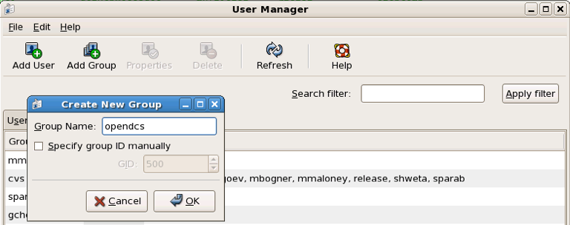Figure 2‑1 shows the group and user creation screens under a Red Hat Linux system. Similar menus are available under Solaris.

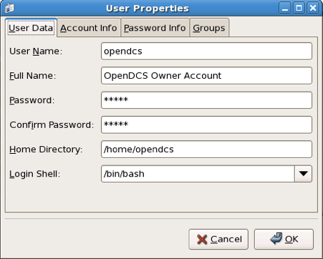

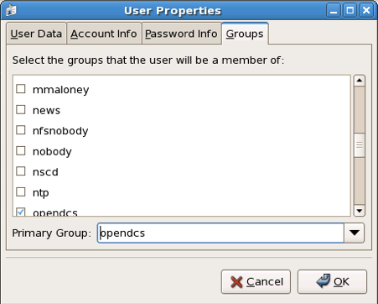

Figure 2‑1: "opendcs" User and Group Creation under Red Hat Linux.

### Permissions on Installation Directories

The central user’s $HOME and the OPENDCS installation directories should have permissions: drwxr-x---. If not, login as the central user and type:

chmod 750 $HOME

mkdir $HOME/OPENDCS

chmod 750 $HOME/OPENDCS

### Install OpenDCS

Use instructions in section 2.1 or 2.3 to install OpenDCS either from the GUI or a compressed TAR image. Install it as user opendcs at location $HOME/OPENDCS.

### Giving a Normal User Access to OpenDCS

After the installation is complete, login as a normal user (other than opendcs, and of course never *root*) that needs to run toolkit programs.

In the new user account, before doing anything else, set an environment variable DCSTOOL_HOME pointing to the actual installation in the owner’s account. For example, if user “opendcs” owns OpenDCS at /home/opendcs/OPENDCS, set an environment variable in BASH like this:

export DCSTOOL_HOME=/home/opendcs/OPENDCS

A script called “opendcs_user_init” is included with OpenDCS to set up a user’s environment. The script will do the following:

* Create a local directory for toolkit files.
* Define a shell variable called DCSTOOL_USERDIR pointing to this directory.
* Create a script $HOME/opendcs.init that you can run to set up your environment.

After running the script modify your .bash_profile in your $HOME directory to source the opendcs.init script by adding a line at the end:

. $HOME/opendcs.init

(Note the dot – space at the beginning of this line. This tells bash to make the variable settings part of your current environment.)

After running this script, your PATH variable now includes the OPENDCS bin directory, giving you access to all of the programs. To start the main toolkit launcher bar, type:

launcher_start &

Troubleshooting:

* If you get some variation of “permission denied”, it probably means that you don’t have access to the OPENDCS bin directory.
  + Make sure you are a member of the “opendcs” group.
  + Check the permissions on the installation directories (see section 2.2.2)
* If you get some variation of “command not found”, then your PATH is probably not set correctly. Did you source the “opendcs.init” file in your .bash_profile, as described above?
  + Type the command “echo $PATH”. You should see the bin directory under the OPENDCS installation (e.g. /home/opendcs/OPENDCS/bin) in the colon-separated list.

### Customizing the User’s Configuration

The OPENDCS configuration is normally stored in the file “decodes.properties” found in the installation directory.

When you login as the central user and run the OPENDCS setup menu, you will have full access to all configuration variables. The values will be stored in $DCSTOOL_HOME/decodes.properties.

You can customize the configuration for individual users. Overrides to the shared settings are stored in $DCSTOOL_USERDIR/user.properties. When you run the OPENDCS setup menu as a normal user, your settings will be stored in your configuration file and will only apply to you.

CWMS modules require access to a few JAR (Java Archive) files that are found in your CWMS installation. Please set the following two environment variables:

* $CWMS_JAR_DIR – Location of CWMS Jar Files (usually /usr/cwms/jar
* $CWMS_SYSJAR_DIR – Location of system Jars used by CWMS (usually (/usr/cwms/jar/system)

## Installing from a Compressed Tar Image

USACE requested that we prepare a compressed TAR (Tape Archive) image file for easy command-line installations.

The installation file will be called: opendcs-*version*-unix-install.tgz. For example release 6.0 is called: opendcs-6-0-unix-install.tgz. These files have been prepared by Cove Software, LLC, and delivered to USACE.

For a fresh install, first create the desired home directory, and then CD into it. For example:

cd $HOME

mkdir OPENDCS

cd OPENDCS

For an upgrade installation, the directory will already exist.

This directory will correspond to a required environment variable called DCSTOOL_HOME.

Un tar the file within this directory. For example if the tar file exists in the /tmp directory, you would type:

tar xvzf /tmp/opendcs-6-0-unix-install.tgz

For this type of installation, you MUST set the environment variable DCSTOOL_HOME. For example, if you are using the BASH (preferred) shell, edit .bash_profile and add a line like this:

export DCSTOOL_HOME=$HOME/OPENDCS

You will probably also want to add the OPENDCS bin directory to your path:

PATH=$DCSTOOL_HOME/bin:$PATH

The TAR file is meant to be used as *either* a fresh install or an upgrade. Therefore it cannot overwrite any configuration files you have customized. The config files in the release have modified filenames:

|  |  |
| --- | --- |
| ***Operational Config File*** | ***Name in the TAR file*** |
| computations.conf | computations.conf.sample |
| ddsrecv.conf | ddsrecv.conf.sample |
| decodes.properties | decodes.properties.sample |
| drgsconf.xml | drgsconf.xml.sample |
| lrgs.conf | lrgs.conf.sample |
| edit-db (directory) | edit-db.init |
| users (directory) | users.init |

For an upgrade install, you can just delete the samples that were included in the TAR file.

For a fresh install, rename the sample included in the TAR file to the operational name before starting the software for the first time.

# Upgrading Database for a Previous Release

As features are added to OpenDCS, it is occasionally necessary to modify the database schema to add new tables, columns, etc. Each new release of the software will come with schema files to build a new database, but what if you already have a working database with the old schema?

**Option 1: Do nothing.**

We always ensure backward compatibility with a new Java software release. The new Java code will work just fine with older versions of the schema. The only down-side is that you won’t be able to take advantage of any new features that require the schema changes.

**Option 2: Update to Latest Schema**

Run the command-line utility ‘dbupdate’ once after installing the new Java code.

The utility will ask you for the username and password of the database schema owner. It will make any necessary modifications to the database structure. Usually this involves defining new tables, or adding columns to existing tables.

The utility will detect the current schema version and make only the changes necessary to update to the latest. It will display all of the changes as they are made.

A sample run is shown below. User responses are in bold italic.

$ bin/decj opendcs.dbupdate.DbUpdate

Enter user name and password for the CP/DECODES schema owner account.

CP schema owner user name: ***aesrd_adm***

Password:

Init DECODES DB: EU, Enum, DataType, Sources,

Site, Equip, Config, Platform List, Presentation Groups, Network Lists,

Routing,

Init done.

TSDB Database is currently 9

DECODES Database is currently 10

Executing: ALTER TABLE NETWORKLISTENTRY ADD COLUMN PLATFORM_NAME VARCHAR(24)

Executing: ALTER TABLE NETWORKLISTENTRY ADD COLUMN DESCRIPTION VARCHAR(80)

Executing: UPDATE TSDB_DATABASE_VERSION SET DB_VERSION = 10, DESCRIPTION = 'Updated on Wed Jun 04 13:07:45 EDT 2014'

Executing: UPDATE DECODESDATABASEVERSION SET VERSION_NUM = 11

# Starting and Configuring OPENDCS

The release directory contains a file called “decodes.properties”. This file contains “name=value” pairs, one per line. The options are shown in Table 3‑1. “Default Value” is the value that will be used by the software if the property is missing from the file.

The installation procedure will create a “decodes.properties” file based on selections you made in the dialogs.

Note: if this is a multi-user installation, then your settings will be stored in $DCSTOOL_USERDIR/user.properties.

Also, new properties are added from time to time to control new features added to OpenDCS. For a complete list, see the Setup GUI available from the Launcher button panel.

| ***Property Name*** | ***Default Value*** | ***Description*** |
| --- | --- | --- |
| SiteNameTypePreference | NWSHB5 | Specifies the “preferred” type for DCP names. By default this is the Handbook-5 standard used by the National Weather Service. |
| EditDatabaseType | “xml” | The is the type for the Editable database. The same values allowed for the DatabaseType property are allowed here; viz “XML” or “SQL”. |
| EditDatabaseLocation | N/A | This is the location for accessing the editable database. The same values allowed for the DatabaseLocation property are allowed here. |
| EditOutputFormat | “Human-Readable” | Output format to test decoding scripts within dbedit. |
| EditPresentationGroup | N/A | Presentation group used to format samples when testing decoding scripts within the editor. |
| EditTimeZone | “UTC” | Time zone used when decoding sample data within the editor. Using UTC makes it easy to correlate sample times with the DCP message time stamp. |
| jdbcDriverClass | org.postgresql.Driver | Full Java class name of the JDBC driver here. |
| SqlKeyGenerator | Java Class Name | Class name of SQL key generator. |
| RoutingStatusDir | Directory Name | Default: $DECODES_INSTALL_DIR/routstat  By default, your routing specs will periodically place their status in this directory. The “Routing Status Monitor” Web Application can be used to make this information visible via a web page. |
| DefaultDataSource | Data Source Name | Default: “drot.wcda.noaa.gov”.  This is used in the database editor (dbedit) to retrieve sample messages to test your decoding. |
| TransportMediumTypePreference | String | Used in the database editor list panels to choose which of the (possibly several) transport media to display. |
| DataTypeStdPreference | String | Used by editor and some output formatters to choose which of the (possibly several) data types to display. |
| decwizTimeZone | String | Time zone used in the decoding wizard displays. |
| decwizDebugLevel | 0, 1, 2, 3 | Debug level in trace log 0=no debug info, 3= verbose. |
| decwizOutputFormat | String | Default = “stdmsg”. |
| decwizRawDataDir | Directory | Default location to move raw data files into. |
| decwizDecodedDataDir | Directory | Default location to save decoded data in. |
| decwizSummaryLog | File Name | Default file to append decoding summaries to. |
| hdbSiteDescriptions | True or False | Default = false. True will automatically place the preferred name at the beginning of the description. HDB requires this. |
| aggregateTimeZone | Time zone name | Name of time zone used to determine the start/end of aggregate periods for computations. If not set, it will default to the sqlTimeZone setting. |
| DbAuthFile | $HOME/.decodes.auth | For SQL Database connections, this file stores the database username and password. It is encrypted and should have protected permissions in the user’s home directory. Thus each user can have a different database role. |
| language | en | For internationalization, “en” is the default (English). |
| Country | us | Country abbreviation for internationalization. |
| Agency | String | Name of agency that owns the database. |
| Location | String | Sub-location of the agency that owns the database. |
| archiveDataDir | Directory | Directory for archiving raw data and summary files. |
| archiveDataFileName | File Template | File (template) for archiving raw data files. |
| rememberScreenPositions | true | By default DECODES will remember the poisition and size of each GUI screen so that when a program is restarted it will appear in the same place. Set this to false to turn off this behavior. |
| CwmsOfficeId | String | Set to override office ID determined at login. |
| writeCwmsLocations | true | Boolean. If false, then DECODES will be unable to create CWMS Location records. |
| showPlatformWizard | false | Boolean. If true, include the platform wizard button on the launcher. |
| showNetlistEditor | false | Boolean. Show the legacy flat-file network list editor on the launcher. |
| showTimeSeriesEditor | true | Boolean. |
| showComputationEditor | true | Boolean. |
| showGroupEditor | true | Boolean. |
| showTestComputations | true | Boolean. |
| showAlgorithmEditor | true | Boolean. |
| showRoutingMonitor | true | Boolean. |
| showPlatformMontiro | true | Boolean. |
| datchkConfigFile | $DCSTOOL_USERDIR/datchk.cfg | For DATCHK CCP validations. |
| retryFailedComputations | true | Set to false to disable all computation retries. |
| maxComputationsRetries | 0 (meaning unlimited) | Set to positive integer to control the maximum number of time a computation will be retried if it fails. Zero (the default) means unlimited. |
| CpEffectiveStart | String | Can be set to a negative increment like “-3 days” to limit the age of data that CP will process. |
| defaultMaxDecimals | 4 | In the absence of a presentation group entry, this will determine the maximum number of fractional digits in various output formats. |
| eventPurgeDays | 5 | Number of days that data acquisition events will be stored in the database before they are purged. |
|  |  |  |

Table 3‑1: DECODES Property Values.

The “decodes.properties” file is read when an OPENDCS program is started. Therefore, in most cases, after making changes you must restart the affected program(s).

You can edit the file directly with a text editor. The preferred way to make changes is through the GUI. Start the launcher with the command:

launcher_start

(Or on Windows, run Start – OPENDCS – Launcher).

Hit the “Setup” button. This brings up the DECODES Properties window as shown below.

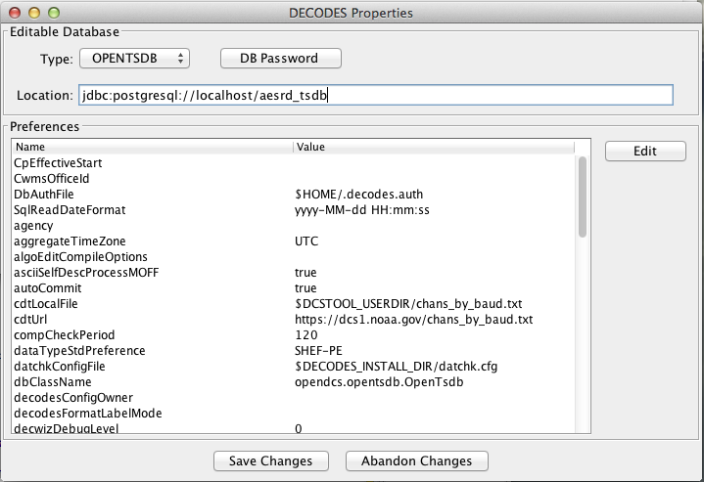

Figure 4‑1: DECODES Properties Setup GUI.

All of the possible properties are shown, regardless of whether they have been set. You can hover the mouse pointer over the name for a tool-tip for each. To edit a property, select it from the list and hit ‘Edit’.

See the sections below for Database connection settings.

After you are finished, hit the Save Changes button at the bottom. Restart any affected program (including the Launcher GUI).

## Configuring From the Database

This section applies to OpenDCS 6.2 RC13 and later.

In certain situations, usually having to do with security, you may need to be able to set the above-mentioned configuration parameters from the database. For example, if the data acquisition runs on a server that you do not have login privileges to. OpenDCS provides a mechanism for this.

The Computation Processor User Guide describes records that describe processes. You can use these process records to store configuration parameters in the database. Parameters stored and referenced in the way described here will override the settings in the decodes.properties or user.properties files described above.

To do this you will first need to create a new Application Type record. Start the reference list editor with the “rledit” command. On the Enumerations tab, select the Application Type enumeration. Create a new enumeration record as shown below.

* Mnemonic Value must be “settings”
* Executable Java Class must be (exactly): decodes.util.DecodesSettings

Before leaving rledit, be sure to hit File – Save to DB.

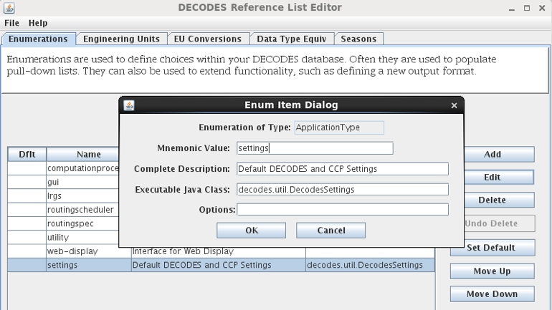

Figure 4‑2: Create the "settings" Application Type in the Reference List Editor.

Now we will create special process (a.k.a. Loading Application) records that store DECODES and CCP settings.

You can create/modify/delete process records in two ways:

* From the computation editor on the “Processes” tab.
* From the Processes button on the launcher screen.

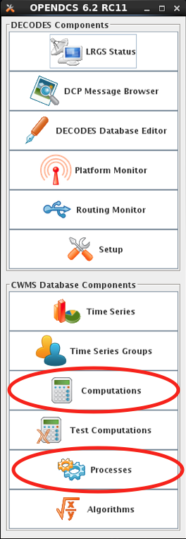

Figure 4‑3: Edit Processes from Two Different Apps.

Create a new process record. The example below shows a process record called “ServerSettings” because its intended for settings to control daemons on a remote server.

Under Process Type, select the “settings” record you created in rledit above. This will cause the Application Properties screen to fill in with a template of all available properties to control DECODES and CCP. These are the same properties listed in Table 3‑1 above.

Hover the mouse over a parameter name for a tool-tip help. Click the parameter and the Edit button to assign a value to the parameters. When you assign a value here, it will override any value from decodes.properties or user.properties. Leave properties blank if the default value is acceptable.

Thus a “process” record here is not really for a process. Rather it is a named set of overrides for the DECODES and CCP settings stored in the startup files.

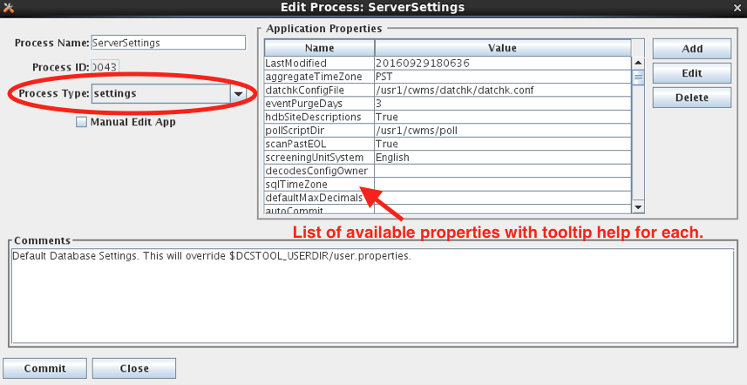

Figure 4‑4: Create a "settings" Process Record to Store DECODES/CCP Overrides.

**Command Line Args for Starting DECODES/CCP Programs:**

Now, how do you start a DECODES or CCP program and tell it to use one of these named settings processes? Add a command line arg as follows:

-Dsettings=*ProcessName*

For example, to start the computation process I could do something like this:

nohup compproc –d1 –l compproc.log –a RatingComps –Dsettings=ServerSettings &

In the above example the “ServerSettings” process is referenced.

You can add this argument to any DECODES or CCP program.

## Accessing Multiple Database Profiles from the GUI

As of 6.6 RC07 it is possible to run multiple profiles from the OpenDCS Launcher GUI. This is handy if you need to have several different OpenDCS configurations, each with a separate database.

By default, your local system configuration is stored in “decodes.properties” (for a single user installation) or “user.properties” (for a multi-user installation). This file specifies the location of your database and all other operational parameters.

The Multiple Profiles feature is normally hidden. To enable it, copy the “decodes.properties” file to a separate file with an extension “.profile”. For example, if I wanted to create a profile for my work with the NOS database, I might name the copy “NOS.profile”. Store it in the same directory as decodes.properties.

Then restart the launcher GUI and you will see a new pull-down list at the top:

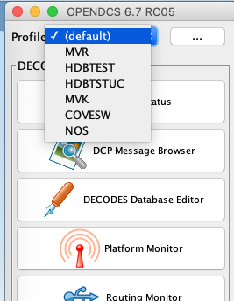

Select the profile you want to work with. Then click Setup. I selected HDBTSTUC. Note the Setup screen indicates the selected profile at the top:

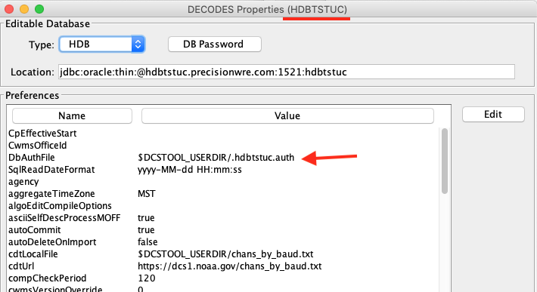

In this screen set the database type and location as needed.

Also note: If you access several SQL databases, you will likely need separate encrypted password files for each. Normally the file is simply “.decodes.auth”. Change it to something unique for each database. I used “.hdbtstuc.auth”.

Now when you click any of the launcher buttons, it will open the GUI for the selected profile. You could, for example, have the DECODES database editor open for multiple profiles at the same time like this:

* Select the (default) profile and click DECODES Database Editor. It will open the editor for the database defined in the normal “decodes.properties” file.
* Then select a different profile (e.g. “COVESW”) and click the Editor button. It will open the editor for the database defined in COVESW.profile.

This could get confusing! What if I modify something in the wrong database?

Two items have been added to every GUI screen to avoid confusion. The header now shows the profile name, and the footer now shows the profile name and the database location:

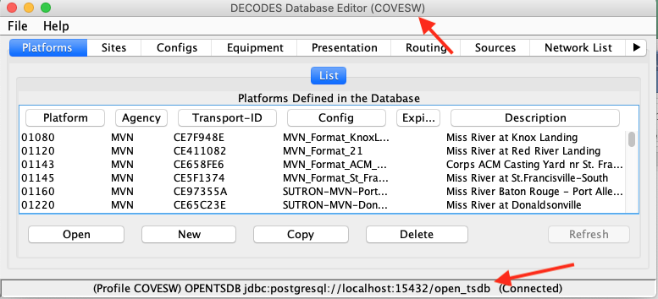

Once you have created the initial profile by copying the decodes.properties file, the feature is now enabled. You can create additional profiles from within the GUI. Back on the setup screen, click the button labeled “…” to the right of the pull-down list of profiles:

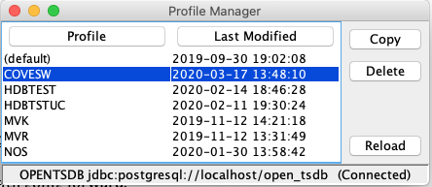

Here you can select a profile and copy it (giving it a different name).

You can delete a profile, except for the “(default)” profile. This corresponds to the “decodes.properties” file and may not be deleted.

# Creating a DECODES Database

## XML Database

The installer creates the tree ‘edit-db’ under the installation. It will install default versions of the necessary XML reference list files for enumerations, engineering units, data types, etc.

After a successful installation, your XML database is ready to go.

## OpenDCS Database under PostgreSQL

OPENDCS comes with scripts needed to create a PostgreSQL database instance with the entire schema to support DECODES and a fully functional time series database.

The SQL schema files and shell scripts are in the “schema/opendcs-pg” directory under the installation.

In this directory, edit a file called “defines.sh”. This file contains a few definitions needed by the installation script:

DBNAME=open_tsdb

DBHOST=localhost

DBSUPER=postgres

LOG=createdb.log

Notes on these settings:

* Set DBNAME to the name of the database that you want to create. For example if your organization’s abbreviation is AESRD, a good name might be “aesrd_tsdb”.
* Set DBHOST to the host name where the PostgreSQL server is running. If it is running on the same machine as OpenDCS, then *localhost* will suffice.
* Set DBSUPER to the name of the database super user that has permission to create new users and databases.
* When you run the install script, all log information will be saved in the file named by LOG. This is useful if any problems occur.

Now select a user name and password for the OpenTSDB administrator account. This will be created during installation. It should *not* be the same as the database-wide superuser.

Next you need to point OPENDCS to the database instance we are about to create. Start the launcher with the command:

launcher_start &

(Or on Windows, run Start – OPENDCS – Launcher).

Hit the Setup button in the upper part of the launcher. This brings up the DECODES Properties window as shown below.



From the pull-down list of database types, select OPENTSDB. In the Location field enter the string in the format shown:

jdbc:postgresql://***DBHOST***/***DBNAME***

Use the DBHOST and DBNAME that you specified in the createDb.sh script above.

Select an administrative user name and password. This is different from the postgres superuser name that you specified above. Write it down and remember it!

Hit the DB Password button. Type in the administrative user name and password that you selected.

You may want to peruse the other settable properties. You can hover the mouse pointer over the name for a tool-tip for each.

After you are finished, hit the Save Changes button at the bottom and exit OpenDCS completely.

You are now read to run the installation script called “createDb.sh”:

cd $DCSTOOL_HOME/schema/opendcs-pg

./createDb.sh

The script will do the following:

1. Query you for the name of the administrator account that you selected above. This will be a new database user with special privileges just in the new database.
2. Query you for the number of numeric and string storage tables for time series data. If you are unsure, just select the default by hitting enter.
3. Define new database roles (described below). If this is the second time you have run the script then warning messages will be displayed that these roles already exist. These warnings can be safely ignored.
4. Create the administrative user that you entered in step 1, and assign it to the OTSDB_ADMIN role.
5. Create the database instance named *DBNAME* (as you defined at the top of the script).
6. Install the schema (tables, indices, triggers, procedures, etc.).
7. Initialize your time series data storage tables.
8. Import several XML files from the edit-db subdirectory under OpenDCS.

Database roles created by the script:

* OTSDB_ADMIN – These users have full administrative privilege in the new database. This is needed mainly for installing the software and updates.
* OTSDB_USER – Grants read-only access to all OpenTSDB tables. This would be used by report generation and other display programs.
* OTSDB_DATA_ACQ – Used for data acquisition. It grants write access to the time series tables but not meta-data.
* OTSDB_COMP_EXEC – Used by the daemon process that will execute computations. Read access is granted to all tables, write access to time-series data, and read/write access is granted to the special tasklist tables used for computations.
* OTSDB_MGR – Grants full read/write access to all tables, including metadata. These are users who maintain the decoding and computation definition metadata.

## Creating OPENDCS DECODES Database under Oracle

OPENDCS comes with scripts needed to create an Oracle database instance with the entire schema to support DECODES and a fully functional time series database.

The instructions below were tested using Oracle RDBMS 11.2 running under CentOS 6.5. We assume you have a working Oracle installation and environment.

**Install the OPENDCS Package**

We recommend a temporary/test installation *on* the database server. We installed as user ‘oracle’ on the database server and allowed it to create a subdirectory $HOME/OPENDCS. As you run the installer GUI, select all packages to install and be sure to follow the installation all the way through to the end.

Following installation, add this to your environment:

DCSTOOL_HOME=$HOME/OPENDCS

export DCSTOOL_HOME

If you installed in a different location, modify the setting appropriately. You can add these lines to your .bash_profile (assuming you’re using bash) so that they are automatically added to your environment.

**Create the Oracle Database Instance**

Create the database instance with Oracle’s Database Creation Assistant tool. In the following examples, we will create a database with SID (a.k.a. TNS Name “aesrddec”.

Start the Database Creation Assistant with the command “dbca”. The following answers will give you a working DECODES database. Advanced Oracle administrators may want to customize their answers for their specific environment:

* Step 1: Select “Create a Database”
* Step 2: Select “General Purpose of Transaction Processing”.
* Step 3: For both Global Database Name and SID, type “aesrddec”
* Step 4: We will uncheck “Configure Enterprise Manager” (you can use that tool if desired.)
* Step 5: Click “Use the Same Administrative Password for All Accounts”. Then type and confirm a good password. Remember it!
* Step 6: For Storage Type, select “File System”. For Storage Locations, select “Use Database File Locations from Template”.
* Step 7: Accept defaults for recovery configuration
* Step 8: Do *not* check Sample schemas. Also, include no Custom Scripts.
* Step 9: Accept defaults for all initialization parameters.
* Step 10: Accept defaults for Database Storage
* Step 11: Check “Create Database”. Then click “Finish” at the bottom.

DBCA will then create and configure your database.

Set an environment variable ORACLE_SID with the name of your database. E.g.:

ORACLE_SID=aesrddec

export ORACLE_SID

To verify that the database creation worked, start SQLPLUS and enter the commands shown in red below:

[oracle@coveoracle ~]$ **echo $ORACLE_SID**

aesrddec

[oracle@coveoracle ~]$ **sqlplus / as sysdba**

SQL*Plus: Release 11.2.0.1.0 Production on Tue Feb 18 14:51:59 2014

Copyright (c) 1982, 2009, Oracle. All rights reserved.

Connected to:

Oracle Database 11g Enterprise Edition Release 11.2.0.1.0 - 64bit Production

With the Partitioning, OLAP, Data Mining and Real Application Testing options

SQL> **select * from global_name;**

GLOBAL_NAME

--------------------------------------------------------------------------------

AESRDDEC

SQL> quit

Disconnected from Oracle Database 11g Enterprise Edition Release 11.2.0.1.0 - 64bit Production

With the Partitioning, OLAP, Data Mining and Real Application Testing options

[oracle@coveoracle ~]$

Make sure you see the single global name corresponding to your SID (but converted to all capitals).

**Edit Definitions for DECODES Database Creation**

Now you are ready to run the OPENDCS DECODES Database Creation Script. This is found in the subdirectory “schema/opendcs-oracle”, under your OPENDCS installation.

CD to this directory and edit the file “defines.sh” with your favorite text editor:

#!/bin/bash

#

# Modify the definitions below before creating the database

#

#

# SYS_SCHEMA is a system administrator account for the oracle server.

# It is used to create users, roles, and tablespaces.

# Set SYS_PASSWD before executing and remove it afterward.

#

export DBSUPER=SYS

export DBSUPER_PASSWD=xxxxxxxx

# Hostname & port where the database is running

export DBHOST=localhost

export DBPORT=1521

# Logfile for installation scripts.

export LOG=createdb.log

# Schema Owner Account and password

export TSDB_ADM_SCHEMA=tsdb_adm

export TSDB_ADM_PASSWD=xxxxxxxx

# SID (a.k.a. TNS Name)

export DB_TNSNAME=aesrddec

# Oracle tablespace name and temporary tablespace name

export TBL_SPACE_DIR=/home/oracle/app/oradata/$DB_TNSNAME

export TBL_SPACE_DATA=aesrddec_data

export TBL_SPACE_TEMP=aesrddec_temp

# Number of numeric and string storage tables to create

export NUM_TABLES=10

export STRING_TABLES=5

You must enter the actual passwords in this file temporarily. You can delete them after database creation is complete. The DBSUPER_PASSWD at the top is what you entered in dbca in step 5.

The specified schema account will be created with the specified password and will be granted full administrative privileges to all DECODES database objects. The above settings are for a small database with default Oracle settings.

**Configure the DCS Toolkit**

Part of the installation will be to run an XML importer to initialize various lists within the database. For this reason you must configure OpenDCS for the new database before running the schema creation script.

Start OpenDCS with the command:

launcher_start &

Then click on the setup button. Make the following changes:

* Database Type: OPENTSDB
* Database Location: jdbc:oracle:thin:@***HOSTNAME***:1521:***DB_TNSNAME***
  + where HOSTNAME is you system hostname, or localhost if you are running on the same machine as the DBMS.
  + DB_TNSSAME is the SID or TNS Name you used in DBCA step 3.
* Click the DB Password Button and enter the administrative user account and password that you entered in defines.sh for “TSDB_ADM_SCHEMA”.
* For jdbcDriverClass, enter: oracle.jdbc.driver.OracleDriver
* For sqlKeyGenerater, enter: decodes.sql.OracleSequenceKeyGenerator

When finished, click “Save Changes”. Then exit completely out of the OPENDCS GUI.

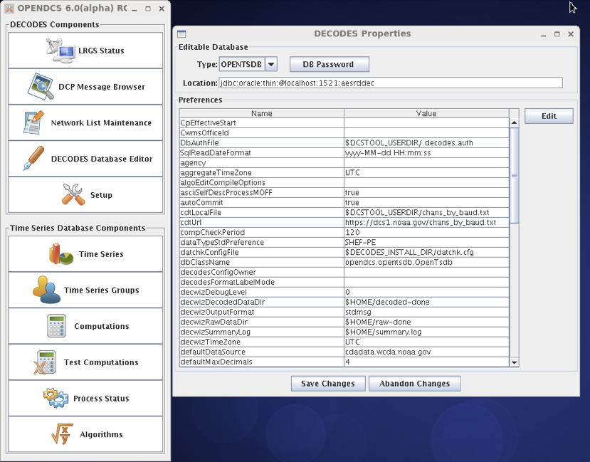

**Run the Database Creation Script**

Finally you are ready to run the script to create the database schema and users:

cd $DCSTOOL_HOME/schema/opendcs-oracle

./createDb.sh

Following script completion you can view a log of all actions taken in the file “createdb.log”.

If any errors have occurred, the log will contain an explanation. After fixing the problem you will want to run the complete script again. To drop the entire schema before restarting, start sqlplus as administrator and issue the command:

drop user ***TSDB_ADM_SCHEMA*** cascade;

... where ***TSDB_ADM_SCHEMA*** is as you defined it in the file “defines.sh”.

**Make the Database Start when the Server is Booted**

Edit /etc/oratab. Find the line corresponding to the database you just created. Change the final field from ‘N’ to ‘Y’. On our system the line reads as follows:

aesrddec:/home/oracle/app/product/11.2.0/dbhome_1:Y

## Using OPENDCS with CWMS

HEC usually creates the complete CWMS database image for use at a USACE district, including the OPENDCS/DECODES schema.

**Create OPENDCS DECODES Schema (Done by HEC)**

We begin after the CWMS is installed.

1. Install the OPENDCS 6.0 Installation in a directory on the Oracle Server. This can be done via the installer GUI (selecting all packages) or with the tarball release.

* Select a reasonable installation path. E.g. /home/oracle/OPENDCS.

1. Set environment variable $DCSTOOL_HOME pointing to the installation location. (Or the location where the tarball was un-tarred.)
2. CD to $DCSTOOL_HOME/schema/cwms30.
3. Edit the file “defines.sh” in this directory. This is a bash shell script containing several definitions, which are passed to the SQL creation scripts. See the comments in this file and make appropriate settings for your environment. Add the necessary passwords. (You can remove them after the schema is successfully created.)
4. *While still in the schema/cwms30 directory,* run the script ./createDefinesSql.sh
   * This creates the file defines.sql which is included in all of the remaining SQL scripts.
5. *To be done by ACE-IT, while still in this schema/cwms30 directory*, run the script ./createTableSpaces.sh.
6. *To be done by HEC Personnel:* run the script ./createDb.sh

* **WARNING: This script drops, and then recreates the entire CCP schema. It will delete any existing CCP database objects.**

1. After the script completes, peruse the file “createdb.log”. Search for the string ERROR. The only acceptable error is in dropping the CCP user near the beginning of the script.

**Create CCP User Accounts (Done by HEC)**

HEC or your local CWMS administrator will create Oracle database accounts for every user. In order to use CCP, the user must be granted the Oracle CCP_USER role. It must also have one of the following CWMS office privileges:

* “CCP Mgr” – A *Manager* has full read-write access to CCP objects in this district. This is used to modify DECODES and CCP meta-data records.
* “CCP Proc” – This privilege is intended for background processes like a DECODES routing spec or the CCP Computation Processor. It has read access to meta data. It has write access to a few tables used for creating locks, etc. It is also able to write time series data into CWMS.
* “CCP Reviewer” – A *Reviewer* can view data for a district and export it to XML, but cannot modify any tables.

**Initialize the CWMS CCP Database for Each District**

You must now initialize the DECODES database for each district by importing a few bootstrap XML files. First run OpenDCS:

cd $DCSTOOL_HOME

bin/launcher_start

Click the Setup button and make the following settings:

* Editable Database Type must be CWMS
* Enter the correct connection string for your database.
* Click DB Password and enter the username and password for a CCP Database User with privilege in the office that you are trying to initialize.
* Click Save Changes and exit.

Now:

cd $DCSTOOL_HOME/schema/cwms30

./importDecodesTemplate.sh

You must do this for every district that will use the database.

**Configure the Operational OPENDCS Toolkit for CWMS**

On the remote system where CCP is to run, install the OPENDCS 6.0 Toolkit:

* Select a reasonable installation path. E.g. /home/oracle/OPENDCS.
* Select all Packages
* No need to create shortcuts (uncheck this)
* Make sure you go all the way through the installation and click ‘Done’ on the final panel.

Set an environment variable DCSTOOL_HOME pointing to the installation. Then add the OpenDCS bin directory to your path. For example, in your .bash_profile:

export DCSTOOL_HOME=/home/opendcs/OPENDCS

PATH=$DCSTOOL_HOME/bin:$PATH

Start the launch menu:

launcher_start&

Click the Setup button and make the following settings:

* Editable Database Type must be CWMS
* Enter the correct connection string for your database. See Below.
* Click DB Password and enter the username and password for a CCP Database User with privilege in the office that you are trying to initialize.
* Click Save Changes and exit.

The Location field is filled in with a URL pointing to your database. It must be of the form:

jdbc:oracle:thin:@***HostName***:***PortNum***:***SID***

Where

* ***HostName***is the host name of your database server
* ***PortNum*** is the port number on which the server listens (typically 1521)
* ***SID*** Is the unique identifier for your database on the server

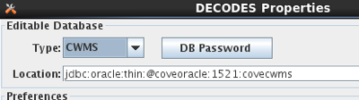

You can now use dbimport and compimport to import DECODES and computation settings from a previous installation.

## Using OPENDCS with USBR HDB

For HDB, in the Setup menu, select HDB for database type. Under location provide a URL pointing to your HDB database. It should be of the form:

jdbc:oracle:thin:@***HostName***:***PortNum***:***SID***

Where

* ***HostName***is the host name of your database server
* ***PortNum*** is the port number on which the server listens (typically 1521)
* ***SID*** Is the unique identifier for your database on the server

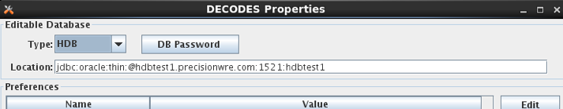

In HDB, the REF_DB_PARAMETER table contains a setting with the label “TIME_ZONE”. This determines how to interpret all the date/time values stored in Oracle DATE objects within the database. The CP software will automatically read this parameter so you do not have to set SqlTimeZone as you did in previous versions.

Many HDB tables contain a column DATE_TIME_LOADED, which records the time that a given record in the database was last modified. These columns are typically set automatically (e.g. within a trigger) from the Oracle “sysdate” value.

Since “sysdate” returns the date/time in the time zone of the underlying operating system, we recommend that the Unix server’s time zone be set to the same as the TIME_ZONE setting in REF_DB_PARAMETER. This will ensure that all DATE values in HDB are consistent.

## Encrypted Password File for Database Connection

Note the decodes.properties parameter listed above labeled “DbAuthFile”. The CP software stores an encrypted version of the database username and password in this file.

When you hit the “DB Password” button in the settings GUI, the software will save your responses in this encrypted file.

For HDB, this is used by all OpenDCS utilities. For CWMS, it is only used for background (daemon) processes. GUIs always prompt the user to enter username and password.

## Initialize from an Export of Another Database

If you are upgrading from a previous version of OpenDCS or CWMS, you will likely want to initialize your DECODES/CCP data from your existing database.

First make an XML image of the existing database. On the old system, type these commands into the old toolkit release:

dbexport > DecodesImage.xml

compexport > CompImage.xml

Now transfer these files to the new installation, and:

dbimport –r –W DecodesImage.xml

*You will be asked for confirmation. Be aware that the –W argument tells the program to DELETE any existing DECODES records in your database. Only use this argument if you want the new database to be a true mirror of the old one.*

compimport CompImage.xml

# Reference List Editor

The DECODES database contains information to populate pull-down lists. You will probably never need to modify this information.

However, if you need to expand DECODES functionality you will need to use the Reference List Editor.

To start the program, type ‘rledit’ at the command prompt. The initial screen is shown in Figure 13‑6‑1. Along the top, you see four tabs for the four types of reference lists:

* Enumerations: Used to populate pull-down lists in the database editor, and also to expand DECODES functionality in some cases.
* Engineering Units: This tab contains the units known to DECODES.
* Engineering Unit Conversions: This tab contains the conversions between units.
* Data Type Equiv: This tab contains the known data types, and assertions as to equivalence.
* Seasons: This tab allows you to define seasons for conditional processing.

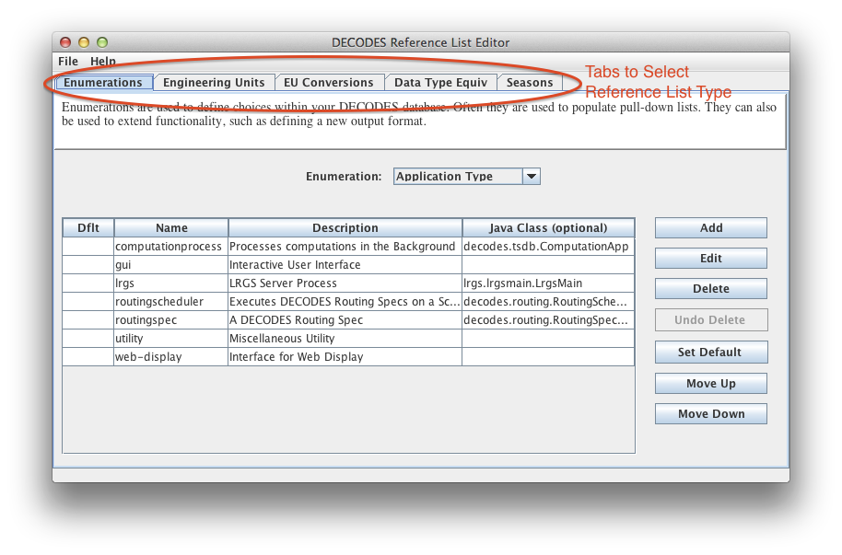

Figure 13‑6‑1: Reference List Editor Enumerations Tab.

## Enumerations

There are several enumeration sets within DECODES. Select one from the pull-down listed labeled “Enumeration”. Notice that when you select a different enumeration, the table below is populated with the values in that set.

Each set has a particular purpose:

* Application Type – DECODES allows multiple types of named processes. Features are enabled/disabled depending on the process type.
* Data Consumer – These are shown in the dbedit routing spec panel. This set associates a name like ‘pipe’ with a Java class that implements the consumer, like ‘decodes.consumer.PipeConsumer’.
* Data Source Type – These values are shown in the dbedit Data Source panel. Each DECODES data source is associated with a type. This set tells DECODES which Java class to use for each type.
* Data Type Standard – This set defines the data type coding standards that you use. Common values are ‘shef-pe’ used by USACE, and ‘epa-code’ used by USGS.
* Interval Code – This is a list of interval codes understood by the time series manipulation an computation modules.
* Measures – This is used for engineering units. Every EU measures some physical quantity like area, length, flow, volume, etc. This is a list of those physical quantities.
* Output Format - These are shown in the dbedit routing spec panel where you select the format for output data. This set associates each name with its Java class.
* Script Type – DECODES was designed to support several types of scripts, although currently only the ‘standard’ script is used.
* Site Name Type – Sites may have many names, but only one of each type. This set defines the name type columns that appear in dbedit.
* Statistics Code – These are typically used in time series naming.
* Transport Medium Type – Each TM has a type like GOES-Self-Timed, or “Data-Logger”. This set determines the values shown in the pull down list in dbedit.
* Unit Conversion Algorithm – currently contains four values for the different conversion types: none, linear, poly-5, and usgs-standard.

Using the buttons on the right you can add, edit, or delete enumeration values.

The ‘Set Default’ button places an asterisk next to the selected value. In certain cases, the default value is used in the absence of a user selection.

The order of values in the list determines the order they will appear in a pull-down list. Hence you can use the Move-Up and Move-Down buttons to change the order shown here.

Many of the enumerations are simple ordered lists with no other information required. Examples of this type are Data Type Standard, Site Name Type Standard, and Interval.

For other enumerations (e.g. Data Source Type) a Java Class Name must be carefully entered for each enumeration value. This provides a way to extend the software, by implementing new functionality in Java and then referencing it in an enumeration.

For example, the figure below shows the enumeration value for the FTP Data Source.

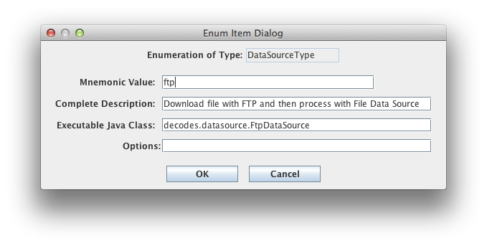

Figure 6‑2: Data Source Enumeration Value for FTP.

## Engineering Units

The Engineering Units tab is shown in Figure 13‑6‑3. This list defines all of the known EUs in DECODES.

You can click on the column headers to sort by:

* Abbreviation
* Full Name
* Family (i.e. English, Metric, or Universal)
* Measures (the physical quantity being measured by the EU)

You can use the buttons to the right to add, edit, or delete an EU.

Abbreviations must not contain embedded spaces.

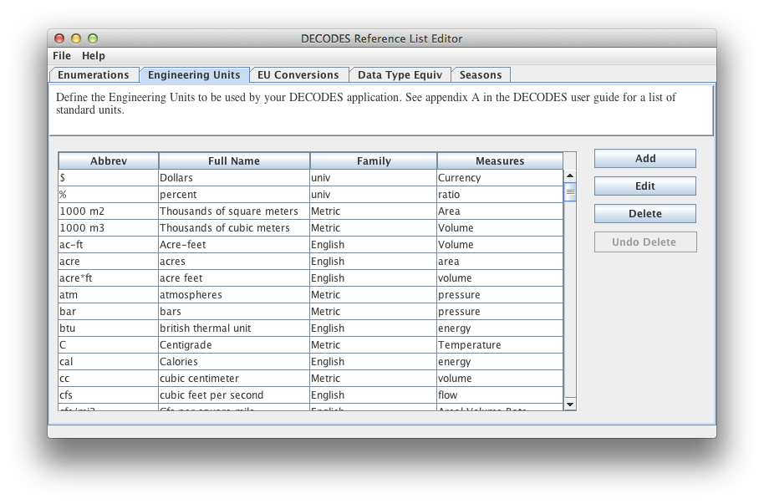

Figure 13‑6‑3: Reference List Editor Engineering Units Tab.

## Engineering Unit conversions

The EU conversions tab is shown in Figure 13‑6‑4.

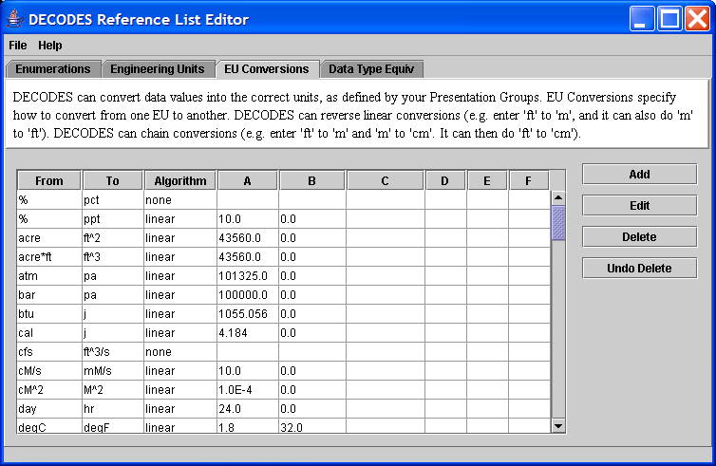

Figure 13‑6‑4: Reference List Editor EU Conversions Tab.

This list shows the standard conversions. Each line specifies how to convert *from* one EU abbreviation *to* another. There are four possibilities for Algorithm:

* none – This means that the two units are to be considered synonyms. Examples: % is a synonym for pct, and cfs is a synonym for ft^3/s.
* linear – Uses the equation y = Ax + B, where *y* is the EU we are converting to, and *x* is the EU we are converting from.
* usgs – Uses the equation y = A * (B + x)^C + D
* poly-5 – 5th order polynomial: y = Ax^4 + Bx^4 + Cx^3 + Dx^2 + Ex + F

To add, edit, or delete, use the buttons to the right of the table.

DECODES can invert “none” and “linear” algorithms. Hence if we specify how to convert from “cal” to “j”, we don’t need to specify how to convert from “j” to “cal”.

DECODES can also combine conversions. Suppose you specify:

* in -> ft
* ft -> m
* m -> mm

Then DECODES can combine these if it needs to convert “in” to “mm”.

## Data Type Equivalencies

Figure 13‑6‑5 shows the tab for Data Type Equivalencies. Recall that DECODES allows you to specify multiple data type codes for each sensor. So, for a stream stage sensor you might enter HG. Then, if you select USGS-STDMSG for your output format, DECODES must convert HG to the equivalent EPA numeric parameter code.

This feature is rarely used and should be considered a last resort. The problem is that mapping between data type systems is rarely one-to-one. For example, USGS (EPA) code 00065 may be represented in SHEF as HG, HP, HT, etc.

You are strongly encouraged to enter the specific data types that you want into each DECODES Configuration record for each sensor. Thus the automatic mapping will never be used.

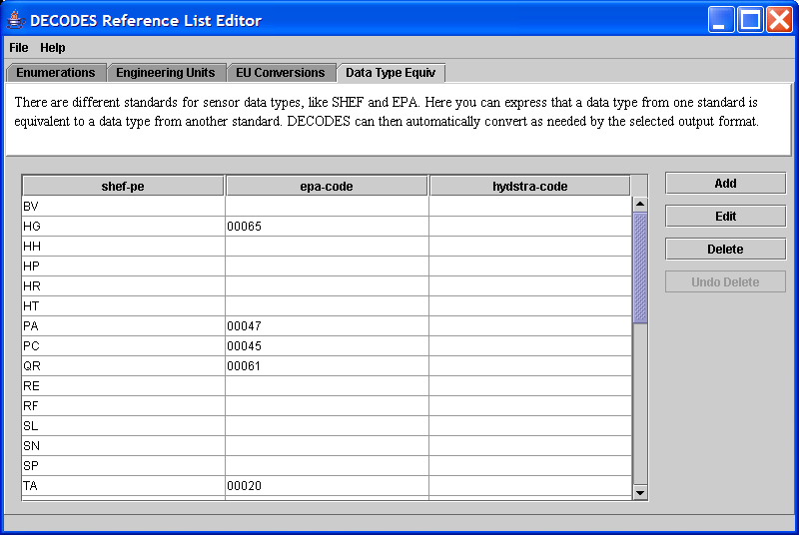

Figure 13‑6‑5: Reference List Editor - Data Type Equivalencies Tab.

## Seasons

As of OpenDCS 6.1 you can define “Seasons” by name, and then use them for conditional processing. For example, a platform that should be ignored in the winter because it is iced-over.

The Seasons tab is shown below. You are not limited to the normal four seasons. You can define a season with any name and any date/time range. For example, “planting” is the planting season, “rainy” could be defined as the rainy season.

To add, edit, or delete seasons, using the buttons on the right. The figure below shows a season being edited.

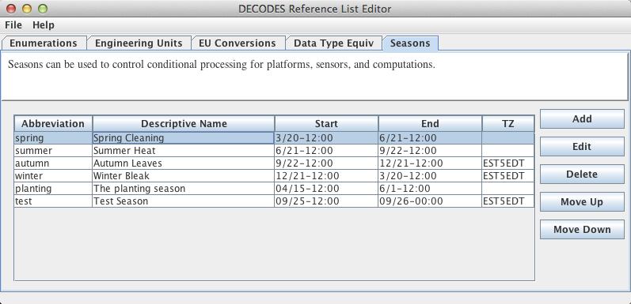

Figure 6‑6: Reference List Editor - Seasons Tab.

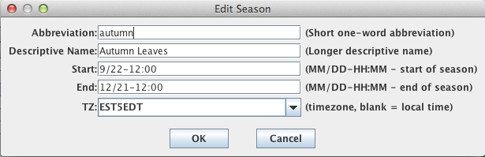

Figure 6‑7: A Season being edited.