Abstract
This paper asks how far a corpus-based model of the English dative alternation can be carried beyond the corpus that produced it. If a model learned from the American data analysed by Bresnan et al. (2007) predicts whether speakers choose give Kim the book or give the book to Kim, does it still predict the choice in later British conversation, for instance in the Spoken British National Corpus 2014 (BNC2014)? Earlier studies show that dative models trained on one variety can rank or classify tokens in another. I ask the stricter question: whether the probabilities remain reliable, which parts of the conditioning carry over, and what that production probability can say about grammar. I freeze a languageR model and score it on BNC2014 with probability scoring, calibration, a BNC2014-trained comparison on the same rows, predictor-group ablation, missing-data sensitivity, and an explicit denominator. The source model ranks BNC2014 choices well, mainly because length, animacy, definiteness, and pronominality carry over better than verb base rates. But calibration, coefficient checks, and the BNC2014-trained comparison expose patterns that ranking alone hides. The model’s probability is a conditional production probability among annotated alternation tokens, not a probability of grammaticality. It supports prediction for the shared high-frequency dative core while leaving grammatical but unattested forms to other evidence.
Keywords: dative alternation; probabilistic grammar; external validation; cross-corpus transport; calibration; projectibility; corpus linguistics

1 The problem
A corpus-based probabilistic grammar should be tested outside the corpus that produced it. For the English dative alternation, a model learned from earlier American data predicts whether speakers choose give Kim the book rather than give the book to Kim. Does the same fitted model still predict the choice in other settings, for example in later British conversation, as in BNC2014? Ranking tokens by their predicted probability of an NP recipient is only a start: it doesn’t show whether the probabilities are reliable, whether the same predictors matter in the same way, or what the production probabilities can support about grammar. This paper tests those distinctions by moving a fitted dative production model to BNC2014.
Here, probabilistic grammar names that fitted production model, not a direct model of speakers’ competence or of which forms a community licenses. The alternation itself is uneven. Speakers can say give Kim the book or give the book to Kim, and the choice varies with verb, length, animacy, definiteness, pronominality, discourse status, corpus, and register. The unevenness is easy to misread, because a rare pattern can be lexically restricted, strongly dispreferred, or tied to a discourse context without falling outside the grammar. Bresnan et al. (2007) modelled that conditioning and argued that corpus probabilities can reveal grammatical possibilities informal judgements miss.
Later work shows that the model travels: trained on one variety and scored on another, it keeps much of its accuracy (Bresnan and Hay, 2008; Kendall et al., 2011; Engel et al., 2025). The question is how well it travels under full predictive evaluation, and what a fitted production probability can and can’t say about grammar. That’s projectibility: what a profile observed in one setting licenses about another (Goodman 1955).
The paper separates questions that a single success score would merge. First, can the classic production profile be reproduced in its original data? Second, when that fitted model is frozen and used in BNC2014, does it predict the NP/PP choice? Third, does a model trained inside BNC2014 do better on the same rows? Calibration and predictor-group tests then ask what carries over: the ranking, the probability levels, verb-specific base rates, or the broader length, animacy, definiteness, and pronominality effects. Finally, a comparative-preference bridge asks whether production probabilities and paired judgements order the same verbs in the same way.

2 The original target
Bresnan et al. (2007) is the anchor because it treats the alternation as a grammatical problem, not a simple frequency count: the claim isn’t that whatever occurs often is grammatical, but that observed choices expose systematic constraints on what speakers treat as available. That matters because informal judgements compress several diagnostics into one feeling. A construction may sound odd because no viable analysis is available, because a verb–construction pairing conflicts with an established value, because the relevant discourse or communicative situation is missing, because speakers have too little evidence to settle a rare form’s status, because an established competitor keeps winning where the form might otherwise appear, or because processing pressure makes a recoverable structure feel bad. Corpus data, especially when normalized to the relevant opportunity set and paired with judgement evidence, can help sort these cases.
The empirical target is production choice. In Bresnan et al.’s data the response is whether the recipient appears as a noun phrase (NP), in the double-object pattern, or as a prepositional phrase (PP), in the prepositional dative, with predictors for the verb, recipient, theme, discourse status, and corpus. This paper preserves that target and treats the production probability as evidence to interpret, not as a direct measure of grammaticality.

3 Data reproduction and reanalysis
The analysis starts with languageR::dative, distributed with the Comprehensive R Archive Network (CRAN) languageR package (Baayen and Shafaei-Bajestan, 2025). The source tarball supplies the packaged dative.rda object; the analysis scripts load it and write derived summaries.
The package documentation identifies the sources as Switchboard and the Treebank Wall Street Journal collection. Those sources place the original data in American English: Switchboard is telephone conversation among speakers from the United States, developed in 1990–1991 (Godfrey and Holliman 1993), and the Treebank Wall Street Journal component is late-1980s American news and financial writing (Marcus et al., 1999; Charniak et al., 2000).
In the packaged dataset, there are 3,263 rows and 15 columns. The response records recipient realization, with 2,414 NP realizations and 849 PP realizations. The dataset contains 75 verb levels and two modalities: 2,360 spoken tokens and 903 written tokens. Speaker identifiers are missing exactly for the written rows.
For the first model sequence, the response stays binary: NP is coded as 1 and PP as 0. The initial split is verb-stratified, with a fixed seed (20260623), so every verb observed in the test set is also represented in training. That split gives 2,637 training rows and 626 test rows.
The denominator is narrow. These rows begin after extraction has already found a dative token with an NP or PP recipient. Transfer events expressed through some other construction, omitted, paraphrased, or left implicit are outside the sample. The models estimate conditional choice within an attested alternation frame: given that a token enters the dative-alternation sample, which realization appears?
Initial analyses are deliberately plain. A marginal model gives the base rate; structured models then ask how much modality, length, verb, and the non-verb predictors add. Negative-control and simulation checks ask whether the fitted structure behaves like a real production signal rather than chance patterning.
A second empirical source is the Spoken British National Corpus 2014 (BNC2014) dative dataset (Jenset and McGillivray, 2018; Jenset and McGillivray, 2019). The verified Figshare comma-separated values (CSV) file has 1,839 parsed data rows and 44 columns under a Creative Commons Attribution 4.0 International (CC BY 4.0) licence.
The BNC2014 dative file comes from the Early-Access Subset of the Spoken BNC2014, whose spontaneous conversations were recorded in 2012–2014 and contain speaker and context metadata.
BNC2014 is the later corpus on which the American source model is tested, not a second copy of languageR::dative. Its outcome field is Pattern, where the verb–noun–noun code VNN maps to NP realization and the verb–noun–prepositional-phrase code VNPP maps to PP realization. The six verbs shared by the two datasets are give, send, show, sell, offer, and lend.

4 Re-evaluating the classic profile
Before the model moves to a new corpus, I re-fit the classic profile under the evaluation the transport test will use: held-out probabilistic scoring, and a hierarchical alternative to one coefficient per verb. That’s a stricter test than in-sample evaluation, not a route to a different answer, so the question is whether it changes Bresnan et al.’s conclusion or only repackages it. Only the packaging changes. The table uses three diagnostics to make that visible: log loss, area under the receiver operating characteristic curve (AUC), and a count of fixed-effect terms.
Two scores carry the paper, so it’s worth fixing what they measure. Log loss rewards probabilities that are both confident and correct and punishes confident mistakes; it’s lower-is-better and reaches zero only for perfect prediction. AUC is the probability that a randomly chosen NP token is scored above a randomly chosen PP token, so 0.5 is chance and 1 is perfect ranking. It’s the measure earlier dative-transport studies report as a concordance index or $C$; the two names denote one quantity. AUC captures only discrimination, the ranking of tokens; log loss also responds to calibration, whether the predicted probabilities match observed rates. Those are separate achievements, which is why both are reported.
All models predict whether the recipient is realized as NP rather than PP. They are logistic regressions with no interactions. The marginal null uses only the training-set NP rate, so it’s the base-rate benchmark. The non-verb model adds modality, semantic class, length, animacy, definiteness, pronominality, and accessibility, but omits verb identity. It asks whether the classic non-lexical profile predicts realization without lexical information.
Two lexical models then ask whether verb-specific biases add anything. The fixed-verb model gives each verb its own coefficient, so each verb can have a different baseline preference for NP versus PP. The hierarchical model gives each verb a varying intercept drawn from a common verb distribution. That’s partial pooling: rare verbs are pulled toward the overall verb mean, while better-attested verbs can differ more. If this model matches fixed verb effects, the lexical signal survives regularization.
Model | Test log loss | Test AUC | Fixed terms
Marginal null | 0.554 | 0.500 | 1
Non-verb main model | 0.271 | 0.932 | 18
Fixed-verb full model | 0.234 | 0.951 | 92
Hierarchical verb-intercept model | 0.233 | 0.952 | 18
Table 1. Held-out languageR::dative results for the main model sequence.
The non-verb model already predicts held-out production choices well. Adding fixed verb effects improves test log loss from 0.271 to 0.234 and raises AUC from 0.932 to 0.951. The improvement confirms that lexical conditioning is not a minor residue after length, animacy, definiteness, pronominality, and accessibility are included.
Partial pooling reaches almost the same held-out performance with far fewer fixed-effect terms: the hierarchical model’s test log loss is 0.233 and its AUC is 0.952. It estimates 18 fixed-effect terms plus a single verb-intercept variance, instead of one coefficient for each of the 75 verbs. The estimated verb random-intercept standard deviation is 2.106, so the lexical signal remains large under partial pooling.
Negative-control and simulation checks behave as they should. Scrambled-label fits lose predictive value. Fake-data fits with no verb signal drive the estimated verb variance to zero, while a fake verb-effect check recovers a nonzero one. These checks make the production result more credible, but they don’t change its explanatory level.
The result supports Bresnan et al.’s production-choice conclusion. By itself, the same-data analysis shows reproducibility and statistical stability. What it can’t show is whether the pattern holds once the model leaves the corpus that produced it.

5 Cross-corpus transport
The BNC2014 analysis takes up the question from the outset: does the fitted model, learned from earlier American data, still predict the NP/PP choice in later British conversation? I train the model on spoken languageR rows for the six verbs that also appear in BNC2014, then score it on the BNC2014 rows where the shared predictors can be reconstructed. The restriction to those complete rows matters because it defines exactly which BNC2014 tokens the prediction claim is about.
Three questions stay separate. The languageR models estimate whether an attested dative token appears with an NP or PP recipient. The BNC2014 test asks how well that fitted production model predicts comparable rows in a new corpus. The supplementary DAIS bridge asks a different question again: whether paired human preferences over constructed DO/PO sentences line up with the production model.
Prior work has already tested dative models out of domain. Bresnan and Hay (2008) extended the Bresnan et al. (2007) analysis to spoken New Zealand English; Kendall et al. (2011) trained a model on the Bresnan et al. (2007) data and predicted the alternation in African American English, then reversed the direction, reporting concordance indices of 0.97 and 0.95; and Engel et al. (2025) trained separate English and Dutch models and tested each on the other language. Bresnan and Ford (2010) and Röthlisberger et al. (2017) document broad cross-variety stability by other means. Together, these studies show that dative conditioning can travel and that one variety’s model can be scored on another. The present contribution lies in what gets evaluated after the model is moved.
Those studies show that a dative model can often choose the right variant in a new setting. They leave open whether its probabilities are at the right level, how much a model trained inside the new corpus would improve on it, which parts of the grammar carry the prediction, and how missing data limits the claim.
I add those checks: probability scoring, calibration, a model trained in BNC2014 on identical rows, predictor group ablation, missing-data sensitivity, and a stated denominator. The open harmonization record keeps each step checkable.
Several real differences are bundled into the test. The source side is American telephone conversation from 1990–1991, restricted to the six shared spoken languageR verbs. The target side is spontaneous British conversation from 2012–2014, mostly intimate face-to-face conversation, under a different annotation and extraction scheme. Those six verbs account for 2,201 of 3,263 languageR rows and for 1,564 of 2,360 spoken rows. They’re the high-frequency core, not a random sample of the alternation.
The transport models are logistic regressions. The core formula is
$$\begin{aligned}Pr(\text{NP})∼​&\text{Verb}+\text{recipient length}+\text{theme length} \\ &+\text{recipient animacy}+\text{recipient pronominality} \\ &+\text{theme animacy}+\text{theme definiteness}+\text{theme pronominality}.\end{aligned}$$
I keep the formula intentionally plain. Lengths are raw word counts, with no centering, scaling, or logging. Each coefficient is read against a reference level, give for the verb and ‘no’ for the binary predictors. There are no interactions in the transport models.
Before BNC2014 is scored, factor levels and coding are fixed from the source analysis; the headline model uses no BNC2014-specific scaling or imputation. Recipient definiteness is unavailable in BNC2014 and enters only as a labelled regex proxy in a sensitivity check. The validation is retrospective in the ordinary corpus sense: the target corpus informed the harmonization, common-predictor set, and six-verb restriction, while the fitted coefficients remain source-trained.
Harmonization loses information unevenly. The outcome maps cleanly at the pattern level: VNN becomes NP and VNPP becomes PP. Verb also maps cleanly once the analysis is restricted to the six shared verbs. Length is the difficult case. In the released BNC2014 file, RecLen and ThemeLen are character counts, defined in the data dictionary as the number of characters in the recipient and theme (Jenset and McGillivray 2019). Those fields measure character length, whereas languageR uses token-like length measures.
The scripts derive recipient and theme word counts from the released phrase strings. Rows with empty phrase strings fall outside the transport model, which uses only complete cases, rows with every predictor present. The harmonized analysis still treats the two extraction protocols as distinct.
The source and target also differ in composition. In the six-verb spoken source rows, give accounts for 0.808 of tokens and send for 0.089; in the BNC2014 complete cases the corresponding shares are 0.450 and 0.300. Recipients are usually pronominal in both corpora, but recipient animacy is lower in BNC2014 (0.837, versus 0.943 in the source), and themes are shorter on average (2.43 versus 3.68 words). Together, these differences define the population shift against which transport is being tested.
The complete-case restriction matters. The core transport model scores 1,621 of the 1,839 released BNC2014 dative rows. The missing rows are outcome-skewed: NP recipients make up 0.819 of the complete rows but only 0.670 of the 218 incomplete rows. The variable-level pattern is also uneven. Recipient pronominality is missing for 112 rows with NP rate 0.357, while theme pronominality is missing for 139 rows with NP rate 0.950. The headline comparison is a complete-case estimate over the shared high-frequency core.
A BNC2014 metadata audit describes the population being tested: the released dative rows are predominantly UK English (1,720 of 1,839), skew female (1,138) and young (the 19–29 band is the largest), and are dominated by close-family, partner, and very-close-friend conversations (1,171 rows). The complete-case subset keeps the same shape, so a single BNC2014 score describes this released corpus slice, not British spoken English in general.
The public BNC2014 release also limits how strong the BNC2014-trained comparison can be. The supporting scripts show that an intermediate main_speaker_id was derived and selected, but it was dropped before the public 44-column CSV. No stable speaker, text, or conversation identifier is recoverable from the released files. I can hold out rows, but I can’t hold out whole conversations. The comparison below still repairs the old sample mismatch: source-trained and BNC2014-trained predictions are scored on the same 1,621 rows, with the AUC gap computed fold by fold. Within-conversation dependence remains.
The model comparison asks where portability comes from. The marginal model gives every target row the same probability. The verb-only model asks whether six-verb base rates travel. The non-verb model omits verb but keeps the harmonized length, animacy, definiteness, and pronominality predictors, asking whether broad conditioning relations travel. The full core combines both.
There are two versions of each family. The source version is fit on languageR and scored unchanged on BNC2014. The BNC2014-trained version is fit inside BNC2014 and predicts held-out BNC2014 rows, giving a within-corpus comparison for the same BNC2014 rows.
Table 2 asks three questions on those same rows: whether the source model beats a target marginal baseline, whether training on BNC2014 does better, and whether the carried-over prediction comes from verb identity or from the non-lexical predictors.
Origin | Model family | Log loss | AUC
languageR source | marginal | 0.473 | 0.500
languageR source | verb only | 0.456 | 0.646
languageR source | non-verb | 0.296 | 0.899
languageR source | full core | 0.308 | 0.906
BNC2014 native | marginal | 0.473 | 0.500
BNC2014 native | verb only | 0.439 | 0.625
BNC2014 native | non-verb | 0.234 | 0.928
BNC2014 native | full core | 0.227 | 0.939
Table 2. Same-row BNC2014 complete-case evaluation. All rows are the same 1,621 BNC2014 complete-case observations. The BNC2014-trained rows use repeated verb-stratified row-level cross-validation because the released file carries no speaker or conversation identifier. BNC2014-trained AUC is averaged within each held-out fold, with the source prediction scored on the same held-out fold for the AUC gap; log loss is pooled. Within-conversation dependence remains.
The American source model still carries useful information about BNC2014, and almost all of it comes from the shared non-lexical conditioning (Table 2). The full source model improves sharply on the source marginal baseline, and a paired row bootstrap puts that gain well clear of zero. Verb identity alone barely beats the baseline; the non-verb model, with length, animacy, definiteness, and pronominality, does nearly all the work, and adding source verb terms to it shifts ranking only slightly. In BNC2014, lexical base-rate ordering adds little beyond the portable non-lexical effects.
Figure 1 shows which parts travel. Fitting the same full formula separately to the source core and the BNC2014 complete cases gives the same sign for ten of the twelve non-intercept terms: recipient and theme length, and recipient and theme pronominality, keep both their direction and roughly their size. Only two signs reverse, recipient animacy and theme definiteness, and they’re among the weaker terms. The sharpest lexical shift is offer: its strong source penalty against the NP recipient nearly disappears in BNC2014. So the transport claim is bounded but real: length and pronominality, and much of animacy, stay predictively useful under a substantial corpus shift.
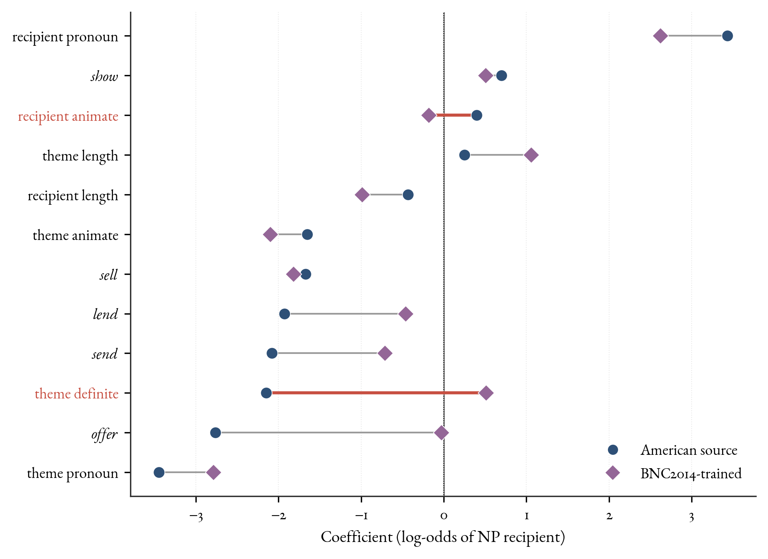
Figure 1. Coefficient transport on the log-odds scale: the full model fitted separately to the American source core and to the BNC2014 complete cases. Each term joins its source estimate (circle) to its BNC2014-trained estimate (diamond), with the vertical line at zero. Ten of the twelve terms keep their sign; the two that cross zero, recipient animacy and theme definiteness, are the reversals. Length and pronominality keep their direction and size, while the source offer penalty collapses toward zero.
BNC2014 still has patterns the source model misses. On the identical rows, the BNC2014-trained full model has log loss 0.227 and a fold-averaged AUC of 0.939. Against the source full model scored on the same held-out folds, its log loss is lower by 0.081 (paired row bootstrap $[-0.104,-0.059]$) and its fold-averaged AUC is higher by 0.032 (fold bootstrap $[0.025,0.039]$); the source fold-averaged AUC in that matched comparison is 0.906. The BNC2014-trained non-verb model is already close to the BNC2014-trained full model, which reinforces the same interpretation: broad length, animacy, definiteness, and pronominality effects are portable, but BNC2014 supplies its own calibration, annotation-regime adaptation, and remaining corpus-specific patterning.
Verb-by-verb calibration (supplementary Figure 4) shows where the source model misses: the source full model underpredicts NP realization for send, offer, and lend, and overpredicts it for sell. Recalibrating the transported predictions on these same rows gives the source model every advantage, because it’s a best-case diagnostic rather than an out-of-sample result. Even so, the best recalibration stays short of the BNC2014-trained full model. The calibration slope measures how stretched the probabilities are: 1 is correct, and below 1 means they run too extreme. Refitting the average level alone barely helps (log loss 0.308 to 0.301); refitting level and slope together pulls the slope to 0.73, confirming the source probabilities are overconfident, and lowers log loss to 0.290. Even this best case stays above the BNC2014-trained model’s 0.227, so the remaining gap is more than a global prevalence shift.
Across the probability range the miscalibration is easier to see than verb by verb. Figure 2 bins predictions against observed rates: the transported source model departs from the diagonal while the BNC2014-trained model tracks it. The two models discriminate similarly but are calibrated differently, which is the property a concordance index can’t show.
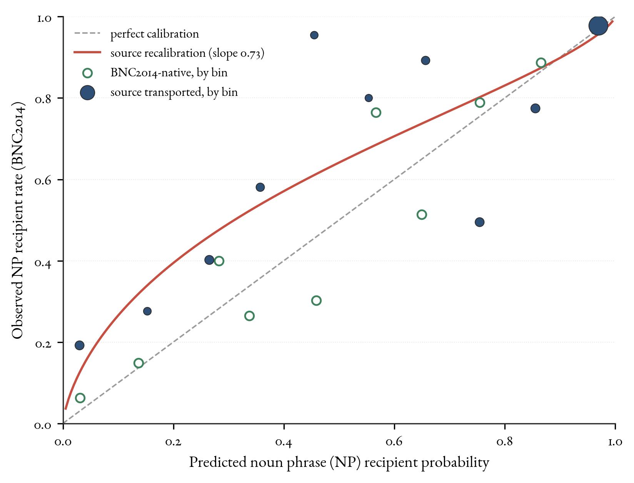
Figure 2. Reliability diagram on the BNC2014 complete-case rows. Points are binned observed noun phrase (NP) recipient rates against mean predicted probability, with marker size proportional to bin count. The transported source model departs from the diagonal (its fitted intercept-and-slope recalibration has slope 0.73), while the BNC2014-trained model sits closer to it. Discrimination and calibration are different properties.
Missingness could matter in two ways: it changes which predictors are available and which rows are scored. A matched check separates them. Only three predictors are observed for every BNC2014 row, so the reduced common-predictor model keeps verb, theme animacy, and theme definiteness. A model restricted to those predictors loses the transport result: on the 1,621 complete-case rows it scores 0.562 log loss and 0.510 AUC, worse than the source marginal baseline’s 0.473 (Table 2) and far short of the full model’s 0.308. Expanding that same reduced model from the complete-case rows to all 1,839 released rows changes performance much less (log loss 0.562 to 0.586, AUC 0.510 to 0.523) than the predictor reduction itself.
The claim depends principally on the availability of the recipient and length predictors; the denominator shift from 1,621 to 1,839 rows is the smaller issue.

6 What the probabilities can and can’t show
The BNC2014 scores can be misunderstood unless the denominator is explicit. The fitted probability is, approximately,
$$P​\left(\text{NP recipient}∣\text{a token entered the annotated NP/PP dative sample}\right),$$
not the probability that a double-object form is grammatical, and not the probability that a transfer event is realized as a dative at all. The corpus rows are already tokens in which a recipient was realized as an NP or a PP. Contexts in which a transfer event could have been expressed, paraphrased, left implicit, or judged belong to a broader opportunity set. The models estimate conditional choice inside an attested alternation frame.
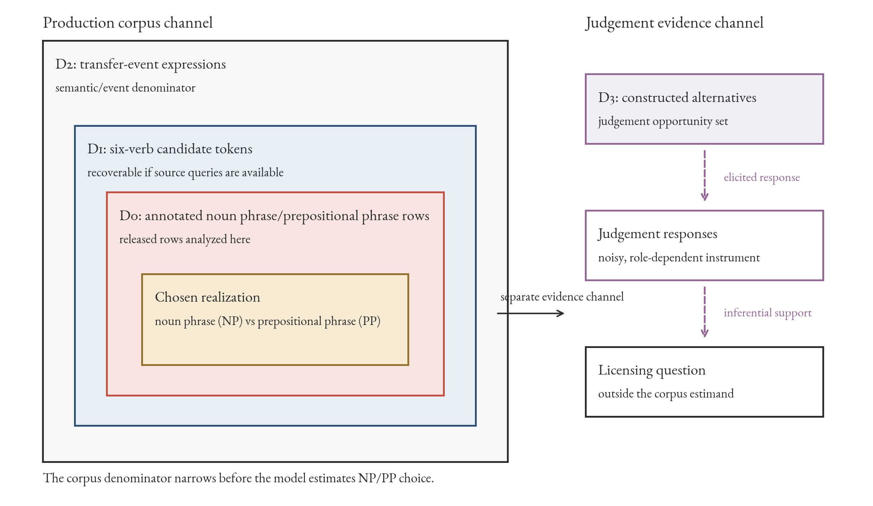
Figure 3. Nested denominators for the dative target quantity. The released corpus rows fix realization choice inside the annotated noun phrase/prepositional phrase sample, the innermost set. The broader transfer-event and judgement sets are different denominators that answer different questions; reaching them is an inferential step to a new target, not a larger sample of the same one.
That denominator bounds the successful transport result. The conditioning relations in the profile, the effects of pronominality, length, animacy, and definiteness, are projectible in Goodman’s sense (Goodman, 1955): the kind of generalization that supports projection to new cases. Transport is the empirical test of that projection in a particular corpus. A relation can be projectible and still travel poorly under a population shift.
Within its demonstrated scope, the production model forecasts realization for unseen tokens among the verbs, registers, and varieties it covers. It stays silent, by construction, about grammatical but unattested cases. Once the sampling design $D_{0}$ fixes the opportunity set, counting harder doesn’t move its boundary. More tokens make the recorded NP/PP region denser and can fill cells that were only sampling zeros, but they can’t record an opportunity the design never exposes, and from positive tokens alone they can’t tell a structural zero from a sampling zero. That’s an observational-identification limit, not a verdict that production evidence is useless. A broader denominator, elicited production, novel-item productivity tests, or judgement data can each add information about the otherwise empty cells.
The DAIS comparative-preference channel illustrates the last route and its limits. DAIS participants compared the double-object and prepositional-object variants of each constructed pair, rather than rating one sentence’s absolute acceptability. That makes DAIS a paired-preference target, not a direct grammaticality target. The bridge shows moderate marginal rank correspondence and little incremental production-score contribution once the manipulated recipient, theme, and verb conditions are represented directly. After marginal production–preference calibration, the clearest verb-level residuals go in opposite directions: offer is more double-object-favouring in DAIS than the production score predicts, while sell is less so. Validity is relative to a target; carrying it across channels requires a new validation claim.
The dative case also shows why one score is too thin. A moved model can rank the two variants well and still put the probabilities at the wrong level, miss a verb-specific shift, or depend on rows that don’t represent the corpus evenly. Table 3 lays out a validation ladder for keeping those failures separate. It borrows from prediction-model validation, especially the separation of discrimination from two aspects of calibration, the overall level (calibration-in-the-large) and the slope (Van Calster et al., 2016), and from the variationist insistence that a variable be analysed inside a defined envelope of variation (Weinreich et al., 1968; Labov, 1972).
In this case, the source model ranks BNC2014 choices well, but an intercept-and-slope recalibration still leaves it worse-calibrated than a BNC2014-trained fit. A prevalence shift alone can’t explain the gap. Reporting only discrimination, as a concordance index or an accuracy, would have hidden that.
Stage | Data | Diagnostic | Licensed conclusion
Source reproduction | Source corpus | Held-out log loss and AUC against nulls | The source profile is real and reproducible
Within-source validation | Source corpus | Partial pooling, negative controls | Lexical and non-lexical signals survive overfitting checks
Frozen external scoring | Target corpus | Log loss and AUC against the target marginal | The profile carries predictive information out of domain
External calibration | Target corpus | Calibration intercept and slope | Whether the levels are right, not just the ranking
Target-trained comparison | Target corpus | Same-row paired loss differences | How much BNC2014-specific patterning the source model misses
Predictor-group ablation | Both | Marginal, verb-only, non-verb, and full contrasts | Which part of the profile transports
Opportunity-set audit | Target corpus | Denominator and missingness map | What quantity the predictions estimate
Table 3. A validation ladder for a corpus-based probabilistic grammar. Each stage has its own diagnostic and licenses a different conclusion, and a model can pass some rungs while failing others.
Other alternations can use the same sequence when the preconditions are met: two corpora sharing a harmonizable categorical alternation, an annotated outcome, and a lexical core large enough to fit and to score on. Its limits carry over too. The comparison is testable only where the corpora intersect, so the periphery of an alternation goes unevaluated; preprocessing learned on the source has to be frozen before the target is scored; and the released data set the ceiling on how honestly dependence can be handled.
The Spoken BNC2014 release makes the last point concrete. Because the public file omits the speaker and conversation identifiers needed for grouped resampling, the BNC2014-trained comparison tests held-out rows rather than held-out conversations. That ceiling belongs to the data release. The row bootstrap and Wilson intervals reported above are conditional row-level intervals: they reflect test-row resampling around the fitted predictions, without source-model estimation uncertainty or within-conversation dependence, which probably makes them too narrow.
So the analyses license a cautious, well-scoped claim. The Bresnan et al. production-conditioning pattern is durable and partly transportable within the shared high-frequency core; its non-lexical component travels better than its lexical base rates; and a BNC2014-trained model still recovers patterns the source model misses. The validated model predicts NP/PP realization for the tested corpus slice and marks low-probability cells where grammaticality, if it’s at issue, has to be settled through another channel and another paper.

7 Conclusion
The dative result is mixed in an informative way. A model trained on the languageR version of Bresnan et al.’s data still helps predict BNC2014 choices, especially through length, animacy, definiteness, and pronominality. Verb base rates travel less cleanly, and a model trained inside BNC2014 still gives better probabilities on the same rows.
The same-data checks remain important. The languageR profile survives baselines, negative controls, simulation checks, and partial pooling, and the hierarchical model matches the fixed-verb model with fewer fixed-effect terms. The stricter re-evaluation confirms the classic production-choice conclusion rather than revising it.
The coefficient comparison points the same way while exposing limits: length and pronominality travel more cleanly than every verb effect or definiteness proxy. The verdict is bounded. The source model beats null comparisons in the high-frequency core, while variety, period, register, annotation, extraction protocol, and missingness stay bundled.
That contrast is visible because the evaluation goes beyond concordance. Earlier transport studies report discrimination or accuracy; probability scoring, calibration, a BNC2014-trained comparison on the same rows, predictor-group ablation, and missing-data sensitivity distinguish ranking new tokens from assigning calibrated probabilities to them. The contribution is a template for other alternations under the preconditions set out above, with no assumption that all alternations behave the same way.
The denominator keeps the grammaticality claim honest. The fitted probability is a conditional production choice inside an annotated alternation sample, not a probability of grammaticality. A validated production model forecasts NP/PP realization in the tested corpus slice and stays silent, by construction, about the grammatical-but-unattested region. Crossing that boundary needs a broader opportunity set or another evidence channel. The DAIS supplement gives one compact illustration: production probability and paired judgement preference are related, but the relation is target-relative rather than automatic.

Data and code availability
The public working repository is [omitted for review blinding]. The exact submitted version will be archived as a tagged release or identifier-bearing repository snapshot.
The analysis scripts fetch public datasets to temporary locations and validate downloaded files by their MD5 (message-digest 5) checksums.
File | MD5
BNC2014 CSV | 1c041dbcb635855f3d8f4be9f3e1fced
DAIS item CSV | 46af310f1633b8784f897e4482faed84
DAIS cleaned-judgement ZIP | e7b3ac6f2dd8e85bc93e6e20fc0f6ec1
Derived files and the source-verification note are stored in the repository; the README gives their paths. The principal reproduction commands are:
Rscript analysis/08_dais_acceptability_bridge.R
Rscript analysis/09_bnc2014_metadata_scope.R
Rscript analysis/10_bnc2014_paired_transport_cv.R
python3 analysis/06_denominator_and_figure_candidates.py
make
The cross-validation and bootstrap seed is 20260625. Session information is written to a derived text file. Raw DAIS files aren’t committed.

Acknowledgements
OpenAI Codex and Anthropic Claude assisted with drafting, coding, and review. All analysis decisions, source checks, and final text remain the author’s responsibility.

Supplementary material: verb-level transport calibration
Figure 4 gives the verb-level detail behind the reliability diagram in the main text (Figure 2). It compares observed NP recipient rates with the transported source model’s mean predictions and with the BNC2014-trained model’s, verb by verb, on the same complete-case rows.
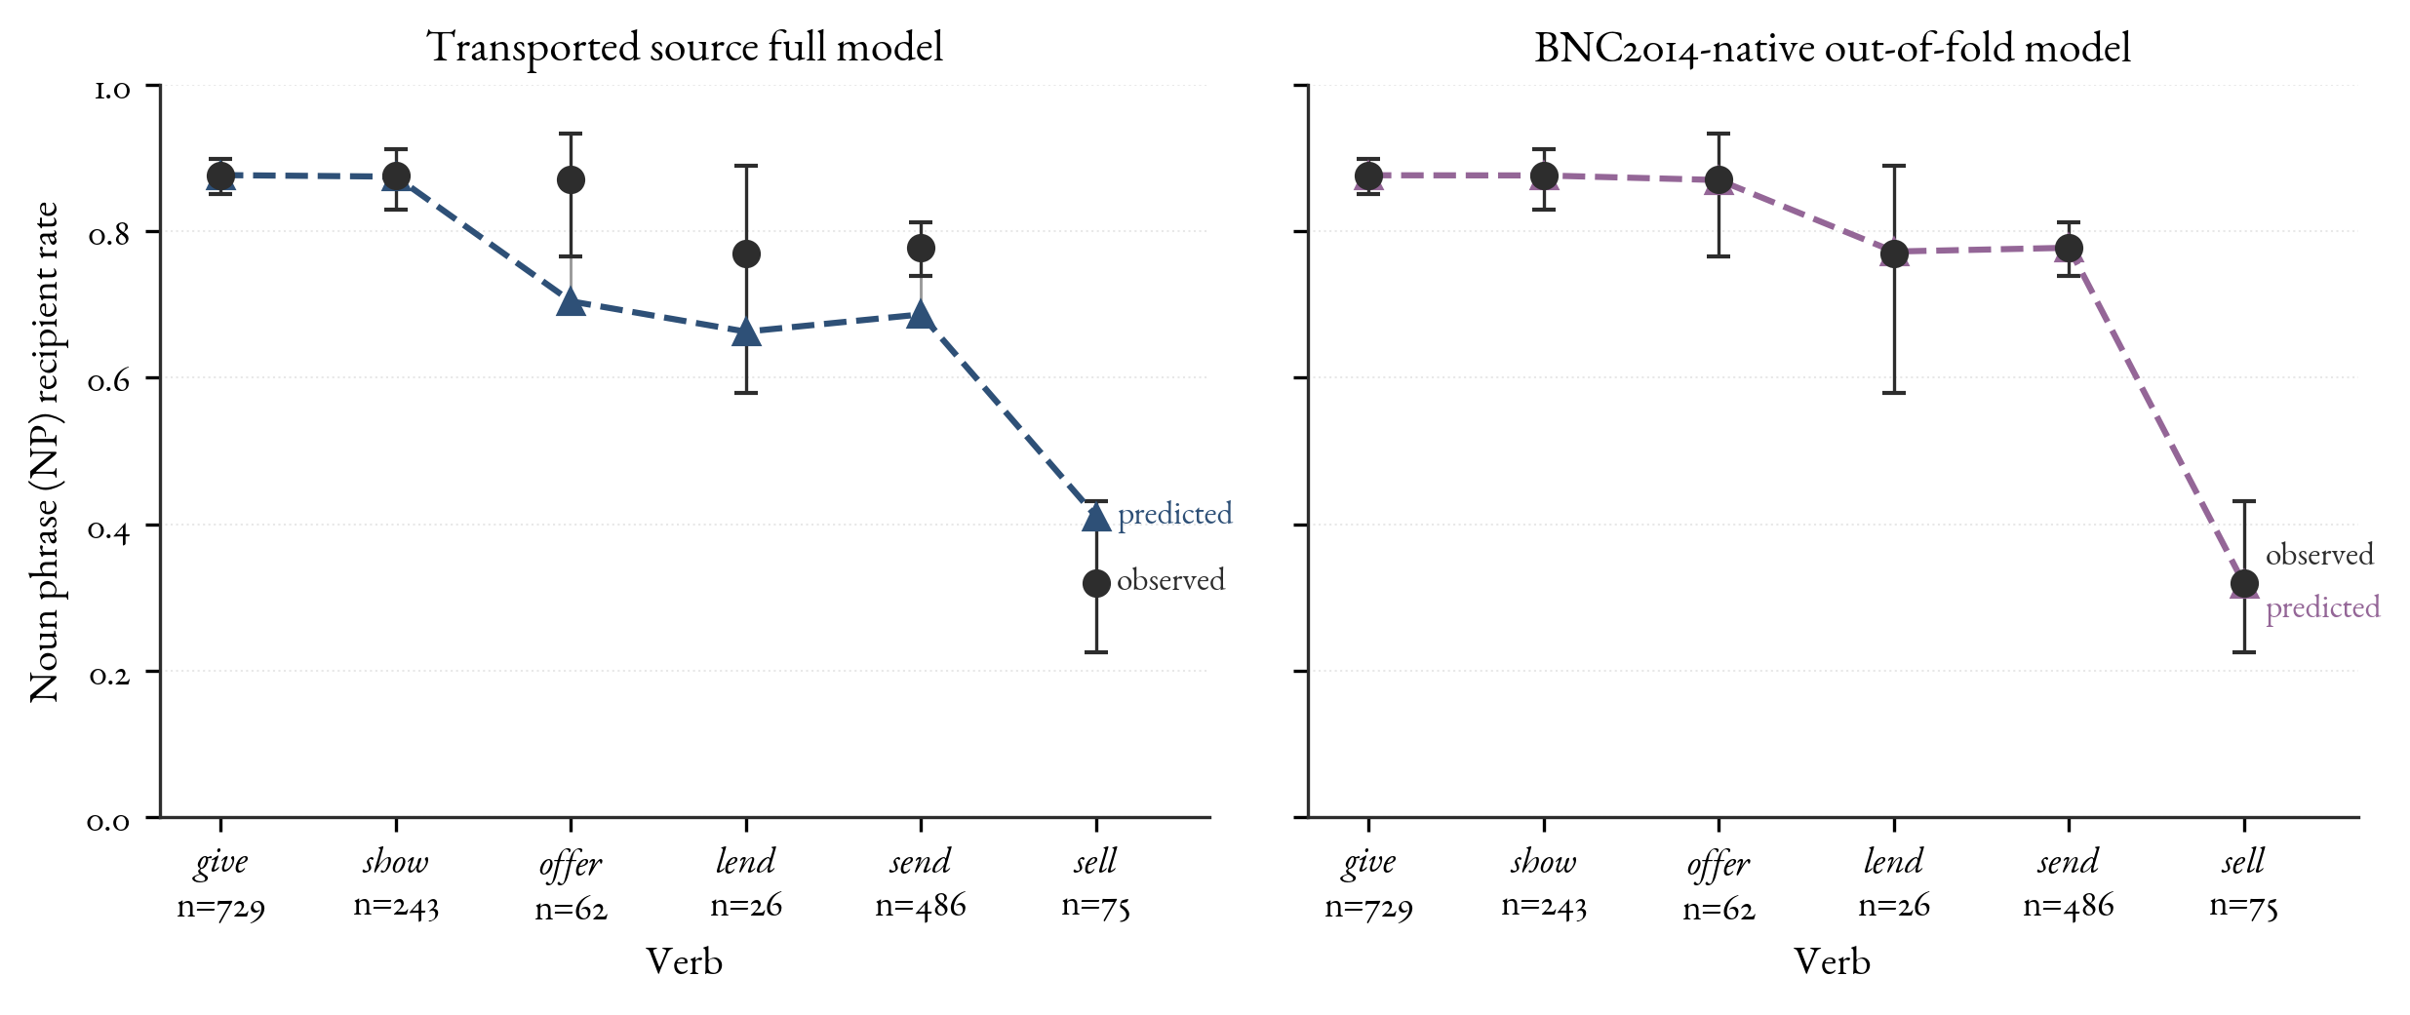
Figure 4. Verb-level calibration for the transported source full model and the BNC2014-trained held-out model on the same complete-case rows. Black points and intervals are observed NP recipient rates with binomial Wilson intervals, unadjusted for conversational clustering; coloured triangles are mean predictions.

Supplementary material: the DAIS comparative-preference bridge
DAIS asks a neighbouring question: when participants see double-object and prepositional-object versions of the same constructed item, do their preferences follow the corpus model’s production probabilities? This bridge is supplementary to the external-validation result and is reported for completeness rather than as part of the paper’s main claim.
The Dative Alternation and Information Structure (DAIS) dataset, introduced by Hawkins et al. (2020b), contains 50,000 human judgements over 5,000 dative sentence pairs and systematically varies verb, definiteness, and argument length. Participants saw both variants of each pair together and used a slider to indicate their relative preference for the double-object (DO) variant over the prepositional-object (PO) variant, with the midpoint labelled “about the same”. DAIS gives comparative preference conditioned on a pair, not an absolute acceptability rating of an individual sentence. The repository carries a CC BY 4.0 licence, and the dataset authors have given explicit permission to reuse the judgements, so DAIS can enter as a compact bridge (Hawkins et al., 2020a).
The bridge keeps the targets separate. I score only the 150 DAIS items whose verbs overlap the six-verb production core. The transported spoken languageR model gives each constructed pair an NP-recipient production probability. The DAIS item mean gives the corresponding human paired DO preference, preference for the same NP-recipient form over its PO counterpart, on a 0–1 scale. Those two values measure different quantities: conditional realization among attested corpus tokens and pairwise slider preference in constructed items. The bridge asks whether they rank items similarly, and where they depart after marginal calibration.
The cleaned DAIS responses use integer values from 0 to 100 and are scaled here by division by 100. The shared-verb subset contains 1,525 judgement rows from 923 participants over 150 constructed items. Item support ranges from 6 to 14 judgements, with a median of 10; the mean item-level standard error is 0.082 on the 0–1 response scale.
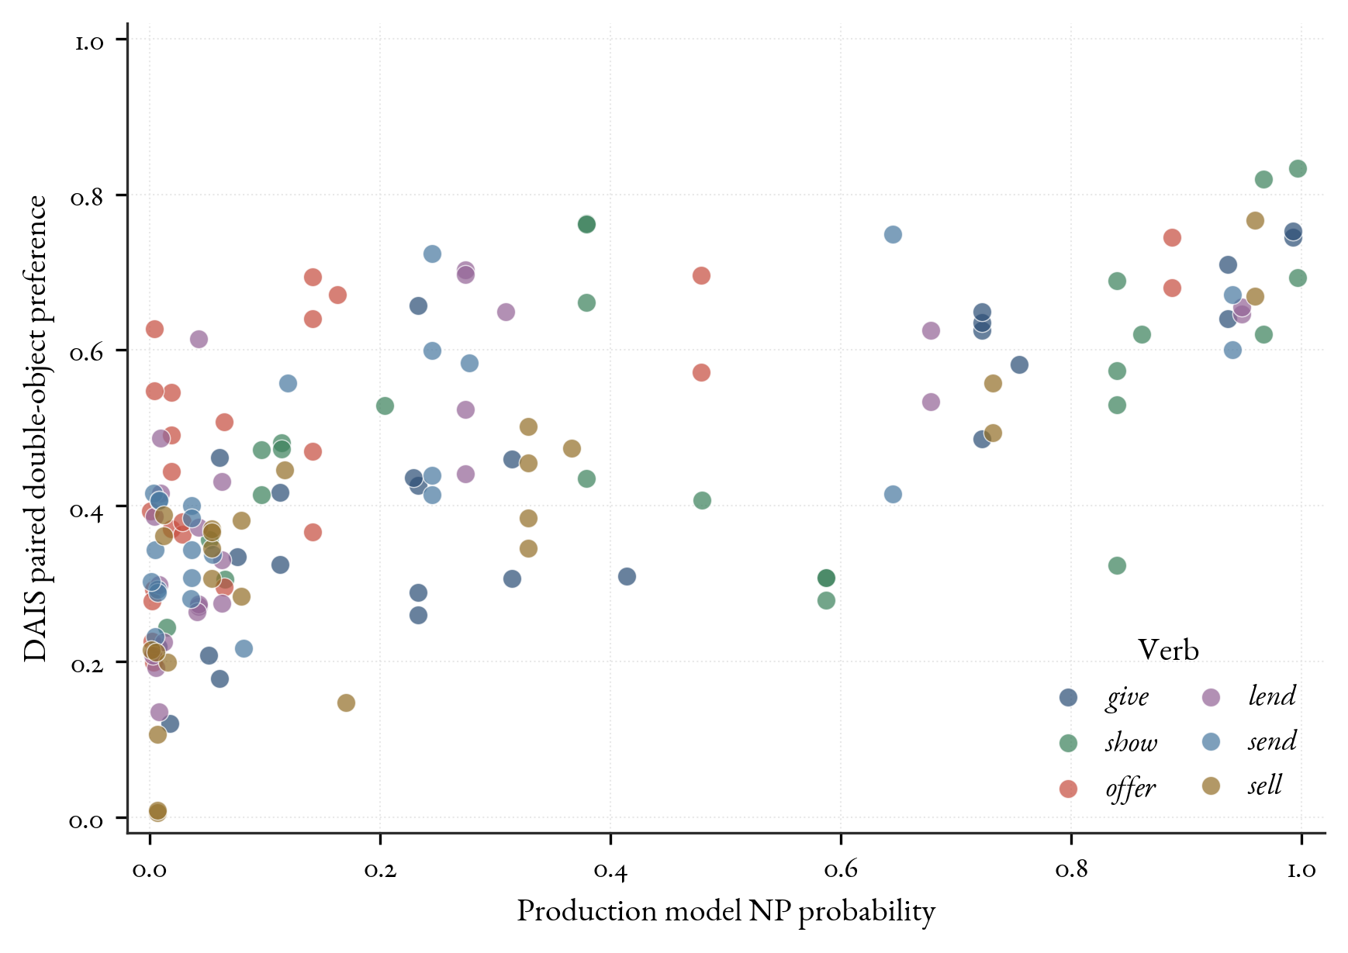
Figure 5. DAIS production/preference bridge for the six shared verbs. Each point is a constructed DAIS item. The horizontal axis is the spoken languageR model’s NP recipient probability; the vertical axis is DAIS paired DO preference. No equality line is shown because the axes are different measurement scales: corpus production probability and comparative slider preference. Points are coloured by verb.
Verb | Prod. rank | DAIS rank | Calib. resid.
show | 1 | 1 | -0.005
give | 2 | 3 | -0.036
sell | 3 | 6 | -0.070
lend | 4 | 5 | 0.015
send | 5 | 4 | 0.020
offer | 6 | 2 | 0.077
Table 4. DAIS bridge for the six shared verbs. Ranks order verbs from strongest to weakest NP/DO preference within each channel. The residual column is mean DAIS paired preference after marginal calibration on production probability; positive values mean more DO preference than the marginal production–preference relation predicts.
The two channels line up moderately, while remaining distinct. With something treated as a pronominal theme, Pearson’s $r$ is 0.667 and Spearman’s $ρ$ is 0.685 over the 150 shared-verb items. Treating something as nonpronominal gives the same rank-based interpretation ($r=0.645$, $ρ=0.675$). The raw difference between the production-probability level and the DAIS slider level would be a misleading absolute calibration error, because the midpoint-labelled comparative scale compresses item means toward 0.5 and uses a different measurement scale from a corpus production probability.
The item and participant checks show why the raw correlation needs a cautious reading. At the item level, a marginal calibration regression has a positive slope, but once recipient condition, theme type, and verb are represented directly, the production-score slope is essentially zero (0.006, standard error 0.078).
A judgement-level mixed model gives the same caution. It predicts the scaled comparative slider response from production score, recipient condition, theme type, and verb, with random intercepts for participant and constructed item. The incremental production-score coefficient is 0.017 (standard error 0.076; approximate interval $[-0.132,0.165]$). DAIS preference and production probability show moderate marginal rank correspondence, much of it attributable to shared sensitivity to the manipulated predictors; the production score adds little once those predictors are represented directly.
The useful cases are calibrated divergences, not isolated raw gaps. After a marginal production–preference calibration, the verb-level residual is 0.077 for offer (bootstrap interval 0.027 to 0.129) and $-0.070$ for sell (interval $-0.119$ to $-0.027$). The point is channel separation: two comparative measures defined over the same alternation frame can preserve moderate rank correspondence while still disagreeing in calibrated, verb-specific ways.

References
Baayen, R. Harald, and Elnaz Shafaei-Bajestan. 2025. languageR: Data Sets and Functions with Analyzing Linguistic Data. https://cran.r-project.org/package=languageR.
Bresnan, Joan, Anna Cueni, Tatiana Nikitina, and R. Harald Baayen. 2007. “Predicting the Dative Alternation.” In Cognitive Foundations of Interpretation, edited by Gerlof Bouma, Irene Krämer, and Joost Zwarts. Royal Netherlands Academy of Arts; Sciences.
Bresnan, Joan, and Marilyn Ford. 2010. “Predicting Syntax: Processing Dative Constructions in American and Australian Varieties of English.” Language 86 (1): 168–213.
Bresnan, Joan, and Jennifer Hay. 2008. “Gradient Grammar: An Effect of Animacy on the Syntax of Give in New Zealand and American English.” Lingua 118 (2): 245–59.
Charniak, Eugene, Don Blaheta, Niyu Ge, Keith Hall, John Hale, and Mark Johnson. 2000. “BLLIP 1987–89 WSJ Corpus Release 1.” Linguistic Data Consortium. https://doi.org/10.35111/fwew-da58.
Engel, Alexandra, Elsy Andries, Laura Rosseel, Benedikt Szmrecsanyi, and Freek Van de Velde. 2025. “Constraints and Lexical Conditioning in the Dative Alternation: A Cross-Linguistic Analysis of English and Dutch.” Languages in Contrast 25 (2): 263–88. https://doi.org/10.1075/lic.00052.eng.
Godfrey, John J., and Edward Holliman. 1993. “Switchboard-1 Release 2.” Linguistic Data Consortium. https://doi.org/10.35111/sw3h-rw02.
Goodman, Nelson. 1955. Fact, Fiction, and Forecast. Harvard University Press.
Hawkins, Robert, Takateru Yamakoshi, Thomas Griffiths, and Adele Goldberg. 2020a. “Dative Alternation and Information Structure (DAIS) Judgements.” https://github.com/taka-yamakoshi/neural_constructions.
Hawkins, Robert, Takateru Yamakoshi, Thomas Griffiths, and Adele Goldberg. 2020b. “Investigating Representations of Verb Bias in Neural Language Models.” Proceedings of the 2020 Conference on Empirical Methods in Natural Language Processing (EMNLP), 4653–63. https://doi.org/10.18653/v1/2020.emnlp-main.376.
Jenset, Gard B., and Barbara McGillivray. 2019. “Data from ‘The Dative Alternation Revisited: Fresh Insights from Contemporary British Spoken Data’.” Journal of Open Humanities Data 5 (1). https://doi.org/10.5334/johd.11.
Jenset, Gard, and Barbara McGillivray. 2018. “Data from ‘The Dative Alternation Revisited: Fresh Insights from Contemporary British Spoken Data’.” Figshare. https://doi.org/10.6084/m9.figshare.7353164.v6.
Kendall, Tyler, Joan Bresnan, and Gerard Van Herk. 2011. “The Dative Alternation in African American English: Researching Syntactic Variation and Change Across Sociolinguistic Datasets.” Corpus Linguistics and Linguistic Theory 7 (2): 229–44. https://doi.org/10.1515/cllt.2011.011.
Labov, William. 1972. Sociolinguistic Patterns. University of Pennsylvania Press.
Marcus, Mitchell P., Beatrice Santorini, Mary Ann Marcinkiewicz, and Ann Taylor. 1999. “Treebank-3.” Linguistic Data Consortium. https://doi.org/10.35111/gq1x-j780.
Röthlisberger, Melanie, Jason Grafmiller, and Benedikt Szmrecsanyi. 2017. “Cognitive Indigenization Effects in the English Dative Alternation.” Cognitive Linguistics 28 (4): 673–710. https://doi.org/10.1515/cog-2016-0051.
Van Calster, Ben, Daan Nieboer, Yvonne Vergouwe, Bavo De Cock, Michael J. Pencina, and Ewout W. Steyerberg. 2016. “A Calibration Hierarchy for Risk Models Was Defined: From Utopia to Empirical Data.” Journal of Clinical Epidemiology 74: 167–76. https://doi.org/10.1016/j.jclinepi.2015.12.005.
Weinreich, Uriel, William Labov, and Marvin I. Herzog. 1968. “Empirical Foundations for a Theory of Language Change.” In Directions for Historical Linguistics, edited by Winfred P. Lehmann and Yakov Malkiel. University of Texas Press.

