Brevin Simon
Professor Ghasemzadeh
TA: Su Zhang
CS 223
12 September, 2018

A: The goal of this exercise was to test four difference functions that would find the max sum in a file of random integers. These four functions all had different execution times and we used this to analyze the time it took for these functions to complete within our code.

B:
- CPU: 1500x Ryzen 5 with a clock speed of 3.5GHz. The RAM is 3200 mb/s with 16 GB
- This was ran on a Windows computer using Ubuntu desktop for a linux environment
- 10 input text files were tested for each of the input sizes

C: Next Page
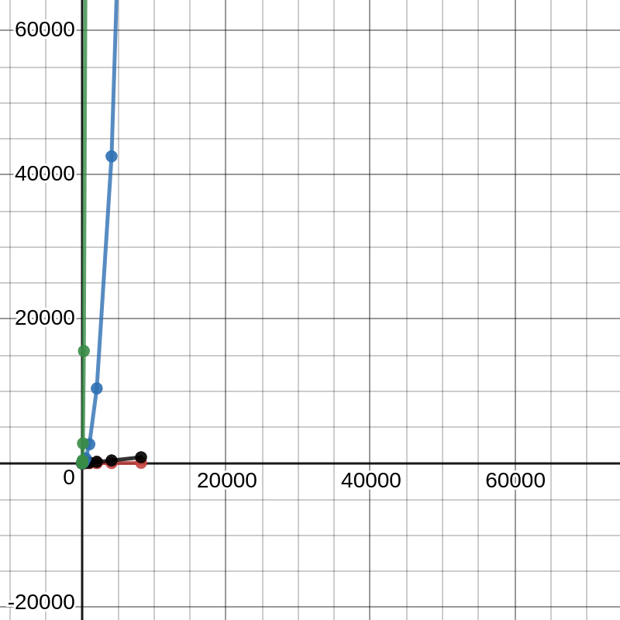
C: This is pretty much what I expected when graphing the equations. The red was E4, black was E3, Blue was E2, and the green was equation 4. It really took the most evident form according to the functions being Cubic, Quadratic, Recursive and Linear respectively. This is precisely as I expected it to look.

