KSB620 SA2 – Visual Summaries
Tazvitya Aubrey Chihota

Introduction
The goal of this report is to apply effective data presentation techniques by producing seven high-quality visuals and descriptive tables using the Real or Fake Job Postings dataset.
The dataset contains job listings with various attributes such as employment type, salary range, required experience, telecommuting availability, and a binary indicator showing whether a posting is fraudulent or legitimate.
The analysis explores these variables through: - Two univariate plots to describe single-variable distributions.
- One bivariate, one trivariate, and one quadrivariate plot to examine relationships between multiple variables.
- Two descriptive tables (one categorical and one numeric) to summarize key data characteristics.
All visuals are generated using R and the tidyverse, following the Effectively Presenting Data principles — emphasizing clarity, simplicity, and accessibility. Each visualization is accompanied by a brief interpretation highlighting meaningful insights about employment trends and fraudulent activity patterns.
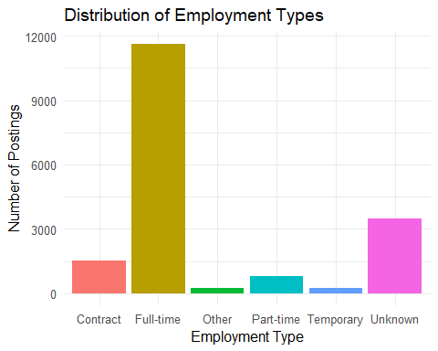

Most job postings are full-time positions, showing a dominance of stable employment over part-time or contract work.
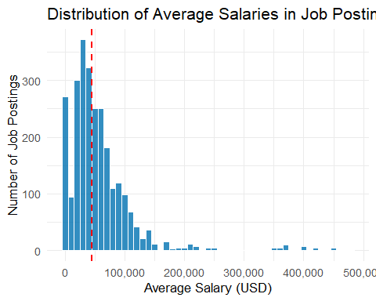

The distribution is right-skewed, with most jobs offering salaries below $70,000 and a few highly paid outliers.
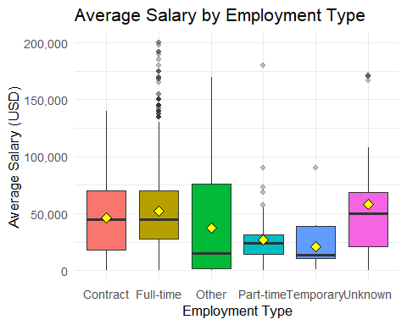

Full-time positions show the widest salary spread and the highest average pay, while internships and temporary roles remain at the lower end.
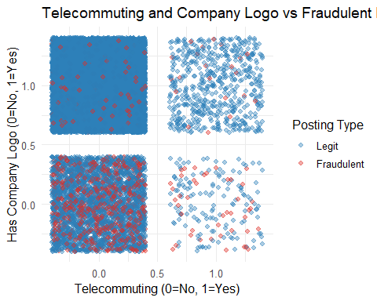

Fraudulent postings are more common among listings that lack company logos and allow telecommuting.
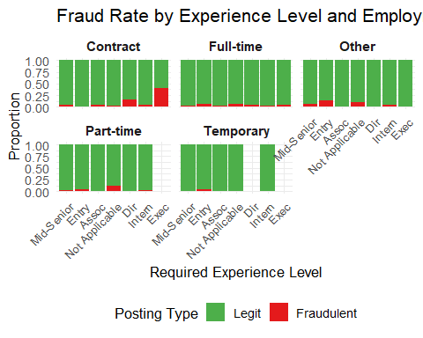

Fraudulent jobs concentrate in entry-level full-time listings, suggesting scammers target inexperienced applicants.
Table 1: Distribution of Employment Types
employment_type | n | Percent
Contract | 1524 | 8.523%
Full-time | 11620 | 64.989%
Other | 227 | 1.270%
Part-time | 797 | 4.457%
Temporary | 241 | 1.348%
Unknown | 3471 | 19.413%

Over half of postings are full-time roles, confirming a high demand for regular employment contracts.
Table 2: Summary Statistics for Average Salary
Mean_Salary | Median_Salary | SD_Salary | Min_Salary | Max_Salary
664074.4 | 45000 | 22373525 | 0 | 1e+09

The salary range shows high variance, indicating that the dataset includes both entry-level and high-paying roles.

